

ab102504
Coenzyme A Detection Kit
Instructions for Use
For the rapid, sensitive and accurate measurement of Coenzyme A levels in various samples.

This product is for research use only and is not intended for diagnostic use.

PLEASE NOTE: With the acquisition of BioVision by Abcam, we have made some changes to component names and packaging to better align with our global standards as we work towards environmental-friendly and efficient growth. You are receiving the same high-quality products as always, with no changes to specifications or protocols.

Table of Contents
Table of Contents 1
1. Overview 2
2. Protocol Summary 3
3. Materials Supplied 4
4. Storage and Stability 4
5. Materials Required, Not Supplier 5
6. Assay Protocol 6
7. Data Analysis 9
8. Troubleshooting 11

Overview
Coenzyme A (CoA) is composed of units derived from cysteine, pantothenic acid, and ATP. It plays important roles in the synthesis and oxidation of fatty acids, pyruvate oxidation in the citric acid cycle and many other biological processes. One of the main functions of CoA is the carrying and transfer of acyl groups. One of the most important acyl groups transferred is the acetate group, in which case the molecule is called acetyl-CoA. The acetyl group eventually finds itself incorporated into a variety of molecules such as cholesterol, acetylcholine, melatonin, heme and the TCA cycle intermediates.
Abcam’s Coenzyme A Detection Kit provides an easy, accurate assay to measure the CoA level in variety biological samples. In the assay, free CoA is specifically utilized to generate products which react with OxiRed Probe to generate color (λ = 570 nm) and fluorescence (Ex = 535/Em = 587 nm).
The assay can detect 0.1 to 10 nmol of CoA (2.5-250 µM concentration range) in a variety of samples.

Protocol Summary

Sample Preparation

Standard Curve Preparation

CoA Conversion

Prepare and Add Reaction Mix

Measure Optical Density or Fluorescence

Materials Supplied

Item | Quantity
Assay Buffer V/CoA Assay Buffer | 25 mL
OxiRed Probe/OxiRed Probe (in DMSO) | 0.2 mL
CoA Converter Mix/Conversion Enzyme Mix (Lyophilized) | 1 vial
ACS Substrate/CoA Substrate | 1 mL
Acyl CoA Enzyme Mix/Acyl CoA Developer (Lyophilized) | 1 vial
CoA Standard/CoA Standard (10 μmol; Lyophilized) | 1 vial

Storage and Stability
Upon arrival, store kit at -20 °C and protected from light.
Briefly centrifuge all small vials prior to opening.
ASSAY BUFFER V/CoA ASSAY BUFFER: Warm Assay Buffer V/CoA Assay Buffer to room temperature before use.
OXIRED PROBE: Ready to use as supplied. Please warm up >18 °C to melt frozen DMSO before use. Mix well, store at -20 °C, protected from light and moisture.
CoA CONVERTER MIX/CONVERSION ENZYME MIX, ACYL CoA ENZYME MIX/ACYL CoA DEVELOPER: Dissolve with 220 μl Assay Buffer V/CoA Assay Buffer. Pipette up and down to completely dissolve. Store at -20 °C. Use within two months.
CoA STANDARD: Dissolve in 100 μl dH2O to generate 100 mM (100 nmol/μl) CoA Standard solution. Keep cold while in use. Aliquot and store at -20 °C.

Materials Required, Not Supplier
- Microcentrifuge
- Pipettes and pipette tips
- Colorimetric microplate reader
- 96 well plate
- Orbital shaker
- PBS buffer

Assay Protocol

- Sample Preparation:
Cell (adherent or suspension) samples:
- Harvest ~2X10^6 cells
- Suspend the cell pellet in 500 μl of the assay buffer on ice.
- Homogenize using a Dounce homogenizer on ice for 10-50 passes until efficient lysis is confirmed by viewing the cells under a microscope.
- Spin homogenate at 10,000g for 10 min at 4C.
- Collect the supernatant on ice.
- Perform deproteinization as described in the next section.
Tissue samples (20-40 mg): should be rapidly homogenized with 100 μl ice cold PBS or other buffer (pH 6.5-8).
Enzymes in samples may interfere with the assay. We suggest deproteinizing samples using 10 kDa molecular weight cut off spin columns (ab93349) or a perchloric acid/KOH or 3M KHCO₃ protocol as follows:
- Tissue samples (20-40 mg) should be frozen rapidly (liquid N₂ or methanol/dry ice), weighed and pulverized.
- Add 2 µl 1N perchloric acid /mg per sample. KEEP COLD!
- Homogenize or sonicate thoroughly. Spin homogenate at 10,000x g for 5-10 minutes.
- Neutralize supernatant with KOH or 3M KHCO₃ (either is suitable), adding repeated 1 µl aliquots/10 µl supernate while vortexing. Add until bubble evolution ceases (2-5 aliquots). Put on ice for 5 minutes.
- Check pH (using 1 µl) is ~6-8. Spin 2 minutes at 10,000 x g to pellet perchloric acid.
Add 1 – 40 μl sample/assay into 96-well plate. If volume < 40 µl, bring volume to 40 µl with Assay Buffer V/CoA Assay Buffer.
Liquid samples (cell culture media, plasma, serum and other biological fluids): liquid samples can be assayed directly or after dilution in Assay Buffer V/CoA Assay Buffer. You might want to test different sample volumes to find the optimal that will give you a reading within the linear range of the standard curve.
Add different volumes of sample directly into 96-well plate. Bring total volume to 40 µl with Assay Buffer V/CoA Assay Buffer.
For unknown samples, we suggest testing several different amounts of sample to ensure the readings are within the standard curve.
- Standard Curve Preparation:
  - For the colorimetric assay:
Dilute the CoA Standard to 1 nmol/µl by adding 10 µl of the Standard to 990 µl of dH₂O, mix well. Add 0, 2, 4, 6, 8, 10 µl into a series of standards wells on a 96-well plate. Adjust volume to 40 µl/well with Assay Buffer V/CoA Assay Buffer to generate 0, 2, 4, 6, 8, 10 nmol/well of the CoA Standard.
  - For the fluorometric assay:
Dilute the CoA Standard to 1 nmol/µl as for the colorimetric assay. Then dilute another 10-fold to 0.1 nmol/µl by taking 10 µl into 90 µl of dH₂O. Mix well. Add 0, 2, 4, 6, 8, 10 µl into a series of standards wells on a 96 well plate. Adjust volume to 40 µl/well with Assay Buffer V/CoA Assay Buffer to generate 0, 0.2, 0.4, 0.6, 0.8, 1.0 nmol/well CoA standard.
- CoA Conversion:
Add 10 µl of Substrate, 2 µl of CoA Converter Mix/Conversion Enzyme Mix* to each standard and sample. Mix well. Incubate for 30 minutes at 37°C.
* Note: Long chain acyl-CoA’s in the sample can generate background in the assay. If your samples contain a significant amount of acyl-CoA, do a background control; omit Conversion Mix/Conversion Enzyme from the reaction. The acyl-CoA background should be subtracted from CoA readings.
- Develop: Mix enough reagent for the number of samples and standards to be performed: For each well, prepare a total 50 µl Reaction Mix containing:
Assay Buffer V/CoA Assay Buffer 46 µl
Acyl-CoA Developer 2 µl**
OxiRed Probe 2 µl***
Add 50 µl of the Reaction Mix to each well containing the CoA Standard and test samples. Incubate for 30 minutes at 37°C, protect from light.
** Note: The Acyl-CoA developer recognizes C8 or longer fatty acid chain to generate signal.
*** Note: Use 0.5 µl OxiRed Probe in the fluorometric Assay to decrease fluorescence background and increase detection sensitivity.
- Measurement: Measure OD at 570 nm for the colorimetric assay, or Ex/Em=535/589 for the fluorometric assay.

Data Analysis
Correct background by subtracting the value of the zero CoA control from all sample readings. The background reading can be significant and must be subtracted from sample readings.
Plot the standard curve. Then apply the sample readings to the standard curve to get CoA amount in the sample wells.
The CoA concentrations in the test samples:
Concentration = Ay / Sv (nmol/μl, or μmol/ml, or mM)
Where:
Ay is the amount of CoA (nmol) in sample well from the standard curve.
Sv is the sample volume (μl) added to the sample well.
CoA molecular weight: 767.5 g/mol.
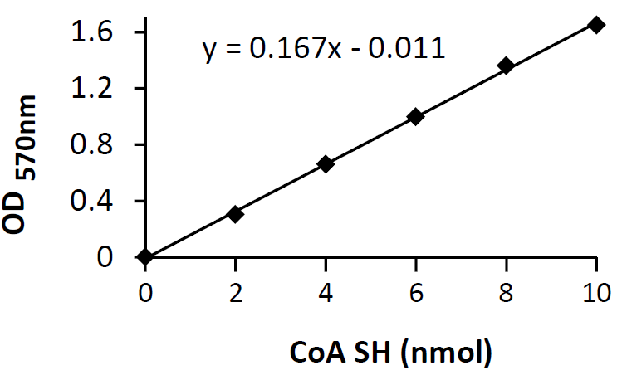

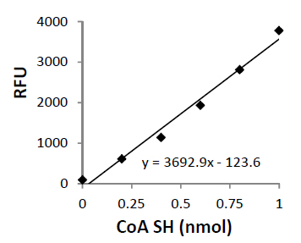
8. Troubleshooting

Problem | Reason | Solution
Assay not working | Assay buffer at wrong temperature | Assay buffer must not be chilled - needs to be at RT
Assay not working | Protocol step missed | Re-read and follow the protocol exactly
Assay not working | Plate read at incorrect wavelength | Ensure you are using appropriate reader and filter settings (refer to datasheet)
Assay not working | Unsuitable microtiter plate for assay | Fluorescence: Black plates (clear bottoms);  Luminescence: White plates;  Colorimetry: Clear plates.  If critical, datasheet will indicate whether to use flat- or U-shaped wells
Unexpected results | Measured at wrong wavelength | Use appropriate reader and filter settings described in datasheet
Unexpected results | Samples contain impeding substances | Troubleshoot and also consider deproteinizing samples
Unexpected results | Unsuitable sample type | Use recommended samples types as listed on the datasheet
Unexpected results | Sample readings are outside linear range | Concentrate/ dilute samples to be in linear range

Samples with inconsistent readings | Unsuitable sample type | Refer to datasheet for details about incompatible samples
Samples with inconsistent readings | Samples prepared in the wrong buffer | Use the assay buffer provided (or refer to datasheet for instructions)
Samples with inconsistent readings | Samples not deproteinized (if indicated on datasheet) | Use the 10kDa spin column (ab93349)
Samples with inconsistent readings | Cell/ tissue samples not sufficiently homogenized | Increase sonication time/ number of strokes with the Dounce homogenizer
Samples with inconsistent readings | Too many freeze-thaw cycles | Aliquot samples to reduce the number of freeze-thaw cycles
Samples with inconsistent readings | Samples contain impeding substances | Troubleshoot and also consider deproteinizing samples
Samples with inconsistent readings | Samples are too old or incorrectly stored | Use freshly made samples and store at recommended temperature until use
Lower/ Higher readings in samples and standards | Not fully thawed kit components | Wait for components to thaw completely and gently mix prior use
Lower/ Higher readings in samples and standards | Out-of-date kit or incorrectly stored reagents | Always check expiry date and store kit components as recommended on the datasheet
Lower/ Higher readings in samples and standards | Reagents sitting for extended periods on ice | Try to prepare a fresh reaction mix prior to each use
Lower/ Higher readings in samples and standards | Incorrect incubation time/ temperature | Refer to datasheet for recommended incubation time and/ or temperature
Lower/ Higher readings in samples and standards | Incorrect amounts used | Check pipette is calibrated correctly (always use smallest volume pipette that can pipette entire volume)

Problem | Reason | Solution
Standard curve is not linear | Not fully thawed kit components | Wait for components to thaw completely and gently mix prior use
Standard curve is not linear | Pipetting errors when setting up the standard curve | Try not to pipette too small volumes
Standard curve is not linear | Incorrect pipetting when preparing the reaction mix | Always prepare a master mix
Standard curve is not linear | Air bubbles in wells | Air bubbles will interfere with readings; try to avoid producing air bubbles and always remove bubbles prior to reading plates
Standard curve is not linear | Concentration of standard stock incorrect | Recheck datasheet for recommended concentrations of standard stocks
Standard curve is not linear | Errors in standard curve calculations | Refer to datasheet and re-check the calculations
Standard curve is not linear | Use of other reagents than those provided with the kit | Use fresh components from the same kit

For further technical questions please do not hesitate to contact us by email (technical@abcam.com) or phone (select “contact us” on www.abcam.com for the phone number for your region).

9. Notes

Technical Support
Copyright © 2023 Abcam. All Rights Reserved. The Abcam logo is a registered trademark. All information / detail is correct at time of going to print.
For all technical or commercial enquiries please go to:
www.abcam.com/contactus
www.abcam.cn/contactus (China)
www.abcam.co.jp/contactus (Japan)

