

ab102527

Glutamate Dehydrogenase Detection Kit

Instructions for Use

For the rapid, sensitive and accurate measurement of Glutamate Dehydrogenase activity in various samples

This product is for research use only and is not intended for diagnostic use.

PLEASE NOTE: With the acquisition of BioVision by Abcam, we have made some changes to component names and packaging to better align with our global standards as we work towards environmental-friendly and efficient growth. You are receiving the same high-quality products as always, with no changes to specifications or protocols.

1

Table of Contents

1. | Overview | 3
2. | Protocol Summary | 4
3. | Components and Storage | 5
4. | Assay Protocol | 7
5. | Data Analysis | 9
6. | Troubleshooting | 11

2

1. Overview

Glutamate dehydrogenase (GDH) is an enzyme that converts glutamate to α-Ketoglutarate, and vice versa. It represents a key link between catabolic and metabolic pathways and is therefore ubiquitous in eukaryotes.

Abcam’s Glutamate Dehydrogenase Detection Kit provides a convenient tool for sensitive detection of GDH in a variety of samples. GDH in sample will consume glutamate as a specific substrate and generate NADH stoichiometrically, resulting in a proportional color development. The GDH activity is easily quantified colorimetrically (λ = 450 nm). This assay detects GDH activity as low as 0.01mU in serum or tissue and cell extracts.

3

2. Protocol Summary

Sample Preparation


Standard Curve Preparation

Prepare and Add Reaction Mix

Measure Optical Density

4

- Components and Storage

  - Kit Components

 | Item | Quantity
 | GDH Assay Buffer | 25 mL
 | Glutamate Solution/Glutamate (2M) | 1 mL
 | Developer Solution III/GDH Developer (Lyophilized) | 1 vial
 | GDH Positive Control/GDH Positive Control (Lyophilized) | 1 vial
 | NADH Standard I/NADH (0.5 µmol; Lyophilized) | 1 vial

- Store kit at -20°C, protect from light. Warm the Assay Buffer to room temperature before use. Briefly centrifuge all small vials prior to opening. Read the entire protocol before performing the assay.

GDH POSITIVE CONTROL: Reconstitute with 220 µl Assay Buffer. Keep the GDH Positive Control on ice during the preparation and protect from light. Aliquot and store -20°C. Stable for up to 2 months after reconstitution or freeze-thaw cycles (< 5 times).

DEVELOPER SOLUTION IIII/GDH DEVELOPER: Reconstitute with 0.9 ml of ddH₂O. Pipette up and down several times to completely dissolve the pellet into solution (DO NOT VORTEX). Stable for up to 2 months at -20°C after reconstitution or freeze-thaw cycles (< 5 times).

5

NADH STANDARD I/NADH: Reconstitute with 50 µl ddH₂O to generate a 10 mM NADH Standard I/NADH stock solution.

Reconstituted NADH Standard I/NADH (10 mM) and the supplied Glutamate Solution/Glutamate (2 M) solution are stable for up to 6 months at -20°C.

- Additional Materials Required

  - Microcentrifuge

  - Pipettes and pipette tips

  - Colorimetric microplate reader

  - 96 well plate

  - Orbital shaker

6

  - Assay Protocol

- Sample Preparation:

- Tissues (50 mg) or cells (1 x 10⁶) can be homogenized in ~200 µl ice-cold Assay Buffer then centrifuged (13,000 x g for 10 min.) to remove insoluble material. Sonicating a few pulses on ice or using a Dounce homogenizer can be used in order to facilitate lysis.

- 5-50 µl serum samples can be directly diluted in the Assay Buffer.

- Add test sample (5-50uL) into the Sample wells and bring volume up to 50 µl/well with Assay Buffer.

For the positive control (optional), add 2 µl positive control solution to wells and adjust to a final volume of 50 µl with Assay Buffer.

2. NADH Standard Curve:

Dilute 10 µl of the NADH Standard I/10 mM NADH stock solution with 90 µl of GDH Assay Buffer to generate a 1 mM NADH standard. Add 0, 2, 4, 6, 8, 10 µl of the 1 mM NADH standard into a 96-well plate to generate 0, 2, 4, 6, 8, 10 nmol/well standard. Adjust the final volume to 50 µl with Assay Buffer.

7

- Reaction Mix: Mix enough reagents for the number of assays to be performed. For each well, prepare a Reaction Mix (100 µl) containing:

Assay Buffer | 82 | µl
Developer Solution III/GDH Developer | 8 | µl
Glutamate Solution/Glutamate (2M) | 10 | µl

Add 100 µl of the Reaction Mix to each well containing the test samples, positive controls and standards. Mix well.

- For the samples and positive controls, incubate the mix for 3 min at 37°C, then measure OD at 450 nm in a microplate reader (A₀), incubate for another 30 min. to 2 hrs at 37°C to measure OD at
- nm again (A₁).

Note:

Incubation times will depend on the GDH activity in the samples. We recommend measuring the OD in a kinetic method (preferably every 3-5 min.) and choose the period of linear range (e.g. A_{n} to A_{n+1}) to calculate the GDH activity of the samples.

8

5. Data Analysis

Plot the Glutamate standard curve. Apply OD = A₁ – A₀

(or A_{n+1} – A_{n}) to the Glutamate Standard Curve to get B nmol of

NADH produced by GDH in the given time.

GDH ₌ | B |  | Sample Dilution
GDH ₌ |  | x | Sample Dilution | = nmol/min/ml = mU/ml
GDH ₌ |  | x | Factor | = nmol/min/ml = mU/ml
Activity | T x V |  | Factor

Where:

B is the NADH amount from standard curve (in nmol).

T is the time incubated (in min).

V is the sample volume added into the reaction well (in ml).

Unit Definition: One unit is the amount of enzyme that will generate 1.0 µmol of NADH per min. at pH 7.6 and 37°C.

9

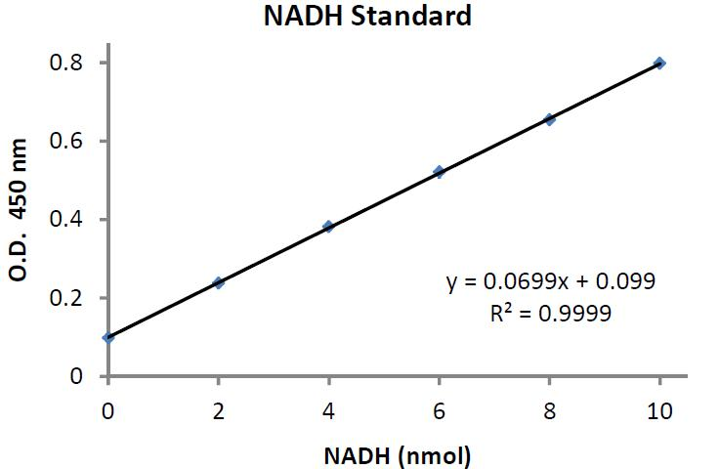
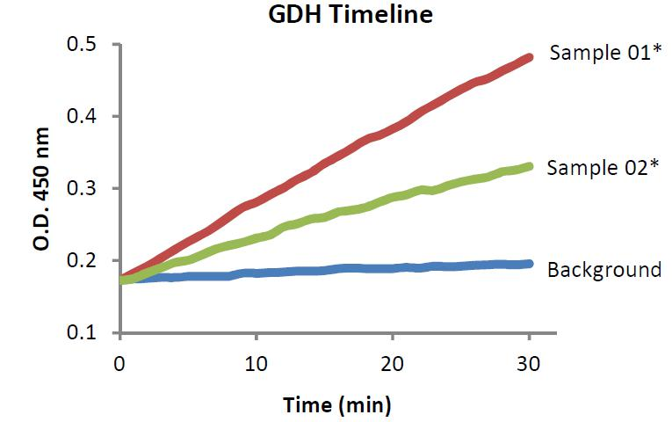

*Sample 01: Bovine Liver extraction (2 µg protein), Sample 02: 5 µl Rabbit serum

10

6. Troubleshooting

Problem |  | Reason |  | Solution
Assay not |  | Assay buffer at |  | Assay buffer must not be chilled
working |  | wrong temperature |  | - needs to be at RT
 |  | Protocol step missed |  | Re-read and follow the protocol
 |  | Protocol step missed |  | exactly
 |  | Plate read at |  | Ensure you are using
 |  | Plate read at |  | appropriate reader and filter
 |  | incorrect wavelength |  | appropriate reader and filter
 |  | incorrect wavelength |  | settings (refer to datasheet)
 |  |  |  | Fluorescence: Black plates
 |  |  |  | (clear bottoms);
 |  | Unsuitable microtiter |  | Luminescence: White plates;
 |  | Unsuitable microtiter |  | Colorimetry: Clear plates.
 |  | plate for assay |  | Colorimetry: Clear plates.
 |  | plate for assay |  | If critical, datasheet will indicate
 |  |  |  | whether to use flat- or U-shaped
 |  |  |  | wells
Unexpected |  | Measured at wrong |  | Use appropriate reader and filter
results |  | wavelength |  | settings described in datasheet
 |  | Samples contain |  | Troubleshoot and also consider
 |  | impeding substances |  | deproteinizing samples
 |  | Unsuitable sample |  | Use recommended samples
 |  | type |  | types as listed on the datasheet
 |  | Sample readings are |  | Concentrate/ dilute samples to
 |  | outside linear range |  | be in linear range

11

Samples |  | Unsuitable sample |  | Refer to datasheet for details
with |  | type |  | about incompatible samples
inconsistent |  | Samples prepared in |  | Use the assay buffer provided
readings |  | Samples prepared in |  | Use the assay buffer provided
readings |  | Samples prepared in |  | (or refer to datasheet for
 |  | the wrong buffer |  | (or refer to datasheet for
 |  | the wrong buffer |  | instructions)
 |  | Samples not
 |  | deproteinized (if |  | Use the 10kDa spin column
 |  | indicated on |  | (ab93349)
 |  | datasheet)
 |  | Cell/ tissue samples |  | Increase sonication time/
 |  | not sufficiently |  | number of strokes with the
 |  | homogenized |  | Dounce homogenizer
 |  | Too many freeze- |  | Aliquot samples to reduce the
 |  | thaw cycles |  | number of freeze-thaw cycles
 |  | Samples contain |  | Troubleshoot and also consider
 |  | impeding substances |  | deproteinizing samples
 |  | Samples are too old |  | Use freshly made samples and
 |  | Samples are too old |  | store at recommended
 |  | or incorrectly stored |  | store at recommended
 |  | or incorrectly stored |  | temperature until use
Lower/ |  | Not fully thawed kit |  | Wait for components to thaw
Higher |  | Not fully thawed kit |  | completely and gently mix prior
Higher |  | components |  | completely and gently mix prior
readings in |  | components |  | use
samples |  | Out-of-date kit or |  | Always check expiry date and
and |  | incorrectly stored |  | store kit components as
standards |  | reagents |  | recommended on the datasheet
 |  | Reagents sitting for |  | Try to prepare a fresh reaction
 |  | extended periods on |  | Try to prepare a fresh reaction
 |  | extended periods on |  | mix prior to each use
 |  | ice |  | mix prior to each use
 |  | Incorrect incubation |  | Refer to datasheet for
 |  | Incorrect incubation |  | recommended incubation time
 |  | time/ temperature |  | recommended incubation time
 |  | time/ temperature |  | and/ or temperature
 |  |  |  | Check pipette is calibrated
 |  | Incorrect amounts |  | correctly (always use smallest
 |  | used |  | volume pipette that can pipette
 |  |  |  | entire volume)
 |  |  | 12

Problem | Reason | Solution

Standard curve is not linear

Not fully thawed kit | Wait for components to thaw
Not fully thawed kit | completely and gently mix prior
components | completely and gently mix prior
components | use
Pipetting errors when | Try not to pipette too small
setting up the | Try not to pipette too small
setting up the | volumes
standard curve | volumes
Incorrect pipetting
when preparing the | Always prepare a master mix
reaction mix
 | Air bubbles will interfere with
Air bubbles in wells | readings; try to avoid producing
Air bubbles in wells | air bubbles and always remove
 | bubbles prior to reading plates
Concentration of | Recheck datasheet for
standard stock | recommended concentrations of
incorrect | standard stocks
Errors in standard | Refer to datasheet and re-check
curve calculations | the calculations
Use of other | Use fresh components from the
reagents than those | Use fresh components from the
reagents than those | same kit
provided with the kit | same kit

13

14



Technical Support

Copyright © 2023 Abcam. All Rights Reserved. The Abcam logo is a registered trademark. All information / detail is correct at time of going to print.

For all technical or commercial enquiries please go to:

www.abcam.com/contactus
www.abcam.cn/contactus (China)
www.abcam.co.jp/contactus (Japan)

