

ab108668 –
17 OH Progesterone ELISA Kit

Instructions for Use

A competitive immunoenzymatic assay for the quantitative measurement of 17 OH Progesterone in serum and plasma (citrate).

This product is for research use only and is not intended for diagnostic use.

Table of Contents

INTRODUCTION
1. BACKGROUND 2
2. ASSAY SUMMARY 4
3. PRECAUTIONS 5

GENERAL INFORMATION
4. STORAGE AND STABILITY 5
5. MATERIALS SUPPLIED 5
6. MATERIALS REQUIRED, NOT SUPPLIED 6
7. LIMITATIONS 7
8. TECHNICAL HINTS 8

ASSAY PREPARATION
9. REAGENT PREPARATION 9
10. SAMPLE COLLECTION AND STORAGE 9
11. PLATE PREPARATION 9

ASSAY PROCEDURE
12. ASSAY PROCEDURE 10

DATA ANALYSIS
13. CALCULATIONS 12
14. TYPICAL DATA 13
15. TYPICAL SAMPLE VALUES 14
16. ASSAY SPECIFICITY 15

RESOURCES
17. TROUBLESHOOTING 16
18. NOTES 18

BACKGROUND
Abcam’s 17 OH Progesterone in vitro competitive ELISA (Enzyme-Linked Immunosorbent Assay) kit is designed for the accurate quantitative measurement of 17 OH Progesterone in Human serum and plasma.
A 96-well plate has been precoated with anti-17 OH Progesterone IgG. Samples and the 17 OH Progesterone-HRP conjugate are added to the wells, where 17 OH Progesterone in the sample competes with the added 17 OH Progesterone-HRP for antibody binding. After incubation, the wells are washed to remove unbound material and TMB substrate is then added which is catalyzed by HRP to produce blue coloration. The reaction is terminated by addition of Stop Solution which stops the color development and produces a color change from blue to yellow. The intensity of signal is inversely proportional to the amount of 17 OH Progesterone in the sample and the intensity is measured at 450 nm.
Progesterone 17 alpha OH is a C-21 steroid hormone produced in the adrenal gland and gonads, during the synthesis of glucocorticoids and sex steroids. It is derived from progesterone via 17-hydroxylase, a P450c17 enzyme, or from 17-hydroxypregnenolone via 3β-hydroxysteroid dehydrogenase/Δ5-4 isomerase. Progesterone 17 alpha OH is a precursor of cortisol that accumulates in the case of adrenal 21-hydroxylase deficiency and decreased after replacement therapy with cortisol. High values are found in congenital adrenal hyperplasia. Progesterone 17 alpha OH has no defined physiologic role except as a precursor molecule. Serum Progesterone 17 alpha OH levels are age-dependent, with peak levels observed during fetal life and the immediate postnatal period.
During the first week of life, serum Progesterone 17 alpha OH levels fall ~50-fold compared to umbilical cord blood levels. A small transient increase occurs in male infants 30-60 days postnatally. Levels for both sexes remain at constant low levels during childhood, and then progressively increase during puberty reaching adult levels of ~100 ng/dL (~3.03 nmol/L). As with Cortisol, serum Progesterone 17-alpha OH levels normally have an ACTH-dependent diurnal variation, with peak levels in the morning and a decline at night. Ovarian production of Progesterone 17-alpha OH increases during the luteal phase of the menstrual cycle. Progesterone 17-alpha OH is a natural progestin and in pregnancy increases in the third trimester primarily due to fetal adrenal production.
Normal levels are 3 – 90 ng/dL in children and in women,
15 – 80 ng/dL prior to ovulation and 35 – 290 ng/dL during the luteal phase. Measurements of levels of Progesterone 17 alpha OH are useful in the evaluation of patients with suspected congenital adrenal hyperplasia as the typical enzymes that are defective, namely
21- hydroxylase and 11 beta-hydroxilase, lead to a build-up of Progesterone 17 alpha OH. In contrast, the rare patient with
17α-hydroxylase deficiency will have very low or undetectable levels of Progesterone 17 alpha OH. Elevated serum Progesterone 17 alpha OH levels at baseline and/or after ACTH stimulation have also been reported in other forms of adrenal hyperplasia.

ASSAY SUMMARY

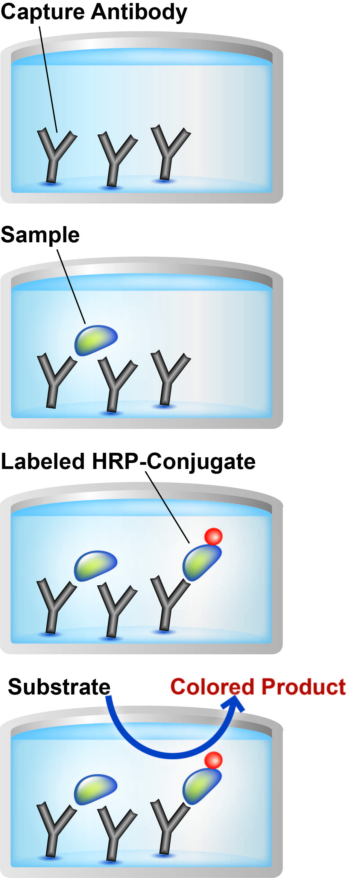

Prepare all reagents, samples, controls and standards as instructed.

Add samples, standards and controls to wells used.

Add prepared labeled HRP-Conjugate to each well. Incubate at 37ºC.

After washing, add TMB substrate solution to each well. Incubate at room temperature. Add Stop Solution to each well. Read immediately.

PRECAUTIONS
Please read these instructions carefully prior to beginning the assay.
All kit components have been formulated and quality control tested to function successfully as a kit. Modifications to the kit components or procedures may result in loss of performance.

STORAGE AND STABILITY
Store kit at 2-8°C immediately upon receipt.
Refer to list of materials supplied for storage conditions of individual components. Observe the storage conditions for individual prepared components in section 9. Reagent Preparation.

MATERIALS SUPPLIED
Item | Amount | Storage  Condition  (Before Preparation)
Anti-17 OH Progesterone IgG Coated Microplate (12 x 8 wells) | 96 Wells | 2-8°C
Stop Solution | 15 mL | 2-8°C
17 OH Progesterone-HRP Conjugate | 22 mL | 2-8°C
TMB Substrate Solution | 15 mL | 2-8°C
17 OH Progesterone Control A | 1 mL | 2-8°C
17 OH Progesterone Control B | 1 mL | 2-8°C
17 OH Progesterone Standard 0 – 0 ng/mL | 1 mL | 2-8°C
17 OH Progesterone Standard 1 – 0.2 ng/mL | 1 mL | 2-8°C
17 OH Progesterone Standard 2 – 0.6 ng/mL | 1 mL | 2-8°C
17 OH Progesterone Standard 3 – 2.0 ng/mL | 1 mL | 2-8°C
17 OH Progesterone Standard 4 – 6.0 ng/mL | 1 mL | 2-8°C
17 OH Progesterone Standard 5 – 16.0 ng/mL | 1 mL | 2-8°C
Wash Solution 10X | 50 mL | 2-8°C
Cover foils | 1 Unit | 2-8°C
Strip holder | 1 Unit | 2-8°C

MATERIALS REQUIRED, NOT SUPPLIED
These materials are not included in the kit, but will be required to successfully utilize this assay:
- Microplate reader capable of measuring absorbance at 450 nm or 620 nm
- Incubator at 37°C
- Multi- and single-channel pipettes to deliver volumes between 10 and 1,000 µL
- Optional: Automatic plate washer for rinsing wells.
- Rotating mixer
- Deionised or (freshly) distilled water.
- Disposable tubes
- Timer

LIMITATIONS
- ELISA kit intended for research use only. Not for use in diagnostic procedures
- All components of Human origin used for the production of these reagents have been tested for anti-HIV antibodies, anti-HCV antibodies and HBsAg and have been found to be non-reactive. Nevertheless, all materials should still be regarded and handled as potentially infectious
- Use only clean pipette tips, dispensers, and lab ware
- Do not interchange screw caps of reagent vials to avoid cross-contamination
- Close reagent vials tightly immediately after use to avoid evaporation and microbial contamination
- After first opening and subsequent storage check conjugate and control vials for microbial contamination prior to further use
- To avoid cross-contamination and falsely elevated results pipette patient samples and dispense conjugate, without splashing, accurately to the bottom of wells

TECHNICAL HINTS
- Avoid foaming or bubbles when mixing or reconstituting components
- Avoid cross contamination of samples or reagents by changing tips between sample, standard and reagent additions
- Ensure plates are properly sealed or covered during incubation steps
- Complete removal of all solutions and buffers during wash steps is necessary for accurate measurement readings
- Addition of the TMB Substrate solution initiates a kinetic reaction, which is terminated by the addition of the Stop Solution. Therefore, the TMB Substrate and the Stop Solution should be added in the same sequence to eliminate any time deviation during the reaction
- It is important that the time of reaction in each well is held constant for reproducible results. Pipetting of samples should not extend beyond ten minutes to avoid assay drift. If more than 10 minutes are needed, follow the same order of dispensation. If more than one plate is used, it is recommended to repeat the dose response curve in each plate
- The incomplete or inaccurate liquid removal from the wells could influence the assay precision and/or increase the background
- This kit is sold based on number of tests. A ‘test’ simply refers to a single assay well. The number of wells that contain sample, control or standard will vary by product. Review the protocol completely to confirm this kit meets your requirements. Please contact our Technical Support staff with any questions

REAGENT PREPARATION
Equilibrate all reagents, samples and controls to room temperature (18-25°C) prior to use.
  - Wash Solution 1X
Prepare 1X Washing Solution by diluting Wash Solution 10X with distilled water. To make 500 mL 1X Wash Solution combine 50 mL Wash Solution 10X with 450 mL distilled water. Mix thoroughly and gently. The Wash Solution 1X is stable for 30 days at 2-8°C. If crystals are present in Wash Solution 10X, mix at room temperature until completely dissolved.

SAMPLE COLLECTION AND STORAGE
- The determination of 17 OH Progesterone can be performed in plasma as well as in serum. If the assay is not performed on the same day of collection store the sample at -20°C. If samples are stored frozen, mix thawed samples gently for 5 min. before testing.
Avoid repeated freezing and thawing

PLATE PREPARATION
- The 96 well plate strips included with this kit are supplied ready to use. It is not necessary to rinse the plate prior to adding reagents
- Unused well strips should be returned to the plate packet and stored at 4°C
- For each assay performed, a minimum of 1 well must be used as a blank, omitting sample and conjugate from well addition
- For statistical reasons, we recommend each standard and sample should be assayed with a minimum of two replicates (duplicates).

ASSAY PROCEDURE
- Equilibrate all materials and prepared reagents to room temperature prior to use.
- Please read the test protocol carefully before performing the assay. Result reliability depends on strict adherence to the test protocol as described.
- If performing the test on ELISA automatic systems we recommend increasing the washing steps from three to five and the volume of washing solution from 300 µL to 350 µL to avoid washing effects.
- Assay all standards, controls and samples in duplicate.
  - Prepare all reagents, working standards, and samples as directed in the previous sections.
  - Remove excess microplate strips from the plate frame, return them to the foil pouch containing the desiccant pack, reseal and return to 4°C storage.
  - Add 25 µL standard, control or sample into their respective wells. Add 200 µL 17 OH Progesterone-HRP Conjugate to each well. Leave a blank well for substrate blank.
  - Cover wells with the foil supplied in the kit.
  - Incubate for 1 hour at 37°C.
  - When incubation has been completed, remove the foil, aspirate the content of the wells and wash each well three times with 300 µL distilled water. Avoid overflows from the reaction wells. During each wash step, gently shake the plate for 5 seconds and remove excess solution by tapping the inverted plate on an absorbent towel.
Automatic washer: In case you use an automatic washer, it is advised to do 6 washing steps.
Note: Washing is critical. Insufficient washing results in poor precision and falsely elevated absorbance values.
  - Add 100 µL TMB Substrate Solution into all wells.
  - Incubate for exactly 15 minutes at room temperature in the dark.
  - Add 100 µL Stop Solution into all wells in the same order and at the same rate as for the TMB Substrate Solution. Shake the microplate gently. Any blue color developed during the incubation turns into yellow.
  - Measure the absorbance of the sample at 450 nm against a reference wavelength of 620-630nm or against blanks within 5 minutes of addition of the Stop Solution.

CALCULATIONS
Calculate the mean background subtracted absorbance for each point of the standard curve and each sample. Plot the mean value of absorbance of the standards against concentration. Draw the best-fit curve through the plotted points. (e. g.: Four Parameter Logistic).
Interpolate the values of the samples on the standard curve to obtain the corresponding values of the concentrations expressed in ng/mL.

TYPICAL DATA
TYPICAL STANDARD CURVE – Data provided for demonstration purposes only. A new standard curve must be generated for each assay performed.

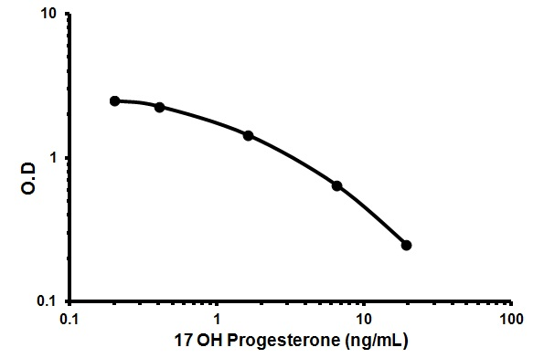

Conc. (ng/mL) | O.D
0 | 2.91
0.2 | 2.51
0.4 | 2.29
1.6 | 1.45
6.4 | 0.65
19.2 | 0.25

TYPICAL SAMPLE VALUES

REFERENCE VALUES-
Human serum 17 OH Progesterone reference values:

Women | Follicular phase | 0.2 – 1.3 ng/mL
Women | Luteal phase | 1.0 – 4.5 ng/mL
Women | Menopause | 0.2 – 0.9 ng/mL
Men |  | 0.2 – 2.3 ng/mL
Children |  | 0.2 – 0.9 ng/mL

SENSITIVITY –
The lowest detectable concentration of 17 OH progesterone that can be distinguished from the zero standard is 0.05 ng/mL at the 95 % confidence limit.

PRECISION –
 | Intra-Assay | Inter-Assay
n= | 3 | 3
%CV | ≤ 8.2 | ≤ 13.8

RECOVERY –
The recovery test performed on three different samples, enriched with 6.6 – 3.3 – 1.65 – 0.83 – 0.41 ng/mL of 17 OH Progesterone gave an average value (±SD) of 98.66% ± 5.99%. In the dilution test three different samples were diluted 2, 4 and 8 times with standard; the average value (±SD) obtained is 95.31% ± 4.88%.

ASSAY SPECIFICITY
The cross reaction of the antibody calculated at 50% is:

17α OH Progesterone | 100%
11-Deoxycortisol | 0.846%
Progesterone | 0.590%
Pregnenolone | 0.250%
Testosterone | 0.017%
17-beta Estradiol | <0.001%
Aldosterone | <0.001%
Estriol | <0.001%
Estrone 3-sulfate | <0.001%
Spironolactone | <0.001%
Androstenedione | <0.01%
Corticosterone | <0.01%
Cortisol | <0.01%
Cortisone | <0.01%
DHEA | <0.01%
DHEA-S | <0.01%
DHT | <0.01%
Prednisolone | <0.01%
Prednisone | <0.01%
Cholesterol | <0.01%

TROUBLESHOOTING
Problem | Cause | Solution
Low signal | Incubation time to short | Try overnight incubation at 4 °C
Low signal | Precipitate can form in wells upon substrate addition when concentration of target is too high | Increase dilution factor of sample
Low signal | Using incompatible  sample type (e.g. serum vs. cell extract) | Detection may be reduced  or absent in untested sample types
Low signal | Sample prepared incorrectly | Ensure proper sample preparation/dilution
Large CV | Bubbles in wells | Ensure no bubbles present prior to reading plate
Large CV | All wells not washed  equally/thoroughly | Check that all ports of plate washer are unobstructed/wash wells as recommended
Large CV | Incomplete reagent mixing | Ensure all reagents/master mixes are mixed thoroughly
Large CV | Inconsistent pipetting | Use calibrated pipettes & ensure accurate pipetting
Large CV | Inconsistent sample  preparation or storage | Ensure consistent sample  preparation and optimal  sample storage conditions  (e.g. minimize freeze/thaws cycles)

Problem | Cause | Solution
High  background | Wells are insufficiently  washed | Wash wells as per protocol recommendations
High  background | Contaminated wash buffer | Make fresh wash buffer
High  background | Waiting too long to read plate after adding stop solution | Read plate immediately  after adding stop solution
Low sensitivity | Improper storage of  ELISA kit | Store all reagents as recommended. Please note all reagents may not have identical storage requirements.
Low sensitivity | Using incompatible  sample type (e.g. Serum vs. cell extract) | Detection may be reduced  or absent in untested sample types

NOTES

Technical Support
Copyright © 2024 Abcam. All Rights Reserved. The Abcam logo is a registered trademark. All information / detail is correct at time of going to print.

For all technical or commercial enquiries please go to:
www.abcam.com/contactus
www.abcam.cn/contactus (China)
www.abcam.co.jp/contactus (Japan)

