

ab111748
Formate Assay Kit
Instructions for Use
For the rapid, sensitive and accurate measurement of Formate levels in various samples.

View kit datasheet: www.abcam.com/ab111748
(use www.abcam.cn/ab111748 for China, or www.abcam.co.jp/ab111748 for Japan)

This product is for research use only and is not intended for diagnostic use.

PLEASE NOTE: With the acquisition of BioVision by Abcam, we have made some changes to component names and packaging to better align with our global standards as we work towards environmental-friendly and efficient growth. You are receiving the same high-quality products as always, with no changes to specifications or protocols.

Table of Contents
1. Overview 3
2. Protocol Summary 4
3. Components and Storage 5
4. Assay Protocol 7
5. Data Analysis 9
6. Troubleshooting 11

Overview
Formic acid (HCOOH) is the simplest carboxylic acid and occurs naturally, notably in ant and bee venom. It is normally present at low levels in blood and urine (up to ~0.5 mM) but can be present in concentrations as high as 5 mM in acute methanol poisoning. Environmental exposure to formaldehyde can also elevate the blood and urine levels of formate.
In Abcam’s Formate Assay Kit, formate is oxidized to generate a product resulting in color formation (λ = 450 nm) proportional to formate concentration. The kit provides a convenient means for detecting formate in biological samples such as in serum or plasma, cells, culture and fermentation media. There is no need for pretreatment or purification of samples.

Protocol Summary

Sample Preparation

Standard Curve Preparation

Add Formate Reagent

Measure Optical Density

Components and Storage
- Kit Components
Item | Quantity
Assay Buffer II/Formate Assay Buffer | 25 mL
Enzyme Mix IX/Formate Enzyme Mix (Lyophilized) | 1 vial
Developer Solution III/Formate Substrate Mix (Lyophilized) | 1 vial
Formate Standard/Formate Standard (100 mM) | 100 μL
* Store kit at -20°C.
ENZYME MIX IX/FORMATE ENZYME MIX: Dissolve in 220 μl Assay Buffer II/Formate Assay Buffer. Pipette up and down to completely dissolve. Aliquot and store at -20°C. Use within two months.
DEVELOPER SOLUTION III/FORMATE SUBSTRATE MIX: Reconstitute with 220 μl of distilled H₂O and mix thoroughly. The solution is stable for 2 months at +4°C.

- Additional Materials Required
- Microcentrifuge
- Pipettes and pipette tips
- Colorimetric microplate reader
- 96 well plate
- Orbital shaker

Assay Protocol
- Sample Preparation:
Prepare test samples at 50 μl/well with Assay Buffer II/Formate Assay Buffer in a 96- well plate.
  - For serum samples: Serum (0.5-10 μl/assay, normal serum contains ~ 0-0.5 nmol/μl formate) can be directly diluted in the Assay Buffer II/Formate Assay Buffer.
  - For tissue or cell samples: Tissue (10 mg) or cells (1 x 10⁶) can be homogenized in 100 μl of Assay Buffer. Centrifuge in Eppendorf centrifuge at top speed for 10 min to remove insoluble materials. The soluble fraction may be assayed directly.
We suggest using several doses of your sample to ensure the readings are within the standard curve range.
- Standard Curve Preparation:
Dilute the Formate Standard to 1 mM by adding 10 μl of the Formate Standard to 990 μl of dH₂O, mix well. Add 0, 2, 4, 6, 8, 10 μl into a series of wells on a 96 well plate.
Adjust volume to 50 μl/well with Assay Buffer II/Formate Assay Buffer to generate 0, 2, 4, 6, 8, 10 nmol/well of the Formate Standard.

- Reaction Mix: Mix sufficient reagent for the number of assays to be performed. For each well, prepare a total 50 μl Reaction Mix containing the following components, mix well:
Assay Buffer II/Formate Assay Buffer 46 μl
Enzyme Mix IX/Enzyme Mix 2 μl
Developer Solution III/Substrate Mix 2 μl
Add 50 μl of the Reaction Mix to each well containing the Formate Standard or test samples, mix well. Incubate the reaction for 60 min at 37°C.
Note:
NAD(P)H in samples may generate background readings. If significant amount of NAD(P)H is present in your sample, a sample background control can be performed by omitting Enzyme Mix IX/Enzyme Mix in the Reaction Mix, then the sample background reading can be subtracted from the sample reading.
- Measurement: Measure OD_{450nm} in a microplate reader. The color is stable for at least 4 hours.

Data Analysis
Correct background by subtracting the value derived from the zero formate standard from all readings. Background can be significant and must be subtracted from all standard and sample readings.
Plot a Standard Curve of nmol/well vs. OD_{450nm}. Apply the sample readings to the Standard Curve.
Calculate the formate concentrations of the test samples:
Concentration = La / Sv (nmol/μl, or μmol/ml, or mM)
Where:
La is the amount of Formate (nmol) of your sample from the standard curve.
Sv is the sample volume (μl) added to the reaction well.
Formate molecular weight: 46.02 g/mol.

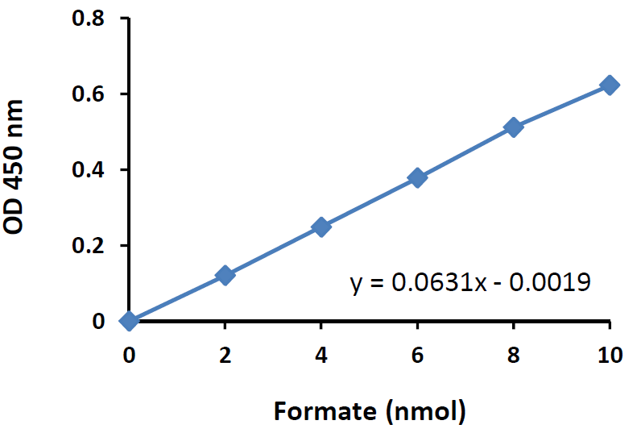
Formate Standard Curve: Performed following the kit protocol.

Troubleshooting
Problem | Reason | Solution
Assay not working | Assay buffer at wrong temperature | Assay buffer must not be chilled - needs to be at RT
Assay not working | Protocol step missed | Re-read and follow the protocol exactly
Assay not working | Plate read at incorrect wavelength | Ensure you are using appropriate reader and filter settings (refer to datasheet)
Assay not working | Unsuitable microtiter plate for assay | Fluorescence: Black plates (clear bottoms);  Luminescence: White plates;  Colorimetry: Clear plates.  If critical, datasheet will indicate whether to use flat- or U-shaped wells
Unexpected results | Measured at wrong wavelength | Use appropriate reader and filter settings described in datasheet
Unexpected results | Samples contain impeding substances | Troubleshoot and also consider deproteinizing samples
Unexpected results | Unsuitable sample type | Use recommended samples types as listed on the datasheet
Unexpected results | Sample readings are outside linear range | Concentrate/ dilute samples to be in linear range

Samples with inconsistent readings | Unsuitable sample type | Refer to datasheet for details about incompatible samples
Samples with inconsistent readings | Samples prepared in the wrong buffer | Use the assay buffer provided (or refer to datasheet for instructions)
Samples with inconsistent readings | Samples not deproteinized (if indicated on datasheet) | Use the 10kDa spin column (ab93349)
Samples with inconsistent readings | Cell/ tissue samples not sufficiently homogenized | Increase sonication time/ number of strokes with the Dounce homogenizer
Samples with inconsistent readings | Too many freeze-thaw cycles | Aliquot samples to reduce the number of freeze-thaw cycles
Samples with inconsistent readings | Samples contain impeding substances | Troubleshoot and also consider deproteinizing samples
Samples with inconsistent readings | Samples are too old or incorrectly stored | Use freshly made samples and store at recommended temperature until use
Lower/ Higher readings in samples and standards | Not fully thawed kit components | Wait for components to thaw completely and gently mix prior use
Lower/ Higher readings in samples and standards | Out-of-date kit or incorrectly stored reagents | Always check expiry date and store kit components as recommended on the datasheet
Lower/ Higher readings in samples and standards | Reagents sitting for extended periods on ice | Try to prepare a fresh reaction mix prior to each use
Lower/ Higher readings in samples and standards | Incorrect incubation time/ temperature | Refer to datasheet for recommended incubation time and/ or temperature
Lower/ Higher readings in samples and standards | Incorrect amounts used | Check pipette is calibrated correctly (always use smallest volume pipette that can pipette entire volume)

Problem | Reason | Solution
Standard curve is not linear | Not fully thawed kit components | Wait for components to thaw completely and gently mix prior use
Standard curve is not linear | Pipetting errors when setting up the standard curve | Try not to pipette too small volumes
Standard curve is not linear | Incorrect pipetting when preparing the reaction mix | Always prepare a master mix
Standard curve is not linear | Air bubbles in wells | Air bubbles will interfere with readings; try to avoid producing air bubbles and always remove bubbles prior to reading plates
Standard curve is not linear | Concentration of standard stock incorrect | Recheck datasheet for recommended concentrations of standard stocks
Standard curve is not linear | Errors in standard curve calculations | Refer to datasheet and re-check the calculations
Standard curve is not linear | Use of other reagents than those provided with the kit | Use fresh components from the same kit

For further technical questions please do not hesitate to contact us by email (technical@abcam.com) or phone (select “contact us” on www.abcam.com for the phone number for your region).

Technical Support
Copyright © 2023 Abcam. All Rights Reserved. The Abcam logo is a registered trademark. All information / detail is correct at time of going to print.
For all technical or commercial enquiries please go to:
www.abcam.com/contactus
www.abcam.cn/contactus (China)
www.abcam.co.jp/contactus (Japan)

