

ab119692 –
Human Citrate Synthase (CS) Activity Assay Kit

Instructions for Use
For the measurement of mitochondrial citrate synthase (CS) activity in Human samples

This product is for research use only and is not intended for diagnostic use.

Table of Contents
Table of Contents 1
1. Introduction 2
2. Assay Summary 5
3. Kit Contents 6
4. Storage and Handling 7
5. Additional Materials Required 7
6. Reagent Preparation 8
7. Test sample Preparation 8
8. Assay Procedure 11
9. Data Analysis 13
10. Troubleshooting 18

Introduction
Principle: The microplate assay ab119692 is used to determine mitochondrial citrate synthase (CS) activity in a sample at an immunocapture based manner. The enzyme is captured within the wells of the microplate, and activity is determined by recording color development of TNB, which is generated from DTNB present in the reaction of citrate synthesis. The overall reaction product, TNB, absorbs at 412 nm.
oxaloacetate + Acetyl CoA + H₂O | → | citrate + CoA-SH + H⁺
CoA-SH + DTNB | → | TNB + CoA-S-S-TNB
CoA-SH + DTNB | (↑ Absorbance at 412 nm)
ab119692 specifically immunocaptures only native citrate synthase in well from the applied test sample. The immunocapture based activity assay allows researchers to measure citrate synthase activity with simple sample preparation and no need for mitochondria isolation.
The kit contains all the required reagents for a fast and simple measurement of citrate synthase activity in a whole cell extract or in tissue homogenate.
Background: Citrate synthase (CS, O75390) is the initial enzyme of the tricarboxylic acid (TCA) cycle. This enzyme is a 51.7 kDa enzyme that catalyzes the reaction of 2 carbon acetyl CoA with 4 carbon oxaloacetate to form the 6 carbon citrate (EC 2.3.3.1). This enzyme is an exclusive marker of the mitochondrial matrix. Citrate synthase is found in nearly all cells capable of oxidative metabolism.
Limitations:
- FOR RESEARCH US ONLY. NOT FOR DIAGNOSTIC PROCEDURES.
- Use this kit before expiration date.
- Do not mix or substitute reagents from other lots or sources.
- If samples generate values outside of the range of the standard curve, further dilute the samples with 1X Incubation buffer and repeat the assay.
- Any variation in operator, pipetting technique, washing technique, incubation time or temperature, and kit age can cause variation in binding.
Technical Hints:
- To avoid cross contamination, change pipette tips between each addition of standard, sample and other reagents. Also use separate clean, dry reservoirs for each reagent.
- Cover plate during incubation steps.
- Thorough and consistent wash technique is essential for proper assay performance. Wash buffer must be forcefully dispensed and completely removed from the wells by aspiration or decanting. Remove remaining wash buffer by inverting the plate and blotting on paper towels.

Assay Summary
Prepare samples as instructed.
Determine the protein concentration of extracts.

Bring all reagents to room temperature.

Dilute sample to desired protein concentration in incubation buffer.
Add 100 μL sample to each well used. Incubate 3 hours at room temperature.

Aspirate and wash each well twice.

Freshly prepare 1X Activity Solution. Add 100 μL 1X Activity Solution to each well.
Pop bubbles and record immediately the color development with time at 412 nm for 15 to 30 minutes.

Kit Contents
Sufficient materials are provided for 96 measurements in a microplate.
Item | Quantity
20X Buffer | 20 ml
Extraction Buffer | 15 ml
10X Blocking Buffer  Base Buffer  10X Reaction Reagent | 6 ml  25 mL  1 Vial
CS Microplate  (12 x 8 antibody coated well strips) | 96 Wells

Storage and Handling
The 10X Reaction Reagent should be stored at -20ºC before resuspension. All other components should be stored at +2-8 ºC.
10X Reaction Reagent mixture is shipped lyophilized. Before use, rehydrate the reaction mixture by adding 0.1mL base buffer. Vortex the tube thoroughly to dissolve the lyophilized powder. Then add 0.9mL base buffer to make up the volume to 1 mL, this will be the 10X Reaction solution. Unused amounts of the 10X Reaction solution should be stored at -80°C for 6 months. This kit is stable for 6 months from receipt.

Additional Materials Required

- Standard absorbance microplate reader capable of kinetic reading at 412nm
- Multichannel pipette (50 - 300 µL) and tips
- 1.5-mL microtubes
- Paper towels
- Deionized water
- Optional plate shaker for all incubation steps

Reagent Preparation
- Prepare 1X Wash Buffer by adding 20 mL 20X Buffer to 380 mL nanopure water.
- Prepare 1X Incubation Buffer by adding 6 mL 10X Blocking Solution to 54 mL 1X Wash Buffer.
- Prepare 10X Reaction Solution, as described above (4. storage and handling).
- Immediately prior to use (in Step 8.6) prepare 1X Activity Solution. To prepare 10 mL of 1X Activity Solution (enough for 96 wells) add 9 mL Base Buffer to 1 mL 10X Reaction Solution. Mix thoroughly and gently.
Note – the final concentration of substrate is now 1mM oxaloacetate, 0.06mM Acetyl CoA, and 0.1mM DTNB.

Test sample Preparation
Note: Extraction buffer DOES NOT CONTAIN PROTEASE INHIBITORS. It can be supplemented with phosphatase inhibitors, PMSF and protease inhibitor cocktail prior to use. Supplements should be used according to manufacturer’s instructions.
7.1 Cell lysates or extracts
    - Collect non adherent cells by centrifugation or scrape to collect adherent cells from the culture flask. Typical centrifugation conditions for cells are 500 x g for 10 min at 4ºC.
    - Rinse cells twice with PBS.
    - Solubilize cell pellet at 2x10⁷/mL in Extraction Buffer.
    - Incubate on ice for 20 minutes. Centrifuge at 16000 x g 4°C for 20 minutes. Transfer the supernatants into clean tubes and discard the pellets. Assay samples immediately or aliquot and store at -80°C for 6 months. The sample protein concentration in the extract may be quantified using a protein assay.
7.2 Tissue lysates
    - Tissue lysates are typically prepared by homogenization of tissue that is first minced and thoroughly rinsed in PBS to remove blood (dounce homogenizer recommended).
    - Suspend the homogenate to 25 mg/mL in PBS.
    - Solubilize the homogenate by adding 4 volumes of Extraction Buffer to a sample protein concentration of 5 mg/mL.
    - Incubate on ice for 20 minutes. Centrifuge at 16,000 x g for 20 minutes at 4°C. Transfer the supernatants into clean tubes and discard the pellets. Assay samples immediately or aliquot and store at -80°C for 6 months. The sample protein concentration in the extract may be quantified using a protein assay.
7.3 Sub-cellular organelle lysates e.g. mitochondria:
    - Prepare the organelle sample by, for example, sub-cellular fractionation.
    - Pellet the sample.
    - Solubilize the pellet by adding 9 volumes Extraction Buffer.
    - Incubate on ice for 20 minutes. Centrifuge at 16,000 x g for 20 minutes at 4°C. Transfer the supernatants into clean tubes and discard the pellets. Assay samples immediately or aliquot and store at -80°C for 6 months. The sample protein concentration in the extract may be quantified using a protein assay.
These test samples should be diluted to within the working range of the assay in 1X Incubation Buffer.

Assay Procedure
Equilibrate all reagents and samples to room temperature before use. It is recommended all samples and standards be assayed in duplicate.
  - Prepare all reagents, and samples as directed in the previous sections.
  - Remove excess microplate strips from the plate frame, return them to the foil pouch containing the desiccant pack, and re-seal.
  - Add 100 µL of each diluted sample per well. It is recommended to include a dilution series of a control (normal) sample as a reference. Also include a 1X Incubation Buffer as a zero standard.
  - Cover/seal the plate and incubate for 3 hours at room temperature. If available use a plate shaker for all incubation steps at 300 rpm.
  - Aspirate each well and wash, repeat this once more for a total of two washes. Wash by aspirating or decanting from wells then dispensing 300 μL 1X Wash buffer into each well as described above. Complete removal of liquid at each step is essential to good performance. After the last wash, remove the remaining buffer by aspiration or decanting. Invert the plate and blot it against clean paper towels to remove excess liquid.
  - Gently add 100 μL freshly prepared 1X Activity Solution (step 6.4) to each well minimizing the production of bubbles.
  - Pop any bubbles immediately and record absorbance in the microplate reader prepared as follows:
Mode: | Kinetic
Wavelength: | 412 nM
Time: | 5 - 30 min.
Temperature | Ambient
Interval: | 20 sec.
Shaking: | Shake between readings
  - *Assay reactions occur faster as ambient temperatures are increased.
  - Analyze the data as described below.

Data Analysis
Example data sets are shown below illustrating data analysis of CS activity measurements in HepG2 cells (as an example human cell line derived from liver), and homogenate samples from human, rat and mouse liver tissues.
The starting concentration of Oxaloacetate and Acetyl CoA in the assay is 1mM and 0.06mM respectively. DTNB is added to the citrate synthase reaction to produce TNB, which can be measured at 412nm. For simplicity the activity can be expressed as the change in absorbance per minute per amount of sample loaded into the well. Activity was collected as described in this protocol using a Molecular Dynamics microplate reader. Standard curves of reference sample data were exported to graphing software capable of a 4-parameter data analysis (shown below). Activity is clearly measurable in the 1.56-100 μg/ mL range when such a fit is applied for HepG2, and human tissue extracts.
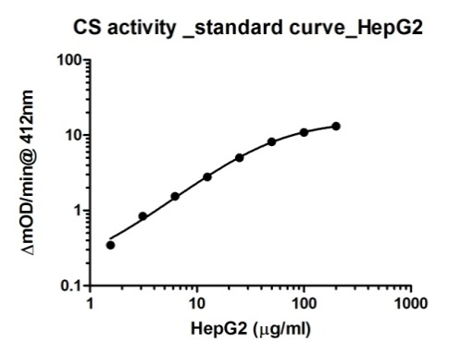  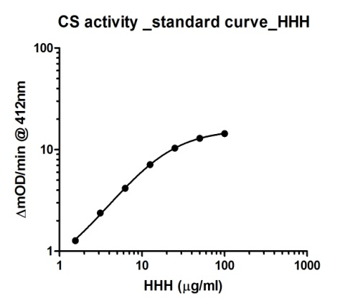 | Figure 1. Example activity measurements from titrated HepG2 cells.  Figure 2. Example activity measurements from titrated of Human heart homogenate.
Unknown samples should be interpolated from these reference sample graphs. This determined relative activity is the amount of reference sample required to generate the same amount of activity as the unknown sample and usually expressed as a percent value.
WORKING RANGE
This assay has been demonstrated with human, rat, and mouse liver and heart tissue homogenate samples as well as HepG2 whole cell lysate, a liver derived human cultured cell line. Typical ranges for several sample types are described below. It is highly recommended to prepare multiple dilutions for each sample to ensure that each is in the working range of the assay (see Data Analysis section).

Sample Type | Range
Cultured whole cell extracts (type dependant) e.g. HepG2 | 1.56 - 100 µg/mL
Tissue extract  e.g. heart homogenate | 1.56 - 100 µg/mL

REPRODUCIBILITY
Parameter | %CV
Intra (n=3,  3 assays at 2,525 µg/mL) | 4.35-6.55
Inter (n=3 days,  at 25 µg/mL)) | 8.3

SPECIFICITY
- Species– human. Does not react with rat and mouse. Others not tested.
- The antibody used to isolate CS in this kit was generated by immunization of bovine heart mitochondrial matrix. The resulting monoclonal mouse antibody specifically immunoprecipitates a single CS band to purity from human samples. The immunoprecipitate was confirmed to be CS by mass spectrometry with no other contamination. The specificity of the immunocapture based activity assay is confirmed by replacing the capture antibody with another unrelated capture antibody.
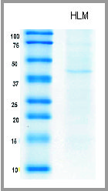
Figure 3. Monoclonal mouse antibody from this kit immunoprecipitated with human liver mitochondria exhibiting a single CS band.
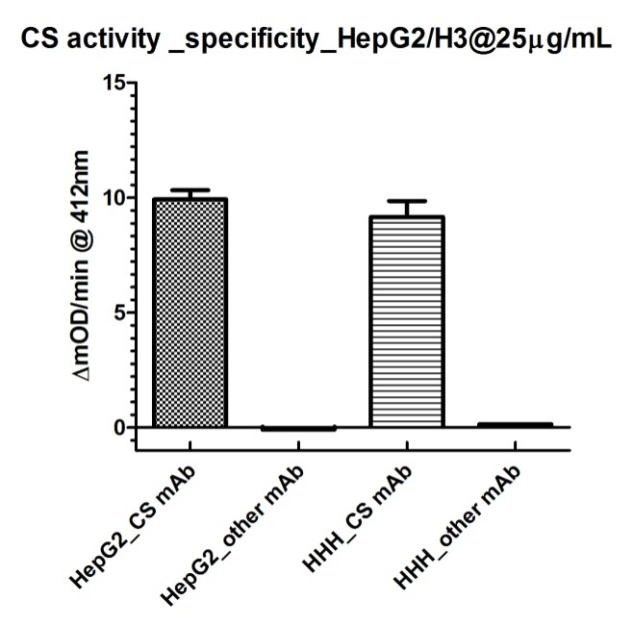
Figure 4. Immunocapture based activity assay specificity is confirmed by replacing the capture antibody with another unrelated capture antibody.

Troubleshooting
Problem | Cause | Solution
Poor standard  curve | Inaccurate Pipetting | Check pipets
Poor standard  curve | Improper standard  dilution | Prior to opening, briefly spin the stock standard tube and dissolve the powder thoroughly by gentle mixing
 | Low cleaved PARP concentration in sample | Use appropriate positive control/treatment to induce apoptosis/PARP cleavage
Low Signal | Incubation times too brief | Ensure sufficient incubation times; change to overnight standard/sample incubation
Low Signal | Inadequate reagent volumes or improper dilution | Check pipettes and ensure correct preparation
Large CV | Plate is insufficiently washed | Review manual for proper wash technique. If using a plate washer, check all ports for obstructions
Large CV | Contaminated wash buffer | Make fresh wash buffer
Low sensitivity | Improper storage of the ELISA kit | Store your reconstituted standards at -80°C, all other assay components 4°C. Keep substrate solution protected from light

Technical Support
Copyright © 2023 Abcam. All Rights reserved. The Abcam logo is a registered trademark. All information / detail is correct at time of going to print.
For all technical or commercial enquiries please go to:
www.abcam.com/contactus
www.abcam.cn/contactus (China)
www.abcam.co.jp/contactus (Japan)

