

|  |
| --- |
| **ab133043 –**  **Direct 8-iso-PGF2alpha ELISA Kit** |

Instructions for Use

For quantitative detection of 8-iso-PGF2alpha in Biological fluids.

This product is for research use only and is not intended for diagnostic use.

Table of Contents

****INTRODUCTION****

1. BACKGROUND 2

2. ASSAY SUMMARY 3

****GENERAL INFORMATION****

3. PRECAUTIONS 4

4. STORAGE AND STABILITY 5

5. MATERIALS SUPPLIED 5

6. MATERIALS REQUIRED, NOT SUPPLIED 6

7. LIMITATIONS 6

8. TECHNICAL HINTS 7

****ASSAY PREPARATION****

9. REAGENT PREPARATION 8

10. STANDARD PREPARATIONS 9

11. SAMPLE COLLECTION AND STORAGE 11

12. PLATE PREPARATION 13

****ASSAY PROCEDURE****

13. ASSAY PROCEDURE 14

****DATA ANALYSIS****

14. CALCULATIONS 16

15. TYPICAL DATA 17

16. TYPICAL SAMPLE VALUES 20

17. ASSAY SPECIFICITY 22

****RESOURCES****

18. TROUBLESHOOTING 23

19. NOTES 24

## **BACKGROUND**

Abcam’s Direct 8-iso-PGF2alpha *in vitro* competitive ELISA (Enzyme-Linked Immunosorbent Assay) kit is designed for the accurate quantitative measurement of 8-iso-PGF2α in Biological fluids.

A goat anti-rabbit IgG antibody has been precoated onto 96-well plates. Standards or test samples are added to the wells, along with an alkaline phosphatase (AP) conjugated-8-iso-PGF2alpha antigen and a rabbit polyclonal antibody specific to 8-iso-PGF2alpha. After incubation the excess reagents are washed away. pNpp substrate is added and after a short incubation the enzyme reaction is stopped and the yellow color generated is read at 405 nm. The intensity of the yellow coloration is inversely proportional to the amount of 8-iso-PGF2alpha captured in the plate.

The 8-epimer of Prostaglandin F2α (8-iso-PGF2alpha) is produced *in vivo* by both non-cyclooxygenase and cyclooxygenase dependent mechanisms from arachidonic acid. 8-iso-PGF2alpha has been shown to be a potent vasoconstrictor, a potential mediator of hepatorenal syndrome and atherosclerosis and a mutagen in 3T3 cells and in vascular smooth muscle cells. It has also been postulated to participate as a pathophysiological mediator and is able to modify the fluidity and integrity of membranes. 8-iso-PGF2alpha has been shown to circulate in plasma and is excreted in urine. Methods for assessing total 8-iso-PGF2alpha typically require the alkaline hydrolysis of 8-iso-PGF2alpha esters from tissues, followed by length procedures involving extractions, phase separations and thin layer chromatography.

## **ASSAY SUMMARY**

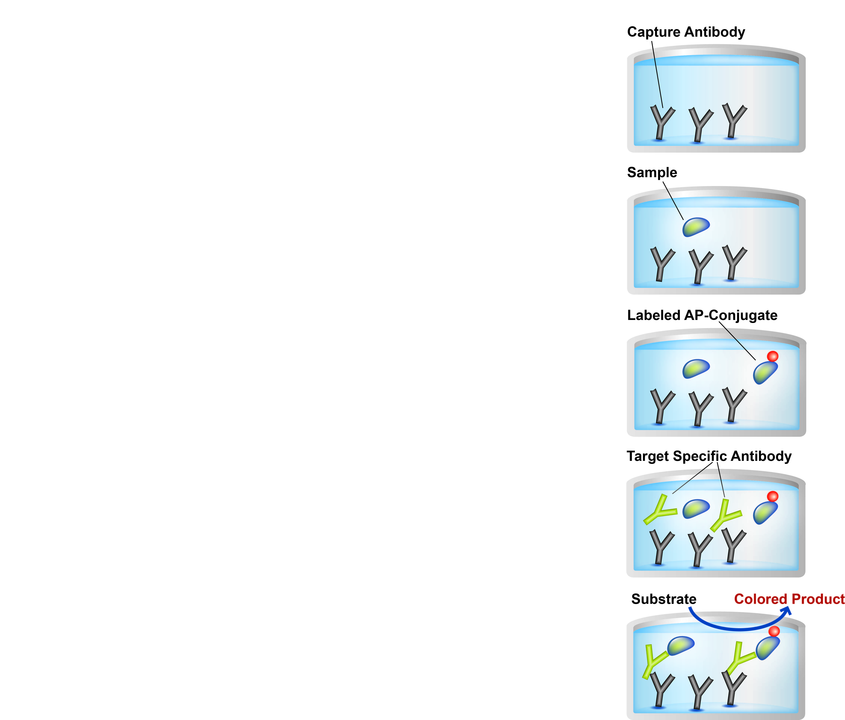

**Prepare all reagents and samples as instructed.**

Add standards and samples to appropriate wells.

Add prepared labeled AP-conjugate to appropriate wells.

Add 8-iso-PGF2alpha antibody to appropriate wells. Incubate at room temperature.

Add pNpp substrate to each well. Incubate at room temperature. Add Stop Solution to each well. Read immediately.

## **PRECAUTIONS**

**Please read these instructions carefully prior to beginning the assay.**

* Some kit components contain azide, which may react with lead or copper plumbing. When disposing of reagents always flush with large volumes of water to prevent azide build-up
* Stop Solution is a solution of trisodium phosphate. This solution is caustic; care should be taken in use
* The activity of the alkaline phosphatase conjugate is dependent on the presence of Mg2+ and Zn2+ ions. The activity of the conjugate is affected by concentrations of chelators (>10 mM) such as EDTA and EGTA
* We test this kit’s performance with a variety of samples, however it is possible that high levels of interfering substances may cause variation in assay results
* Care should be taken handling the Standard and Conjugate material because of the known and unknown effects of 8-iso-PGF2alpha

## **STORAGE AND STABILITY**

**Store kit at +4°C immediately upon receipt.** All components of this kit are stable at 4°C until the kit’s expiration date.

Refer to list of materials supplied for storage conditions of individual components.

## **MATERIALS SUPPLIED**

|  |  |  |
| --- | --- | --- |
| **Item** | **Amount** | **Storage Condition** |
| Goat anti-rabbit IgG Microplate (12 x 8 wells) | 96 Wells | +4ºC |
| Direct 8-iso-PGF2 alpha Alkaline Phosphatase Conjugate | 5 mL | +4ºC |
| Direct 8-iso-PGF2 alpha Antibody | 5 mL | +4ºC |
| Direct 8-iso-PGF2 alpha Sample Diluent | 27 mL | +4ºC |
| Neutralizing Reagent | 5 mL | +4ºC |
| 8-iso-PGF2 alpha Standard | 500 µL | +4ºC |
| 20X Wash Buffer Concentrate | 27 mL | +4ºC |
| pNpp Substrate | 20 mL | +4ºC |
| Stop Solution | 5 mL | +4ºC |

## **MATERIALS REQUIRED, NOT SUPPLIED**

These materials are not included in the kit, but will be required

* Deionized or distilled water
* 10N NaOH, for serum and plasma
* Concentrated HCl (12.1N) for serum and plasma
* 2N NaOH, for tissue samples
* 2N HCl, for tissue samples
* Precision pipettes for volumes between 5 μL and 1,000 μL
* Repeater pipettes for dispensing 50 μL and 200 μL
* A disposable beaker for diluting buffer concentrates
* 45°C water bath or incubator
* Microcentrifuge
* A microplate shaker
* Adsorbent paper for blotting
* Microplate reader capable of reading at 405 nm, preferably with correction between 570 and 590 nm

## **LIMITATIONS**

* Assay kit intended for research use only. Not for use in diagnostic procedures
* Do not mix or substitute reagents or materials from other kit lots or vendors. Kits are QC tested as a set of components and performance cannot be guaranteed if utilized separately or substituted

## **TECHNICAL HINTS**

* Standards can be made up in either glass or plastic tubes
* Pre-rinse the pipette tip with the reagent, use fresh pipette tips for each sample, standard and reagent
* Pipette standards and samples to the bottom of the wells
* Add the reagents to the side of the well to avoid contamination
* This kit uses break-apart microtiter strips, which allow the user to measure as many samples as desired. Unused wells must be kept desiccated at 4°C in the sealed bag provided. The wells should be used in the frame provided
* Care must be taken to minimize contamination by endogenous alkaline phosphatase. Contaminating alkaline phosphatase activity, especially in the substrate solution, may lead to high blanks. Care should be taken not to touch pipet tips and other items that are used in the assay with bare hands
* Prior to addition of substrate, ensure that there is no residual wash buffer in the wells. Any remaining wash buffer may cause variation in assay results
* **This kit is sold based on number of tests. A ‘test’ simply refers to a single assay well. The number of wells that contain sample, control or standard will vary by product. Review the protocol completely to confirm this kit meets your requirements. Please contact our Technical Support staff with any questions**

## **REAGENT PREPARATION**

Equilibrate all reagents and samples to room temperature (18 - 25°C) prior to use.

* 1. **Conjugate 1:10 Dilution for Total Activity Measurement** Prepare the conjugate 1:10 Dilution by diluting 50 μL of the supplied conjugate with 450 μL of the Sample Diluent. The dilution should be used within 3 hours of preparation. This 1:10 dilution is intended for use in the Total Activity Wells only.
  2. **1X Wash Buffer**

Prepare the 1X Wash Buffer by diluting 5 mL of the Wash Buffer Concentrate in 95 mL of deionized water. Mix thoroughly and gently. This can be stored at room temperature until the kit expiration or for 3 months, whichever is earlier.

## **STANDARD PREPARATIONS**

Prepare serially diluted standards immediately prior to use. Always prepare a fresh set of standards for every use. Diluted standards should be used within 60 minutes of preparation.

* 1. Allow the 1,000,000 pg/mL 8-iso-PGF2alpha **Stock Standard** solution to equilibrate to room temperature
  2. Label five tubes with numbers #1 – #5.
  3. Add 900 µL of appropriate diluent (Direct 8-iso-PGF2 alpha Sample Diluent or Tissue Culture Media) to tube #1
  4. Add 800 µL appropriate diluent to tubes #2 through #5
  5. Prepare a 100,000 pg/mL Standard 1 by adding 100 µL of the 1,000,000 pg/mL Stock Standard to tube #1. Vortex thoroughly.
  6. Prepare **Standard 2** by transferring 200 μL from Standard 1 to tube 2. Vortex thoroughly.
  7. Prepare **Standard 3** by transferring 200 μL from Standard 2 to tube 3. Vortex thoroughly.
  8. Using the table below as a guide, repeat for tubes 4 and 5.

|  |  |  |  |  |  |
| --- | --- | --- | --- | --- | --- |
| **Standard** | **Sample to Dilute** | **Volume to Dilute (µL)** | **Volume of Diluent (µL)** | **Starting Conc. (pg/mL)** | **Final Conc. (pg/mL)** |
| **1** | **Standard** | **100** | **900** | **1,000,000** | **100,000** |
| **2** | **Standard 1** | **200** | **800** | **100,000** | **20,000** |
| **3** | **Standard 2** | **200** | **800** | **20,000** | **4,000** |
| **4** | **Standard 3** | **200** | **800** | **4,000** | **800** |
| **5** | **Standard 4** | **200** | **800** | **800** | **160** |

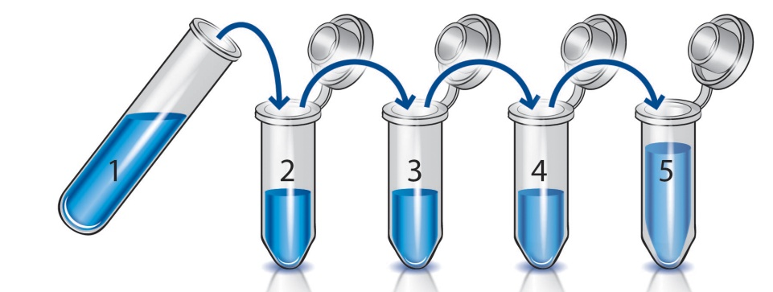

## **SAMPLE COLLECTION AND STORAGE**

* Hydrolysis of lipoprotein or phospholipid coupled 8-iso-PGF2alpha is required to ensure that the measured 8-iso-PGF2alpha is a true reflection of both free and esterified isoprostane. To hydrolyze this ester bond, the sample is treated with NaOH at 45°C for 2 hours. Dilution of the liberated 8-iso-PGF2alpha is minimized in liquid samples (e.g. serum and plasma) when 4 parts of sample are treated with 1 part of 10N NaOH
* Tissue samples are hydrolyzed in an excess of 2N NaOH. Samples are then neutralized. See below for full details. It is important that all standards and diluted samples be in the same matrix. All dilutions of samples and standards must be made with the direct 8-iso-PGF2alpha Sample Diluent solution provided
* Please note that the hydrolysis step will destroy some of the liberated 8-iso-PGF2alpha due to the effects of strong base on the isoprostane structure. However, the relative change in 8-iso-PGF2alpha should be identical from sample to sample. If you wish to determine the percentage of endogenous 8-iso-PGF2alpha destroyed during hydrolysis, we suggest adding a known amount of 8-iso-PGF2alpha to a sample prior to hydrolysis and determine the percent recovery of added 8-iso-PGF2alpha
  1. **Tissue Samples**
     1. Prior to hydrolysis, samples should be stored at -2 0 °C or lower.
     2. Tissue samples should be powdered prior to hydrolysis. Homogenization or other methods of cell disruption may be used.
     3. An appropriate excess volume of 2N NaOH should be used. We recommend from 10 μg to 1 mg of tissue per mL of 2N NaOH.
     4. Samples in 2N NaOH should be covered and heated at 45 °C for 2 hours to ensure hydrolysis.
     5. After hydrolysis, the samples should be cooled and neutralized with an equal volume of 2N HCl. For example, if 2 mg of tissue are hydrolyzed in 2 mL of 2N NaOH, 2 mL of 2N HCl would be added after the hydrolysis step.
     6. Centrifuge the neutralized samples at 3,000 rpm in a microcentrifuge. If necessary, check the pH of the neutralized samples. The pH should be in the range of 6-8. If it is not, adjust the pH to this range.
     7. The clear supernatant can be used in the assay or stored at -20 °C for future use.
  2. **Serum and Plasma (EDTA, Heparin) samples** 
     1. Samples should be kept frozen at -20 °C or lower.
     2. Use 1 part of 10N NaOH for every 4 parts of liquid sample. Cap and heat the sample at 45 °C for 2 hours. Cool, then neutralize sample by adding 100 μL of concentrated (12.1N) HCl per 500 μ L of hydrolyzed sample. The sample should appear milky after this addition.
     3. Centrifuge the samples for 5 minutes at 14,000 rpm in a microcentrifuge.
     4. The clear supernatant can be used in the assay or stored at -20 °C for future use.
     5. If necessary check the pH of the neutralized samples. The pH should be in the range of 6-8. If it is not, adjust the pH to this range.

## **PLATE PREPARATION**

* The 96 well plate strips included with this kit are supplied ready to use. It is not necessary to rinse the plate prior to adding reagents.
* Unused well strips should be returned to the plate packet and stored at 4°C.
* For statistical reasons, we recommend each sample should be assayed with a minimum of two replicates (duplicates).
* Well effects have not been observed with this assay.

## **ASSAY PROCEDURE**

* **Equilibrate all materials and prepared reagents to room temperature prior to use**
* **It is recommended to assay all standards, controls and samples in duplicate**
* **Refer to the recommended plate layout in Section 12 before proceeding with the assay**
  1. Add 50 μL of Neutralizing Reagent into all wells, except the TA and Blank wells.
  2. Add 100 μL of Direct 8-iso-PGF2 alpha Sample Diluent into the NSB wells.
  3. Add 50 μL of Direct 8-iso-PGF2 alpha Sample Diluent into the B0 wells.
  4. Add 50 μL of prepared standards and 50 µL diluted samples to appropriate wells.
  5. Add 50 μL of Direct 8-iso-PGF2alpha Alkaline Phosphatase conjugate (blue) into NSB, B0, standard and sample wells, i.e. not the Total Activity (TA) and Bs wells.
  6. Add 50 μL of Direct 8-iso-PGF2alpha antibody (yellow) into B0, standard and sample wells, i.e. not Bs, TA and NSB wells.

*Note*: Every well should be green in color except the NSB wells which should be blue. The Bs and TA wells are empty at this point and have no color.

* 1. Incubate the plate at room temperature on a plate shaker for 2 hours at ~500 rpm. The plate may be covered with the plate sealer provided.
  2. Empty the contents of the wells and wash by adding 400 µL of 1X Wash Buffer to every well. Repeat the wash 2 more times for a total of 3 washes. After the final wash, empty or aspirate the wells, and firmly tap the plate on a lint free paper towel to remove any remaining wash buffer.
  3. Add 5 μL of the light blue conjugate 1:10 dilution (see step 9.2 Reagent Preparation section) to the TA wells only.
  4. Add 200 μL of the pNpp Substrate solution to every well. Incubate at room temperature for 45 minutes without shaking.
  5. Add 50 μL Stop Solution into each well.
  6. Blank the plate reader against the Bs wells, read the O.D. absorbance at 405 nm, preferably with correction between 570 and 590 nm. If the plate reader is not able to be blanked against the blank wells, manually subtract the mean optical density of the blank wells from all readings.

## **CALCULATIONS**

1. Calculate the average net absorbance measurement (Average Net OD) for each standard and sample by subtracting the average NSB absorbance measurement from the average absorbance measurement (Average OD) for each standard and sample.

Average Net OD = Average Bound OD - Average NSB OD

14.2 Calculate the binding of each pair of standard wells as a percentage of the maximum binding wells (Bo), using the following formula

Percent Bound = Average Net OD x 100

Average Net B0 OD

14.3 Plot the Percent Bound (B/B0) and the net OD versus concentration of 8-isoPGF2α for the standards. The concentration of 8-isoPGF2α in the unknowns can be determined by interpolation of net OD values.

A four parameter algorithm (4PL) provides the best fit, though other equations can be examined to see which provides the most accurate (e.g. linear, semi-log, log/log, 4 parameter logistic). Interpolate protein concentrations for unknown samples from the standard curve plotted.

Samples producing signals greater than that of the highest standard should be further diluted and reanalyzed, then multiplying the concentration found by the appropriate dilution factor.

Remember to correct any measured 8-iso-PGF2α concentrations for the dilution of the original sample by addition of added acid/base used for neutralization.

## **TYPICAL DATA**

**TYPICAL STANDARD CURVE** – Data provided for **demonstration purposes only**. A new standard curve must be generated for each assay performed.

**2 Hour Format:**

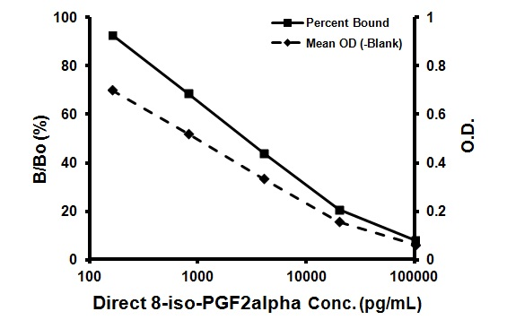

|  |  |  |  |
| --- | --- | --- | --- |
| **Sample** | **Mean OD (-Bs)** | **Bound**  **(%)** | **8-iso-PGF2alpha (pg/mL)** |
| TA | 0.398 | - | - |
| NSB | 0.001 | 0 | - |
| Standard 1 | 0.062 | 8.2 | 100,000 |
| Standard 2 | 0.157 | 20.8 | 20,000 |
| Standard 3 | 0.334 | 44.2 | 4,000 |
| Standard 4 | 0.521 | 69.0 | 800 |
| Standard 5 | 0.700 | 92.7 | 160 |
| B0 | 0.755 | 100 | 0 |
| Unknown1 | 0.238 | 31.5 | 8,949 |
| Unknown 2 | 0.563 | 74.6 | 1,245 |

**2 Hour Format Typical Quality Control Parameters:**

Total Activity Added = 0.398 x 10 x 10 = 39.8

%NSB = 0.0%

%B0/TA = 19.0%

Quality of Fit = 1.00 (Calculated from 4 parameter logistic curve fit)

20% Intercept = 23,192 pg/mL

50% Intercept = 2,627 pg/mL

**Overnight Format:**

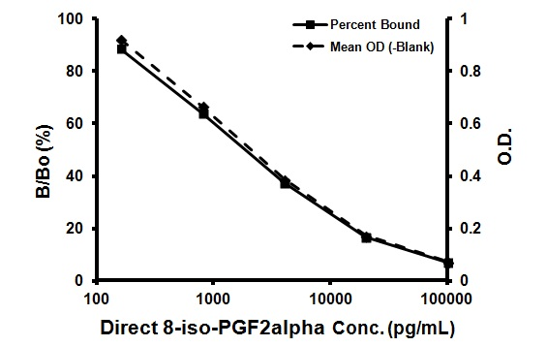

|  |  |  |  |
| --- | --- | --- | --- |
| **Sample** | **Mean OD (-Bs)** | **% Bound** | **Direct 8-iso-PGF2alpha pg/mL** |
| TA | 0.312 | - | - |
| NSB | 0.001 | 0 | - |
| Standard 1 | 0.073 | 7.0 | 100,000 |
| Standard 2 | 0.174 | 16.7 | 20,000 |
| Standard 3 | 0.388 | 37.3 | 4,000 |
| Standard 4 | 0.667 | 64.1 | 800 |
| Standard 5 | 0.921 | 88.6 | 160 |
| B0 | 1.040 | 100 | 0 |
| Unknown1 | 0.282 | 27.1 | 8,005 |
| Unknown 2 | 0.661 | 63.6 | 836 |

**Overnight Format Typical Quality Control Parameters:**

Total Activity Added = 0.312 x 10 x 10 = 31.2

%NSB = 0.0%

%B0/TA = 3.3%

Quality of Fit = 1.00 (Calculated from 4 parameter logistic curve fit)

20% Intercept = 14,802 pg/mL

50% Intercept = 1,820 pg/mL

## **TYPICAL SAMPLE VALUES**

**SENSITIVITY –**

The sensitivity, minimum detectable dose of Direct 8-iso-PGF2α using this Abcam ELISA kit was measured at 2 standard deviations from the mean of 16 zeros along the standard curve, and was determined to be 103.2 pg/mL in the 2 Hour assay format, and 40.0 pg/mL in the Overnight assay format.

**SAMPLE RECOVERY –**

Recovery was determined by 8-iso-PGF2α into Porcine Serum, Equine Plasma (Heparin) and Porcine Plasma (EDTA). Mean recoveries are as follows:

|  |  |  |
| --- | --- | --- |
| **Sample Type** | **Average % Recovery** | **Recommended Dilution** |
| Porcine Serum | 93.8 | None |
| Equine Plasma (Heparin) | 97.2 | None |
| Porcine Plasma (EDTA) | 109.8 | 1:8 |

Urine is not a suitable sample for analysis in this kit. Urine samples should be measured using the 8-iso-PGF2α EIA Kit.

**LINEARITY OF DILUTION –**

A sample containing 50,000 pg/mL 8-iso-PGF2α was diluted 7 times 1:2 in the kit Direct 8-iso-PGF2 alpha Sample Diluent and measured in the assay. The data was plotted graphically as actual 8-iso-PGF2α concentration versus measured 8-iso-8-iso-PGF2α concentration.

The line obtained had a slope of 0.967 and a correlation coefficient of 0.986.

**PRECISION –**

Intra-assay precision was determined by taking samples containing low, medium and high concentrations of 8-iso-PGF2α and running these samples multiple times (n=16) in the same assay. Inter-assay precision was determined by measuring three samples with low, medium and high concentrations of 8-iso-PGF2α in multiple assays (n=8).

The precision numbers listed below represent the percent coefficient of variation for the concentrations of 8-iso-PGF2α determined in these assays as calculated by a 4 parameter logistic curve fitting program.

**Intra-Assay**

|  |  |  |
| --- | --- | --- |
|  | **8-iso-PGF2α** **(pg/mL)** | **%CV** |
| Low | 970 | 11.3 |
| Medium | 3,264 | 5.7 |
| High | 5,092 | 5.1 |

**Inter-Assay**

|  |  |  |
| --- | --- | --- |
|  | **8-iso-PGF2α**  **(pg/mL)** | **%CV** |
| Low | 1,473 | 5.4 |
| Medium | 4,501 | 5.8 |
| High | 6,679 | 10.4 |

## **ASSAY SPECIFICITY**

The cross reactivities for a number of related eicosanoid compounds was determined in the regular 8-iso-PGF2α ELISA assay by dissolving the cross reactant (purity checked by N.M.R. and other analytical methods) in Direct 8-iso-PGF2 alpha Sample Diluent at concentrations from 100,000 to 6 pg/mL. These samples were then measured in the assay, and the measured 8-iso-PGF2α concentration at 50% B/B0 was calculated. The % cross reactivity was calculated by comparison with the actual concentration of cross reactant in the sample and expressed as a percentage.

**CROSS REACTIVITY –**

|  |  |
| --- | --- |
| **Compound** | **Cross Reactivity**  **(%)** |
| 8-iso-PGF2α | 100 |
| PGF1α | 4.6 |
| PGF2α | 1.85 |
| PGE1 | 0.19 |
| TXB2 | 0.023 |
| PGB1 | 0.02 |
| PGE3 | 0.012 |
| 6-keto-PGF1α | 0.008 |
| 13,14-dihydro-15-keto-PGF2α | 0.008 |
| 6,15-keto-13,14-dihydro-PGF1α | 0.005 |
| 8-iso-PGE1 | <0.001 |
| PGA2 | <0.001 |
| 2-Arachidonoylglycerol | <0.001 |
| Anandamide | <0.001 |

## **TROUBLESHOOTING**

|  |  |  |
| --- | --- | --- |
| **Problem** | **Cause** | **Solution** |
| Poor standard curve | Inaccurate pipetting | Check pipettes |
| Improper standards dilution | Prior to opening, briefly spin the stock standard tube and dissolve the powder thoroughly by gentle mixing |
|
| Low Signal | Incubation times too brief | Ensure sufficient incubation times; change to overnight standard/sample incubation |
| Inadequate reagent volumes or improper dilution | Check pipettes and ensure correct preparation |
| Samples give higher value than the highest standard | Starting sample concentration is too high | Dilute the specimens and repeat the assay |
| Large CV | Plate is insufficiently washed | Review manual for proper wash technique. If using a plate washer, check all ports for obstructions |
| Contaminated wash buffer | Prepare fresh wash buffer |
| Low sensitivity | Improper storage of the kit | Store the all components as directed |

## **NOTES**



**For all technical and commercial enquires please go to:**

[www.abcam.com/contactus](http://www.abcam.com/contactus)

[www.abcam.cn/contactus](http://www.abcam.cn/contactus) (China)

[www.abcam.co.jp/contactus](http://www.abcam.co.jp/contactus) (Japan)

Copyright © 2024 Abcam, All Rights Reserved. The Abcam logo is a registered trademark.

All information / detail is correct at time of going to print.