

ab138875
Renin Assay Kit (Fluorometric)
Instructions for Use
This kit provides a convenient assay for high throughput screening of renin inhibitors and for continuous assay of renin activity.

This product is for research use only and is not intended for diagnostic use.

Table of Contents
1. Introduction 3
2. Protocol Summary 5
3. Kit Contents 6
4. Storage and Handling 6
5. Additional Materials Required 6
6. Assay Protocol 7
7. Data Analysis 10
8. Troubleshooting 11

Introduction
Renin is an enzyme that participates in the renin-angiotensin system (RAS) that mediates extracellular volume, and arterial vasoconstriction. It regulates blood pressure and electrolyte homoeostasis. At the first and rate-limiting step of the RAS cascade, renin cleaves angiotensinogen to yield angiotensin I, which is further converted into angiotensin II by Angiotensin Converting Enzyme (ACE). Angiotensin II constricts blood vessels leading to increased blood pressure. It also increases the secretion of ADH and aldosterone, and stimulates the hypothalamus to activate the thirst reflex. An over-active renin-angiotension system leads to vasoconstriction and retention of sodium and water. These effects lead to hypertension. Thus, renin is an attractive target for the treatment of this disease.
ab138875 provides a convenient assay for high throughput screening of renin inhibitors and for continuous assay of renin activity using a TF3/TQ3 FRET peptide. In the FRET peptide the fluorescence of TF3 is quenched by TQ3. Upon cleavage into two separate fragments by renin, the fluorescence of TF3 is recovered, the fluorescent signal can be easily monitored by a fluorescence microplate reader at Ex/Em = 540/590 nm. This assay is about fifty fold more sensitive than an EDANS/DABCYL-based assay. With Abcam's Renin Assay Kit (Fluorometric), we have detected as little as 1ng renin in a 100 μL reaction volume.

Kit Key Features
- Convenient Format: Includes all the key assay components.
- Optimized Performance: Optimized for detecting renin activities and screening its inhibitors.
- Continuous: Easily adapted to automation without a separation step.
- Convenient: Formulated to have minimal hands-on time. No wash is required.
- Non-Radioactive: No special requirements for waste treatment

Protocol Summary
Summary for One 96-well Plate
Add appropriate controls, or test samples

Add Renin Red Substrate solution

Incubate for 30-60 min at 37°C incubator (for end point reading

Monitor fluorescence intensity at Ex/Em = 540/590 nm

Note: Thaw all the kit components to room temperature before starting the experiment.

Kit Contents

Components | Amount
Component A: Renin Red Substrate | 50 µL
Component B: Renin Standard | 1 vial (40 µg/mL, 25 µL)
Component C: Assay Buffer | 1 bottle (10 mL)

Storage and Handling
Keep at -20°C. Avoid exposure to light.

Additional Materials Required
- 96 or 384-well microplates: solid black microplates
- Fluorescent microplate reader

Assay Protocol
Note: This protocol is for one 96 - well plate.
- Preparation
- Prepare Renin containing biological samples as desired.

- Prepare Renin Assay Mixture: Dilute reconstituted 100X Renin Red Substrate stock solution (Component A) with Assay Buffer (Component C) at 1:100 as shown in Table 1.
Components | Volume
100 X Renin Red Substrate Solution | 50 µL
Assay Buffer (Component C) | 5 mL
Total volume | 5.05 mL
Table 1: Renin Assay Mixture for one 96-well plate (100 assays)
- Prepare serially diluted Renin standards (0 to 1 µg/mL):
- Add 12.5 μL of 40 µg /mL Renin Standard (Component B) into 487.5 μL of Assay Buffer (Component C) to get 1 µg /mL Renin standard solution.
- Take 150 μL of 1 µg/mL Renin standard solution to perform 1:3 serial dilutions to get 300, 100, 30, 10, 3, 1 and 0 ng /mL serially diluted Renin standards.
- Add Renin standards and/or Renin-containing test samples into a black wall/solid bottom 96-well microplate as described in Tables 2 and 3.

BL | BL | TS | TS | …. | ….
Ren 1 | Ren 1 | …. | …. | …. | ….
Ren 2 | Ren 2
Ren 3 | Ren 3
Ren 4 | Ren 4
Ren 5 | Ren 5
Ren 6 | Ren 6
Ren 7 | Ren 7
Table 2. Layout of Renin standards and test samples in a solid black 96-well microplate.
Note: Ren= Renin Standards, BL=Blank control, TS=test samples.

Renin Standard | Blank Control | Test Sample
Serial Dilutions*: 50 μL | Assay Buffer: 50 μL | 50 μL
Table 3. Reagent composition for each well.
*Note 1: Add the serial dilutions of Renin standard from 1 ng/mL to 1000 ng/mL into wells from Ren 1 to Ren 7 in duplicate.
Note 2: For 384-well plates, use 25 μL/well.
- Run the enzyme reaction:
- Pre-incubate the plate at a desired temperature for the enzyme reaction (e.g. 25 °C or 37 °C) for 10-15 min if you are screening Renin inhibitors.
- Add 50 μL (96-well) or 25 μL (384-well) Renin Red Substrate solution to the standard, sample, and control wells of the assay plate.
- Incubate the reaction at 37 °C incubator for 30 to 60 minutes.
- Monitor the fluorescence intensity with a fluorescence plate reader at Ex/Em = 540/590 nm (cut off = 570 mn).
For kinetic reading: Immediately start measuring fluorescence intensity and continuously record data every 5 minutes for 30 to 60 minutes.
For end-point reading: Incubate the reaction at 37°C for 60 minutes or longer, kept from light if possible. And then measure the fluorescence intensity.

Data Analysis
The fluorescence in the substrate control well is used as a control, and is subtracted from the values for other wells with the enzyme reactions.
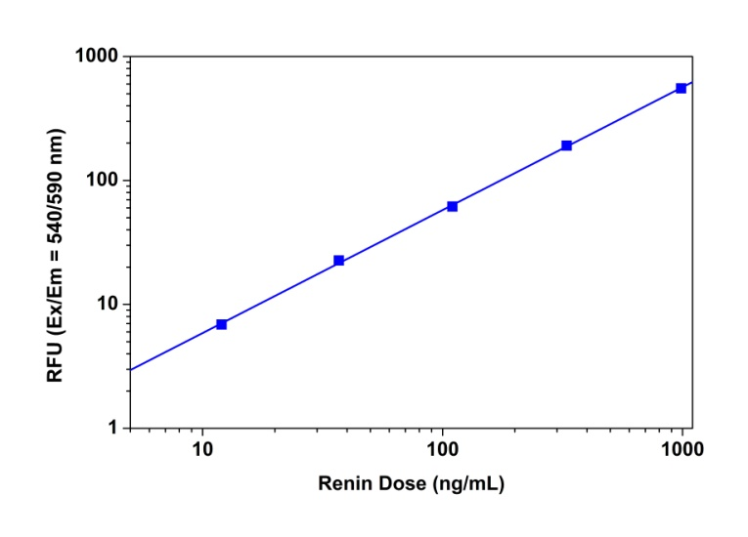
Figure 1. Renin dose response was measured with ab138875 in a 96-well black solid plate using a fluorescence microplate reader. As low as 10 ng /mL Renin was detected with 60 minutes incubation in 37°C

Troubleshooting
Problem | Reason | Solution
Assay not working | Assay buffer at wrong temperature | Assay buffer must not be chilled - needs to be at RT
Assay not working | Protocol step missed | Re-read and follow the protocol exactly
Assay not working | Plate read at incorrect wavelength | Ensure you are using appropriate reader and filter settings (refer to datasheet)
Assay not working | Unsuitable microtiter plate for assay | Fluorescence: Black plates (clear bottoms);  Luminescence: White plates;  Colorimetry: Clear plates.  If critical, datasheet will indicate whether to use flat- or U-shaped wells
Unexpected results | Measured at wrong wavelength | Use appropriate reader and filter settings described in datasheet
Unexpected results | Samples contain impeding substances | Troubleshoot and also consider deproteinizing samples
Unexpected results | Unsuitable sample type | Use recommended samples types as listed on the datasheet
Unexpected results | Sample readings are outside linear range | Concentrate/ dilute samples to be in linear range

Problem | Reason | Solution
Samples with inconsistent readings | Unsuitable sample type | Refer to datasheet for details about incompatible samples
Samples with inconsistent readings | Samples prepared in the wrong buffer | Use the assay buffer provided (or refer to datasheet for instructions)
Samples with inconsistent readings | Samples not deproteinized (if indicated on datasheet) | Use the 10kDa spin column (ab93349) or Deproteinizing sample preparation kit (ab93299)
Samples with inconsistent readings | Cell/ tissue samples not sufficiently homogenized | Increase sonication time/ number of strokes with the Dounce homogenizer
Samples with inconsistent readings | Too many freeze-thaw cycles | Aliquot samples to reduce the number of freeze-thaw cycles
Samples with inconsistent readings | Samples contain impeding substances | Troubleshoot and also consider deproteinizing samples
Samples with inconsistent readings | Samples are too old or incorrectly stored | Use freshly made samples and store at recommended temperature until use
Lower/ Higher readings in samples and standards | Not fully thawed kit components | Wait for components to thaw completely and gently mix prior use
Lower/ Higher readings in samples and standards | Out-of-date kit or incorrectly stored reagents | Always check expiry date and store kit components as recommended on the datasheet
Lower/ Higher readings in samples and standards | Reagents sitting for extended periods on ice | Try to prepare a fresh reaction mix prior to each use
Lower/ Higher readings in samples and standards | Incorrect incubation time/ temperature | Refer to datasheet for recommended incubation time and/ or temperature
Lower/ Higher readings in samples and standards | Incorrect amounts used | Check pipette is calibrated correctly (always use smallest volume pipette that can pipette entire volume)
Standard curve is not linear | Not fully thawed kit components | Wait for components to thaw completely and gently mix prior use
Standard curve is not linear | Pipetting errors when setting up the standard curve | Try not to pipette too small volumes
Standard curve is not linear | Incorrect pipetting when preparing the reaction mix | Always prepare a master mix
Standard curve is not linear | Air bubbles in wells | Air bubbles will interfere with readings; try to avoid producing air bubbles and always remove bubbles prior to reading plates
Standard curve is not linear | Concentration of standard stock incorrect | Recheck datasheet for recommended concentrations of standard stocks
Standard curve is not linear | Errors in standard curve calculations | Refer to datasheet and re-check the calculations
Standard curve is not linear | Use of other reagents than those provided with the kit | Use fresh components from the same kit

For further technical questions please do not hesitate to contact us by email (technical@abcam.com) or phone (select “contact us” on www.abcam.com for the phone number for your region).

For all technical and commercial enquires please go to:
www.abcam.com/contactus
www.abcam.cn/contactus (China)
www.abcam.co.jp/contactus (Japan)

Copyright © 2012 Abcam, All Rights Reserved. The Abcam logo is a registered trademark.
All information / detail is correct at time of going to print.

