

ab178020 –
Protein Carbonyl Assay Kit (Western Blot)

Instructions for Use
For the measurement of designed for the measurement of carbonyl groups introduced into proteins by oxidative reactions with ozone or oxides of nitrogen or by metal catalyzed oxidation.
View kit datasheet: www.abcam.com/ab178020
(use www.abcam.cn/ab178020 for China, or www.abcam.co.jp/ab178020 for Japan)

This product is for research use only and is not intended for diagnostic use.

Table of Contents

INTRODUCTION
1. BACKGROUND 1
2. ASSAY SUMMARY 1

GENERAL INFORMATION
3. PRECAUTIONS 1
4. STORAGE AND STABILITY 1
5. MATERIALS SUPPLIED 1
6. MATERIALS REQUIRED, NOT SUPPLIED 1
7. LIMITATIONS 1

ASSAY PREPARATION
8. REAGENT PREPARATION 1
9. PREPARATION OF PROTEIN LYSATES 1

ASSAY PROCEDURE
10. DERIVATION OF PROTEIN MIXTURE 1
11. SDS-PAGE, TRANSFER AND WESTERN BLOTTING 1
DATA ANALYSIS
12. DATA ANALYSIS 1
RESOURCES
13. TROUBLESHOOTING 1
14. NOTES 1

BACKGROUND
Protein Carbonyl Assay Kit is designed for the measurement of carbonyl groups introduced into proteins by oxidative reactions with ozone, oxides of nitrogen or by metal catalyzed oxidation. The kit provides the chemical and immunological reagents necessary to perform the Western Blot (immunoblot) detection.

Oxygen-derived free radicals have been implicated to have important roles in aging, apoptosis, and cancer. These highly reactive chemical species are also involved in a wide variety of clinical disorders, such as atherosclerosis, cataractogenesis, neurodegenerative diseases, chronic inflammatory diseases, pulmonary diseases and cardiovascular diseases.

Oxygen free radicals are generated by environmental factors such as ionizing radiation and chemical substances. They are also produced during normal cellular metabolism by mitochondrial electron transport, the cellular redox system and by immune responses. Free radicals that escape the defenses attack and modify subcellular components, including nucleic acids, lipids and proteins, with proteins being one of the major targets of oxygen free radicals and other reactive species. Oxidative modification of proteins modifies the side chains of methionine, histidine, and tyrosine and forms cysteine disulfide bonds. Metal catalyzed oxidation of proteins introduces carbonyl groups (aldehydes and ketones) at lysine, arginine, proline or threonine residues in a site-specific manner. These oxidative modifications of proteins can modulate biochemical characteristics of the proteins such as enzymatic activity, DNA binding activities of transcription factors, and the susceptibility to proteolytic degradation.

Protein Carbonyl Assay Kit provides a sensitive and simple methodology for detection and quantification of carbonyl groups, which is a hallmark of the oxidation status of proteins.
The carbonyl groups in the protein side chains are derivatized to 2,4-dinitrophenylhydrazone (DNP-hydrazone) by reaction with 2,4-dinitrophenylhydrazine (DNPH). The DNP-derivatized protein samples are separated by polyacrylamide gel electrophoresis followed by Western blotting. The membranes are incubated with primary antibody, specific to the DNP moiety of the proteins. This step is followed by incubation with an HRP-conjugated secondary detector antibody specific for the primary antibody (which for this kit is a goat anti-rabbit IgG). The membranes are then treated with chemiluminescent reagents (luminol and enhancer). The light emitting from the transformed luminol is detected by short exposure to blue-light sensitive films.

The detection of oxidatively modified proteins by immunoblotting has additional advantages. Individual oxidized proteins are separated and identified from a complex mixture by SDS-PAGE. The oxidative status of each protein can be analyzed quantitatively by comparison of the signal intensity of the same protein in different lanes on the same or different gels.

ASSAY SUMMARY

Prepare protein solution

Derivatize the carbonyl groups

Separate the protein sample by SDS-PAGE

Transfer to a membrane

Block Non-Specific Sites

Incubate in Primary Antibody

Incubate in HRP-Conjugated Secondary Antibody

Add Chemiluminescent Reagent

Expose to Film

PRECAUTIONS
Please read these instructions carefully prior to beginning the assay.
- All kit components have been formulated and quality control tested to function successfully as a kit. Modifications to the kit components or procedures may result in loss of performance.
- Component 2,4-Dinitrophenylhydrazine contains 2,4-dinitrophenyl Hydrazine and 2N HCl acid. Component 1X derivatization control solution also contains 2N HCl acid. Harmful if swallowed or inhaled; wear personal protective equipment (wear lab coat, gloves and eye protection) before handling the reagents. Avoid contact with skin and eyes, wash areas of contact immediately.

STORAGE AND STABILITY
Store kit at - 20ºC immediately upon receipt.
Refer to list of materials supplied for storage conditions of individual components. Observe the storage conditions for individual prepared components in sections 9 & 10.

MATERIALS SUPPLIED
Item | Amount | Storage  Condition  (Before Preparation)
1X 2,4-Dinitrophenylhydrazine (DNPH) Solution | 4 mL | -20°C
Neutralization Solution | 4 mL | -20°C
1X Derivatization Control Solution | 4 mL | -20°C
Standard protein with DNP residues | 1 mL | -20°C
5000X Primary anti-DNP Antibody (Rabbit) | 100 μL | -20°C
5000X HRP Conjugated Secondary Antibody (Goat anti-Rabbit) | 100 μL | -20°C
12% SDS | 2 mL | -20°C
2X Extraction Buffer | 4 mL | -20°C

MATERIALS REQUIRED, NOT SUPPLIED
These materials are not included in the kit, but will be required to successfully utilize this assay:
- 1X PBST (PBS, pH 7.5, containing 0.05% Tween20)
- 1X PBS (1.4 mM KH₂PO4, 8 mM Na₂HPO₄, 140 mM NaCl, 2.7 mM KCl, pH 7.3)
- Reagents necessary to perform SDS-PAGE
- Transfer Apparatus
- Transfer Buffer
- Blocking Buffer (5%Non Fat Milk /PBS-T)
- 1X Gel loading buffer
- 0.5-1.5mL Eppendorf Tubes
- Nitrocellulose or PVDF Membrane
- Distilled Water (dH2O)
- Chemiluminescent Reagent (e.g. ECL plus)

LIMITATIONS
- Assay kit intended for research use only. Not for use in diagnostic procedures
- Do not use kit or components if it has exceeded the expiration date on the kit labels
- Do not mix or substitute reagents or materials from other kit lots or vendors. Kits are QC tested as a set of components and performance cannot be guaranteed if utilized separately or substituted

REAGENT PREPARATION
- Standard Protein
Upon first use, thaw the standard protein on ice. Aliquot and store the protein at -20°C or -80°C. For each polyacrylamide gel, 10 - 20 μL of Standard Protein with DNP Residues will be used.

- 1X Extraction Buffer
Prepare 1X Extraction Buffer by diluting the 2X Extraction Buffer 1:1 (volume) with dH₂O. As an example to prepare 4 mL of 1X Extraction Buffer, add 2 mL 2X Extraction Buffer to 2 mL distilled water. Mix thoroughly and gently.

- 1X DNP Primary Antibody
Prepare the 1X DNP Primary Antibody by diluting the 5,000X DNP Primary Antibody 5,000-fold with Blocking Buffer (not supplied, see section 6), immediately prior to use. Prepare 5-10 mL for each blot used. As an example to prepare 5 mL 1X DNP Primary Antibody, add 1 µL 5,000X DNP Primary Antibody to 4,999 µL Blocking Buffer.

- 1X HRP conjugated Secondary Antibody
Prepare the 1X HRP conjugated Secondary Antibody by diluting the stock 5,000X Secondary Antibody 5,000-fold with Blocking Buffer (not supplied, see section 6), immediately before use. Prepare 5-10 mL for each blot used. As an example to prepare 5 mL 1X HRP conjugated Secondary Antibody, add 1 µL 5,000X HRP conjugated Secondary Antibody to 4,999 µL Blocking Buffer.

PREPARATION OF PROTEIN LYSATES
It is recommended to add a reducing agent to the 1X or 2X Extraction Buffer to prevent oxidation of proteins that may occur after cell lysis. 1X or 2X Extraction Buffer containing either 1-2% 2-mercaptoethanol or 50 mM DTT should be sufficient to inhibit this oxidation, but will have no adverse effect on the derivatization reaction.
  - Preparation of extracts from cell pellets
    - Collect non adherent cells by centrifugation or scrape to collect adherent cells from the culture flask. Typical centrifugation conditions for cells are 500 x g for 5 minutes at 4ºC.
    - Rinse cells twice with PBS.
    - Solubilize cell pellet at 2x10⁷/mL in 1X Extraction Buffer
    - Incubate on ice for 20 minutes. Centrifuge at 18,000 x g for 20 minutes at 4°C. Transfer the supernatants into clean tubes and discard the pellets. Assay samples immediately or aliquot and store at -80°C. The sample protein concentration in the extract may be quantified using a protein assay.
  - Preparation of lysates from cells in media (in-well lysis)
    - Seed cells at the same density into a multi-well plate (e.g. 96-well plate) and treat them as desired.
    - Solubilize the cells by adding equal volume (equal to the volume of culture media) of 2X Extraction Buffer directly to the cells in growth media.
    - Incubate on ice for 20 minutes. If available use a plate shaker at 300 rpm.
    - Assay samples immediately or aliquot and store at -80°C.

  - Preparation of extracts from tissue homogenates
    - Tissue lysates are typically prepared by homogenization of tissue that is first minced and thoroughly rinsed in PBS to remove blood (dounce homogenizer recommended).
    - Suspend the homogenate to 10 mg/mL in PBS.
    - Solubilize the homogenate by combining equal volumes of 2X Extraction Buffer and the homogenate.
    - Incubate on ice for 20 minutes. Centrifuge at 18,000 x g for 20 minutes at 4°C. Transfer the supernatants into clean tubes and discard the pellets. Assay samples immediately or aliquot and store at -80°C. The sample protein concentration in the extract may be quantified using a protein assay.

- Samples should be diluted to desired concentration before starting the derivatization.

DERIVATION OF PROTEIN MIXTURE
Two aliquots of each specimen to be analyzed will be treated simultaneously. One aliquot will be treated with derivatization reaction while the other aliquot will serve as a negative control.
NOTE: the volume of protein samples can vary depending on the concentration of the sample. Generally, 3-4 mg/mL of protein is recommended per derivatization reaction. Avoid high protein concentration (>10 mg/mL) to assure solubility during the derivatization reaction. User may need to try several protein concentrations to obtain desirable results.
  - Transfer 10 µL of a solubilized protein sample (crude or purified) into each of 2 Eppendorf Tubes (500 µL - 1.5 mL).
  - Before use, thaw 12% SDS to room temperature. Denature each aliquot of protein by adding equal volume of 12% SDS for a final concentration of 6% SDS.
  - Before use, thaw 1X DNPH Solution and 1X Derivatization Control Solution to room temperature. Derivatize the sample by adding 20 μL of 1X DNPH Solution to the derivatization reaction tube. Add 20 μL of 1X Derivatization Control Solution to the negative control tube.
  - Incubate both tubes at room temperature for 15 minutes. Do not allow the reaction to proceed more than 30 minutes as side reactions other than hydrazone linkage may occur.
  - Add 20 μL of Neutralization Solution to both tubes.
  - Both the treated sample and the negative control are ready to load into a polyacrylamide gel. Protein concentration is around 500 µg/mL if the preparation begins with a recommended concentration. Samples can be further diluted to a customer defined concentration using 1X Gel Loading Buffer (not supplied).
NOTE: Treated samples can be stored at 4°C for up to one week or be aliquoted and stored at -20°C for up to a month.

SDS-PAGE, TRANSFER AND WESTERN BLOTTING
  - Loading and running the gel
    - Load equal amounts of derivatized protein and its control into the wells of the SDS-PAGE gel, along with molecular weight markers and 10 μL DNP-BSA. Load 10- 20 μg of total protein from cell lysate or tissue homogenate, or 50 - 500 ng of purified protein.
NOTE: it is not necessary to add 1X Gel Loading Buffer to the samples prior to loading the gel. However, the addition of Loading Buffer will not adversely affect the electrophoresis of the sample. DO NOT HEAT SAMPLES PRIOR TO LOADING INTO THE GEL.
    - Run the gel for 1 to 2 hours at 150 V.
NOTE: This time and voltage is based on using bio-rad electrophoresis apparatus and precast tris-Glycine gels. It is recommended to follow the manufacturer’s instructions.
  - Transferring the protein from the gel to the membrane
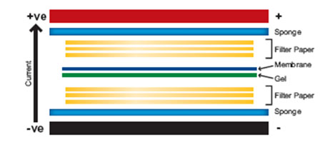
    - Prepare the transfer stack as follows:

NOTE: The membrane can be either nitrocellulose or PVDF. “Activate” PVDF with methanol for one minute and rinse with Transfer Buffer before preparing the stack. The time and voltage may require some optimization. We recommend following the manufacturer’s instructions. Transfer to the membrane can be checked using Ponceau Red staining before the blocking step.
    - The membrane is ready for antibody staining.
  - Antibody staining
    - Block the membrane for 1 hour at room temperature or overnight at 4°C using Blocking Buffer (not supplied, see section 6).
    - Incubate membrane with 1X Primary anti-DNP Antibody in Blocking Buffer overnight at 4°C or for 3 hours at room temperature.
    - Wash the membrane in three washes of 1X PBST, 5 minutes each.
    - Incubate the membrane with 1X HRP conjugated Secondary Antibody in Blocking Buffer at room temperature for 1 hour.
    - Wash the membrane in three washes of 1X PBST, 5 minutes each, then rinse in 1X PBS.
  - Signal Development
  - If using the ECL plus kit (not supplied), follow the manufacturer’s recommendations.
  - Remove excess reagent and cover the membrane in transparent plastic wrap.
  - Acquire image using darkroom development techniques.

DATA ANALYSIS
Proteins which have undergone oxidative modification will be identified by appearing as a band only in the lane containing the derivatized sample but not in the lane containing the negative control.
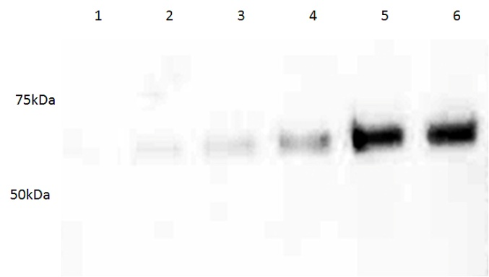

Figure 1. Sensitivity of DNP detection demonstrated by serial dilution of DNP –derivatized BS:.
Lane 1: 5 ng BSA
Lane 2: 10 ng BSA
Lane 3: 20 ng BSA
Lane 4: 40 ng BSA
Lane 5: 80 ng BSA
Lane 6: 160 ng BSA

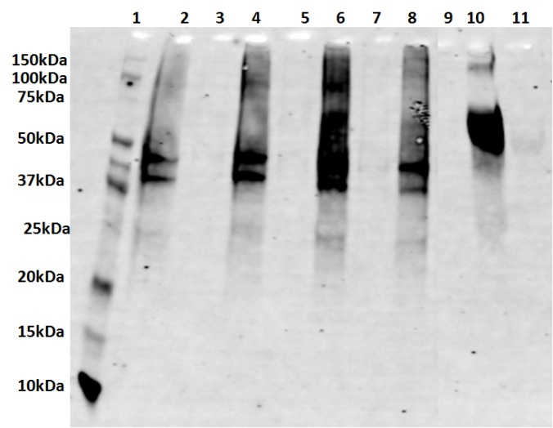

Figure 2. Example of DNP detection demonstrated by DNP derivatized H₂O₂ treated Hela cells.
Lane 1: MW ladder
Lane 2 (DNPH): HeLa cells with 0.1 mM H₂O₂, 15 minutes treatment.
Lane 3(Negative Control): HeLa cells with 0.1 mM H₂O₂, 15 minutes treatment.
Lane 4 (DNPH): HeLa cells with 1 mM H₂O₂, 15 minutes treatment.
Lane 5 (Negative Control): HeLa cells with 1 mM H₂O₂, 15 minutes treatment.
Lane 6 (DNPH): HeLa cells with 10 mM H₂O₂, 15 minutes treatment.
Lane 7 (Negative Control): HeLa cells with 10 mM H₂O₂, 15 minutes treatment.
Lane 8(DNPH): HeLa cells with 0 mM H₂O₂, 15 minutes treatment.
Lane 9 (Negative Control): HeLa cells with 0 mM H₂O₂, 15 minutes treatment.
Lane 10 (DNPH): BSA with DNPH derivatization.
Lane 11 (Negative Control): BSA with DNPH derivatization.

TROUBLESHOOTING
Problem | Cause | Solution
No signal or poor signal | No or poor transfer during Western Blot procedure | Check the power supply and electroblot apparatus
No signal or poor signal | No or poor transfer during Western Blot procedure | Check that the membrane was properly hydrated according to manufacturer’s instructions
No signal or poor signal | Detection system | Store the antibodies and reagents properly, use as recommended in the manufacturer’s protocol
No signal or poor signal | Detection system | Check that chemiluminescent reagents are properly used and film developer and fixer are fresh
High background | Inadequate blocking of membrane | Using properly prepared Blocking/Dilution Buffer  OR increase the incubation time of the blocking step
Diffused bands | gel was over loaded with protein | Apply less protein sample to the gel
Diffused bands | Less SDS in sample buffer or running buffer | Check and make sure the buffers were prepared correctly
Distorted bands | Air bubbles are trapped during Electrophoresis | Check that no leak of the gel apparatus
Distorted bands | Air bubbles are trapped during transferring | Check and make sure any air bubbles between the gel and the membrane are carefully removed prior to transfer

NOTES

Copyright © 2020 Abcam, All Rights Reserved. The Abcam logo is a registered trademark. All information / detail is correct at time of going to print.
For all technical or commercial enquiries please go to:
www.abcam.com/contactus
www.abcam.cn/contactus (China)
www.abcam.co.jp/contactus (Japan)

