
ab204721
Lipoprotein Lipase
Activity Assay Kit
(Fluorometric)

Instructions for use:

For quantitative measurement of Lipoprotein Lipase activity in a variety of biological samples.

This product is for research use only and is not intended for diagnostic use.

PLEASE NOTE: With the acquisition of BioVision by Abcam, we have made some changes to component names and packaging to better align with our global standards as we work towards environmental-friendly and efficient growth. You are receiving the same high-quality products as always, with no changes to specifications or protocols.

Table of Contents
INTRODUCTION 1
1. BACKGROUND 1
2. ASSAY SUMMARY 2
GENERAL INFORMATION 3
3. PRECAUTIONS 3
4. STORAGE AND STABILITY 3
5. LIMITATIONS 4
6. MATERIALS SUPPLIED 4
7. MATERIALS REQUIRED, NOT SUPPLIED 5
8. TECHNICAL HINTS 6
ASSAY PREPARATION 7
9. REAGENT PREPARTATION 7
10. STANDARD PREPARTATION 8
11. SAMPLE PREPARATION 9
ASSAY PROCEDURE 11
12. ASSAY PROCEDURE 11
DATA ANALYSIS 13
13. CALCULATIONS 13
14. TYPICAL DATA 15
RESOURCES 17
15. QUICK ASSAY PROCEDURE 17
16. TROUBLESHOOTING 18
17. INTERFERENCES 20
18. FAQ 20
19. NOTES 21

INTRODUCTION

BACKGROUND
Lipoprotein Lipase Activity Assay Kit (Fluorometric) (ab204721) contains a quenched substrate that fluoresces upon hydrolysis by lipoprotein lipase (LPL). The fluorometric intensity is directly proportional to the amount of substrate hydrolyzed by the enzyme. This assay detects total lipase activity when no inhibitor is used. Comparing results in the presence or absence of an LPL inhibitor allows for quantification of LPL activity specifically. Our results indicate that the majority (~90%) of lipase activity detected by this kit in post-heparin treated mouse plasma is from LPL. To determine the exact LPL specific activity in mouse plasma, measure activity in pre- and post-heparin treated plasma.

Lipoprotein lipase (LPL) is a member of the lipase family that hydrolyzes triglycerides in chylomicrons and very low-density lipoprotein (VLDL). Digestion of triglycerides in VLDL by LPL leads to their conversion to intermediate-density lipoprotein (IDL) and then low-density lipoprotein (LDL). LPL is found attached to the luminal surface of endothelial cells in the heart, muscle, and adipose tissue. Mutations in lipoprotein lipase can lead to a variety of disorders such as lipoprotein metabolism, hypertriglyceridemia etc. Overexpression of LPL in mice has been shown to promote obesity and insulin resistance

ASSAY SUMMARY
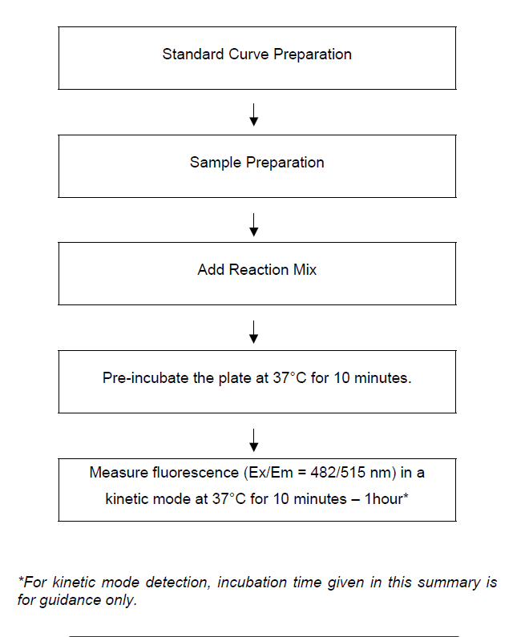

GENERAL INFORMATION

PRECAUTIONS
Please read these instructions carefully prior to beginning the assay.
- All kit components have been formulated and quality control tested to function successfully as a kit.
- We understand that, occasionally, experimental protocols might need to be modified to meet unique experimental circumstances. However, we cannot guarantee the performance of the product outside the conditions detailed in this protocol booklet.
- Reagents should be treated as possible mutagens and should be handled with care and disposed of properly. Please review the Safety Datasheet (SDS) provided with the product for information on the specific components.
- Observe good laboratory practices. Gloves, lab coat, and protective eyewear should always be worn. Never pipet by mouth. Do not eat, drink or smoke in the laboratory areas.
- All biological materials should be treated as potentially hazardous and handled as such. They should be disposed of in accordance with established safety procedures.

STORAGE AND STABILITY
Store kit at 4°C in the dark immediately upon receipt. Kit has a storage time of 1 year from receipt, providing components have not been reconstituted. Once opened use within 2 months.
Refer to list of materials supplied for storage conditions of individual components. Observe the storage conditions for individual prepared components in section 9. Reagent Preparation.
Aliquot components in working volumes before storing at the recommended temperature.

LIMITATIONS
- Assay kit intended for research use only. Not for use in diagnostic procedures.
- Do not use kit or components if it has exceeded the expiration date on the kit labels.
- Do not mix or substitute reagents or materials from other kit lots or vendors. Kits are QC tested as a set of components and performance cannot be guaranteed if utilized separately or substituted.

MATERIALS SUPPLIED
Item | Amount | Storage Condition (Before Preparation) | Storage Condition  (After Preparation)
LPL Assay Buffer | 5 mL | 4°C | 4°C
LPL Substrate/Substrate (in DMSO) | 10 µL | 4°C | 4°C
LPL Positive Control/Positive Control | 1 Vial | 4°C | -20°C
LPL Inhibitor/Inhibitor (Orlistat) | 20 µL | 4°C | 4°C

MATERIALS REQUIRED, NOT SUPPLIED
These materials are not included in the kit, but will be required to successfully perform this assay:
- Microplate reader capable of measuring fluorescence at Ex/Em = 482/515 nm
- MilliQ water or other type of double distilled water (ddH₂O)
- Pipettes and pipette tips, including multi-channel pipette
- Assorted glassware for the preparation of reagents and buffer solutions
- Tubes for the preparation of reagents and buffer solutions
- 96 well plate with flat bottom, preferably black
- Dounce homogenizer (if using tissue)
- (Optional) Heparin – if measuring LPL activity from plasma

TECHNICAL HINTS
- This kit is sold based on number of tests. A ‘test’ simply refers to a single assay well. The number of wells that contain sample, control or standard will vary by product. Review the protocol completely to confirm this kit meets your requirements. Please contact our Technical Support staff with any questions.
- Selected components in this kit are supplied in surplus amount to account for additional dilutions, evaporation, or instrumentation settings where higher volumes are required. They should be disposed of in accordance with established safety procedures.
- Avoid foaming or bubbles when mixing or reconstituting components.
- Avoid cross contamination of samples or reagents by changing tips between sample, standard and reagent additions.
- Ensure plates are properly sealed or covered during incubation steps.
- Ensure all reagents and solutions are at the appropriate temperature before starting the assay.
- Samples which generate values that are greater than the most concentrated standard should be further diluted in the appropriate sample dilution buffer.
- Make sure you have the right type of plate for your detection method of choice.
- Make sure all necessary equipment is switched on and set at the appropriate temperature.

ASSAY PREPARATION

REAGENT PREPARTATION
- Briefly centrifuge small vials at low speed prior to opening
  - LPL Assay Buffer:
Ready to use as supplied. Equilibrate to 37°C before use. Store at 4°C.
  - LPL Substrate/Substrate (in DMSO):
Warm by placing in a 37°C bath for 1 – 5 minutes to thaw the DMSO solution before use. NOTE: DMSO tends to be solid when stored at 4°C, even when left at room temperature, so it needs to melt for few minutes at 37°C. Aliquot so that you have enough volume to performed the desired number of assays.
Dilute 2 µL of LPL Substrate/substrate in 1 mL of LPL Assay Buffer (or as per assay requirement). Store diluted LPL Substrate/substrate at 4°C protected from light and moisture for up to 2 weeks.
  - LPL Positive Control/Positive Control:
Reconstitute the LPL Positive Control/Positive Control with 220 μL of ddH2O to make LPL Positive Control/Positive Control stock solution. Aliquot LPL Positive Control/Positive Control stock solution so that you have enough volume to perform the desired number of assays. Store at -20°C protected from light. Avoid repeated freeze/thaw. Once the LPL Positive Control/Positive Control is thawed, use within two months.
  - LPL Inhibitor/Inhibitor (Orlistat):
Ready to use as supplied. Equilibrate to room temperature before use. Store at 4°C.

STANDARD PREPARTATION
- Always prepare a fresh set of standards for every use.
- Discard the working standard solutions after use as they do not store well.

  - Use diluted LPL Substrate/Substrate from Section 9.2 to prepare standard curve dilution as described in the table in a microplate or microcentrifuge tubes:

Standard # | Volume of diluted LPL Substrate/Substrate (µL) | Assay Buffer (µL) | Final volume standard in well (µL) | End Conc LPL Substrate/Substrate in well (pmol/well)
1 | 0 | 150 | 50 | 0
2 | 6 | 144 | 50 | 2
3 | 12 | 138 | 50 | 4
4 | 18 | 132 | 50 | 6
5 | 24 | 126 | 50 | 8
6 | 30 | 120 | 50 | 10

Each dilution has enough amount of standard to set up duplicate readings (2 x 50 µL).

SAMPLE PREPARATION
General Sample Information
- We recommend performing several dilutions of your sample to ensure the readings are within the standard value range.
- We recommend that you use fresh samples. If you cannot perform the assay at the same time, we suggest that you complete the Sample Preparation step before storing the samples. Alternatively, if that is not possible, we suggest that you snap freeze your samples in liquid nitrogen upon extraction and store them immediately at -80°C. When you are ready to test your samples, thaw them on ice. Be aware however that this might affect the stability of your samples and the readings can be lower than expected.
  - Cell (adherent or suspension) samples:
    - Harvest the amount of cells necessary for each assay (initial recommendation = 1 x 10⁶ cells).
    - Wash cells with cold PBS.
    - Resuspend cells in 200 μL of ice cold PBS.
    - Homogenize cells quickly by pipetting up and down a few times.
    - Centrifuge sample for 5 – 10 minutes at 4°C at 10,000 x g using a cold microcentrifuge to remove any insoluble material.
    - Collect supernatant and transfer to a clean tube.
Initial recommendation for assay: 10 – 50 µL/well.
  - Tissue Samples:
    - Rapidly homogenize tissue with 200 μL ice cold PBS (initial recommendation = 50 mg tissue).
    - Wash tissue in cold PBS.
    - Resuspend tissue in 200 μL of ice cold PBS.

    - Homogenize tissue with a Dounce homogenizer sitting on ice, with 10 – 15 passes.
    - Centrifuge samples for 5 – 10 minutes at 4°C at 10,000 x g using a cold microcentrifuge to remove any insoluble material.
    - Collect supernatant and transfer to a clean tube.
Initial recommendation for assay: 10 – 50 µL/well.
  - Plasma:
NOTE: LPL is attached to endothelial cells by heparin-sulfated proteoglycans. Inject heparin into mouse/rat to release LPL into the blood. Isolate plasma to measure the LPL activity.
    - To measure maximum LPL activity in plasma, inject mouse/rat with 0.2 Units heparin/gram of body weight by tail vein injection.
    - Collect blood 10 minutes after injection.
    - Centrifuge samples at 3000 x g for 15 min. at 4°C using a cold microcentrifuge.
    - Collect supernatant and transfer to a clean tube.
Initial recommendation for assay: 1 – 10 µL/well.
  - Purified Enzyme:
Purified protein should be dissolved in ddH₂O, PBS or appropriate buffer prior use.
Initial recommendation for assay: 1 – 10 µL/well.

NOTE: We suggest using different volumes of sample to ensure readings are within the Standard Curve range.

ASSAY PROCEDURE

ASSAY PROCEDURE
- Equilibrate all materials and prepared reagents to room temperature prior to use.
- We recommend that you assay all standards, controls and samples in duplicate.

  - Prior to use, dilute LPL Positive Control/positive control stock (section 9.3) 1:100 in ddH₂O as per assay requirement.
  - Set up Reaction Wells
Standard wells = 50 µL standard dilutions.
Sample wells = 1 – 50 µL samples (adjust volume to 50 µL/well with ddH₂O).
Background Control wells= 50 µL ddH₂O.
Positive Control wells = 4 µL diluted LPL Positive Control/positive control (section 12.1) + 46 µL ddH₂O.
Assay Control wells = 4 µL diluted LPL Positive Control/positive control (section 12.1) + 2 µL LPL Inhibitor/Inhibitor + 44 µL ddH₂O.
  - LPL Reaction Mix:
    - Prepare 50 µL of Reaction Mix for each standard reaction. Mix enough reagents for the number of standard reactions to be performed. Prepare a master mix of the Reaction Mix to ensure consistency. We recommend the following calculation: X µL component x (Number reactions +1).
Components | Reaction Mix Standard (µL)
Diluted LPL Positive Control/Positive Control | 4
ddH₂O | 46
    - Add 50 µL of Reaction Mix into each standard well. Mix well.
    - Add 50 μL of diluted LPL Substrate/Substrate (see Section 9.2) into each sample, LPL Positive Control/Positive Control and assay validation well. Mix well.
The table below summarizes how to set up the reactions:
Components | Standard well (µL) | Sample well (µL) | Backgound control well (µL) | Positive control well (µL) | Assay Control well (µL)
Standard | 50 | - | - | - | -
Sample | - | 1 – 50 | - | - | -
Diluted LPL Positive Control/positive control (1/100) | - | - | - | 4 | 4
LPL Inhibitor/Inhibitor | - | - | - | - | 2
ddH₂O | - | Up to 50 | 50 | 46 | 44
Reaction Mix Standard | 50 | - | - | - | -
Diluted LPL Substrate/substrate | - | 50 | 50 | 50 | 50
TOTAL WELL | 100 | 100 | 100 | 100 | 100
  - Pre-incubate the plate at 37°C for 10 minutes protected from light to stabilize the signal.
  - Measure output at Ex/Em = 482/515 nm on a microplate reader in a kinetic mode, every 10 minutes, for at least 1 hour at 37°C protected from light.
NOTE: Incubation time depends on the LPL Activity in the samples. We recommend measuring fluorescence in a kinetic mode, and choosing two time points (T1 and T2) in the linear range to calculate the LPL activity of the samples. The Standard Curve can be read in end point mode (i.e. at the end of incubation time).
RFU value at T2 should not exceed the highest RFU in the standard curve. For standard curve, do not subtract RFU1 from RFU2 reading.

DATA ANALYSIS

CALCULATIONS
- Samples producing signals greater than that of the highest standard should be further diluted in appropriate buffer and reanalyzed, then multiply the concentration found by the appropriate dilution factor.
- Ensure you are using the linear portion of the kinetic reading when calculating enzymatic activity.
- The Standard Curve can be read in end point mode (i.e. at the end of incubation time).
  - Average the duplicate reading for each standard and sample.
  - Subtract 0 standard reading from all standard readings. Plot the LPL Substrate/Substrate Standard Curve.
  - Subtract Background Control (RC) reading from Sample (S) reading.
Δ RFU_{s} = RFU_{2S} - RFU_{1S}
ΔRFU_{BC} = RFU_{2BC} – RFU_{1BC}
Corrected ΔRFU = RFU_{S} – RFU_{BC}
where: RFU_{2S} and RFU_{1S} = Sample reading at chosen time points 2 and 1 (RFU), respectively
RFU_{2BC} and RFU_{1BC} = BC reading at chosen time points 2 and 1 (RFU), respectively
  - Apply the corrected ΔRFU482/515nm to the Standard Curve to obtain B pmol of LPL Substrate formed during the reaction time (ΔT = T2 – T1).
  - Activity of LPL in the test samples is calculated as:
$$Sample Lipoprotein Lipase Activity (A) = B/(ΔT x V) X D = pmol/ml/min = mU/ml$$
Where:
B = Amount of LPL Substrate/substrate in the sample well calculated from Standard Curve (pmol).
ΔT = Reaction time (min).
V = Original sample volume added into the reaction well (mL).
D = Sample dilution factor.

Unit Definition:
1 Unit LPL activity = amount of Lipoprotein Lipase that generates 1.0 nmol of fatty acid product per min. at pH 7.4 at 37°C.

TYPICAL DATA
TYPICAL STANDARD CURVE – Data provided for demonstration purposes only. A new standard curve must be generated for each assay performed
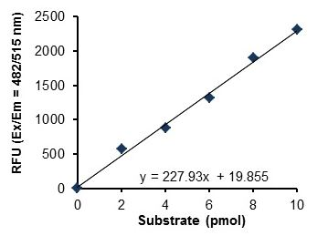
Figure 1 Typical LPL Substrate/Substrate Standard calibration curve using the kit protocol.
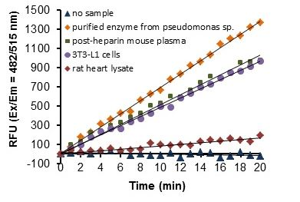
Figure 2. Measurement over time of LPL activity in purified enzyme from Pseudomonas sp. (5 ng), post-heparin treated mouse plasma (2 µL), lysate of 7-day post-differentiated 3T3-L1 cells (100 µg), and rat heart lysate (200 µg).
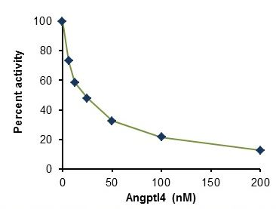
Figure 3. Inhibition of LPL activity from post-heparin treated mouse plasma by Angptl 4, a LPL specific inhibitor. The assay was run for 1 hour and the activity was determined by calculating the slope. The half minimal inhibitory concentration (IC₅₀) was found to be IC₅₀ = 22.6 nM.

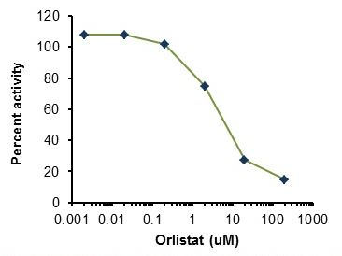
Figure 4. Inhibition of LPL Positive Control/Positive Control by Orlistat, a generic lipase inhibitor. The assay was run for 1 hour and the IC₅₀ was determined as IC₅₀ =11.4 µM.

RESOURCES

QUICK ASSAY PROCEDURE
NOTE: This procedure is provided as a quick reference for experienced users. Follow the detailed procedure when performing the assay for the first time.

- Prepare standard, LPL Positive Control/positive control and prepare enzyme mix (aliquot if necessary); get equipment ready.
- Prepare LPL substrate standard dilution [0 – 10 pmol/well].
- Prepare samples in optimal dilutions so that they fit standard curve readings.
- Set up plate in duplicate for standard (50 µL), samples (50 µL) and appropriate controls.
- Prepare a master mix for Lipoprotein Reaction Mix.
Component | Reaction Mix  (µL)
LPL Positive Control/Positive Control | 4
dH₂O | 46
- Add 50 µL of Lipoprotein Lipase Reaction Mix to the standard wells.
- Add 50 μL of diluted LPL Substrate/Substrate into each sample, LPL Positive Control/Positive Control and assay validation well. Mix well.
- Pre-Incubate plate at 37°C for 10 minutes protected from light.
- Incubate plate at 37°C for 30- 60 minutes protected from light and read fluorescence at Ex/Em= 482/515 nm in a kinetic mode.

TROUBLESHOOTING
Problem | Cause | Solution
Assay not working | Use of ice-cold buffer | Buffers must be at room temperature
Assay not working | Plate read at incorrect wavelength | Check the wavelength and filter settings of instrument
Assay not working | Use of a different 96-well plate | Colorimetric: Clear plates  Fluorometric: black wells/clear bottom plate
Sample with erratic readings | Samples not deproteinized (if indicated on protocol) | Use provided protocol for deproteinization
Sample with erratic readings | Cells/tissue samples not homogenized completely | Use Dounce homogenizer, increase number of strokes
Sample with erratic readings | Samples used after multiple free/ thaw cycles | Aliquot and freeze samples if needed to use multiple times
Sample with erratic readings | Use of old or inappropriately stored samples | Use fresh samples or store at - 80°C (after snap freeze in liquid nitrogen) till use
Sample with erratic readings | Presence of interfering substance in the sample | Check protocol for interfering substances; deproteinize samples
Lower/ Higher readings in samples and standards | Improperly thawed components | Thaw all components completely and mix gently before use
Lower/ Higher readings in samples and standards | Allowing reagents to sit for extended times on ice | Always thaw and prepare fresh reaction mix before use
Lower/ Higher readings in samples and standards | Incorrect incubation times or temperatures | Verify correct incubation times and temperatures in protocol
Lower/ Higher readings in samples and standards | Standard stock is at incorrect concentration | Always refer to dilutions described in the protocol

Problem | Cause | Solution
Standard readings do not follow a linear pattern | Pipetting errors in standard or reaction mix | Avoid pipetting small volumes (< 5 µL) and prepare a master mix whenever possible
Standard readings do not follow a linear pattern | Air bubbles formed in well | Pipette gently against the wall of the tubes
Standard readings do not follow a linear pattern | Standard stock is at incorrect concentration | Always refer to dilutions described in the protocol
Unanticipated results | Measured at incorrect wavelength | Check equipment and filter setting
Unanticipated results | Samples contain interfering substances | Troubleshoot if it interferes with the kit
Unanticipated results | Sample readings above/ below the linear range | Concentrate/ Dilute sample so it is within the linear range

INTERFERENCES
These chemicals or biological materials will cause interferences in this assay causing compromised results or complete failure:
- RIPA buffer – it contains SDS which can destroy/decrease the activity of the enzyme.

FAQ

NOTES



Technical Support
Copyright © 2024 Abcam. All Rights Reserved. The Abcam logo is a registered trademark. All information / detail is correct at time of going to print.
For all technical or commercial enquiries please go to:
www.abcam.com/contactus
www.abcam.cn/contactus (China)
www.abcam.co.jp/contactus (Japan)

