Version 4a, Last updated 9 June 2023

ab211088

HRV 3C Protease Activity Assay Kit (Colorimetric)

For the rapid, sensitive and accurate measurement of HRV 3C Protease activity in a variety of samples.

This product is for research use only and is not intended for diagnostic use.

PLEASE NOTE: With the acquisition of BioVision by Abcam, we have made some changes to component names and packaging to better align with our global standards as we work towards environmental-friendly and efficient growth. You are receiving the same high-quality products as always, with no changes to specifications or protocols.
Table of Contents
1. Overview 1
2. Protocol Summary 2
3. Precautions 3
4. Storage and Stability 3
5. Limitations 4
6. Materials Supplied 4
7. Materials Required, Not Supplied 5
8. Technical Hints 6
9. Reagent Preparation 7
10. Standard Preparation 8
11. Sample Preparation 9
12. Assay Procedure 10
13. Calculations 12
14. Typical Data 14
15. Quick Assay Procedure 16
16. Troubleshooting 17
17. Notes 19

- Overview
HRV 3C Protease Activity Assay Kit (Colorimetric) (ab211088) provides a convenient method for detecting HRV 3C Protease activity in mammalian tissue lysates and biological fluids from infected individuals, as well as from purified proteins. The assay is based on the ability of a 3C Protease (derived from a HRV rhinovirus- 14) to cleave a chromogenic peptide substrate to release a chromophore (pNA) which can be easily quantified at OD = 405 nm using a microplate reader. This assay kit is simple, rapid and can detect HRV 3C Protease activity from as low as 50 ng protein present in samples.

HRV 3C Substrate-pNA HRV 3C Protease Cleaved substrate + pNA
(absorbance @ OD405 nm)

Human rhinovirus (HRV) infections are the most frequent causative agents of common cold and various other upper respiratory tract infections. Rhinoviruses are members of the picornavirus family, which have a positive-sense, single-stranded RNA genome that is translated into a single polyprotein precursor. In the case of HRVs, the viral polyprotein is mainly processed by the proteases (2A and 3C) to generate functional proteins and enzymes.
Human rhinovirus 3C protease (EC: 3.4.22.28) is a cysteine protease that recognizes the cleavage site Leu-Glu-Val-Leu-Phe-Gln*Gly-Pro.

- Protocol Summary
Standard curve preparation.
Measure absorbance at OD405 nm in end point mode

Sample preparation

Add reaction mix

Measure absorbance at OD405 nm in kinetic mode
for 1-2 hours at room temperature

*For kinetic mode detection, incubation time given in this summary is for guidance only

- Precautions
Please read these instructions carefully prior to beginning the assay.
- All kit components have been formulated and quality control tested to function successfully as a kit.
- We understand that, occasionally, experimental protocols might need to be modified to meet unique experimental circumstances. However, we cannot guarantee the performance of the product outside the conditions detailed in this protocol booklet.
- Reagents should be treated as possible mutagens and should be handled with care and disposed of properly. Please review the Safety Datasheet (SDS) provided with the product for information on the specific components.
- Observe good laboratory practices. Gloves, lab coat, and protective eyewear should always be worn. Never pipette by mouth. Do not eat, drink or smoke in the laboratory areas.
- All biological materials should be treated as potentially hazardous and handled as such. They should be disposed of in accordance with established safety procedures.
- Storage and Stability
Store kit at -80°C in the dark immediately upon receipt. Kit has a storage time of 1 year from receipt, providing components have not been reconstituted.
Refer to list of materials supplied for storage conditions of individual components. Observe the storage conditions for individual prepared components in the Materials Supplied section.
Aliquot components in working volumes before storing at the recommended temperature.

- Limitations
- Assay kit intended for research use only. Not for use in diagnostic procedures.
- Do not mix or substitute reagents or materials from other kit lots or vendors. Kits are QC tested as a set of components and performance cannot be guaranteed if utilized separately or substituted.
- Materials Supplied
Item | Quantity | Storage temperature (before prep) | Storage temperature (after prep)
HRV 3C Protease Assay Buffer | 25 mL | -80°C | 4°C
HRV 3C Protease Positive Control/HRV 3C Protease (positive control) | 10 µL | -80°C | -80°C
HRV 3C Protease Substrate | 500 µL | -80°C | -80°C
pNA Standard I/pNA Standard (0.1 M) | 20 µL | -80°C | -80°C

- Materials Required, Not Supplied
These materials are not included in the kit, but will be required to successfully perform this assay:
- Microplate reader capable of measuring absorbance at OD 405 nm
- Pipettes and pipette tips, including multi-channel pipette
- Assorted glassware for the preparation of reagents and buffer solutions
- Tubes for the preparation of reagents and buffer solutions
- 96 well plate with clear bottom
- Dounce homogenizer (if using tissue)
- BCA protein assay kit (reducing agent compatible): we recommend using BCA protein assay kit reducing agent compatible (microplate) (ab207003)

- Technical Hints
- This kit is sold based on number of tests. A “test” simply refers to a single assay well. The number of wells that contain sample, control or standard will vary by product. Review the protocol completely to confirm this kit meets your requirements. Please contact our Technical Support staff with any questions.
- Selected components in this kit are supplied in surplus amount to account for additional dilutions, evaporation, or instrumentation settings where higher volumes are required. They should be disposed of in accordance with established safety procedures.
- Avoid foaming or bubbles when mixing or reconstituting components.
- Avoid cross contamination of samples or reagents by changing tips between sample, standard and reagent additions.
- Ensure plates are properly sealed or covered during incubation steps.
- Ensure all reagents and solutions are at the appropriate temperature before starting the assay.
- Samples which generate values that are greater than the most concentrated standard should be further diluted in the appropriate sample dilution buffer.
- Make sure all necessary equipment is switched on and set at the appropriate temperature.
- Reagent Preparation
Briefly centrifuge small vials at low speed prior to opening.
HRV 3C Protease Assay Buffer (25 mL):
Ready to use as supplied. Equilibrate to room temperature before use. Store at 4°C.
HRV 3C Protease Positive Control/HRV 3C Protease (10 μg, Positive Control) (10 µL):
Ready to use as supplied. Aliquot enzyme so that you have enough volume to perform the desired number of assays. Store aliquoted enzyme at -80°C for long term storage. Avoid repeated freeze/thaw.
HRV 3C Protease Substrate (500 µL):
Ready to use as supplied. Equilibrate to room temperature before use. Aliquot substrate so that you have enough volume to perform the desired number of assays. Store at -80°C.
pNA Standard I/pNA Standard (0.1 M) (20 µL):
Ready to use as supplied. Equilibrate to room temperature before use. Aliquot pNA Standard I/pNA standard so that you have enough volume to perform the desired number of assays Store at - 80°C.

- Standard Preparation
- Always prepare a fresh set of standards for every use.
- Discard working standard dilutions after use as they do not store well.

Prepare a 5 mM pNA working standard solution by adding 5 µL of pNA Standard I/0.1M pNA standard to 95 µL of HRV 3C Protease Assay Buffer.
Using 5 mM pNA working standard, prepare standard curve dilution as described in the table in a microplate or microcentrifuge tubes:

Standard# | pNA 5 mM standard (µL) | Assay Buffer (µL) | Final volume standard in well (µL) | End amount pNA in well (nmol/well)
1 | 0 | 300 | 100 | 0
2 | 6 | 294 | 100 | 10
3 | 12 | 288 | 100 | 20
4 | 18 | 282 | 100 | 30
5 | 24 | 276 | 100 | 40
6 | 30 | 270 | 100 | 50
Each dilution has enough amount of standard to set up duplicate readings (2 x 100 µL).
Immediately measure absorbance in an end point mode program on a microplate reader at OD = 405 nm.

- Sample Preparation
General sample information:
- We recommend performing several dilutions of your sample to ensure the readings are within the standard value range.
- We recommend that you use fresh samples. If you cannot perform the assay at the same time, we suggest that you complete the Sample Preparation step before storing the samples. Alternatively, if that is not possible, we suggest that you snap freeze your samples in liquid nitrogen upon extraction and store them immediately at -80°C. When you are ready to test your samples, thaw them on ice. Be aware however that this might affect the stability of your samples and the readings can be lower than expected.

Tissue lysates:
    - Harvest the amount of tissue necessary for each assay (initial recommendation ~ 5 – 10 mg).
    - Wash tissue in cold PBS.
    - Add 100 µL HRV 3C Protease Assay Buffer to tissue. Keep on ice for 5 minutes.
    - Homogenize tissue with a Dounce homogenizer sitting on ice, with 10 – 15 passes.
    - Centrifuge sample for 10 minutes at 4°C at 16,000 xg using a cold microcentrifuge to remove any insoluble material.
    - Collect supernatant and transfer to a new tube.
    - Keep on ice.
    - Measure the amount of protein in the lysate using BCA Protein Assay kit (reducing agent compatible).
Serum and Urine Samples:
No sample preparation is required. Measure the amount of protein in the sample using a BCA Protein Assay kit (reducing agent compatible).
Purified protein:
No sample preparation is required.

Δ Note: We suggest using different volumes of sample to ensure readings are within the standard curve range.

- Assay Procedure
- Equilibrate all materials and prepared reagents to room temperature prior to use.
- We recommend that you assay all standards, controls and samples in duplicate.
- Prepare all reagents, working standards, and samples as directed in the previous sections.

Δ Note: If you suspect your samples contain substances that can generate background, set up Sample Background Controls to correct for background noise.

Positive control preparation:
    - Immediately prior to use, dilute 2 µL of HRV 3C Protease Positive Control (Step 9.2) in 18 µL of HRV 3C Protease Assay Buffer and mix well to obtain 20 µL of 100 ng/µL enzyme solution.
Plate Loading:
- Positive control = 5 -20 µL diluted HRV 3C Protease (adjust volume to 95 µL/well with HRV 3C Protease Assay Buffer).
- Sample wells = 5 – 20 µL samples (adjust volume to 95 µL/well with HRV 3C Protease Assay Buffer).
- Sample Background Control wells = 5- 20 µL samples (adjust volume to 100 µL/well with HRV 3C Protease Assay Buffer).
- Reagent Background Control wells = 95 µL/well HRV 3C Protease Assay Buffer.
HRV 3C Protease Reaction:
    - Add 5 µL of HRV 3C Protease Substrate to Sample, Reagent Background Control and Positive control wells.
Δ Note: Do not add Substrate to the Sample Background Control wells.
    - Mix well by pipetting up and down.

The table below shows the reaction set up:

Component | Positive control (µL) | Sample (µL) | Sample Bckg Control (µL) | Reagent Bckg Control (µL)
Sample | 0 | 5-20 | 5-20 | 0
Diluted HRV 3C positive control | 5-20 | 0 | 0 | 0
Assay Buffer | Adjust volume to 95 µL
HRV 3C protease substrate | 5 | 5 | 0 | 5

Measurement:
    - Measure immediately absorbance at OD 405 nm on a microplate reader in a kinetic mode for up to 1-2 hours at room temperature.
Δ Note: Incubation time depends on the HRV 3C Protease activity in the samples. We recommend measuring absorbance in a kinetic mode, and choosing two time points (T1 and T2) in the linear range to calculate the HRV 3C Protease activity of the samples. For standard curve, do not subtract OD2 from OD1.

- Calculations
- Samples producing signals greater than that of the highest standard should be further diluted in appropriate buffer and reanalyzed, then multiply the concentration found by the appropriate dilution factor.
- Use only the linear rate for calculation.

  - Standard curve calculation:
    - Subtract the mean absorbance value of the blank (Standard #1) from all standard readings, read in end point mode. This is the corrected absorbance.
    - Average the duplicate reading for each standard.
    - Plot standard curve readings and draw the line of the best fit to construct the standard curve (most plate reader software or Excel can do this step). Calculate the trend line equation based on your standard curve data (use the equation that provides the most accurate fit).
  - Measurement of HRV 3C Protease in the sample:
    - For all reaction wells, choose two points (T1 and T2) in the linear phase of the reaction progress curves and obtain the corresponding absorbance values at those points (OD1 and OD2).
    - Calculate ΔOD405 as follows:
ΔOD405 = OD2 – OD1
    - Subtract the sample background control from the sample reading if significant.
    - Apply variation of absorbance in the sample (ΔOD405) to the pNA Standard Curve to get B nmoles of corresponding product formed during the reaction.

    - HRV 3C Protease activity (nmol/min/mL or U/mL) in the test sample is calculated as:

$$HRV 3C Activity=\left.\frac{B}{ΔT x V}\right. x D$$

Where:
B = amount of product calculated from the pNA standard curve (nmol)
∆T = linear phase reaction time T2 – T1 (min)
V = volume initially added into the reaction well (mL)
D = sample dilution factor.

Alternatively, activity can be displayed based on protein amount using the following formula:
$$HRV 3C Activity per mg of protein=\left.\frac{B}{ΔT x M}\right. x D$$

Where:
B = amount of product calculated from the pNA standard curve (nmol)
∆T = linear phase reaction time T2 – T1 min)
M = Amount of protein in the sample (mg)

Unit definition:
1 Unit HRV 3C Protease activity = amount of enzyme which can cleave 1 nmol of substrate/min under the assay conditions.

- Typical Data
Typical standard curve – data provided for demonstration purposes only. A new standard curve must be generated for each assay performed.
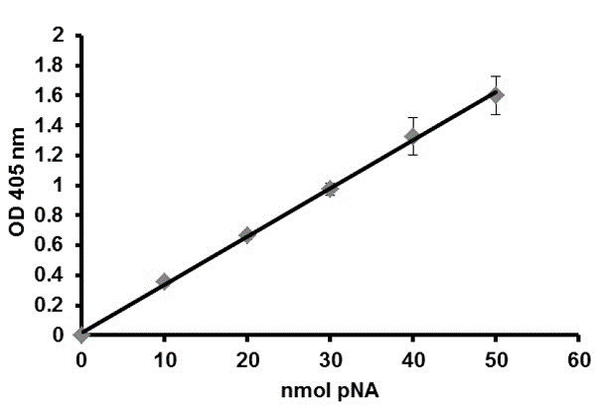
Figure 1. Typical pNA standard calibration curve.

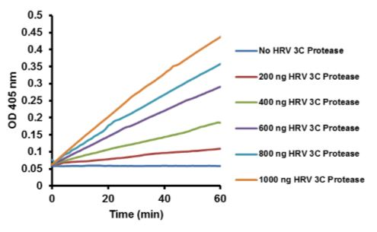
Figure 2. Kinetic progress curves at OD 405 nm for different amounts of HRV 3C Protease Positive Control/HRV 3C Protease (positive control) after 1 hour incubation. Assays were performed following the kit protocol.
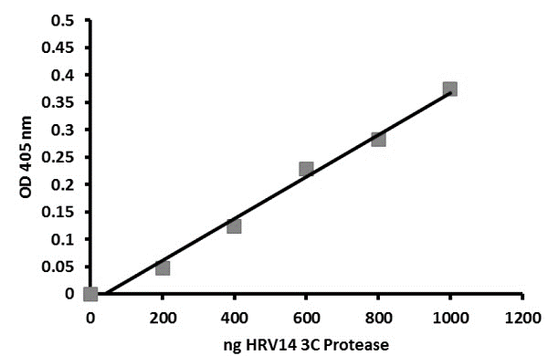
Figure 3. Change in OD 405 nm for different amounts of HRV 3C Protease Positive Control/HRV 3C Protease(positive control) calculated from kinetic curves (figure 2).

- Quick Assay Procedure
Δ Note: this procedure is provided as a quick reference for experienced users. Follow the detailed procedure when performing the assay for the first time.

- Prepare reagents; get equipment ready.
- Prepare pNA Standard I/pNA standard dilution [10 – 50 nmol/well].
- Prepare samples in optimal dilutions to fit standard curve readings.
- Set up plate in duplicate for standard (100 µL) and measure absorbance of standard in a microplate reader at OD 405 nm in end point mode.
- Set up sample background control samples (100 µL), reagent background control (95 µL), sample (95 µL) and positive control wells (95 µL).
- Add 5 µL of HRV 3C Protease Substrate to Sample, Reagent Background Control and Positive control wells.

Component | Positive control (µL) | Sample (µL) | Sample Bckg Control (µL) | Reagent Bckg Control (µL)
Sample | 0 | 5-20 | 5-20 | 0
Diluted HRV 3C positive control | 5 – 20 | 0 | 0 | 0
Assay Buffer | Adjust volume to 95 µL
HRV 3C protease substrate | 5 | 5 | 0 | 5
- Measure absorbance immediately at OD 405 nm in a kinetic mode for 1-2 hours at room temperature.

- Troubleshooting
Problem | Reason | Solution
Assay not working | Use of ice-cold buffer | Buffers must be at assay temperature
Assay not working | Plate read at incorrect wavelength | Check the wavelength and filter settings of instrument
Assay not working | Use of a different microplate | Colorimetric: clear plates  Fluorometric: black wells/clear bottom plates  Luminometric: white wells/clear bottom plates
Sample with erratic readings | Cells/tissue samples not homogenized completely | Use Dounce homogenizer, increase number of strokes
Sample with erratic readings | Samples used after multiple free/ thaw cycles | Aliquot and freeze samples if needed to use multiple times
Sample with erratic readings | Use of old or inappropriately stored samples | Use fresh samples or store at - 80°C (after snap freeze in liquid nitrogen) till use
Sample with erratic readings | Presence of interfering substance in the sample | Check protocol for interfering substances
Lower/higher readings in samples and standards | Improperly thawed components | Thaw all components completely and mix gently before use
Lower/higher readings in samples and standards | Allowing reagents to sit for extended times on ice | Always thaw and prepare fresh reaction mix before use
Lower/higher readings in samples and standards | Incorrect incubation times or temperatures | Verify correct incubation times and temperatures in protocol

Problem | Reason | Solution
Standard readings do not follow a linear pattern | Pipetting errors in standard or reaction mix | Avoid pipetting small volumes (< 5 µL) and prepare a master mix whenever possible
Standard readings do not follow a linear pattern | Air bubbles formed in well | Pipette gently against the wall of the tubes
Standard readings do not follow a linear pattern | Standard stock is at incorrect concentration | Always refer to dilutions described in the protocol
Unanticipated results | Measured at incorrect wavelength | Check equipment and filter setting
Unanticipated results | Samples contain interfering substances | Troubleshoot if it interferes with the kit
Unanticipated results | Sample readings above/ below the linear range | Concentrate/ dilute sample so it is within the linear range

- Notes

Technical Support
Copyright © 2023 Abcam. All Rights Reserved. The Abcam logo is a registered trademark. All information / detail is correct at time of going to print.
For all technical or commercial enquiries please go to:
www.abcam.com/contactus
www.abcam.cn/contactus (China)
www.abcam.co.jp/contactus (Japan)

