Version 4b, Last updated 17 November 2023

ab211094

Adenosine Assay Kit (Fluorometric)

For the sensitive and accurate measurement of Adenosine in plasma.

This product is for research use only and is not intended for diagnostic use.

PLEASE NOTE: With the acquisition of BioVision by Abcam, we have made some changes to component names and packaging to better align with our global standards as we work towards environmental-friendly and efficient growth. You are receiving the same high-quality products as always, with no changes to specifications or protocols.

Table of Contents
1. Overview 1
2. Protocol Summary 2
3. Precautions 3
4. Storage and Stability 3
5. Limitations 4
6. Materials Supplied 4
7. Materials Required, Not Supplied 5
8. Technical Hints 6
9. Reagent Preparation 7
10. Standard Preparation 9
11. Sample Preparation 10
12. Assay Procedure 11
13. Calculations 13
14. Typical Data 14
15. Quick Assay Procedure 17
16. Troubleshooting 19
17. Notes 21

- Overview
Adenosine Assay Kit (Fluorometric) (ab211094) provides a convenient method to detect adenosine in plasma and urine. In this assay, adenosine is measured using adenosine deaminase followed by a multi-step enzymatic approach resulting in the generation of an intermediate that reacts with the OxiRed Probe/adenosine probe, leading to the formation of a fluorescent product. The fluorescent product can be detected at Ex/Em = 535/587 nm, and its intensity is proportional to the amount of adenosine in the sample.
The detection range of this product is 2-80 pmol of adenosine in plasma or urine.

Adenosine

Detector, Convertor, Developer

Intermediate + OxiRed Probe/Adenosine probe

Fluorescent Product
(Ex/Em = 535/587 nm)

Adenosine, a purine nucleoside, is present throughout the body. It plays an important role in energy transfer via the formation of ATP, ADP and AMP and in signal transduction via the formation of cAMP. Adenosine mediates its effects directly via adenosine receptors A1, A2A, A2B and A3. It regulates myocardial oxygen consumption and coronary blood flow, exerts anti-inflammatory effects throughout the body and also regulates the Renin-Angiotensin system. It also plays a role in tissue damage and repair, and cell death. Plasma adenosine levels are increased in patients with ischemic and non-ischemic heart failure.

- Protocol Summary

Standard curve preparation

Sample preparation

Add reaction mix.
Incubate for 15 minutes at RT

Measure fluorescence (Ex/Em = 535/587 nm)

- Precautions
Please read these instructions carefully prior to beginning the assay.
- All kit components have been formulated and quality control tested to function successfully as a kit.
- We understand that, occasionally, experimental protocols might need to be modified to meet unique experimental circumstances. However, we cannot guarantee the performance of the product outside the conditions detailed in this protocol booklet.
- Reagents should be treated as possible mutagens and should be handled with care and disposed of properly. Please review the Safety Datasheet (SDS) provided with the product for information on the specific components.
- Observe good laboratory practices. Gloves, lab coat, and protective eyewear should always be worn. Never pipette by mouth. Do not eat, drink or smoke in the laboratory areas.
- All biological materials should be treated as potentially hazardous and handled as such. They should be disposed of in accordance with established safety procedures.
- Storage and Stability
Store kit at -20°C in the dark immediately upon receipt. Kit has a storage time of 1 year from receipt, providing components have not been reconstituted.
Refer to list of materials supplied for storage conditions of individual components. Observe the storage conditions for individual prepared components in the Materials Supplied section.
Aliquot components in working volumes before storing at the recommended temperature.

Δ Note: Reconstituted components are stable for 2 months.
- Limitations
- Assay kit intended for research use only. Not for use in diagnostic procedures.
- Do not mix or substitute reagents or materials from other kit lots or vendors. Kits are QC tested as a set of components and performance cannot be guaranteed if utilized separately or substituted.
- Materials Supplied
Item | Quantity | Storage temperature (before prep) | Storage temperature (after prep)
Assay Buffer X/Adenosine Assay Buffer | 25 mL | -20°C | -20°C
Xanthine Enzyme Mix | 1 vial | -20°C | -20°C
Adenosine Deaminase I/Adenosine Detector | 1 vial | -20°C | -20°C
Converter Enzyme IX/Adenosine Convertor | 1 vial | -20°C | -20°C
Adenosine Developer/Adenosine Developer | 1 vial | -20°C | -20°C
Adenosine Standard/Adenosine Standard (10 mM) | 100 µL | -20°C | -20°C
OxiRed Probe/Adenosine Probe (in DMSO) | 200 µL | -20°C | -20°C
PLEASE NOTE: With the acquisition of BioVision by Abcam, we have made a change to this product. Older lots of this kit were supplied with a Urine Clarifier vial instead of Xanthine Enzyme Mix. Alternate reagent preparation instructions are outlined below. There have been no changes to protocol or kit function.

- Materials Required, Not Supplied
These materials are not included in the kit, but will be required to successfully perform this assay:
- Microplate reader capable of measuring fluorescence at Ex/Em = 535/587 nm
- Pipettes and pipette tips, including multi-channel pipette
- Assorted glassware for the preparation of reagents and buffer solutions
- Tubes for the preparation of reagents and buffer solutions
- 96 well white plate with flat bottom
- Catalase Beads (ab218718) – for urine sample preparation

- Technical Hints
- This kit is sold based on number of tests. A “test” simply refers to a single assay well. The number of wells that contain sample, control or standard will vary by product. Review the protocol completely to confirm this kit meets your requirements. Please contact our Technical Support staff with any questions.
- Selected components in this kit are supplied in surplus amount to account for additional dilutions, evaporation, or instrumentation settings where higher volumes are required. They should be disposed of in accordance with established safety procedures.
- Avoid foaming or bubbles when mixing or reconstituting components.
- Avoid cross contamination of samples or reagents by changing tips between sample, standard and reagent additions.
- Ensure plates are properly sealed or covered during incubation steps.
- Ensure all reagents and solutions are at the appropriate temperature before starting the assay.
- Samples generating values that are greater than the most concentrated standard should be further diluted in the appropriate sample dilution buffer.
- Make sure all necessary equipment is switched on and set at the appropriate temperature.
- Reagent Preparation
Briefly centrifuge small vials at low speed prior to opening.
Assay Buffer X/Adenosine Assay Buffer (25 mL):
Ready to use as supplied. Equilibrate to room temperature before use. Store at -20°C.
Xanthine Enzyme Mix (lyophilized) (1 vial):
Reconstitute in 220 µL Assay Buffer X/Adenosine Assay Buffer. Pipette gently to dissolve. Aliquot so that you have enough volume to perform the desired number of assays. Store at -20°C. Keep on ice while in use. Once reconstituted, use within two months. Directly before use, mix 40 µl Xanthine Enzyme Mix with 160 µL Assay Buffer X/Adenosine Assay Buffer to make Urine Clarifier. After experiment, discard excess Urine Clarifier.
Or
Urine Clarifier (older versions of this kit)(lyophilized) (1 vial):
Reconstitute in 220 µL Assay Buffer X/Adenosine Assay Buffer. Pipette gently to dissolve. Aliquot so that you have enough volume to perform the desired number of assays. Store at -20°C. Keep on ice while in use. Once reconstituted, use within two months.
Adenosine Detector (lyophilized, 10 U) (1 vial):
Reconstitute in 220 µL Assay Buffer X/Adenosine Assay Buffer. Pipette gently to dissolve. Aliquot detector so that you have enough volume to perform the desired number of assays. Store at -20°C. Keep on ice while in use. Once reconstituted, use within two months.
Converter Enzyme IX/Adenosine Convertor (lyophilized, 10 U) (1 vial):
Reconstitute in 440 µL Assay Buffer X/Adenosine Assay Buffer. Pipette gently to dissolve. Aliquot convertor so that you have enough volume to perform the desired number of assays. Store at -20°C. Keep on ice while in use. Once reconstituted, use within two months.

Adenosine Developer/Adenosine Developer (lyophilized, 1 U) (1 vial):
Reconstitute in 220 µL Assay Buffer X/Adenosine Assay Buffer. Pipette gently to dissolve. Aliquot developer so that you have enough volume to perform the desired number of assays. Store at - 20°C. Keep on ice while in use. Once reconstituted, use within two months.

Adenosine Standard/Adenosine Standard (10 mM) (100 µL):
Ready to use as supplied. Aliquot standard so that you have enough volume to perform the desired number of assays. Store at -20°C. Keep on ice while in use.OxiRed Probe/Adenosine Probe (in DMSO) (200 µL):
Ready to use as supplied. Warm by placing in a 37°C bath for 1 – 5 minutes to thaw the DMSO solution before use.
Δ Note: DMSO tends to be solid when stored at -20°C, even when left at room temperature, so it needs to melt for a few minutes at 37°C. Repeat this step every time probe is needed.
Aliquot probe so that you have enough volume to perform the desired number of assays. Store at -20°C protected from light. Once the probe is thawed, use within two months.

- Standard Preparation
- Always prepare a fresh set of standards for every use.
- Discard working standard dilutions after use as they do not store well.
Prepare a 1mM Adenosine Standard by diluting 10 µL of Adenosine Standard/10 mM Adenosine Standard to 90 µL Assay Buffer X/Adenosine Assay Buffer.
Further dilute the Adenosine Standard to 10 µM by adding 10 µL of 1 mM Adenosine to 990 µL Assay Buffer X/Adenosine Assay Buffer.
Using the 10 µM Adenosine Standard, prepare the standard curve dilution as described in the table in a microplate or microcentrifuge tubes:
Standard# | Adenosine Standard (µL) | Assay Buffer (µL) | Final volume standard in well (µL) | End amount Adenosine in well (pmol/well)
1 | 0 | 150 | 50 | 0
2 | 6 | 144 | 50 | 20
3 | 12 | 138 | 50 | 40
4 | 18 | 132 | 50 | 60
5 | 24 | 126 | 50 | 80
Each dilution has enough amount of standard to set up duplicate readings (2 x 50 µL).

- Sample Preparation
General sample information:
- We recommend performing several dilutions of your sample to ensure the readings are within the standard value range.
- We recommend that you use fresh samples. If you cannot perform the assay at the same time, we suggest that you snap freeze your samples in liquid nitrogen upon extraction and store them immediately at -80°C. When you are ready to test your samples, thaw them on ice and proceed with the Sample Preparation step. Be aware however that this might affect the stability of your samples and the readings can be lower than expected.

Plasma:
Plasma requires no sample preparation.
Urine:
    - Centrifuge urine sample at 1000 xg at 4°C for 5 minutes to remove any particulates.
    - To 50 µL urine, add 2 µL each of Converter Enzyme IX/Adenosine Convertor and Urine Clarifier and 10 µL of a 50 % suspension of Catalase Beads (ab218178).
    - Adjust volume to 100 µL with Assay Buffer X/Adenosine Assay Buffer and incubate at room temperature for 15 minutes.
    - Centrifuge sample at 1000 xg for one minute.
    - Transfer the supernatant to a fresh tube.
    - Keep on ice.
    - Assay immediately.
Pre-treated urine sample is diluted 2X. Urine can be further dilute 2X in Assay Buffer (4X dilution) to fit within the standard curve range.
Δ Note: If using more than one urine sample, the pretreatment can be carried out in a 96-well plate.

Δ Note: We suggest using different volumes of sample to ensure readings are within the standard curve range.

- Assay Procedure
- Equilibrate all materials and prepared reagents to room temperature prior to use.
- We recommend that you assay all standards, controls and samples in duplicate.
- Prepare all reagents, working standards, and samples as directed in the previous sections.

Δ Note: Small molecules such as inosine, xanthine and hypoxanthine present in the samples will contribute to the background. Set up Sample Background Controls to correct for background.

Set up reaction wells:
- Standard wells = 50 µL standard dilutions.
- Sample wells:
Plasma = 5 – 20 µL plasma (adjust volume to 50 µL/well with Assay Buffer X/Adenosine Assay Buffer).
Urine = 1 – 5 µL pre-treated urine (adjust volume to 50 µL/well with Assay Buffer X/Adenosine Assay Buffer).
- Background Control Sample wells:
Plasma = 5 – 20 µL plasma (adjust volume to 50 µL/well with Assay Buffer X/Adenosine Assay Buffer).
Urine = 1 – 5 µL pre-treated urine (adjust volume to 50 µL/well with Assay Buffer X/Adenosine Assay Buffer).
Adenosine Reaction preparation:
    - Prepare 50 µL of Reaction Mix and Background Reaction Mix. Mix enough reagents for the number of assays to be performed. Prepare a master mix to ensure consistency.

Reaction Mix for PLASMA:
Component | Reaction Mix (µL) | Background Reaction Mix (µL)
Assay Buffer X/Adenosine Assay Buffer | 43 | 45
Adenosine Detector | 2 | 0
Converter Enzyme IX/Adenosine Convertor | 2 | 2
Adenosine Developer | 2 | 2
OxiRed Probe/Adenosine Probe | 1 | 1

Reaction Mix for URINE:
Component | Reaction Mix (µL) | Background Reaction Mix (µL)
Assay Buffer X/Adenosine Assay Buffer | 42 | 44
Adenosine Detector | 2 | 0
Converter Enzyme IX/Adenosine Convertor | 2 | 2
Adenosine Developer | 2 | 2
OxiRed Probe/Adenosine Probe* | 2 | 2

    - Add 50 µL of Reaction Mix into each standard and sample wells.
    - Add 50 µL of Background Reaction Mix into the background control sample wells.
    - Mix and incubate at room temperature for 15 minutes, protected from light.
Plate measurement:
    - Measure fluorescence immediately on a microplate reader at Ex/Em = 535/587 nm.
- Calculations
- Samples producing signals greater than that of the highest standard should be further diluted in appropriate buffer and reanalyzed, then multiply the concentration found by the appropriate dilution factor.

  - If significant, subtract the sample background control from sample reading.
  - Average the duplicate reading for each standard and sample.
  - Subtract the mean fluorescence value of the blank (Standard #1) from all standard and sample readings. This is the corrected fluorescence (RFU).
  - Plot the corrected fluorescence values for each standard as a function of the final concentration of Adenosine.
  - Draw the best smooth curve through these points to construct the standard curve. Most plate reader software or Excel can plot these values and curve fit. Calculate the trend line equation based on your standard curve data (use the equation that provides the most accurate fit).
  - Apply the corrected sample RFU reading to the standard curve to get Adenosine (B) amount in the sample wells.
  - Concentration of Adenosine (pmol/µL or µM) in the test samples is calculated as:
$$Adenosine concentration=\frac{B}{V}*D$$
Where:
B = amount of Adenosine in the sample well calculated from standard curve (pmol).
V = sample volume added in the sample wells (µL).
D = sample dilution factor if sample diluted to fit within standard curve range.

Adenosine in urine is expressed as µmol adenosine/mmol creatinine

- Typical Data
Typical standard curve – data provided for demonstration purposes only. A new standard curve must be generated for each assay performed.
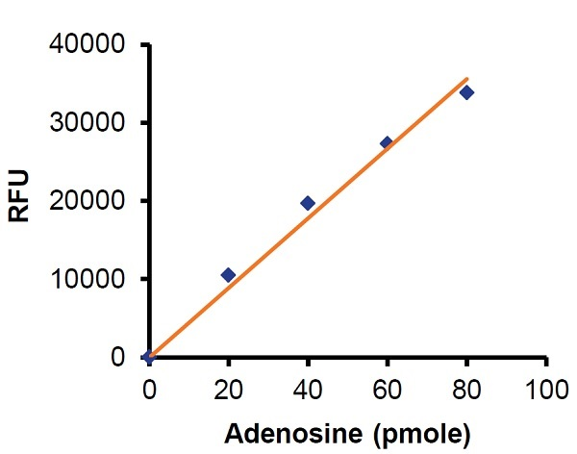
Figure 1. Typical Adenosine standard calibration curve.

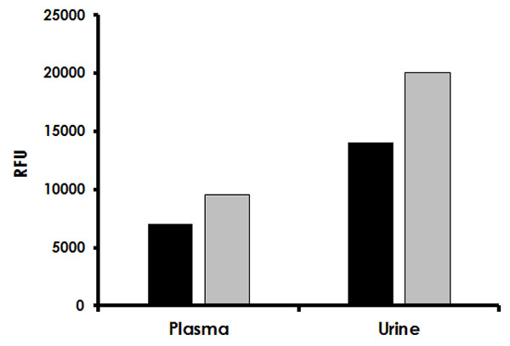
Figure 2. Measurement of Adenosine in pooled human plasma (20 µL) and human urine (4 µL of pretreated urine, 2X diluted during the pre-treatment method). Black columns represent Sample Background Control wells. Grey columns represent the adenosine measured in pooled human plasma and urine samples.

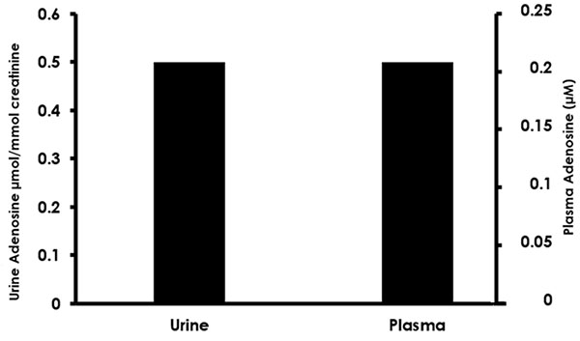
Figure 3. Adenosine amount in human plasma and human urine calculated from data shown in figure 2.

- Quick Assay Procedure
Δ Note: this procedure is provided as a quick reference for experienced users. Follow the detailed procedure when performing the assay for the first time.

- Prepare reagents and aliquot; get equipment ready.
- Prepare Adenosine standard dilution [20 – 80 pmol/well].
- Prepare samples in optimal dilutions to fit standard curve readings.
- Set up plate in duplicate for standard (50 µL), samples (50 µL) and background sample control wells (50 µL).
- Prepare a master mix for Adenosine Reaction Mix and for Background Reaction Mix:

Component | Reaction Mix (µL) | Background Reaction Mix (µL)
Assay Buffer X/Adenosine Assay Buffer | 43 | 45
Adenosine Detector | 2 | 0
Converter Enzyme IX/Adenosine Convertor | 2 | 2
Adenosine Developer | 2 | 2
OxiRed Probe/Adenosine Probe* | 1 | 1
Δ Note: * For testing urine samples, use 2 µL OxiRed Probe/Adenosine Probe.
- Add 50 µL Reaction to standard and sample wells.
- Add 50 µL Background Reaction Mix to Sample Background control wells.
- Incubate plate at room temperature for 15 minutes protected from light.
- Measure fluorescence (Ex/Em = 535/587 nm).

- Troubleshooting
Problem | Reason | Solution
Assay not working | Use of ice-cold buffer | Buffers must be at assay temperature
Assay not working | Plate read at incorrect wavelength | Check the wavelength and filter settings of instrument
Assay not working | Use of a different microplate | Use 96 well white plate with flat bottom
Sample with erratic readings | Cells/tissue samples not homogenized completely | Use Dounce homogenizer, increase number of strokes
Sample with erratic readings | Samples used after multiple free/ thaw cycles | Aliquot and freeze samples if needed to use multiple times
Sample with erratic readings | Use of old or inappropriately stored samples | Use fresh samples or store at - 80°C (after snap freeze in liquid nitrogen) till use
Sample with erratic readings | Presence of interfering substance in the sample | Check protocol for interfering substances; deproteinize samples
Lower/higher readings in samples and standards | Improperly thawed components | Thaw all components completely and mix gently before use
Lower/higher readings in samples and standards | Allowing reagents to sit for extended times on ice | Always thaw and prepare fresh reaction mix before use
Lower/higher readings in samples and standards | Incorrect incubation times or temperatures | Verify correct incubation times and temperatures in protocol

Problem | Reason | Solution
Standard readings do not follow a linear pattern | Pipetting errors in standard or reaction mix | Avoid pipetting small volumes (< 5 µL) and prepare a master mix whenever possible
Standard readings do not follow a linear pattern | Air bubbles formed in well | Pipette gently against the wall of the tubes
Standard readings do not follow a linear pattern | Standard stock is at incorrect concentration | Always refer to dilutions described in the protocol
Unanticipated results | Measured at incorrect wavelength | Check equipment and filter setting
Unanticipated results | Samples contain interfering substances | Troubleshoot if it interferes with the kit
Unanticipated results | Sample readings above/ below the linear range | Concentrate/ Dilute sample so it is within the linear range

- Notes

Technical Support
Copyright © 2023 Abcam. All Rights Reserved. The Abcam logo is a registered trademark. All information / detail is correct at time of going to print.
For all technical or commercial enquiries please go to:
www.abcam.com/contactus
www.abcam.cn/contactus (China)
www.abcam.co.jp/contactus (Japan)

