Version 2a, Last updated 5 June 2023

ab211096

Sodium Assay Kit (Colorimetric)
For the sensitive and accurate measurement of sodium in biological fluids.
View kit datasheet: www.abcam.com/ab211096
(use www.abcam.cn/ab211096 for China, or www.abcam.co.jp/ab211096 for Japan)

This product is for research use only and is not intended for diagnostic use.

PLEASE NOTE: With the acquisition of BioVision by Abcam, we have made some changes to component names and packaging to better align with our global standards as we work towards environmental-friendly and efficient growth. You are receiving the same high-quality products as always, with no changes to specifications or protocols.
Table of Contents
1. Overview 1
2. Protocol Summary 2
3. Precautions 3
4. Storage and Stability 3
5. Limitations 4
6. Materials Supplied 4
7. Materials Required, Not Supplied 5
8. Technical Hints 6
9. Reagent Preparation 7
10. Standard Preparation 8
11. Sample Preparation 9
12. Assay Procedure 10
13. Calculations 11
14. Typical Data 12
15. Quick Assay Procedure 14
16. Troubleshooting 15
17. Interferences 17
18. Notes 18

- Overview
Sodium Assay Kit (Colorimetric) (ab211096) provides a convenient two-step method to detect sodium ions (Na⁺) present in serum, urine and saliva. In this assay, sodium ions present in the sample are used by the enzyme β-galactosidase to produce an intermediate product, which reacts with a developer to generate a color signal that can be detected at OD = 405 nm.
This kit can detect as low as 25 µM sodium in biological fluids. Endogenous mono-, di-, and trivalent ions, ascorbic acid, creatinine, glucose, urea, and bilirubin do not interfere with the assay.

Step 1 Sodium
Apo β-Gal β-galactosidase (β-Gal)

Step 2 β-Gal Na developer
Substrate Hydrolysis Chromophore
Products (OD405 nm)

Sodium (Na⁺) is one of the most important electrolytes along with chloride, calcium and potassium. Sodium plays vital roles in the maintenance normal cell functions such as plasma volume, pH balance or transmission of nerve impulses. Healthy individuals can absorb sodium ingested in food, and kidneys maintain proper sodium balance by excreting its excess in urine. Normal Sodium intake has been defined to be between 200-500 mg/day. Hyponatremia (low sodium concentration in blood) can occur in patients with nephrotic syndrome, excessive vomiting and diarrhea, while Hypernatremia (high sodium concentration in blood) is developed in patients suffering from liver diseases, burns, and pregnancy. Traditionally, sodium concentration in clinical settings is determined by potentiometric, gravimetry, photometry, titrimetry and flame atomic emission spectroscopy, but these methods require expensive and complex protocols that need to be performed by trained personnel.
- Protocol Summary

Standard curve preparation

Sample preparation

Add β-Gal and incubate for 10 minutes at 37°C

Add Substrate and incubate for 30 minutes at 37°C

Measure absorbance (OD405 nm)

- Precautions
Please read these instructions carefully prior to beginning the assay.
- All kit components have been formulated and quality control tested to function successfully as a kit.
- We understand that, occasionally, experimental protocols might need to be modified to meet unique experimental circumstances. However, we cannot guarantee the performance of the product outside the conditions detailed in this protocol booklet.
- Reagents should be treated as possible mutagens and should be handled with care and disposed of properly. Please review the Safety Datasheet (SDS) provided with the product for information on the specific components.
- Observe good laboratory practices. Gloves, lab coat, and protective eyewear should always be worn. Never pipette by mouth. Do not eat, drink or smoke in the laboratory areas.
- All biological materials should be treated as potentially hazardous and handled as such. They should be disposed of in accordance with established safety procedures.
- Storage and Stability
Store kit at -20°C in the dark immediately upon receipt. Kit has a storage time of 1 year from receipt.
Refer to list of materials supplied for storage conditions of individual components. Observe the storage conditions for individual prepared components in the Materials Supplied section.
Aliquot components in working volumes before storing at the recommended temperature.

- Limitations
- Assay kit intended for research use only. Not for use in diagnostic procedures.
- Do not mix or substitute reagents or materials from other kit lots or vendors. Kits are QC tested as a set of components and performance cannot be guaranteed if utilized separately or substituted.
- Materials Supplied
Item | Quantity | Storage temperature (before prep) | Storage temperature (after prep)
β -Galactosidase Enzyme/β-Gal | 15 µL | -20°C | -20°C
DTT I/DTT (1 M) | 250 µL | -20°C | -20°C
Sodium Assay Buffer/Na Assay Buffer | 25 mL | -20°C | -20°C
Sodium Developer/Na Developer | 10 mL | -20°C | -20°C
Sodium Standard/Na Standard (1.5 M) | 1 mL | -20°C | -20°C
Substrate I/Substrate | 5 mL | -20°C | -20°C

- Materials Required, Not Supplied
These materials are not included in the kit, but will be required to successfully perform this assay:
- Microplate reader capable of measuring absorbance at OD 405 nm
- MilliQ water or other type of double distilled water (ddH₂O)
- Pipettes and pipette tips, including multi-channel pipette
- Assorted glassware for the preparation of reagents and buffer solutions
- Tubes for the preparation of reagents and buffer solutions
- 96 well plate with clear flat bottom

- Technical Hints
- This kit is sold based on number of tests. A “test” simply refers to a single assay well. The number of wells that contain sample, control or standard will vary by product. Review the protocol completely to confirm this kit meets your requirements. Please contact our Technical Support staff with any questions.
- Selected components in this kit are supplied in surplus amount to account for additional dilutions, evaporation, or instrumentation settings where higher volumes are required. They should be disposed of in accordance with established safety procedures.
- Avoid foaming or bubbles when mixing or reconstituting components.
- Avoid cross contamination of samples or reagents by changing tips between sample, standard and reagent additions.
- Ensure plates are properly sealed or covered during incubation steps.
- Ensure all reagents and solutions are at the appropriate temperature before starting the assay.
- Samples generating values that are greater than the most concentrated standard should be further diluted in the appropriate sample dilution buffer.
- Make sure all necessary equipment is switched on and set at the appropriate temperature.
- Reagent Preparation
Briefly centrifuge small vials at low speed prior to opening.
β-Galactosidase Enzyme/β-Gal (15 µL):
Ready to use as supplied. Keep on ice while in use. Aliquot β- Gal so that you have enough volume to perform the desired number of assays. Store at -20°C. Freeze/thaw should be limited. Once opened, use within two months.
DTT I/DTT 1 M (250 µL):
Ready to use as supplied. Equilibrate to room temperature before use. Keep on ice while in use. Store at -20°C.
Sodium Assay Buffer/Na Assay Buffer (25 mL):
Ready to use as supplied. Equilibrate to room temperature before use. Store at -20°C.
Prior to starting the assay, add DTT I/DTT to Sodium Assay Buffer/Na Assay Buffer to a final concentration of 10 mM and label tube as DTT/Assay Buffer. Make as much as needed for the assay. Keep on ice while in use. Use within 24 hours.
Sodium Developer/Na Developer (10 mL):
Ready to use as supplied. Equilibrate to room temperature before use. Keep on ice while in use. Store at -20°C.
Sodium Standard/Na Standard 1.5 M (1 mL):
Ready to use as supplied. Equilibrate to room temperature before use. Store at -20°C.
Substrate I/Substrate (5 mL):
Ready to use as supplied. Equilibrate to room temperature before use. Mix well before using.
Δ Note: If precipitation is observed in the vial, sonicate the contents in a water bath sonicator at 2-minute interval. Repeat if necessary.
Store at -20°C protected from light. Once opened, use within two months.

- Standard Preparation
- Always prepare a fresh set of standards for every use.
- Discard working standard dilutions after use as they do not store well.
Prepare a 7.5 mM Sodium Standard by diluting 5 µL of the 1.5 M Sodium Standard/Na Standard (Step 9.5) in 995 µL of ddH₂O.
Using 7.5 mM Sodium Standard, prepare standard curve dilutions as described in the table in a microplate or microcentrifuge tubes:

Standard# | Sodium Standard (µL) | DTT/Assay Buffer (µL) | Final volume standard in well (µL) | End amount Sodium in well (nmol/well)
1 | 0 | 120 | 40 | 0
2 | 6 | 114 | 40 | 15
3 | 12 | 108 | 40 | 30
4 | 18 | 102 | 40 | 45
5 | 24 | 96 | 40 | 60
6 | 30 | 90 | 40 | 75
Each dilution has enough amount of standard to set up duplicate readings (2 x 40 µL).

- Sample Preparation
General sample information:
- We recommend performing several dilutions of your sample to ensure the readings are within the standard value range.
- We recommend that you use fresh samples. If you cannot perform the assay at the same time, we suggest that you snap freeze your samples in liquid nitrogen upon extraction and store them immediately at -80°C. When you are ready to test your samples, thaw them on ice and proceed with the Sample Preparation step. Be aware however that this might affect the stability of your samples and the readings can be lower than expected.
- Sodium concentration range can vary widely. Normal range in humans is 135 – 145 mM for serum, 40 – 220 mmol/day for urine (or > 20 mM for one-time sample), and 30 – 220 mM for saliva.

Serum:
    - Dilute serum 1:10 – 1:100 in DTT/Assay Buffer.
Δ Note: Serum samples should not contain any sodium-salt additives such as sodium heparin, sodium EDTA or sodium citrate as they interfere with the results. We recommend using freshly collected serum free of additives or off-the-clot pooled human serum samples.
Urine:
    - Dilute urine 1:25 – 1:200 in DTT/Assay Buffer.
Saliva:
    - Centrifuge saliva samples at 10,000 x g, 4°C for 10 minutes and collect supernatant.
    - Dilute supernatant 1:2 – 1:10 in DTT/Assay Buffer.

Δ Note: We suggest using different volumes of sample to ensure readings are within the standard curve range.

- Assay Procedure
- Equilibrate all materials and prepared reagents to room temperature prior to use.
- We recommend that you assay all standards, controls and samples in duplicate.
- Prepare all reagents, working standards, and samples as directed in the previous sections.

Δ Note If you suspect your samples contain substances that can generate background, set up Sample Background Controls.

Set up reaction wells:
- Standard wells = 40 µL standard dilutions.
- Sample wells = 1 – 40 µL samples (adjust volume to 40 µL/well with DTT/Assay Buffer).
- Background Control Sample wells =1 – 40 µL samples (adjust volume to 40 µL/well with DTT/Assay Buffer).
β-Gal Reaction:
    - Dilute β-Galactosidase Enzyme/β-Gal 1:200 by adding 1 µL of β-Galactosidase Enzyme/β-Gal to 199 µL of DTT/Assay Buffer. Make as much as needed for the reaction. Keep on ice while in use.
Δ Note: Do not store the diluted βG solution.
    - Add 20 µL of diluted β-Galactosidase Enzyme/β-Gal into standard, and sample wells only.
    - Incubate plate at 37°C for 10 minutes protected from light.
    - After incubation, add 40 µl of Substrate I/Substrate into each well containing Standards, sample background control, and samples. Mix well by pipetting up and down.
    - Incubate at 37°C for 30 minutes protected from light.
    - After incubation, add 100 µL Sodium Developer/Na Developer into each well. Mix well by pipetting up and down.
Plate measurement:
    - Measure absorbance on a colorimetric microplate reader at OD = 405 nm in end point mode.

- Calculations
- Samples producing signals greater than that of the highest standard should be further diluted in appropriate buffer and reanalyzed, then multiply the concentration found by the appropriate dilution factor.

  - If significant, subtract the sample background control from sample reading.
  - Average the duplicate reading for each standard and sample.
  - Subtract the mean absorbance value of the blank (Standard #1) from all standard and sample readings. This is the corrected absorbance.
  - Plot the corrected absorbance values for each standard as a function of the final concentration of Sodium.
  - Draw the best smooth curve through these points to construct the standard curve. Most plate reader software or Excel can plot these values and curve fit. Calculate the trendline equation based on your standard curve data (use the equation that provides the most accurate fit).
  - Apply the corrected sample OD reading to the standard reading to get Sodium (B) amount in the sample wells.
  - Concentration of Sodium (nmol/µL or mM) in the test samples is calculated as:
$$Sodium concentration=\frac{B}{V}*D$$
Where:
B = amount of Sodium in the sample well calculated from standard curve (nmol).
V = sample volume added in the sample wells (µL).
D = sample dilution factor.

Sodium Molar Mass = 22.98 g/mol

- Typical Data
Typical standard curve – data provided for demonstration purposes only. A new standard curve must be generated for each assay performed.
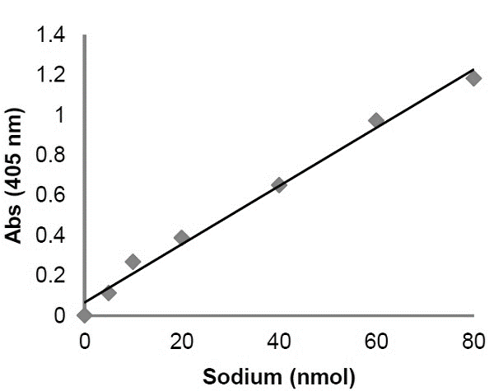
Figure 1. Typical Sodium standard calibration curve.

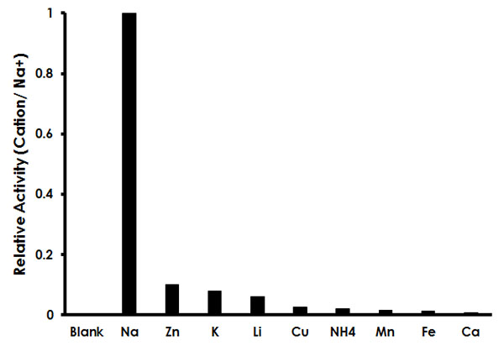
Figure 2. Assay Specificity: Sodium, and other mono, di and trivalent cations (15 nmol/0.15 mM each) were tested to evaluate possible interferences. Interferences were found to be < 10% when data was normalized using Sodium as 100% activity.

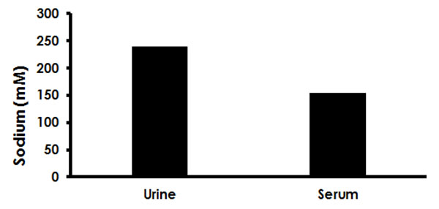
Figure 3. Estimation of sodium in human pooled serum off-the-clot (5 µL; 1:50 dilution) and human urine (10 µL; 1:100 dilution).

- Quick Assay Procedure
Δ Note: this procedure is provided as a quick reference for experienced users. Follow the detailed procedure when performing the assay for the first time.

- Prepare reagents; get equipment ready.
- Prepare DTT/Assay Buffer.
- Prepare Sodium standard dilution [15 – 75 nmol/well].
- Prepare samples in optimal dilutions to fit standard curve readings.
- Set up plate in duplicate for standard (40 µL), samples (40 µL) and background sample control wells (40 µL).
- Dilute β-Galactosidase Enzyme/β-Gal 1:200 in DTT/Assay Buffer.
- Add 20 µL of diluted βG into Standard, sample background control and sample wells.
- Incubate plate at 37°C for 10 minutes protected from light.
- Add 40 µL of Substrate I/Substrate into each well.
- Incubate plate at 37°C for 30 minutes protected from light.
- Add 100 µL Sodium Developer/Na Developer into each well.
- Measure absorbance on a colorimetric microplate reader at OD = 405 nm in end point mode.

- Troubleshooting
Problem | Reason | Solution
Assay not working | Use of ice-cold buffer | Buffers must be at assay temperature
Assay not working | Plate read at incorrect wavelength | Check the wavelength and filter settings of instrument
Assay not working | Use of a different microplate | Colorimetric: clear plates  Fluorometric: black wells/clear bottom plates  Luminometric: white wells/clear bottom plates
Sample with erratic readings | Cells/tissue samples not homogenized completely | Use Dounce homogenizer, increase number of strokes
Sample with erratic readings | Samples used after multiple free/ thaw cycles | Aliquot and freeze samples if needed to use multiple times
Sample with erratic readings | Use of old or inappropriately stored samples | Use fresh samples or store at - 80°C (after snap freeze in liquid nitrogen) till use
Sample with erratic readings | Presence of interfering substance in the sample | Check protocol for interfering substances; deproteinize samples
Lower/higher readings in samples and standards | Improperly thawed components | Thaw all components completely and mix gently before use
Lower/higher readings in samples and standards | Allowing reagents to sit for extended times on ice | Always thaw and prepare fresh reaction mix before use
Lower/higher readings in samples and standards | Incorrect incubation times or temperatures | Verify correct incubation times and temperatures in protocol

Problem | Reason | Solution
Standard readings do not follow a linear pattern | Pipetting errors in standard or reaction mix | Avoid pipetting small volumes (< 5 µL) and prepare a master mix whenever possible
Standard readings do not follow a linear pattern | Air bubbles formed in well | Pipette gently against the wall of the tubes
Standard readings do not follow a linear pattern | Standard stock is at incorrect concentration | Always refer to dilutions described in the protocol
Unanticipated results | Measured at incorrect wavelength | Check equipment and filter setting
Unanticipated results | Samples contain interfering substances | Troubleshoot if it interferes with the kit
Unanticipated results | Sample readings above/ below the linear range | Concentrate/ Dilute sample so it is within the linear range

- Interferences
These chemical or biological materials will cause interferences in this assay causing compromised results or complete failure:
- Sodium-salt additives such as sodium heparin, sodium EDTA or sodium citrate (for serum collection) as they interfere with the results. We recommend using freshly collected serum free of additives or off-the-clot pooled human serum samples

- Notes

Technical Support
Copyright © 2023 Abcam. All Rights Reserved. The Abcam logo is a registered trademark. All information / detail is correct at time of going to print.
For all technical or commercial enquiries please go to:
www.abcam.com/contactus
www.abcam.cn/contactus (China)
www.abcam.co.jp/contactus (Japan)

