Version 2 Last updated 27 October 2023

ab211098

Tryptophan Assay Kit (Fluorometric)
For the sensitive and accurate measurement of Tryptophan in serum and urine.

This product is for research use only and is not intended for diagnostic use.

PLEASE NOTE: With the acquisition of BioVision by Abcam, we have made some changes to component names and packaging to better align with our global standards as we work towards environmental-friendly and efficient growth. You are receiving the same high-quality products as always, with no changes to specifications or protocols.
Table of Contents
1. Overview 1
2. Protocol Summary 2
3. Precautions 3
4. Storage and Stability 3
5. Limitations 4
6. Materials Supplied 4
7. Materials Required, Not Supplied 5
8. Technical Hints 6
9. Reagent Preparation 7
10. Standard Preparation 8
11. Sample Preparation 9
12. Assay Procedure 11
13. Calculations 12
14. Typical Data 14
15. Quick Assay Procedure 16
16. Troubleshooting 17
17. Notes 19

- Overview
Tryptophan Assay Kit (Fluorometric) (ab211098) provides a convenient method to quantify tryptophan present in serum and urine. The assay can detect bound tryptophan in urine and free and bound tryptophan in serum. The assay principle is based on a non-enzymatic reaction that uses tryptophan as a building block, producing an intermediate product that reacts with a catalyst in order to generate a fluorophore that can be detected at Ex/Em = 370/440 nm.
The reaction is specific for Tryptophan and other amino acids do not interfere with the assay. The assay can detect as little as 2.5 µM of tryptophan in a variety of biological samples.

TRP condenser TRP catalyst
Tryptophan Intermediate Fluorescence
(Ex/Em = 370/440 nm)

Tryptophan (TRP, W) is one of the eight essential amino acids, and is mainly used for protein synthesis. Additionally, Tryptophan serves as a building block for several metabolites including kynurenine, serotonin, tryptamine, melatonin, niacin, and NAD/NAPD. Tryptophan is the only amino acid that can be found in blood in two forms: bound (BTRP) and free (FTRP) Tryptophan. Changes in tryptophan concentrations are directly related to a number of physiological and behavioral processes including: sleep, memory, depression, motion sickness, bipolar disorders, and schizophrenia. In general, tryptophan is the least abundant amino acid in humans. External sources of tryptophan include chicken, tuna, bananas, cheese, chocolate etc. Chemically, tryptophan side chain (indole) confers its unique fluorometric properties.

- Protocol Summary

Standard curve preparation

Sample preparation

Add TRP Condenser and incubate for 2 minutes at RT

Add TRP Catalyst and incubate for 60 minutes at 105°C

Keep on ice for 10 minutes

Measure fluorescence (Ex/Em = 370/440 nm)
in end point mode

- Precautions
Please read these instructions carefully prior to beginning the assay.
- All kit components have been formulated and quality control tested to function successfully as a kit.
- We understand that, occasionally, experimental protocols might need to be modified to meet unique experimental circumstances. However, we cannot guarantee the performance of the product outside the conditions detailed in this protocol booklet.
- Reagents should be treated as possible mutagens and should be handled with care and disposed of properly. Please review the Safety Datasheet (SDS) provided with the product for information on the specific components.
- Observe good laboratory practices. Gloves, lab coat, and protective eyewear should always be worn. Never pipette by mouth. Do not eat, drink or smoke in the laboratory areas.
- All biological materials should be treated as potentially hazardous and handled as such. They should be disposed of in accordance with established safety procedures.
- Storage and Stability
Store kit at +4°C in the dark immediately upon receipt. Kit has a storage time of 1 year from receipt.
Refer to list of materials supplied for storage conditions of individual components. Observe the storage conditions for individual prepared components in the Materials Supplied section.
Aliquot components in working volumes before storing at the recommended temperature.

- Limitations
- Assay kit intended for research use only. Not for use in diagnostic procedures.
- Do not mix or substitute reagents or materials from other kit lots or vendors. Kits are QC tested as a set of components and performance cannot be guaranteed if utilized separately or substituted.
- Materials Supplied
Item | Quantity | Storage temperature (before prep) | Storage temperature (after prep)
Trichloroacetic Acid Solution/TRP Deproteinization Reagent | 3 mL | 4°C | 4°C
Neutralization Buffer I/TRP Neutralization Solution | 4 mL | 4°C | 4°C
TRP Condenser | 2 mL | 4°C | 4°C
TRP Catalyst | 2 mL | 4°C | 4°C
TRP Standard/TRP Standard (25 mM) | 100 µL | 4°C | 4°C

- Materials Required, Not Supplied
These materials are not included in the kit, but will be required to successfully perform this assay:
- Microplate reader capable of measuring fluorescence at Ex/Em = 370/440 nm
- 0.2 mL microcentrifuge tubes
- PCR thermal cycler or heat block
- MilliQ water or other type of double distilled water (ddH₂O)
- Pipettes and pipette tips, including multi-channel pipette
- Assorted glassware for the preparation of reagents and buffer solutions
- Tubes for the preparation of reagents and buffer solutions
- 96 well white plate with clear flat bottom
- (Optional) 10kD Spin Column (ab93349): for free tryptophan detection sample preparation

- Technical Hints
- This kit is sold based on number of tests. A “test” simply refers to a single assay well. The number of wells that contain sample, control or standard will vary by product. Review the protocol completely to confirm this kit meets your requirements. Please contact our Technical Support staff with any questions.
- Selected components in this kit are supplied in surplus amount to account for additional dilutions, evaporation, or instrumentation settings where higher volumes are required. They should be disposed of in accordance with established safety procedures.
- Avoid foaming or bubbles when mixing or reconstituting components.
- Avoid cross contamination of samples or reagents by changing tips between sample, standard and reagent additions.
- Ensure plates are properly sealed or covered during incubation steps.
- Ensure all reagents and solutions are at the appropriate temperature before starting the assay.
- Samples generating values that are greater than the most concentrated standard should be further diluted in the appropriate sample dilution buffer.
- Make sure all necessary equipment is switched on and set at the appropriate temperature.
- Reagent Preparation
Briefly centrifuge small vials at low speed prior to opening.
Trichloroacetic Acid Solution/TRP Deproteinization Reagent (3 mL):
Ready to use as supplied. Equilibrate to room temperature before use. Store at 4°C protected from light.
Neutralization Buffer I/TRP Neutralization Solution (4 mL):
Ready to use as supplied. Equilibrate to room temperature before use. Store at 4°C protected from light.
TRP Condenser (2 mL):
Ready to use as supplied. Equilibrate to room temperature before use. Store at 4°C protected from light.
TRP Catalyst (2 mL):
Ready to use as supplied. Equilibrate to room temperature before use. Store at 4°C protected from light.
TRP Standard/TRP Standard 25 mM (100 µL)
Ready to use as supplied. Equilibrate to room temperature before use. Store at 4°C protected from light.

- Standard Preparation
- Always prepare a fresh set of standards for every use.
- Discard working standard dilutions after use as they do not store well.
Prepare a 0.25mM TRP Standard by diluting 10 µL of 25 mM TRP Standard in 990 µL of ddH₂O.
Using 0.25 mM TRP Standard, prepare standard curve dilutions as described in the table in 0.2 mL microcentrifuge (PCR) tubes:

Standard# | TRP Standard (µL) | ddH₂O (µL) | Final volume standard in tube (µL) | End amount TRP in well (nmol/well)
1 | 0 | 330 | 110 | 0
2 | 6 | 324 | 110 | 0.5
3 | 12 | 318 | 110 | 1
4 | 18 | 312 | 110 | 1.5
5 | 24 | 306 | 110 | 2
6 | 30 | 300 | 110 | 2.5

Each dilution has enough amount of standard to set up duplicate readings (2 x 110 µL).

- Sample Preparation
General sample information:
- We recommend performing several dilutions of your sample to ensure the readings are within the standard value range.
- We recommend that you use fresh samples. If you cannot perform the assay at the same time, we suggest that you snap freeze your samples in liquid nitrogen upon extraction and store them immediately at -80°C. When you are ready to test your samples, thaw them on ice and proceed with the Sample Preparation step. Be aware however that this might affect the stability of your samples and the readings can be lower than expected.

Urine:
    - Dilute urine sample 1:10 in ddH₂O.
Serum:
To measure total Tryptophan (TTRP):
    - Dilute Trichloroacetic Acid Solution/TRP Deproteinizing reagent 1:3 in ddH₂O (1-part Reagent + 2 parts ddH₂O).
    - Add 100 µL of diluted Trichloroacetic Acid Solution/TRP Deproteinizing Reagent to 400 µL of serum. Vortex sample to mix well.
    - Keep samples on ice.
Δ Note: Deproteinized samples may be stored at -80°C for up to one month without neutralization.
    - Centrifuge samples at 13,000 x g in a cold microcentrifuge at 4°C for 5 minutes.
    - Transfer supernatant (~ 380 µL) to another centrifuge tube.
    - Add 20 µL of Neutralization Buffer I/TRP Neutralization Solution to neutralize the sample.
    - Keep the sample on ice for 5 minutes.
    - Vent the sample tube as there may be some released CO₂.
To measure free Tryptophan (FTRP):
    - Deproteinize samples using a 10 kD Spin Colum (ab93349) by centrifugating sample at 10,000 x g, 4°C for 10 minutes. Collect the filtrate.
Δ Note: Deproteinization using columns will only measure FTRP. It does not measure total Tryptophan in samples.

Δ Note: Tryptophan concentrations can vary over a wide range, depending on the sample. We suggest using different volumes of sample to ensure readings are within the standard curve range.

- Assay Procedure
- Equilibrate all materials and prepared reagents to room temperature prior to use.
- We recommend that you assay all standards, controls and samples in duplicate.
- Prepare all reagents, working standards, and samples as directed in the previous sections.

Δ Note: Is you suspect your samples contain substances that generate background, set up Sample Background Controls.

Set up reaction PCR tubes:
- Standard tubes = 110 µL standard dilutions.
- Sample tubes = 1 – 30 µL samples (adjust volume to 110 µL/tube with ddH₂O).
- Background Control Sample tubes =1 – 30 µL samples (adjust volume to 110 µL/tube with ddH₂O).
TRP Reaction:
    - Add 20 µL of TRP Condenser to each of the 0.2 mL microcentrifuge tubes.
    - Mix well and incubate at room temperature for 2 minutes.
    - Add 20 µL of TRP catalyst to Standard and sample PCR tubes. Mix well. DO NOT add TRP catalysts to the sample background control wells.
Δ Note: TRP Condenser and TRP Catalyst should be added sequentially.
    - Incubate tubes at 105°C for 60 minutes in a PCR thermal cycler or heat block.
    - Keep PCR tubes on ice for 10 minutes. Gently tap the tubes to bring the content at the bottom of the tube.
    - Transfer 130 µL into a 96-well white microplate.
Plate measurement:
    - Measure fluorescence on a fluorometric microplate reader at Ex/Em = 370/440 nm in end point mode.
- Calculations
- Samples producing signals greater than that of the highest standard should be further diluted in appropriate buffer and reanalyzed, then multiply the concentration found by the appropriate dilution factor.

CALCULATION OF TOTAL TRP (URINE AND SERUM) AND/OR FTRP (SERUM ONLY)
  - If significant, subtract the sample background control from sample reading.
  - Average the duplicate reader for each standard and sample.
  - Subtract the mean fluorescence value of the blank (Standard #1) from all standard and sample readings. This is the corrected fluorescence.
  - Plot the corrected fluorescence values for each standard as a function of the final concentration of Tryptophan.
  - Draw the best smooth curve through these points to construct the standard curve. Most plate reader software or Excel can plot these values and curve fit. Calculate the trendline equation based on your standard curve data (use the equation that provides the most accurate fit).
  - Apply the corrected sample RFU reading to the standard reading to get Tryptophan (B) amount in the sample wells.
  - Concentration of Tryptophan (nmol/ µL or mM) in the test samples is calculated as:
$$Tryptophan concentration=\frac{B}{V}*D$$
Where:
B = amount of Tryptophan (TRP) in the sample well calculated from standard curve (nmol).
V = sample volume added in the sample wells (µL).
D = sample dilution factor (1.3 for TTRP in serum).

Tryptophan molecular weight: 204.23 g/mol

CALCULATION OF SERUM BOUND TRP
Use the following equation to determine the bound Tryptophan in serum

Serum Bound TRP = Serum TTRP (total) - Serum FTRP

- Typical Data
Typical standard curve – data provided for demonstration purposes only. A new standard curve must be generated for each assay performed.
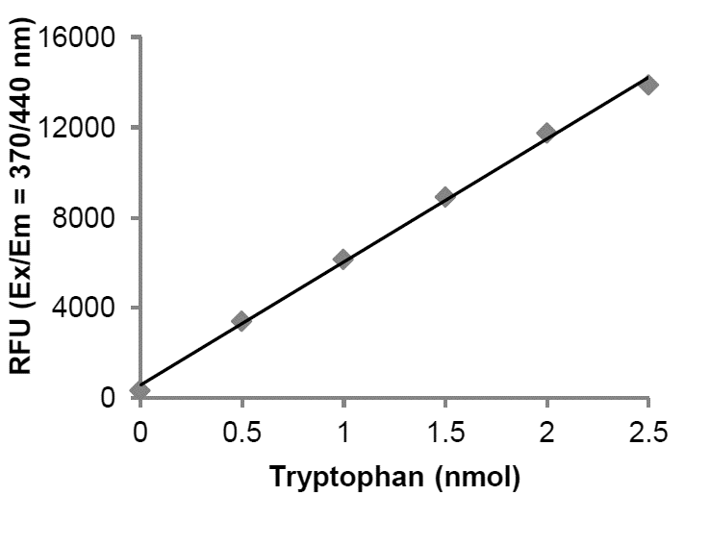
Figure 1. Typical Tryptophan standard calibration curve.

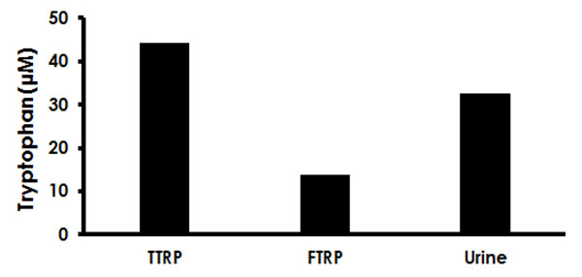
Figure 2. Estimation of Tryptophan in human urine and serum (TTRP, total, and FTRP, free). To measure TTRP and FTRP levels in serum, samples were deproteinized using the kit protocol. Serum total Tryptophan (10 µL, undiluted), serum free Tryptophan (30 µL, undiluted), and urine (25 µL, 10-fold diluted). Samples were assayed following the kit protocol. Estimated concentrations of Tryptophan: total Tryptophan in serum: 44.2 µM; free Tryptophan in serum: 13.7 µM; bound Tryptophan in serum: 30.5 µM; Total Tryptophan in urine: 32.6 µM.

- Quick Assay Procedure
Δ Note: this procedure is provided as a quick reference for experienced users. Follow the detailed procedure when performing the assay for the first time.

- Thaw components; get equipment ready.
- Prepare TRP standard dilution [0.5 – 2.5 nmol/tube].
- Prepare samples in optimal dilutions to fit standard curve readings.
- Set up tubes in duplicate for standard (110 µL), samples (110 µL) and background sample control wells (110 µL).
- Add 20 µL of TRP Condenser to the tubes containing Standards, samples and sample background control.
- Incubate at room temperature for 2 minutes.
- Add 20 µL of TRP catalyst to Standard, and sample tubes.
- Incubate tubes at 105°C for 60 minutes in a PCR thermal cycler or heat block.
- Keep tubes on ice for 10 minutes.
- Transfer tube contents to a 96-well white microplate.
- Measure fluorescence on a fluorometric microplate reader at Ex/Em = 370/440 nm in end point mode.

- Troubleshooting
Problem | Reason | Solution
Assay not working | Use of ice-cold buffer | Buffers must be at assay temperature
Assay not working | Plate read at incorrect wavelength | Check the wavelength and filter settings of instrument
Assay not working | Use of a different microplate | Colorimetric: clear plates  Fluorometric: black wells/clear bottom plates  Luminometric: white wells/clear bottom plates
Sample with erratic readings | Cells/tissue samples not homogenized completely | Use Dounce homogenizer, increase number of strokes
Sample with erratic readings | Samples used after multiple free/ thaw cycles | Aliquot and freeze samples if needed to use multiple times
Sample with erratic readings | Use of old or inappropriately stored samples | Use fresh samples or store at - 80°C (after snap freeze in liquid nitrogen) till use
Sample with erratic readings | Presence of interfering substance in the sample | Check protocol for interfering substances; deproteinize samples
Lower/higher readings in samples and standards | Improperly thawed components | Thaw all components completely and mix gently before use
Lower/higher readings in samples and standards | Allowing reagents to sit for extended times on ice | Always thaw and prepare fresh reaction mix before use
Lower/higher readings in samples and standards | Incorrect incubation times or temperatures | Verify correct incubation times and temperatures in protocol

Problem | Reason | Solution
Standard readings do not follow a linear pattern | Pipetting errors in standard or reaction mix | Avoid pipetting small volumes (< 5 µL) and prepare a master mix whenever possible
Standard readings do not follow a linear pattern | Air bubbles formed in well | Pipette gently against the wall of the tubes
Standard readings do not follow a linear pattern | Standard stock is at incorrect concentration | Always refer to dilutions described in the protocol
Unanticipated results | Measured at incorrect wavelength | Check equipment and filter setting
Unanticipated results | Samples contain interfering substances | Troubleshoot if it interferes with the kit
Unanticipated results | Sample readings above/ below the linear range | Concentrate/ Dilute sample so it is within the linear range

- Notes

Technical Support
Copyright © 2023 Abcam, All Rights Reserved. The Abcam logo is a registered trademark. All information / detail is correct at time of going to print.
Austria
wissenschaftlicherdienst@abcam.com | 019-288-259
France
supportscientifique@abcam.com | 01.46.94.62.96
Germany
wissenschaftlicherdienst@abcam.com | 030-896-779-154
Spain
soportecientifico@abcam.com | 91-114-65-60
Switzerland
technical@abcam.com
Deutsch: 043-501-64-24 | Français: 061-500-05-30
UK, EU and ROW
technical@abcam.com | +44(0)1223-696000
Canada
ca.technical@abcam.com | 877-749-8807
US and Latin America
us.technical@abcam.com | 888-772-2226
Asia Pacific
hk.technical@abcam.com | (852) 2603-6823
China
cn.technical@abcam.com | 400 921 0189 / +86 21 2070 0500
Japan
technical@abcam.co.jp | +81-(0)3-6231-0940
Singapore
sg.technical@abcam.com | 800 188-5244
Australia
au.technical@abcam.com | +61-(0)3-8652-1450
New Zealand
nz.technical@abcam.com | +64-(0)9-909-7829

