
ab212165 – Human Lipoprotein A SimpleStep ELISA® Kit

Instructions for use:

For the quantitative measurement of human Lipoprotein A in human serum, plasma, urine, and cerebrospinal fluid.

This product is for research use only and is not intended for diagnostic use.

Table of Contents
INTRODUCTION 1
1. BACKGROUND 1
2. ASSAY SUMMARY 2
GENERAL INFORMATION 3
3. PRECAUTIONS 3
4. STORAGE AND STABILITY 3
5. LIMITATIONS 3
6. MATERIALS SUPPLIED 4
7. MATERIALS REQUIRED, NOT SUPPLIED 4
8. TECHNICAL HINTS 5
ASSAY PREPARATION 7
9. REAGENT PREPARATION 7
10. STANDARD PREPARATION 8
11. SAMPLE PREPARATION 9
12. PLATE PREPARATION 10
ASSAY PROCEDURE 11
13. ASSAY PROCEDURE 11
DATA ANALYSIS 13
14. CALCULATIONS 13
15. TYPICAL DATA 14
16. TYPICAL SAMPLE VALUES 15
17. ASSAY SPECIFICITY 19
18. SPECIES REACTIVITY 19
RESOURCES 20
19. TROUBLESHOOTING 20
20. NOTES 21

INTRODUCTION

BACKGROUND
Lipoprotein A in vitro SimpleStep ELISA® (Enzyme-Linked Immunosorbent Assay) kit is designed for the quantitative measurement of human Lipoprotein A protein in human serum, plasma, urine, and cerebrospinal fluid.

The SimpleStep ELISA® employs an affinity tag labeled capture antibody and a reporter conjugated detector antibody which immunocapture the sample analyte in solution. This entire complex (capture antibody/analyte/detector antibody) is in turn immobilized via immunoaffinity of an anti-tag antibody coating the well. To perform the assay, samples or standards are added to the wells, followed by the antibody mix. After incubation, the wells are washed to remove unbound material. TMB Development Solution is added and during incubation is catalyzed by HRP, generating blue coloration. This reaction is then stopped by addition of Stop Solution completing any color change from blue to yellow. Signal is generated proportionally to the amount of bound analyte and the intensity is measured at 450 nm. Optionally, instead of the endpoint reading, development of TMB can be recorded kinetically at 600 nm.

Lipoprotein A is an atherogenic lipoprotein particle formed by an assembly of LDL particles and apo(a) bound to apoB-100 component of LDL. Apolipoprotein A, the main constituent of Lipoprotein A, has serine proteinase activity and is capable of autoproteolysis. Apolipoprotein A has 4,548 amino acids, variable sizes from 200 to 700 kDa, multiple isoforms, and structural homology with plasminogen. It competes with plasminogen for its binding site, inhibiting tissue-type plasminogen activator 1 and leading to reduced fibrinolysis. High levels of Lipoprotein A in the blood is a risk factor for myocardial infarction (MI), coronary heart disease (CHD), cerebrovascular disease (CVD), atherosclerosis, thrombosis, and stroke.

ASSAY SUMMARY
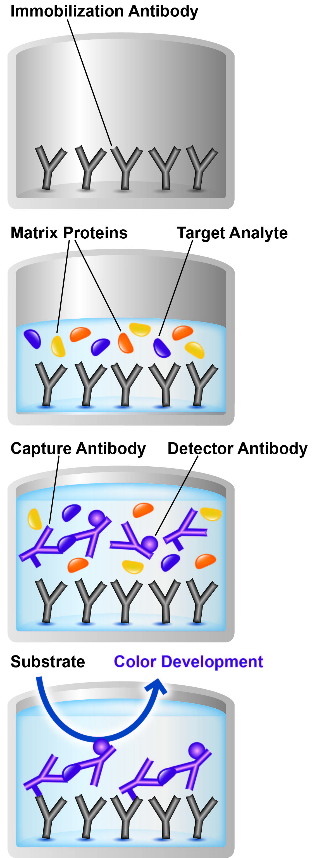

Remove appropriate number of antibody coated well strips. Equilibrate all reagents to room temperature. Prepare all reagents, samples, and standards as instructed.

Add standard or sample to appropriate wells.

Add Antibody Cocktail to all wells. Incubate at room temperature.

Aspirate and wash each well. Add TMB Development Solution to each well and incubate. Add Stop Solution at a defined endpoint.
Alternatively, record color development kinetically after TMB substrate addition.

GENERAL INFORMATION

PRECAUTIONS
Please read these instructions carefully prior to beginning the assay.
- All kit components have been formulated and quality control tested to function successfully as a kit.
- We understand that, occasionally, experimental protocols might need to be modified to meet unique experimental circumstances. However, we cannot guarantee the performance of the product outside the conditions detailed in this protocol booklet.
- Reagents should be treated as possible mutagens and should be handle with care and disposed of properly. Please review the Safety Datasheet (SDS) provided with the product for information on the specific components.
- Observe good laboratory practices. Gloves, lab coat, and protective eyewear should always be worn. Never pipet by mouth. Do not eat, drink or smoke in the laboratory areas.
- All biological materials should be treated as potentially hazardous and handled as such. They should be disposed of in accordance with established safety procedures.

STORAGE AND STABILITY
Store kit at +4ºC immediately upon receipt.
Refer to list of materials supplied for storage conditions of individual components. Observe the storage conditions for individual prepared components in the Reagent and Standard Preparation sections.

LIMITATIONS
- Assay kit intended for research use only. Not for use in diagnostic procedures.
- Do not mix or substitute reagents or materials from other kit lots or vendors. Kits are QC tested as a set of components and performance cannot be guaranteed if utilized separately or substituted.

MATERIALS SUPPLIED
Item | Amount | Storage  Condition  (Before Preparation)
10X Human Lipoprotein A Capture Antibody | 600 µL | +4ºC
10X Human Lipoprotein A Detector Antibody | 600 µL | +4ºC
Human Lipoprotein A Lyophilized Recombinant Protein | 2 Vials | +4ºC
Antibody Diluent CPI2 | 6 mL | +4ºC
10X Wash Buffer PT | 20 mL | +4ºC
TMB Development Solution | 12 mL | +4ºC
Stop Solution | 12 mL | +4ºC
Sample Diluent NS | 50 mL | +4ºC
Pre-Coated 96 Well Microplate (12 x 8 well strips) | 96 Wells | +4ºC
Plate Seal | 1 | +4ºC
Note: Antibody Diluent CPI2 - This buffer has been reformulated to enhance stability after freeze-thaw cycles while producing data equivalent to the original formulation of antibody diluent CPI previously used in this kit.

MATERIALS REQUIRED, NOT SUPPLIED
These materials are not included in the kit, but will be required to successfully utilize this assay:
- Microplate reader capable of measuring absorbance at 450 or 600 nm.
- Method for determining protein concentration (BCA assay recommended).
- Deionized water.
- Multi- and single-channel pipettes.
- Tubes for standard dilution.
- Plate shaker for all incubation steps.
- Optional: Phenylmethylsulfonyl Fluoride (PMSF) (or other protease inhibitors).

TECHNICAL HINTS
- Samples generating values higher than the highest standard should be further diluted in the appropriate sample dilution buffers.
- Avoid foaming or bubbles when mixing or reconstituting components.
- Avoid cross contamination of samples or reagents by changing tips between sample, standard and reagent additions.
- Ensure plates are properly sealed or covered during incubation steps.
- Complete removal of all solutions and buffers during wash steps is necessary to minimize background.
- As a guide, typical ranges of sample concentration for commonly used sample types are shown below in Sample Preparation (section 11).
- All samples should be mixed thoroughly and gently.
- Avoid multiple freeze/thaw of samples.
- Incubate ELISA plates on a plate shaker during all incubation steps.
- When generating positive control samples, it is advisable to change pipette tips after each step.
- The provided 50X Cell Extraction Enhancer Solution may precipitate when stored at + 4ºC. To dissolve, warm briefly at + 37ºC and mix gently. The 50X Cell Extraction Enhancer Solution can be stored at room temperature to avoid precipitation.
- To avoid high background always add samples or standards to the well before the addition of the antibody cocktail.
- This kit is sold based on number of tests. A ‘test’ simply refers to a single assay well. The number of wells that contain sample, control or standard will vary by product. Review the protocol completely to confirm this kit meets your requirements. Please contact our Technical Support staff with any questions.

ASSAY PREPARATION

REAGENT PREPARATION
- Equilibrate all reagents to room temperature (18-25°C) prior to use. The kit contains enough reagents for 96 wells. The sample volumes below are sufficient for 48 wells (6 x 8-well strips); adjust volumes as needed for the number of strips in your experiment.
- Prepare only as much reagent as is needed on the day of the experiment. Capture and Detector Antibodies have only been tested for stability in the provided 10X formulations.

  - 1X Wash Buffer PT
Prepare 1X Wash Buffer PT by diluting 10X Wash Buffer PT with deionized water. To make 50 mL 1X Wash Buffer PT combine 5 mL 10X Wash Buffer PT with 45 mL deionized water. Mix thoroughly and gently.
  - Antibody Cocktail
Prepare Antibody Cocktail by diluting the capture and detector antibodies in Antibody Diluent. To make 3 mL of the Antibody Cocktail combine 300 µL 10X Capture Antibody and 300 µL 10X Detector Antibody with 2.4 mL Antibody Diluent CPI2. Mix thoroughly and gently.

STANDARD PREPARATION
Prepare serially diluted standards immediately prior to use. Always prepare a fresh set of positive controls for every use.
The following section describes the preparation of a standard curve for duplicate measurements (recommended).

  - IMPORTANT: If the protein standard vial has a volume identified on the label, reconstitute the Lipoprotein A standard by adding that volume of Sample Diluent NS indicated on the label. Alternatively, if the vial has a mass identified, reconstitute the Lipoprotein A standard by adding 500 µL Sample Diluent NS. Hold at room temperature for 10 minutes and mix gently. This is the 1,160 ng/mL Stock Standard Solution.
  - Label eight tubes, Standards 1– 8.
  - Add 16 μL Sample Diluent NS into tube number 1 and 150 μL of Sample Diluent NS into numbers 2-8.
  - Use the Stock Standard to prepare the following dilution series. Standard #8 contains no protein and is the Blank control:
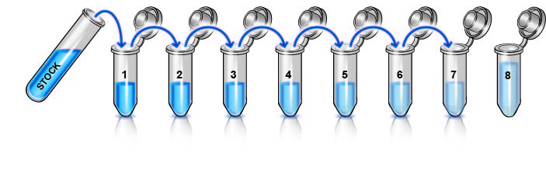
1,160
ng/mL
1100
ng/mL
550
ng/mL
275
ng/mL
137.5
ng/mL
68.8
ng/mL
34.4
ng/mL
17.2
ng/mL
291 µL

150 µL
µ

150 µL
µ

150 µL
µ

150 µL
µ

150 µL
µ

150 µL
µ

0
ng/mL

SAMPLE PREPARATION
TYPICAL SAMPLE DYNAMIC RANGE
Sample Type | Range
Human Plasma - Heparin | 1:5000-1:400
Human Plasma - EDTA | 15000-1:400
Human Plasma - Citrate | 1:5000-1:400
Human Serum | 1:5000-1:400
Human Urine | 3.1-50%
Human Cerebrospinal fluid | 5-80%

  - Plasma
Collect plasma using citrate, EDTA or heparin. Centrifuge samples at 2,000 x g for 10 minutes. Dilute samples into Sample Diluent NS and assay. Store un-diluted plasma samples at -20ºC or below for up to 3 months. Avoid repeated freeze-thaw cycles.
  - Serum
Samples should be collected into a serum separator tube. After clot formation, centrifuge samples at 2,000 x g for 10 minutes and collect serum. Dilute samples into Sample Diluent NS and assay. Store un-diluted serum at -20ºC or below. Avoid repeated freeze-thaw cycles.
  - Urine
Centrifuge urine at 2,000 x g for 10 minutes to remove debris. Collect supernatants, dilute in Sample Diluent NS and assay. Store un-diluted samples at -20°C or below. Avoid repeated freeze-thaw cycles.

  - Cerebrospinal Fluid
Dilute within the recommended sample range in Sample Diluent NS and assay. Store un-diluted samples at -20°C or below. Avoid repeated freeze-thaw cycles.

PLATE PREPARATION
- The 96 well plate strips included with this kit are supplied ready to use. It is not necessary to rinse the plate prior to adding reagents.
- Unused plate strips should be immediately returned to the foil pouch containing the desiccant pack, resealed and stored at 4°C.
- For each assay performed, a minimum of two wells must be used as the zero control.
- For statistical reasons, we recommend each sample should be assayed with a minimum of two replicates (duplicates).
- Differences in well absorbance or “edge effects” have not been observed with this assay.

ASSAY PROCEDURE

ASSAY PROCEDURE
- Equilibrate all materials and prepared reagents to room temperature prior to use.
- It is recommended to assay all standards, controls and samples in duplicate.
  - Prepare all reagents, working standards, and samples as directed in the previous sections.
  - Remove excess microplate strips from the plate frame, return them to the foil pouch containing the desiccant pack, reseal and return to 4ºC storage.
  - Add 50 µL of all sample or standard to appropriate wells.
  - Add 50 µL of the Antibody Cocktail to each well.
  - Seal the plate and incubate for 1 hour at room temperature on a plate shaker set to 400 rpm.
  - 13.6 Wash each well with 3 x 350 µL 1X Wash Buffer PT. Wash by aspirating or decanting from wells then dispensing 350 µL 1X Wash Buffer PT into each well. Wash Buffer PT should remain in wells for at least 10 seconds. Complete removal of liquid at each step is essential for good performance. After the last wash invert the plate and tap gently against clean paper towels to remove excess liquid.
  - Add 100 µL of TMB Development Solution to each well and incubate for 10 minutes in the dark on a plate shaker set to 400 rpm.
Given variability in laboratory environmental conditions, optimal incubation time may vary between 5 and 20 minutes.
Note: The addition of Stop Solution will change the color from blue to yellow and enhance the signal intensity about 3X. To avoid signal saturation, proceed to the next step before the high concentration of the standard reaches a blue color of O.D.600 equal to 1.0.
  - Add 100 µL of Stop Solution to each well. Shake plate on a plate shaker for 1 minute to mix. Record the OD at 450 nm. This is an endpoint reading.
Alternative to 13.7 – 13.8: Instead of the endpoint reading at 450 nm, record the development of TMB Substrate kinetically. Immediately after addition of TMB Development Solution begin recording the blue color development with elapsed time in the microplate reader prepared with the following settings:

Mode: | Kinetic
Wavelength: | 600 nm
Time: | up to 20 min
Interval: | 20 sec - 1 min
Shaking: | Shake between readings
Note that an endpoint reading can also be recorded at the completion of the kinetic read by adding 100 µL Stop Solution to each well and recording the OD at 450 nm.
  - Analyze the data as described below.

DATA ANALYSIS

CALCULATIONS
  - Calculate the average absorbance value for the blank control (zero) standards. Subtract the average blank control standard absorbance value from all other absorbance values.
  - Create a standard curve by plotting the average blank control subtracted absorbance value for each standard concentration (y-axis) against the target protein concentration (x-axis) of the standard. Use graphing software to draw the best smooth curve through these points to construct the standard curve.
Note: Most microplate reader software or graphing software will plot these values and fit a curve to the data. A four parameter curve fit (4PL) is often the best choice; however, other algorithms (e.g. linear, semi-log, log/log, 4 parameter logistic) can also be tested to determine if it provides a better curve fit to the standard values.
  - Determine the concentration of the target protein in the sample by interpolating the blank control subtracted absorbance values against the standard curve. Multiply the resulting value by the appropriate sample dilution factor, if used, to obtain the concentration of target protein in the sample.
  - Samples generating absorbance values greater than that of the highest standard should be further diluted and reanalyzed. Similarly, samples which measure at an absorbance values less than that of the lowest standard should be retested in a less dilute form.

TYPICAL DATA
TYPICAL STANDARD CURVE – Data provided for demonstration purposes only. A new standard curve must be generated for each assay performed.

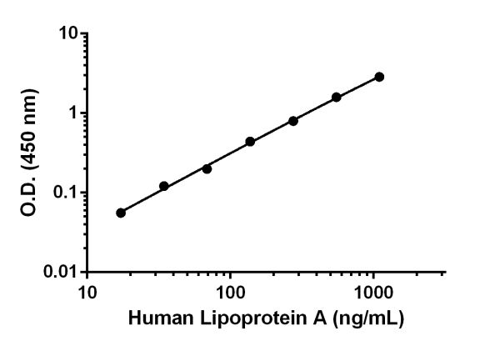

Standard Curve Measurements
Conc. | O.D. 450 nm |  | Mean
(ng/mL) | 1 | 2 | O.D.
0 | 0.045 | 0.046 | 0.046
17.2 | 0.107 | 0.098 | 0.103
34.4 | 0.166 | 0.169 | 0.168
68.8 | 0.247 | 0.245 | 0.246
137.5 | 0.508 | 0.467 | 0.488
275 | 0.883 | 0.808 | 0.845
550 | 1.534 | 1.749 | 1.641
1,100 | 2.873 | 2.924 | 2.899
Figure 1. Example of human Lipoprotein A standard curve in Sample Diluent NS. The Lipoprotein A standard curve was prepared as described in Section 10. Raw data values are shown in the table. Background-subtracted data values (mean +/- SD) are graphed.

TYPICAL SAMPLE VALUES
SENSITIVITY –
The calculated minimal detectable dose (MDD) is 2.5 ng/mL. The MDD was determined by calculating the mean of zero standard replicates (n=8) and adding 2 standard deviations then extrapolating the corresponding concentration.

RECOVERY –
Three concentrations of Lipoprotein A were spiked in duplicate to the indicated biological matrix to evaluate signal recovery in the working range of the assay.
Sample Type | Average %  Recovery | Range (%)
Human serum | 99 | 97-103
Human Plasma-Citrate | 102 | 99-105
Human Plasma-EDTA | 104 | 101-108
Human Plasma-Heparin | 104 | 100-107
Human Urine | 107 | 107-108
Human Cerebrospinal fluid | 109 | 108-110
RPMI 1640+10% fetal bovine serum | 102 | 99-105

LINEARITY OF DILUTION –
Linearity of dilution is determined based on interpolated values from the standard curve. Linearity of dilution defines a sample concentration interval in which interpolated target concentrations are directly proportional to sample dilution.
Native Lipoprotein A was measured in the following biological samples in a 2-fold dilution series. Sample dilutions are made in Sample Diluent NS.
Dilution  Factor | Interpolated value | 0.25%  Human Serum | 0.25%  Human Plasma (Citrate) | 0.125%  Human Plasma (EDTA) | 0.25%  Human Plasma (Heparin)
Undiluted | ng/mL | 785 | 726 | 656 | 380
Undiluted | % Expected value | 100 | 100 | 100 | 100
2 | ng/mL | 401 | 367 | 329 | 186
2 | % Expected value | 102 | 101 | 100 | 98
4 | ng/mL | 197 | 182 | 159 | 93
4 | % Expected value | 100  93 | 100 | 97 | 98
8 | ng/mL | 93 | 90 | 81 | 47
8 | % Expected value | 95 | 99 | 99 | 99
16 | ng/mL | 46 | 45 | 41 | 24
16 | % Expected value | 94 | 99 | 101 | 100

Dilution  Factor | Interpolated value | 50%  Urine | 80%  CSF
Undiluted | ng/mL | 258 | 101
Undiluted | % Expected value | 100 | 100
2 | ng/mL | 130 | 53
2 | % Expected value | 100 | 106
4 | ng/mL | 66 | 27
4 | % Expected value | 101  3 | 106
8 | ng/mL | 33 | NL
8 | % Expected value | 103
16 | ng/mL | 18 | NL
16 | % Expected value | 110
NL – Non-Linear

PRECISION –
Mean coefficient of variations of interpolated values of Lipoprotein A in 3 concentrations of normal human serum within the working range of the assay.
 | Intra-  Assay | Inter-  Assay
n= | 5 | 3
CV (%) | 1.8 | 2

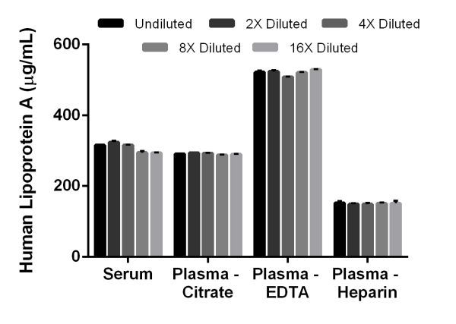

Figure 2. Interpolated concentrations of native Lipoprotein A in human serum and plasma samples. The concentrations of Lipoprotein A were measured in duplicate, interpolated from the Lipoprotein A standard curve, and corrected for sample dilution. Undiluted samples are as follows: serum 0.25%, plasma (citrate) 0.25%, plasma (heparin) 0.25% and plasma (EDTA) 0.125%. The interpolated dilution factor corrected values are plotted (mean +/- SD, n=2). The mean Lipoprotein A concentration was determined to be 309 μg/mL in serum, 291 μg/mL in plasma (citrate), 520 μg/mL in plasma (EDTA), and 150 μg/mL in plasma (Heparin).

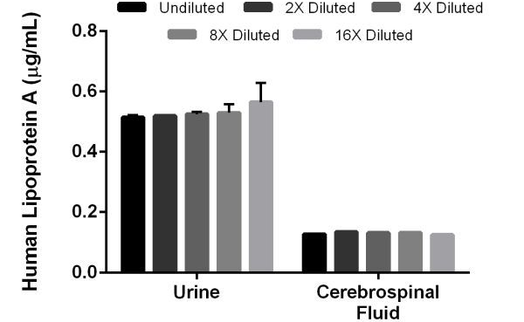
Figure 3. Interpolated concentrations of native Lipoprotein A in human urine and cerebrospinal fluid samples. The concentrations of Lipoprotein A were measured in duplicates, interpolated from the Lipoprotein A standard curves and corrected for sample dilution. The interpolated dilution factor corrected values are plotted (mean +/- SD, n=2). The mean Lipoprotein A concentration was determined to be 500 ng/mL in urine, and 130 ng/mL in cerebrospinal fluid.

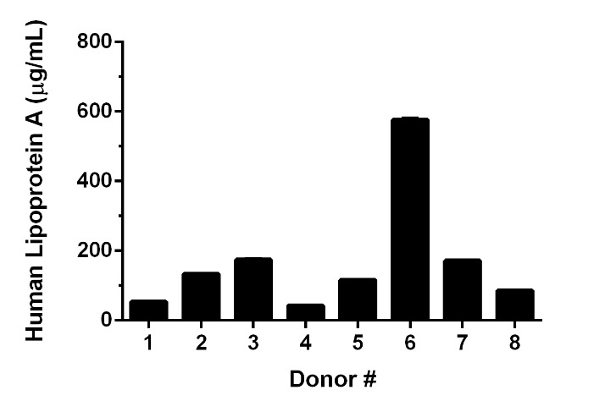

Figure 4. Serum from eight individual human male donors was measured in duplicate. Interpolated dilution factor corrected values are plotted (mean +/- SD, n=2). The mean Lipoprotein A concentration was determined to be 169 µg/mL with a range of 42 – 576 µg/mL.

ASSAY SPECIFICITY
This kit recognizes both native and recombinant human Lipoprotein A protein in serum, plasmas, urine, and cerebrospinal fluid samples only.

Cellular and tissue extract samples have not been tested with this kit.

SPECIES REACTIVITY
This kit recognizes human Lipoprotein A protein.

Other species reactivity was determined by measuring 0.125% serum samples of various species, interpolating the protein concentrations from the human standard curve, and expressing the interpolated concentrations as a percentage of the protein concentration in human serum assayed at the same dilution.

Reactivity < 3% was determined for the following species:
- Mouse
- Rat
- Cow

Please contact our Technical Support team for more information.

RESOURCES

TROUBLESHOOTING
Problem | Cause | Solution
Poor standard  curve | Inaccurate Pipetting | Check pipettes
Poor standard  curve | Improper standard  dilution | Prior to opening, briefly spin the stock standard tube and dissolve the powder thoroughly by gentle mixing
Low Signal | Incubation times too brief | Ensure sufficient incubation times; increase to 2 or 3 hour standard/sample incubation
Low Signal | Inadequate reagent volumes or improper dilution | Check pipettes and ensure correct preparation
Low Signal | Incubation times with TMB too brief | Ensure sufficient incubation time until blue color develops prior addition of Stop solution
Large CV | Plate is insufficiently washed | Review manual for proper wash technique. If using a plate washer, check all ports for obstructions.
Large CV | Contaminated wash buffer | Prepare fresh wash buffer
Low sensitivity | Improper storage of the ELISA kit | Store your reconstituted standards at -80°C, all other assay components 4°C. Keep TMB Development Solution protected from light.
Precipitate in Diluent | Precipitation and/or coagulation of components within the Diluent. | Precipitate can be removed by gently warming the Diluent to 37ºC.

NOTES

Technical Support

Copyright © 2024 Abcam, All Rights Reserved. The Abcam logo is a registered trademark. All information / detail is correct at time of going to print.
For all technical or commercial enquiries please go to:
www.abcam.com/contactus
www.abcam.cn/contactus (China)
www.abcam.co.jp/contactus (Japan)

