Version 2 Last updated 18 November 2021

ab219633

Human Caspase-1 SimpleStep ELISA® Kit

For the quantitative measurement of Caspase-1 in human cell culture supernatant, cell and tissue extract samples.

This product is for research use only and is not intended for diagnostic use.

Table of Contents
1. Overview 1
2. Protocol Summary 2
3. Precautions 3
4. Storage and Stability 3
5. Limitations 4
6. Materials Supplied 4
7. Materials Required, Not Supplied 5
8. Technical Hints 5
9. Reagent Preparation 7
10. Standard Preparation 8
11. Sample Preparation 9
12. Plate Preparation 11
13. Assay Procedure 12
14. Calculations 14
15. Typical Data 15
16. Typical Sample Values 17
17. Assay Specificity 22
18. Species Reactivity 23
19. Troubleshooting 24
20. Notes 25

- Overview
Caspase-1 in vitro SimpleStep ELISA® (Enzyme-Linked Immunosorbent Assay) kit is designed for the quantitative measurement of Caspase-1 protein in human cell culture supernatant, cell and tissue extract samples.

The SimpleStep ELISA® employs an affinity tag labeled capture antibody and a reporter conjugated detector antibody which immunocapture the sample analyte in solution. This entire complex (capture antibody/analyte/detector antibody) is in turn immobilized via immunoaffinity of an anti-tag antibody coating the well. To perform the assay, samples or standards are added to the wells, followed by the antibody mix. After incubation, the wells are washed to remove unbound material. TMB Development Solution is added and during incubation is catalyzed by HRP, generating blue coloration. This reaction is then stopped by addition of Stop Solution completing any color change from blue to yellow. Signal is generated proportionally to the amount of bound analyte and the intensity is measured at 450 nm. Optionally, instead of the endpoint reading, development of TMB can be recorded kinetically at 600 nm.

Caspase-1 is a thiol protease that cleaves IL-1 beta precursor releasing the mature cytokine which is involved in a variety of inflammatory processes. Caspase-1 is part of the inflammasome complex. It is important for defense against pathogens. Caspase-1 also cleaves and activates sterol regulatory element binding proteins (SREBPs). Caspase-1 can also promote apoptosis as it is part of caspase cascade.

- Protocol Summary

Prepare all reagents, samples, and standards as instructed

Add 50 µL standard or sample to appropriate wells

Add 50 µL Antibody Cocktail to all wells

Incubate at room temperature for 1 hour

Aspirate and wash each well three times with 350 µL 1X Wash Buffer PT

Add 100 µL TMB Development Solution to each well and incubate for 10 minutes.

Add 100 µL Stop Solution and read OD at 450 nm

- Precautions
Please read these instructions carefully prior to beginning the assay.
- All kit components have been formulated and quality control tested to function successfully as a kit.
- We understand that, occasionally, experimental protocols might need to be modified to meet unique experimental circumstances. However, we cannot guarantee the performance of the product outside the conditions detailed in this protocol booklet.
- Reagents should be treated as possible mutagens and should be handle with care and disposed of properly. Please review the Safety Datasheet (SDS) provided with the product for information on the specific components.
- Observe good laboratory practices. Gloves, lab coat, and protective eyewear should always be worn. Never pipet by mouth. Do not eat, drink or smoke in the laboratory areas.
- All biological materials should be treated as potentially hazardous and handled as such. They should be disposed of in accordance with established safety procedures.

- Storage and Stability
Store kit at +4°C immediately upon receipt. Kit has a storage time of 1 year from receipt, providing components have not been reconstituted.
Refer to list of materials supplied for storage conditions of individual components.

- Limitations
- Assay kit intended for research use only. Not for use in diagnostic procedures.
- Do not mix or substitute reagents or materials from other kit lots or vendors. Kits are QC tested as a set of components and performance cannot be guaranteed if utilized separately or substituted.

- Materials Supplied
Item | Quantity | Storage Condition
Human Caspase-1 Capture Antibody 10X | 600 µL | +4ºC
Human Caspase-1 Detector Antibody 10X | 600 µL | +4ºC
Human Caspase-1 Lyophilized Recombinant Protein | 2 Vials | +4ºC
Antibody Diluent 5BR | 6 mL | +4ºC
Wash Buffer PT 10X | 20 mL | +4ºC
Cell Extraction Buffer PTR 5X | 10 mL | +4ºC
Cell Extraction Enhancer Solution 50X | 1 mL | +4ºC
TMB Development Solution | 12 mL | +4ºC
Stop Solution | 12 mL | +4ºC
Sample Diluent NS | 50 mL | +4ºC
Anti-tag coated microplate (12 x 8 well strips) | 96 Wells | +4ºC
Plate Seal | 1 | +4ºC

- Materials Required, Not Supplied
These materials are not included in the kit, but will be required to successfully perform this assay:
- Microplate reader capable of measuring absorbance at 450 or 600 nm.
- Method for determining protein concentration (BCA assay recommended).
- Deionized water.
- Multi- and single-channel pipettes.
- Tubes for standard dilution.
- Plate shaker for all incubation steps.
- Optional: Phenylmethylsulfonyl Fluoride (PMSF) (or other protease inhibitors).

- Technical Hints
- Samples generating values higher than the highest standard should be further diluted in the appropriate sample dilution buffers.
- Avoid foaming or bubbles when mixing or reconstituting components.
- Avoid cross contamination of samples or reagents by changing tips between sample, standard and reagent additions.
- Ensure plates are properly sealed or covered during incubation steps.
- Complete removal of all solutions and buffers during wash steps is necessary to minimize background.
- As a guide, typical ranges of sample concentration for commonly used sample types are shown below in Sample Preparation (section 11).
- All samples should be mixed thoroughly and gently.
- Avoid multiple freeze/thaw of samples.
- Incubate ELISA plates on a plate shaker during all incubation steps.
- When generating positive control samples, it is advisable to change pipette tips after each step.
- The provided Cell Extraction Enhancer Solution 50X may precipitate when stored at + 4ºC. To dissolve, warm briefly at + 37ºC and mix gently. The Cell Extraction Enhancer Solution 50X can be stored at room temperature to avoid precipitation.
- To avoid high background always add samples or standards to the well before the addition of the antibody cocktail.
- This kit is sold based on number of tests. A ‘test’ simply refers to a single assay well. The number of wells that contain sample, control or standard will vary by product. Review the protocol completely to confirm this kit meets your requirements. Please contact our Technical Support staff with any questions.

- Reagent Preparation
- Equilibrate all reagents to room temperature (18-25°C) prior to use. The kit contains enough reagents for 96 wells. The sample volumes below are sufficient for 48 wells (6 x 8-well strips); adjust volumes as needed for the number of strips in your experiment.
- Prepare only as much reagent as is needed on the day of the experiment. Capture and Detector Antibodies have only been tested for stability in the provided 10X formulations.

1X Cell Extraction Buffer PTR (For cell and tissue extracts only):
Prepare 1X Cell Extraction Buffer PTR by diluting Cell Extraction Buffer PTR 5X and 50X Cell Extraction Enhancer Solution to 1X with deionized water. To make 10 mL 1X Cell Extraction Buffer PTR combine 7.8 mL deionized water, 2 mL Cell Extraction Buffer PTR 5X and 200 µL Cell Extraction Enhancer Solution 50X. Mix thoroughly and gently. If required protease inhibitors can be added.
Alternative – Enhancer may be added to 1X Cell Extraction Buffer PTR after extraction of cells or tissue. Refer to note in the Troubleshooting section.
1X Wash Buffer PT:
Prepare 1X Wash Buffer PT by diluting Wash Buffer PT 10X with deionized water. To make 50 mL 1X Wash Buffer PT combine 5 mL Wash Buffer PT 10X with 45 mL deionized water. Mix thoroughly and gently.
Antibody Cocktail:
Prepare Antibody Cocktail by diluting the capture and detector antibodies in Antibody Diluent 5BR. To make 3 mL of the Antibody Cocktail combine 300 µL 10X Capture Antibody and 300 µL 10X Detector Antibody with 2.4 mL Antibody Diluent 5BR. Mix thoroughly and gently.
- Standard Preparation
- Always prepare a fresh set of standards for every use.
- Discard working standard dilutions after use as they do not store well.
- The following section describes the preparation of a standard curve for duplicate measurements (recommended).
- The protein standard included in this kit is the p20 subunit of human Caspase-1.

  - IMPORTANT: If the protein standard vial has a volume identified on the label, reconstitute the Caspase-1 lyophilized protein standard by adding that volume of Diluent indicated on the label. Alternatively, if the vial has a mass identified, reconstitute the Caspase-1 lyophilized protein standard by adding 500 µL Diluent.
For cell culture supernatant samples measurements, reconstitute the Caspase-1 lyophilized protein standard by adding Sample Diluent NS.
For cell and tissue extract samples measurements, reconstitute the Caspase-1 lyophilized protein standard by adding 1X Cell Extraction Buffer PTR.
Hold at room temperature for 10 minutes and mix thoroughly and gently. This is the 6,000 pg/mL Stock Standard Solution.
  - Label eight tubes, Standards 1– 8.
  - Add 175 μL of appropriate diluent (see step 10.1) into tube number 1 and 150 μL of appropriate diluent into numbers 2-8.
  - Use the Stock Standard to prepare the following dilution series. Standard #8 contains no protein and is the Blank control:

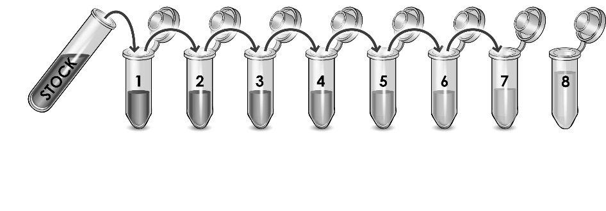
6,000
pg/mL

2,500
pg/mL

1,250
pg/mL

625
pg/mL

312.5
pg/mL

156.25
pg/mL

39.06
pg/mL

125 µL

78.13
pg/mL

150 µL
µ

150 µL
µ

150 µL
µ

150 µL
µ

150 µL
µ

150 µL
µ

0
pg/mL

- Sample Preparation
Typical Sample Dynamic Range
Sample Type | Recommended Dilution
THP-1 Cell Extract | 3.13 – 50 µg/mL
BxPC-3 Cell Extract | 15.63 – 250 µg/mL
Thyroid Tissue Extract | > 250 µg/mL
LPS Stimulated THP-1 Cell Culture Supernatant (8 hours) | 12.5 – 100%
Unstimulated THP-1 Cell Culture Supernatant (8 hours) | Neat
PHA-M Stimulated PBMC Cell Culture Supernatant (2 days) | 25 – 100%
Unstimulated PBMC Cell Culture Supernatant (2 days) | Neat
Cell Culture Supernatants:
Centrifuge cell culture media at 2,000 x g for 10 minutes to remove debris. Collect supernatants and assay or dilute samples into Sample Diluent NS and assay. Store un-diluted samples at -20°C or below. Avoid repeated freeze-thaw cycles.

Preparation of extracts from cell pellets:
    - Collect non-adherent cells by centrifugation or scrape to collect adherent cells from the culture flask. Typical centrifugation conditions for cells are 500 x g for 5 minutes at 4ºC.
    - Rinse cells twice with PBS.
    - Solubilize pellet at 2x10⁷ cell/mL in chilled 1X Cell Extraction Buffer PTR.
    - Incubate on ice for 20 minutes.
    - Centrifuge at 18,000 x g for 20 minutes at 4°C.
    - Transfer the supernatants into clean tubes and discard the pellets.
    - Assay samples immediately or aliquot and store at -80°C. The sample protein concentration in the extract may be quantified using a protein assay.
    - Dilute samples to desired concentration in 1X Cell Extraction Buffer PTR.
Preparation of extracts from adherent cells by direct lysis (alternative protocol):
    - Remove growth media and rinse adherent cells 2 times in PBS.
    - Solubilize the cells by addition of chilled 1X Cell Extraction Buffer PTR directly to the plate (use 750 µL - 1.5 mL 1X Cell Extraction Buffer PTR per confluent 15 cm diameter plate).
    - Scrape the cells into a microfuge tube and incubate the lysate on ice for 15 minutes.
    - Centrifuge at 18,000 x g for 20 minutes at 4°C.
    - Transfer the supernatants into clean tubes and discard the pellets.
    - Assay samples immediately or aliquot and store at -80°C. The sample protein concentration in the extract may be quantified using a protein assay.
    - Dilute samples to desired concentration in 1X Cell Extraction Buffer PTR.
Preparation of extracts from tissue homogenates:
    - Tissue lysates are typically prepared by homogenization of tissue that is first minced and thoroughly rinsed in PBS to remove blood (dounce homogenizer recommended).
    - Homogenize 100 to 200 mg of wet tissue in 500 µL – 1 mL of chilled 1X Cell Extraction Buffer PTR. For lower amounts of tissue adjust volumes accordingly.
    - Incubate on ice for 20 minutes.
    - Centrifuge at 18,000 x g for 20 minutes at 4°C.
    - Transfer the supernatants into clean tubes and discard the pellets.
    - Assay samples immediately or aliquot and store at -80°C. The sample protein concentration in the extract may be quantified using a protein assay.
    - Dilute samples to desired concentration in 1X Cell Extraction Buffer PTR.

- Plate Preparation
- The 96 well plate strips included with this kit are supplied ready to use. It is not necessary to rinse the plate prior to adding reagents.
- Unused plate strips should be immediately returned to the foil pouch containing the desiccant pack, resealed and stored at 4°C.
- For each assay performed, a minimum of two wells must be used as the zero control.
- For statistical reasons, we recommend each sample should be assayed with a minimum of two replicates (duplicates).
- Differences in well absorbance or “edge effects” have not been observed with this assay.

- Assay Procedure
- Equilibrate all materials and prepared reagents to room temperature prior to use.
- We recommend that you assay all standards, controls and samples in duplicate.

  - Prepare all reagents, working standards, and samples as directed in the previous sections.
  - Remove excess microplate strips from the plate frame, return them to the foil pouch containing the desiccant pack, reseal and return to 4ºC storage.
  - Add 50 µL of all sample or standard to appropriate wells.
  - Add 50 µL of the Antibody Cocktail to each well.
  - Seal the plate and incubate for 1 hour at room temperature on a plate shaker set to 400 rpm.
  - Wash each well with 3 x 350 µL 1X Wash Buffer PT. Wash by aspirating or decanting from wells then dispensing 350 µL 1X Wash Buffer PT into each well. Wash Buffer PT should remain in wells for at least 10 seconds. Complete removal of liquid at each step is essential for good performance. After the last wash invert the plate and tap gently against clean paper towels to remove excess liquid.
  - Add 100 µL of TMB Development Solution to each well and incubate for 10 minutes in the dark on a plate shaker set to 400 rpm.
Given variability in laboratory environmental conditions, optimal incubation time may vary between 5 and 20 minutes. Note: The addition of Stop Solution will change the color from blue to yellow and enhance the signal intensity about 3X. To avoid signal saturation, proceed to the next step before the high concentration of the standard reaches a blue color of O.D.600 equal to 1.0.
  - Add 100 µL of Stop Solution to each well. Shake plate on a plate shaker for 1 minute to mix. Record the OD at 450 nm. This is an endpoint reading.
  - Alternative to 13.7 – 13.8: Instead of the endpoint reading at 450 nm, record the development of TMB Substrate kinetically. Immediately after addition of TMB Development Solution begin recording the blue color development with elapsed time in the microplate reader prepared with the following settings:

Mode | Kinetic
Wavelength: | 600 nm
Time: | up to 20 min
Interval: | 20 sec - 1 min
Shaking: | Shake between readings
- Note: that an endpoint reading can also be recorded at the completion of the kinetic read by adding 100 µL Stop Solution to each well and recording the OD at 450 nm.
  - Analyze the data as described below.

- Calculations
  - Calculate the average absorbance value for the blank control (zero) standards. Subtract the average blank control standard absorbance value from all other absorbance values.
  - Create a standard curve by plotting the average blank control subtracted absorbance value for each standard concentration (y-axis) against the target protein concentration (x-axis) of the standard. Use graphing software to draw the best smooth curve through these points to construct the standard curve.
- Note: Most microplate reader software or graphing software will plot these values and fit a curve to the data. A four parameter curve fit (4PL) is often the best choice; however, other algorithms (e.g. linear, semi-log, log/log, 4 parameter logistic) can also be tested to determine if it provides a better curve fit to the standard values.
  - Determine the concentration of the target protein in the sample by interpolating the blank control subtracted absorbance values against the standard curve. Multiply the resulting value by the appropriate sample dilution factor, if used, to obtain the concentration of target protein in the sample.
  - Samples generating absorbance values greater than that of the highest standard should be further diluted and reanalyzed. Similarly, samples which measure at an absorbance values less than that of the lowest standard should be retested in a less dilute form.

- Typical Data
Typical standard curve – data provided for demonstration purposes only. A new standard curve must be generated for each assay performed.

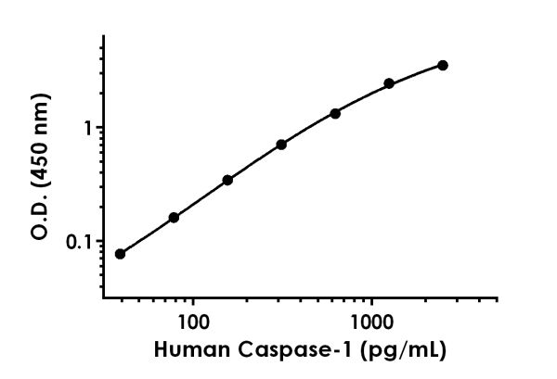

Standard Curve Measurements
Concentration (pg/mL) | O.D 450 nm |  | Mean  O.D
Concentration (pg/mL) | 1 | 2 | Mean  O.D
0 | 0.082 | 0.088 | 0.085
39.06 | 0.161 | 0.164 | 0.162
78.13 | 0.243 | 0.248 | 0.246
156.25 | 0.431 | 0.426 | 0.428
312.5 | 0.834 | 0.752 | 0.793
625 | 1.402 | 1.412 | 1.407
1,250 | 2.495 | 2.555 | 2.525
2,500 | 3.617 | 3.595 | 3.606
Figure 1. Example of human Caspase-1 standard curve in Sample Diluent NS. The Caspase-1 standard curve was prepared as described in Section 10. Raw data values are shown in the table. Background-subtracted data values (mean +/- SD) are graphed.

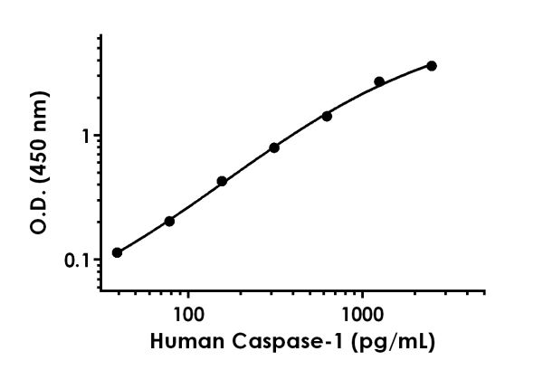

Standard Curve Measurements
Concentration (pg/mL) | O.D 450 nm |  | Mean  O.D
Concentration (pg/mL) | 1 | 2 | Mean  O.D
0 | 0.117 | 0.110 | 0.114
39.06 | 0.229 | 0.226 | 0.228
78.13 | 0.306 | 0.329 | 0.317
156.25 | 0.539 | 0.544 | 0.541
312.5 | 0.862 | 0.950 | 0.906
625 | 1.521 | 1.538 | 1.529
1250 | 2.761 | 2.847 | 2.804
2500 | 3.705 | 3.726 | 3.715
Figure 2. Example of human Caspase-1 standard curve in 1X Cell Extraction Buffer PTR. The Caspase-1 standard curve was prepared as described in Section 10. Raw data values are shown in the table. Background-subtracted data values (mean +/- SD) are graphed.
- Typical Sample Values
SENSITIVITY –
The MDD was determined by calculating the mean of zero standard replicates and adding 2 standard deviations then extrapolating the corresponding concentration.
Sample Diluent Buffer | n= | Minimal Detectable Dose
Sample Diluent NS | 24 | 16.1 pg/mL
1X Cell Extraction Buffer PTR | 17 | 5.5 pg/mL

RECOVERY –
Three concentrations of recombinant Caspase-1 were spiked in duplicate to the indicated biological matrix to evaluate signal recovery in the working range of the assay.
Sample Type | Average % Recovery | Range (%)
20 µg/mL THP-1 Cell Extract | 95 | 89 - 99
50 µg/mL BxPC-3 Cell Extract | 94 | 87 - 100
250 µg/mL Thyroid Tissue Extract | 86 | 83 - 90
100% Cell Culture Media (RPMI + 10% FBS) | 103 | 101 - 105

Linearity of Dilution
Linearity of dilution is determined based on interpolated values from the standard curve. Linearity of dilution defines a sample concentration interval in which interpolated target concentrations are directly proportional to sample dilution.

Native Caspase-1 was measured in the following biological samples in a 2-fold dilution series. Sample dilutions are made in 1X Cell Extraction Buffer PTR.

Dilution  Factor | Interpolated value | 50 µg/mL  LPS (8hr) THP-1 Cell Extract | 50 µg/mL  Mock (8hr) THP-1 Cell Extract | 50 µg/mLUntreated THP-1 Cell Extract | 250 µg/mL  BxPC-3 Cell Extract | 500 µg/mL  Thyroid Tissue Extract
Undiluted | pg/mL | 1676 | 1795 | 1987 | 2203 | 121.9
Undiluted | % Expected value | 100 | 100 | 100 | 100 | 100
2 | pg/mL | 780.4 | 814.7 | 908.3 | 1293 | 67.79
2 | % Expected value | 93 | 91 | 91 | 117 | 111
4 | pg/mL | 362.0 | 379.3 | 407.2 | 537.9 | ND
4 | % Expected value | 86 | 85 | 82 | 98 | ND
8 | pg/mL | 177.4 | 188.3 | 202.4 | 275.8 | ND
8 | % Expected value | 85 | 84 | 81 | 100 | ND
16 | pg/mL | 86.26 | 92.68 | 101.6 | 140.4 | ND
16 | % Expected value | 82 | 83 | 82 | 102 | ND
ND – Not detectable. Indicates interpolated values with concentrations below the concentration of the 7th point of the standard curve.

Native Caspase-1 was measured in the following biological samples in a 2-fold dilution series. Sample dilutions are made in Sample Diluent NS.

Dilution  Factor | Interpolated value | 100%  LPS Treated (8 hours) THP-1 Cell Culture Supernatant | 100%  PHA-M Treated (8 hours) PBMC Cell Culture Supernatant
Undiluted | pg/mL | 559.4 | 202.2
Undiluted | % Expected value | 100 | 100
2 | pg/mL | 289.5 | 102.4
2 | % Expected value | 104 | 101
4 | pg/mL | 141.3 | 51.01
4 | % Expected value | 101 | 101
8 | pg/mL | 61.48 | ND
8 | % Expected value | 88 | ND
16 | pg/mL | ND | ND
16 | % Expected value | ND | ND
ND – Not detectable. Indicates interpolated values with concentrations below the concentration of the 7th point of the standard curve.

PRECISION –
Mean coefficient of variations of interpolated values from three concentrations of THP-1 cell extract within the working range of the assay.
 | Intra-  Assay | Inter-  Assay
n = | 3 | 5
CV(%) | 4.4 | 6.1

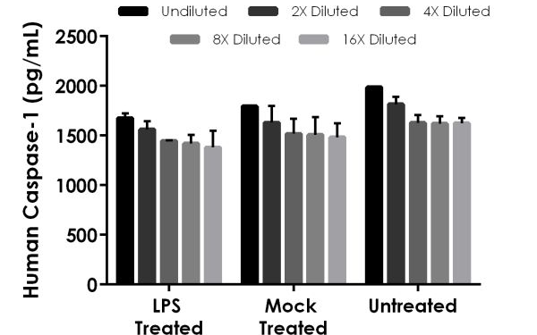

Figure 3. Interpolated concentrations of native Caspase-1 in human LPS treated (8 hours), mock treated (8 hours), and untreated THP-1 cell extract samples based on a 50 μg/mL extract load. The concentrations of Caspase-1 were measured in duplicate and interpolated from the Caspase-1 standard curve and corrected for sample dilution. The interpolated dilution factor corrected values are plotted (mean +/- SD, n=2). The mean Caspase-1 concentration was determined to be 1497 pg/mL in LPS treated (8 hours) THP-1 cell extract, 1586 pg/mL in mock treated (8 hours) THP-1 cell extract, and 1735 pg/mL in untreated THP-1 cell extract.

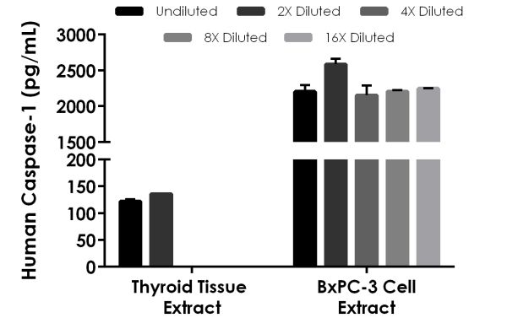

Figure 4. Interpolated concentrations of native Caspase-1 in human thyroid tissue extract based on a 500 μg/mL extract load and BxPC-3 cell extract based on a 250 μg/mL extract load. The concentrations of Caspase-1 were measured in duplicate and interpolated from the Caspase-1 standard curve and corrected for sample dilution. The interpolated dilution factor corrected values are plotted (mean +/- SD, n=2). The mean Caspase-1 concentration was determined to be 128.7 pg/mL in thyroid tissue extract and 2279 pg/mL in BxPC-3 cell extract.
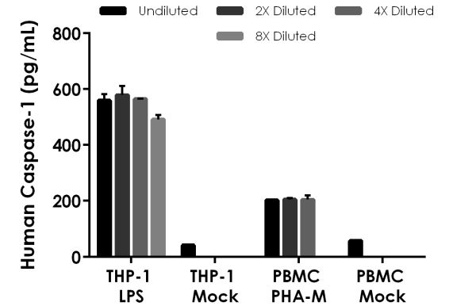

Figure 5. Interpolated concentrations of native Caspase-1 in human cell culture supernatant samples. The concentrations of Caspase-1 were measured in duplicates, interpolated from the Caspase-1 standard curves and corrected for sample dilution. Undiluted samples are as follows: THP-1 LPS neat, THP-1 mock neat, PBMC PHA-M neat, PBMC mock neat. The interpolated dilution factor corrected values are plotted (mean +/- SD, n=2). The mean Caspase-1 concentration was determined to be 549 pg/mL in LPS treated (8 hours) THP-1 cell culture supernatant, 41.8 pg/mL in mock treated (8 hours) THP-1 cell culture supernatant, 204 pg/mL PHA-M treated (2 days) PBMC cell culture supernatant, and 57.3 pg/mL in mock treated (2 days) PBMC cell culture supernatant.

- Assay Specificity
This kit recognizes both native and recombinant human precursor and p20 subunit of Caspase-1 protein in cell culture supernatant, cell and tissue extract samples only.
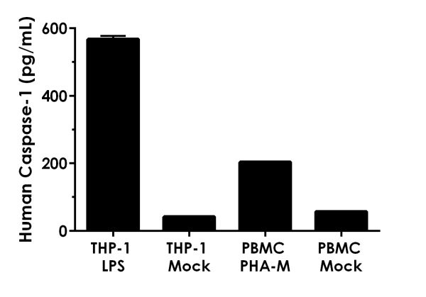

Figure 6. Comparison of Caspase-1 in unstimulated and LPS stimulated THP-1 cell supernatants and unstimulated and PHA-M stimulated PBMC cell supernatants. THP-1 cells were differentiated overnight with 80nM TPA then cultured for 8 hours in the presence or absence of 1 µg/mL LPS. Human PBMC cells were cultured in the absence or presence of 1.5% PHA-M for 2 days. The concentrations of Caspase-1 were measured in three different dilutions of the supernatant samples in duplicates and interpolated from the Caspase-1 standard curve. The interpolated values are plotted (mean +/- SD, n=2). The mean Caspase-1 concentration was determined to be 549 pg/mL in LPS stimulated THP-1 cell supernatant, 41.8 pg/mL in unstimulated THP-1 cell supernatant, 204 pg/mL in PHA-M stimulated PBMC cell supernatant, 57.3 pg/mL in unstimulated PBMC supernatant, and undetectable in media (not shown).

Urine, saliva, and milk samples have not been tested with this kit.
Serum and plasma samples are not compatible with this kit.

- Species Reactivity
This kit recognizes human Caspase-1 protein.

Other species reactivity was not determined.

Please contact our Technical Support team for more information.
- Troubleshooting
Problem | Reason | Solution
Difficulty pipetting lysate; viscous lysate. | Genomic DNA solubilized | Prepare 1X Cell Extraction Buffer PTR (without enhancer). Add enhancer to lysate after extraction.
Poor standard  curve | Inaccurate Pipetting | Check pipettes
Poor standard  curve | Improper standard  dilution | Prior to opening, briefly spin the stock standard tube and dissolve the powder thoroughly by gentle mixing
Low Signal | Incubation times too brief | Ensure sufficient incubation times; increase to 2 or 3 hour standard/sample incubation
Low Signal | Inadequate reagent volumes or improper dilution | Check pipettes and ensure correct preparation
Low Signal | Incubation times with TMB too brief | Ensure sufficient incubation time until blue color develops prior addition of Stop solution
Large CV | Plate is insufficiently washed | Review manual for proper wash technique. If using a plate washer, check all ports for obstructions.
Large CV | Contaminated wash buffer | Prepare fresh wash buffer
Low sensitivity | Improper storage of the ELISA kit | Store your reconstituted standards at -80°C, all other assay components 4°C. Keep TMB Development Solution solution protected from light.
Precipitate in Diluent | Precipitation and/or coagulation of components within the Diluent. | Precipitate can be removed by gently warming the Diluent to 37ºC.

Technical Support
Copyright © 2020 Abcam, All Rights Reserved. The Abcam logo is a registered trademark. All information / detail is correct at time of going to print.
For all technical or commercial enquiries please go to:
www.abcam.com/contactus
www.abcam.cn/contactus (China)
www.abcam.co.jp/contactus (Japan)

