Version 2e Last updated 8 February 2024

ab219801

EdU Proliferation Kit (iFluor 488)

For the measurement of DNA synthesis in live cells by flow cytometry or fluorescence microscopy.

This product is for research use only and is not intended for diagnostic use.

Table of Contents
1. Overview 1
2. Protocol Summary – Flow Cytometry 2
3. Protocol Summary – Fluorescence microscopy 3
4. Precautions 4
5. Storage and Stability 4
6. Limitations 5
7. Materials Supplied 5
8. Materials Required, Not Supplied 6
9. Technical Hints 7
10. Reagent Preparation 8
11. Assay Procedure – Flow cytometry 10
12. Assay Procedure – Fluorescence microscopy 13
13. Data Analysis 16
14. Typical data 17
15. FAQs 19
16. Notes 20

- Overview
EdU Proliferation Kit (iFluor 488) (ab219801) provides a sensitive and robust method to detect and quantify cell proliferation in live cells using flow cytometry or fluorescence microscopy. The iFluor 488 dye (Ex/Em = 491/520 nm) has spectral properties almost identical to those of FITC and other alternative green fluorophores available in the market. This kit provides enough reagents to perform 50 flow cytometry tests or 50 microscopy tests (for 18 x 18 mm coverslips) or 200 microscopy tests (adapted for 96-well plate format).

The most accurate method to measure DNA proliferation is by directly measuring DNA synthesis. The most common method used nowadays is the antibody-based detection of the nucleoside analog bromo-deoxyuridine (BrdU). EdU (5-ethynyl-2’-deoxyuridine) is a thymidine analog that is incorporated into the newly synthesized DNA. EdU can be covalently crosslinked with a fluorescent azide (such as iFluor-488), which is small enough to diffuse freely through native tissues and DNA (figure 1). Since EdU detection uses ‘click’ chemistry, and does not require DNA denaturation or addition of a detection antibody like BrdU-detection, the EdU proliferation assay is much quicker and easier to perform.

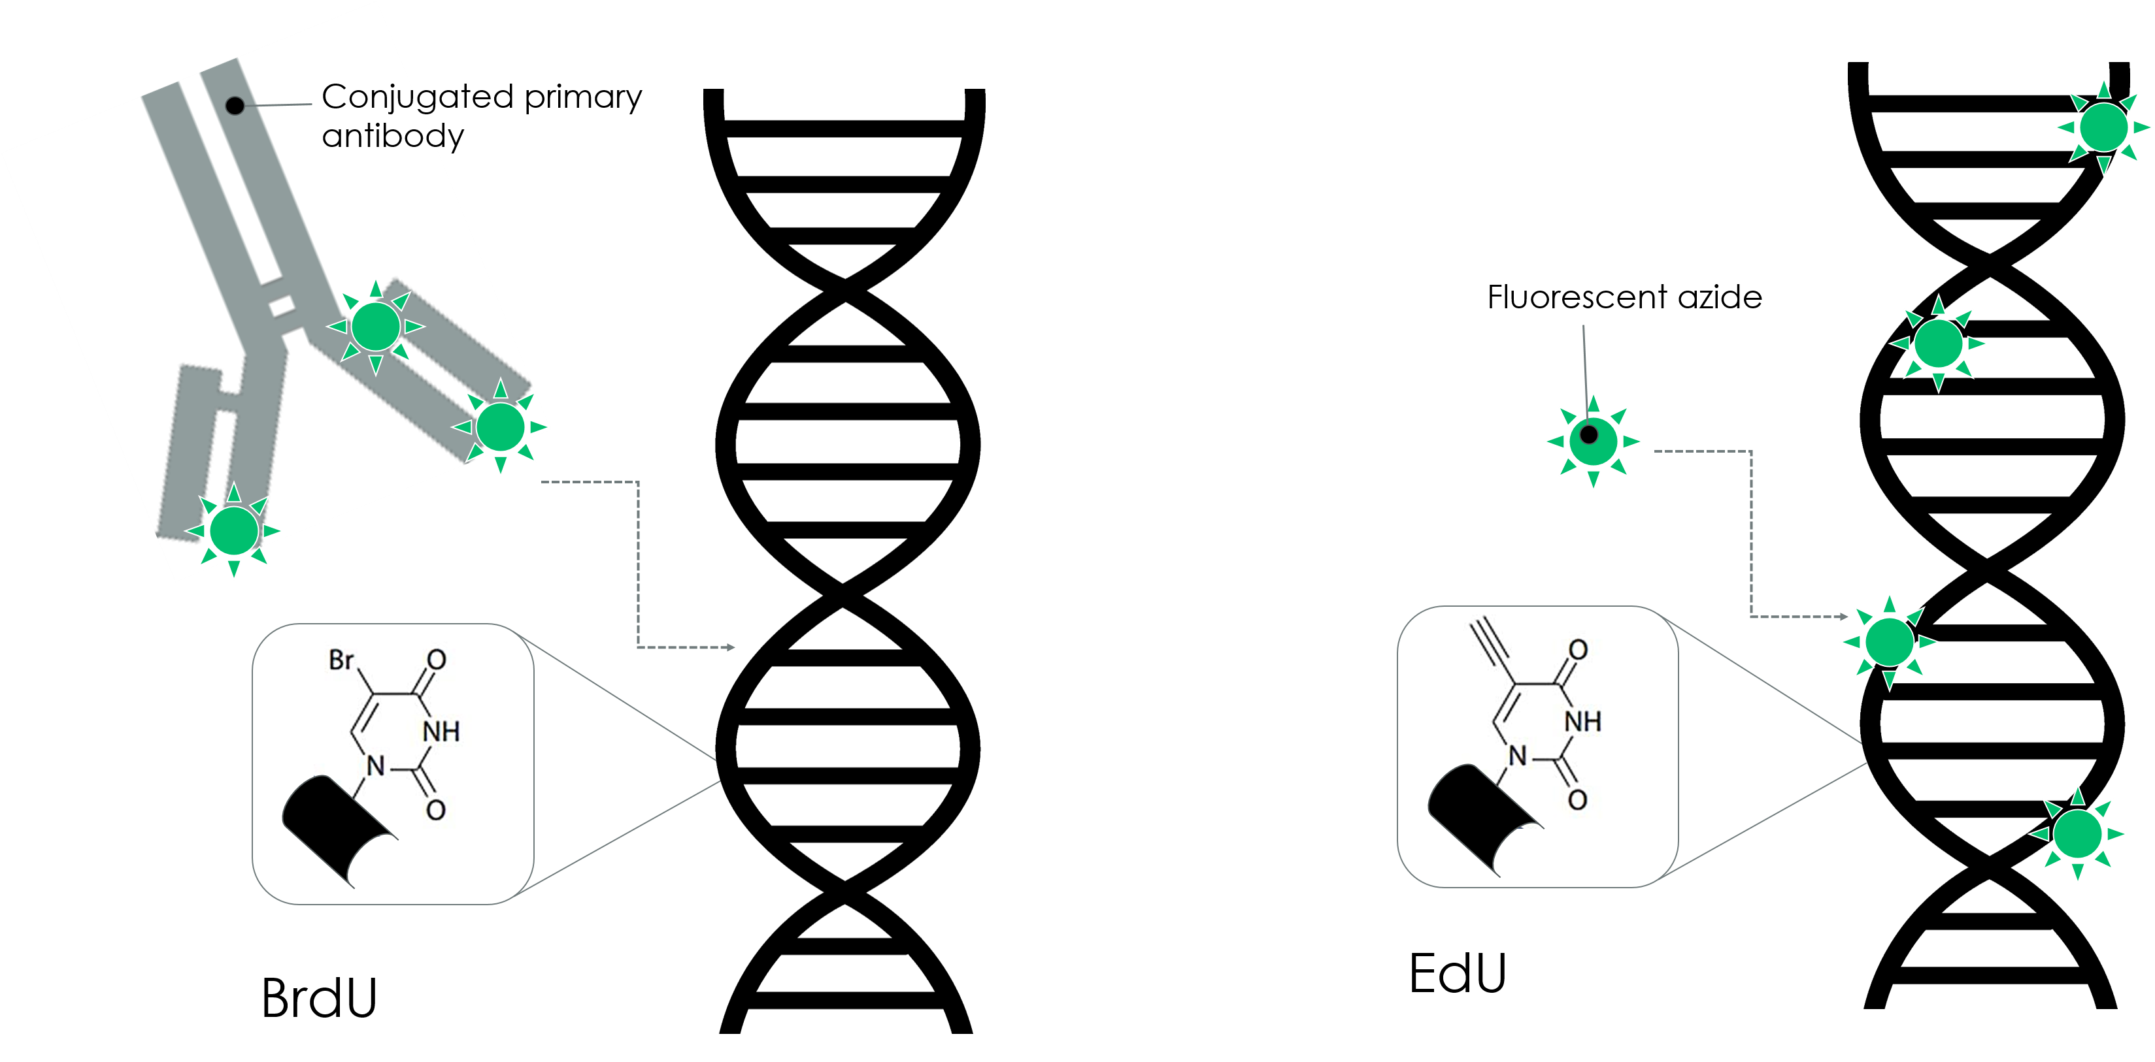
Figure 1. BrdU assays (left) require DNA denaturation in order to allow an anti-BrdU primary antibody access to the BrdU molecule. EdU assays (right) rely on ‘click’ chemistry, in which the fluorescent azide can freely bind the EdU molecule.
- Protocol Summary – Flow Cytometry

Grow/prepare cells

Incubate cells with EdU

Harvest cells

(Optional) Treat cells with antibodies to cell surface antigens

Fix and permeabilize cells

Detection of EdU

Analyze cells by flow cytometry (Ex/Em = 491/520 nm)

- Protocol Summary – Fluorescence microscopy

Plate cells

Incubate cells with EdU

Fix and permeabilize cells

Detection of EdU

(Optional) Stain cells with antibodies
and/or nuclear stain

Image cells by fluorescence microscopy (Ex/Em = 491/520 nm)

- Precautions
Please read these instructions carefully prior to beginning the assay.
- All kit components have been formulated and quality control tested to function successfully as a kit.
- We understand that, occasionally, experimental protocols might need to be modified to meet unique experimental circumstances. However, we cannot guarantee the performance of the product outside the conditions detailed in this protocol booklet.
- Reagents should be treated as possible mutagens and should be handled with care and disposed of properly. Please review the Safety Datasheet (SDS) provided with the product for information on the specific components.
- Observe good laboratory practices. Gloves, lab coat, and protective eyewear should always be worn. Never pipet by mouth. Do not eat, drink or smoke in the laboratory areas.
- All biological materials should be treated as potentially hazardous and handled as such. They should be disposed of in accordance with established safety procedures.
- Storage and Stability
Store kit at 4°C (store EdU and iFluor 488 azide at - 20°C) in the dark immediately upon receipt. Kit has a storage time of 1 year from receipt, providing components have not been reconstituted.
Refer to list of materials supplied for storage conditions of individual components. Observe the storage conditions for individual prepared components in the Materials Supplied section.
Aliquot components in working volumes before storing at the recommended temperature.

- Limitations
- Assay kit intended for research use only. Not for use in diagnostic procedures.
- Do not mix or substitute reagents or materials from other kit lots or vendors. Kits are QC tested as a set of components and performance cannot be guaranteed if utilized separately or substituted.
- Materials Supplied
Item | Quantity | Storage temperature (before prep) | Storage temperature (after prep)
Copper Sulfate (100 mM in ddH₂O) | 1 mL | 4°C | 4°C
Dimethylsulfoxide (DMSO) | 4.25 mL | 4°C | RT
EdU (10 mg) | 1 vial | -20°C | -20°C
Fixative solution (40% formaldehyde in ddH₂O) | 5 mL | 4°C | 4°C
iFluor 488 azide dye (500 µM in DMSO) | 130 µL | -20°C | -20 °C
Sodium ascorbate (400 mg) | 1 vial | 4°C | -20°C
10X Permeabilization Buffer | 25 mL | 4°C | 4°C

- Materials Required, Not Supplied
These materials are not included in the kit, but will be required to successfully perform this assay:
For flow cytometry assay:
- Flow cytometer fitted with filters capable of detecting fluorescence at Ex/Em = 491/520 nm (typically, FL1 channel)
- Double distilled water (ddH₂O)
- PBS (phosphate buffered saline)
- 3% BSA (bovine serum albumin) in PBS
- Pipettes and pipette tips, including multi-channel pipette
- Assorted glassware for the preparation of reagents and buffer solutions
- Tubes for the preparation of reagents and buffer solutions
- 12 x 75 mm tubes for flow cytometry
- 1X TBS (Tris buffered saline) [50 mM Tris HCl pH 7.5, 150 mM NaCl]

For fluorescence microscopy assay:
- Fluorescence microscope fitted with filters capable of detecting fluorescence at Ex/Em = 491/520 nm (green channel)
- Double distilled water (ddH₂O)
- PBS (phosphate buffered saline)
- 3% BSA (bovine serum albumin) in PBS
- 1X TBS (Tris buffered saline) [50 mM Tris HCl pH 7.5, 150 mM NaCl]
- Pipettes and pipette tips, including multi-channel pipette
- Assorted glassware for the preparation of reagents and buffer solutions
- Tubes for the preparation of reagents and buffer solutions
- 96 well plate (appropriate for cell type and/or microscope) or 18 x 18 mm glass square coverslips, depending on the desired method chosen for image analysis.
- DNA labeling reagent with different excitation/emission spectra to EdU – for fluorescence microscopy: we recommend Hoechst 33342 (ab145597) at 10 mg/mL in ddH₂O.
- Technical Hints
- This kit is sold based on number of tests. A “test” simply refers to a single assay well. The number of wells that contain sample, control or standard will vary by product. Review the protocol completely to confirm this kit meets your requirements. Please contact our Technical Support staff with any questions.
- Selected components in this kit are supplied in surplus amount to account for additional dilutions, evaporation, or instrumentation settings where higher volumes are required. They should be disposed of in accordance with established safety procedures.
- Avoid foaming or bubbles when mixing or reconstituting components.
- Avoid cross contamination of samples or reagents by changing tips between sample and reagent additions.
- Ensure all reagents and solutions are at the appropriate temperature before starting the assay.
- Make sure all necessary equipment is switched on and set at the appropriate temperature.
- Reagent Preparation
Briefly centrifuge small vials at low speed prior to opening.

Copper sulfate (100 mM):
Ready to use as supplied. Equilibrate to room temperature before use. Store at 4°C.
Dimethylsulfoxide (DMSO):
Ready to use as supplied. Equilibrate to room temperature before use. Store at room temperature.
EdU (10 mg):
Prepare a 10 mM stock solution of EdU by adding 4 mL of DMSO (Step 10.2) to the vial. Mix well by pipetting up and down. Aliquot so that you have enough volume to perform the desired number of assays. Store at -20°C protected from light.
Fixative Stock Solution (40% formaldehyde):
Make a Working Fixative Solution (4% formaldehyde) by diluting Fixative Stock Solution 1:10 in PBS. Prepare as much as you need for each experiment. Equilibrate to room temperature before use.
Store remaining stock solution at 4°C.
iFluor 488 azide dye (500 µM in DMSO):
Ready to use as supplied. Aliquot so that you have enough to perform the desired number of assays. Store at -20°C protected from light.
Sodium ascorbate (lyophilized, 400 mg):
Make a 10X Stock Solution by dissolving sodium ascorbate in 2 mL of ddH₂O. Mix by pipetting up and down until fully dissolved. Label as 10X Additive Solution. Aliquot 10X Stock Solution so that you have enough volume to perform the desired number of assays. Store at -20°C.
Δ Note: solution should be colorless. Any discoloration is a sign of oxidation; this means that the solution has degraded and should be discarded.

10X Permeabilization Buffer (Triton X-100 based):
Make 1X Permeabilization Buffer by diluting 10X Buffer 1:10 in PBS. Prepare as much as you need for each experiment. Equilibrate to room temperature before use.
Store remaining undiluted 10X Buffer solution at 4°C.
- Assay Procedure – Flow cytometry
- Equilibrate all materials and prepared reagents to room temperature prior to use.
- We recommend that you assay all controls and samples in duplicate.
- Prepare all reagents and samples as directed in the previous sections.
- This protocol has been optimized for HEK293_6E cells in suspension using 10-20 µM EdU for 2-4 hours. Different cell lines will require additional user optimization.

Prepare cells:
    - Grow cells to be tested under normal growth conditions.
    - On the day of the experiment, dilute cells to 0.5-1 x 10⁶ cells/mL in appropriate culture medium.
    - Aliquot 1 mL of cells for each sample into 12 x 75 mm sterile flow test tubes or 15 mL centrifuge tubes.
Additional reagent preparation:
    - Prepare 5 mL of 1X Fixative Solution (Step 10.4) = 0.5 mL 40% formaldehyde + 4.5 mL PBS.
    - Prepare 220 mL 1X Permeabilization Buffer (Step 10.7) =22 mL 10X Permeabilization Buffer + 198 mL PBS.
    - Prepare 500 mL Wash Buffer: make a 3% BSA solution in PBS.
Label cells with EdU:
    - Prepare a 2X EdU Stock solution at 20-40 µM.
    - Add an equal volume of 2X EdU solution to the volume of cells to be treated to obtain a 1X EdU solution at 10-20 µM end concentration in the tube.
Δ Note: alternatively, you can add EdU 10 mM stock solution directly to cells at 1:1,000-1:500 to obtain a EdU concentration of 10 -20 µM.
Δ Note: you might need to change and optimize the EdU concentration to suit your experimental settings.
    - Incubate cells with EdU for 2-4 hours under the optimal growth conditions.
    - Harvest cells by centrifugation at 300 xg for 5 minutes at 4°C.
    - Proceed to Step 11.4 if staining cell surface antigens. Otherwise, skip this step and perform Step 11.5.
Staining of cell surface antigens (optional):
    - Wash cells twice in 2 mL in Wash Buffer by centrifugation at 300 xg for 5 minutes at 4°C and discard supernatant.
    - Gently dislodge the pelleted cells by pipetting or gentle vortexing.
    - Add the surface antibodies in Wash Buffer and incubate under appropriate conditions for the cell type and target antigen.
Δ Note: a list of compatible fluorescent conjugates that can be used together with EdU can be found in the FAQs section.
Cell fixation and permeabilization:
    - Wash cells twice in 2 mL in Wash Buffer by centrifugation at 300 xg for 5 minutes at 4°C and discard supernatant.
    - Add 100 µL of Fixative Solution (4% formaldehyde) to each test sample. Incubate for 15 minutes at room temperature, protected from light.
    - Remove fixative by centrifugation at 300 xg for 5 minutes at 4°C and discard supernatant.
    - Wash cells twice in 2 mL in Wash Buffer by centrifugation at 300 xg for 5 minutes at 4°C and discard supernatant.
    - Resuspend pelleted cells in 100 µL 1X Permeabilization Buffer and incubate at room temperature for 15 minutes.
EdU detection:
    - Prepare 2.5 mL EdU Additive Solution by diluting 10X Additive Solution (Step 10.6) 1:10 in ddH₂O (250 µL 10X Additive Solution + 2250 µL ddH₂O). To prepare smaller amounts of Additive Solution, dilute required volume 1:10 in ddH₂O.
Δ Note: prepare this solution fresh and use on the same day.
    - Prepare Reaction mix for each reaction as described in the table below. Add the components in the order they are listed in the table to ensure optimal reaction conditions.
Δ Note: use the reaction mix within 15 minutes of preparation.

Component | Reaction mix for 1 test (µL) | Reaction mix for 50 tests (mL)
TBS | 438 | 21.9
CuSO₄ | 10 | 0.5
iFluor 488 azide | 2.5 | 0.125
EdU additive solution | 50 | 2.5
TOTAL VOLUME | 500 µL | 25 mL
    - Add 500 µL Reaction mix to each tube of permeabilized cells and mix well.
    - Incubate cells for 30 minutes at room temperature, protected from light.
    - Centrifuge the cells at 300 xg for 5 minutes at 4°C and discard supernatant.
    - Wash cells twice in 2 mL 1X Permeabilization buffer by centrifugation at 300 xg for 5 minutes at 4°C and discard supernatant.
    - Resuspend cells in 200-300 µL PBS. Transfer cells to 12 x 75 mm flow tubes (if they are not already in flow tubes) and analyze on a flow cytometer at Ex/Em = 491/520 nm.

- Assay Procedure – Fluorescence microscopy
- Equilibrate all materials and prepared reagents to room temperature prior to use.
- We recommend that you assay all controls and samples in duplicate.
- Prepare all reagents and samples as directed in the previous sections.
- This protocol has been optimized for HeLa cells using 10-40 µM EdU. It can be adapted for any adherent cell line, although it might require additional user optimization.

Prepare cells:
    - Plate cells in 200 µL culture media so that they are at 60%-70% confluence. Allow the cells to recover overnight.
Additional reagent preparation:
    - Prepare 50 mL of 1X Fixative Solution (Step 10.4) = 5 mL 40% formaldehyde + 45 mL PBS.
    - Prepare 50 mL 1X Permeabilization Buffer (Step 10.7) = 5 mL 10X Permeabilization Buffer + 45 mL PBS.
    - Prepare 500 mL Wash Buffer: make a 3% BSA solution in PBS.
Label cells with EdU:
    - Prepare a 2X EdU stock solution at 20-80 µM at the desired concentration: for example, if you wish to test EdU at 10 µM final concentration then prepare a 20 µM EdU stock.
    - Replace 100 µL of cell culture media from cells to be treated with 100 µL of 2X EdU solution at the desired concentration to obtain a 1X EdU solution.
Δ Note: do not replace all the cell culture media as this might affect the cell proliferation rate.
    - Incubate cells with EdU for 2-4 hours under optimum cell growth conditions.
Cell fixation and permeabilization:
    - Aspirate media containing EdU solution.
    - Add 200 µL of 1X Fixative Solution to each well. Incubate for 15 minutes at room temperature, protected from light.
    - Remove fixative by aspiration.
    - Wash cells in 200 µL Wash Buffer twice.
    - Aspirate Wash Buffer.
    - Add 200 µL 1X Permeabilization Buffer to each well.
    - Incubate at room temperature for 20 minutes.
EdU reaction:
    - Create the EdU Additive Solution by diluting 10X Additive Solution (Step 10.6) 1:10 in ddH₂O
(eg. 50 µL 10X Additive Solution + 450 µL ddH₂O).
Δ Note: prepare this solution fresh and use on the same day.
    - Prepare Reaction mix for each reaction as described in the table below. Add the components in the order they are listed in the table to ensure optimal reaction conditions.
Δ Note: use the reaction mix within 15 minutes of preparation.
Component | Reaction mix for 5 tests | Reaction mix for 50 tests | Reaction mix for 250 tests
TBS | 430 µL | 4.3 mL | 21.5 mL
CuSO₄ | 20 µL | 200 µL | 1 mL
iFluor 488 azide | 1.2 µL | 12.5 µL | 62.5 µL
EdU additive solution | 50 µL | 500 µL | 2.5 mL
TOTAL VOLUME | 500 µL | 5 mL | 25 mL
    - Aspirate 1X Permeabilization Buffer from cells.
    - Wash cells twice in 200 µL Wash Buffer.
    - Aspirate Wash Buffer.
    - Add 100 µL Reaction mix to each well. Rock the plate briefly to ensure that the reaction cocktail is distributed evenly.
    - Incubate plate for 30 minutes at room temperature, protected from light.
    - Aspirate Reaction mix from the wells.
    - Wash cells once in 200 µL in Wash Buffer and aspirate.
    - Wash cells once with 200 µL PBS and aspirate.
EdU detection:
    - Optional DNA staining step - Dilute Hoechst 33342 stock solution (10 mg/mL) 1:2000 in PBS to obtain a Hoechst working solution at 5 µg/mL.

    - Add 100 µL of Hoechst working solution to cells and incubate for 30 minutes at room temperature, protected from light.
    - Aspirate Hoechst solution.
    - Wash cells twice with 100 µL PBS and keep in the final wash.
    - Proceed to view cells in a fluorescence microscope equipped with filter for Ex/Em= 491/520 nm.

- Data Analysis
FLOW CYTOMETRY MEASUREMENT
- Establish appropriate FSC vs SSC gates to exclude debris and cell aggregates.
Gate EdU-positive cells based on iFluor 488 intensity (FL1 channel) or, using mean fluorescent intensity, determine fold change between control and treated cells.

FOR FLUORESCENCE MICROSCOPY
- We recommend acquiring several images per well.
- We recommend data analysis after coding and mixing images to ensure unbiased results.

- Typical data
Data provided for demonstration purposes only.
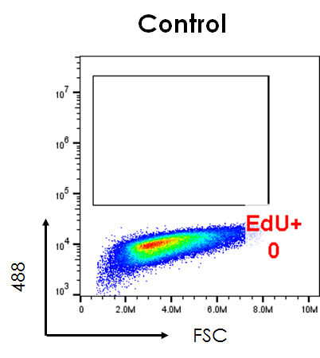
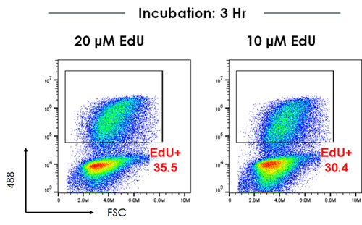
Figure 2. Dot plot of EdU-488 staining (Y-axis, 488) vs FSC. 10⁶ HeLa cells were incubated with the stated concentrations of EdU for 3 hours (bottom panel). Control cells (top panel) were incubated with media only. Images were acquired on an Accuri C6 Cytometer (BD Biosciences) with cells excited using a 488 nm laser and data analyzed using FlowJo (v10). The percentage of gated cells is highlighted.
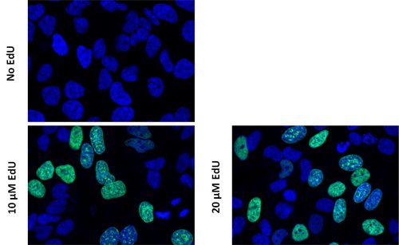
Figure 3.
EdU staining of proliferating cells. HeLa cells (4 x 104 cells/well in 96 plate) were incubated with media only (No EdU), 10 μM EdU or 20 µM EdU for 3 hours. Cells were analyzed using a TCS SP8 confocal microscope (Leica-Microsystems). DNA (blue) was staining with Hoechst 33342 (ab145597). Green cells show EdU/Hoechst-positive cells.

- FAQs
Q. Which fluorescent conjugates are compatible with the EdU reagent using flow cytometry?
A. The following fluorescent molecules can be used to stain cells together with EdU:
Fluorescent molecule | Compatible?
Fluorescent proteins (RFP, etc) | Yes. Use anti-RFP antibodies before the EdU reaction
Organic dyes (iFluor, Alexa Fluor® dyes) | Yes
PerCP, APC and APC-based tandems | Yes
R-PE and R-PE based-tandems | Yes. Use R-PE and R-PE-based tandems after the EdU reaction

Q. Can I stain my cells with phalloidin to look at the cytoskeleton while assessing proliferation?
A. No, phalloidin staining is not compatible with the ‘click’ chemistry. We would recommend using antibodies against proteins such as alpha-tubulin to look at the cytoskeleton components.

- Notes

Technical Support
Copyright © 2024 Abcam. All Rights Reserved. The Abcam logo is a registered trademark. All information / detail is correct at time of going to print.
For all technical or commercial enquiries please go to:
www.abcam.com/contactus
www.abcam.cn/contactus (China)
www.abcam.co.jp/contactus (Japan)

