Version 2 Last updated 18 November 2021

ab221834

Rat IL-2 SimpleStep ELISA® Kit

For the quantitative measurement of IL-2 in rat serum, plasma, and cell culture supernatant samples.

This product is for research use only and is not intended for diagnostic use.

Table of Contents
1. Overview 1
2. Protocol Summary 2
3. Precautions 3
4. Storage and Stability 3
5. Limitations 4
6. Materials Supplied 4
7. Materials Required, Not Supplied 5
8. Technical Hints 5
9. Reagent Preparation 7
10. Standard Preparation 8
11. Sample Preparation 10
12. Plate Preparation 11
13. Assay Procedure 12
14. Calculations 14
15. Typical Data 15
16. Typical Sample Values 17
17. Assay Specificity 22
18. Species Reactivity 23
19. Troubleshooting 24
20. Notes 25

- Overview
IL-2 in vitro SimpleStep ELISA® (Enzyme-Linked Immunosorbent Assay) kit is designed for the quantitative measurement of IL-2 protein in rat serum, plasma, and cell culture supernatant samples.

The SimpleStep ELISA® employs an affinity tag labeled capture antibody and a reporter conjugated detector antibody which immunocapture the sample analyte in solution. This entire complex (capture antibody/analyte/detector antibody) is in turn immobilized via immunoaffinity of an anti-tag antibody coating the well. To perform the assay, samples or standards are added to the wells, followed by the antibody mix. After incubation, the wells are washed to remove unbound material. TMB substrate is added and during incubation is catalyzed by HRP, generating blue coloration. This reaction is then stopped by addition of Stop Solution completing any color change from blue to yellow. Signal is generated proportionally to the amount of bound analyte and the intensity is measured at 450 nm. Optionally, instead of the endpoint reading, development of TMB can be recorded kinetically at 600 nm.

IL-2, also known as T cell growth factor (TCGF), is a glycosylated alpha-helical monomeric polypeptide. It is secreted by activated CD4+ and CD8+ T cells, neurons, microglia and hematopoietic stem cells in response to antigenic or mitogenic stimulation. IL-2 is required for T-cell proliferation, natural killer cells (NK) cytolytic activity, differentiation of regulatory T cells, modulation of T helper (Th) cell differentiation and activation-induced cell death. In particular, IL-2 modulates the expression of receptors for other cytokines and transcription factors, therefore regulating cytokine cascades that correlate with each of the Th differentiation states. Complete deficiency of IL-2 has been implicated in severe combined immunodeficiency, whereas reduction of IL-2 correlates with reduced function of CD4+CD25+ regulatory T cells and destabilization of immune homeostasis leading to autoimmune disease. Increased expression of IL-2 has also been implicated in inflammatory conditions such as inflammatory bowel disease and chronic liver diseases.

- Protocol Summary

Prepare all reagents, samples, and standards as instructed

Add 50 µL standard or sample to appropriate wells

Add 50 µL Antibody Cocktail to all wells

Incubate at room temperature for 1 hour

Aspirate and wash each well three times with 350 µL 1X Wash Buffer PT

Add 100 µL TMB Substrate to each well and incubate for 10 minutes.

Add 100 µL Stop Solution and read OD at 450 nm

- Precautions
Please read these instructions carefully prior to beginning the assay.
- All kit components have been formulated and quality control tested to function successfully as a kit.
- We understand that, occasionally, experimental protocols might need to be modified to meet unique experimental circumstances. However, we cannot guarantee the performance of the product outside the conditions detailed in this protocol booklet.
- Reagents should be treated as possible mutagens and should be handle with care and disposed of properly. Please review the Safety Datasheet (SDS) provided with the product for information on the specific components.
- Observe good laboratory practices. Gloves, lab coat, and protective eyewear should always be worn. Never pipet by mouth. Do not eat, drink or smoke in the laboratory areas.
- All biological materials should be treated as potentially hazardous and handled as such. They should be disposed of in accordance with established safety procedures.

- Storage and Stability
Store kit at +4°C immediately upon receipt. Kit has a storage time of 1 year from receipt, providing components have not been reconstituted.
Refer to list of materials supplied for storage conditions of individual components.

- Limitations
- Assay kit intended for research use only. Not for use in diagnostic procedures.
- Do not mix or substitute reagents or materials from other kit lots or vendors. Kits are QC tested as a set of components and performance cannot be guaranteed if utilized separately or substituted.

- Materials Supplied
Item | Quantity | Storage Condition
Rat IL-2 Capture Antibody 10X | 600 µL | +4ºC
Rat IL-2 Detector Antibody 10X | 600 µL | +4ºC
Rat IL-2 Lyophilized Recombinant Protein | 2 Vials | +4ºC
Antibody Diluent 4BI | 6 mL | +4ºC
Wash Buffer PT 10X | 20 mL | +4ºC
TMB Substrate | 12 mL | +4ºC
Stop Solution | 12 mL | +4ºC
Sample Diluent NS | 50 mL | +4ºC
Sample Diluent 75BS | 20mL | +4ºC
Anti-tag coated microplate (12 x 8 well strips) | 96 Wells | +4ºC
Plate Seal | 1 | +4ºC

- Materials Required, Not Supplied
These materials are not included in the kit, but will be required to successfully perform this assay:
- Microplate reader capable of measuring absorbance at 450 or 600 nm.
- Method for determining protein concentration (BCA assay recommended).
- Deionized water.
- Multi- and single-channel pipettes.
- Tubes for standard dilution.
- Plate shaker for all incubation steps.
- Optional: Phenylmethylsulfonyl Fluoride (PMSF) (or other protease inhibitors).

- Technical Hints
- Samples generating values higher than the highest standard should be further diluted in the appropriate sample dilution buffers.
- Avoid foaming or bubbles when mixing or reconstituting components.
- Avoid cross contamination of samples or reagents by changing tips between sample, standard and reagent additions.
- Ensure plates are properly sealed or covered during incubation steps.
- Complete removal of all solutions and buffers during wash steps is necessary to minimize background.
- As a guide, typical ranges of sample concentration for commonly used sample types are shown below in Sample Preparation (section 11).
- All samples should be mixed thoroughly and gently.
- Avoid multiple freeze/thaw of samples.
- Incubate ELISA plates on a plate shaker during all incubation steps.
- When generating positive control samples, it is advisable to change pipette tips after each step.
- To avoid high background always add samples or standards to the well before the addition of the antibody cocktail.
- This kit is sold based on number of tests. A ‘test’ simply refers to a single assay well. The number of wells that contain sample, control or standard will vary by product. Review the protocol completely to confirm this kit meets your requirements. Please contact our Technical Support staff with any questions.

- Reagent Preparation
- Equilibrate all reagents to room temperature (18-25°C) prior to use. The kit contains enough reagents for 96 wells. The sample volumes below are sufficient for 48 wells (6 x 8-well strips); adjust volumes as needed for the number of strips in your experiment.
- Prepare only as much reagent as is needed on the day of the experiment. Capture and Detector Antibodies have only been tested for stability in the provided 10X formulations.
- Sample Diluent 75BS may contain precipitate, this is normal. If precipitate is not dissolved by gentle mixing, the precipitate may be dissolved by gentle warming and mixing at 37°C for 10 minutes. If precipitate remains, gently spin down and avoid visible precipitates when pipetting.

Sample Diluent 60BS (For serum and plasma samples only):
Prepare Sample Diluent 60BS by diluting 8 mL Sample Diluent 75BS with 2 mL Sample Diluent NS. Mix thoroughly and gently.
1X Wash Buffer PT:
Prepare 1X Wash Buffer PT by diluting Wash Buffer PT 10X with deionized water. To make 50 mL 1X Wash Buffer PT combine 5 mL Wash Buffer PT 10X with 45 mL deionized water. Mix thoroughly and gently.
Antibody Cocktail:
Prepare Antibody Cocktail by diluting the capture and detector antibodies in Antibody Diluent 4BI. To make 3 mL of the Antibody Cocktail combine 300 µL 10X Capture Antibody and 300 µL 10X Detector Antibody with 2.4 mL Antibody Diluent 4BI. Mix thoroughly and gently.
- Standard Preparation
- Always prepare a fresh set of standards for every use.
- Discard working standard dilutions after use as they do not store well.
- The following section describes the preparation of a standard curve for duplicate measurements (recommended).

  - For serum and plasma samples follow these instructions:
    - IMPORTANT: If the protein standard vial has a volume identified on the label, reconstitute the IL-2 standard by adding that volume of Sample Diluent 60BS indicated on the label. Alternatively, if the vial has a mass identified, reconstitute the IL-2 standard by adding 500 µL Sample Diluent 60BS. Hold at room temperature for 10 minutes and mix gently. This is the 6,000 pg/mL Stock Standard Solution.
    - Label eight tubes, Standards 1– 8.
    - Add 100 μL of Sample Diluent 60BS into tube number 1 and 150 μL of Sample Diluent 60BS into numbers 2-8.
    - Use the Stock Standard to prepare the following dilution series. Standard #8 contains no protein and is the Blank control:

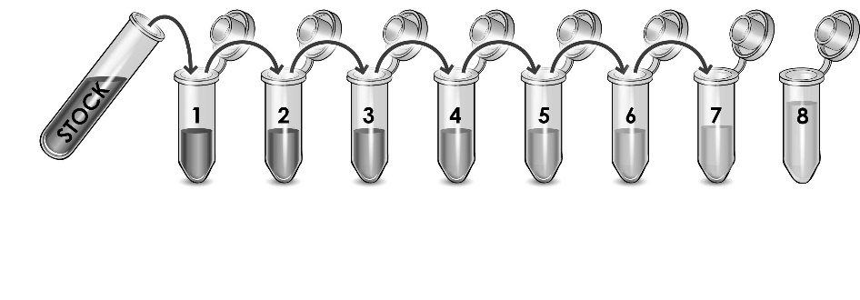
6,000
pg/mL

4,000
pg/mL

2,000
pg/mL

1,000
pg/mL

500
pg/mL

250
pg/mL

62.5
pg/mL

200 µL

125
pg/mL

150 µL
µ

150 µL
µ

150 µL
µ

150 µL
µ

150 µL
µ

150 µL
µ

0
pg/mL

  - For cell culture supernatant samples follow these instructions:
    - IMPORTANT: If the protein standard vial has a volume identified on the label, reconstitute the IL-2 standard by adding that volume of Sample Diluent NS indicated on the label. Alternatively, if the vial has a mass identified, reconstitute the IL-2 standard by adding 500 µL Sample Diluent NS. Hold at room temperature for 10 minutes and mix gently. This is the 6,000 pg/mL Stock Standard Solution.
    - Label eight tubes, Standards 1– 8.
    - Add 200 μL of Sample Diluent NS into tube number 1 and 150 μL of Sample Diluent NS into numbers 2-8.
    - Use the Stock Standard to prepare the following dilution series. Standard #8 contains no protein and is the Blank control:

6,000
pg/mL

2,000
pg/mL

1,000
pg/mL

500
pg/mL

250
pg/mL

125
pg/mL

31.25
pg/mL

100 µL

62.5
pg/mL

150 µL
µ

150 µL
µ

150 µL
µ

150 µL
µ

150 µL
µ

150 µL
µ

0
pg/mL

- Sample Preparation
Typical Sample Dynamic Range
Sample Type | Range
5 μg/mL Concanavalin A Treated Rat Spleen Supernatant (2 days) | 1.56 – 25%
Plasma:
Collect plasma using citrate. Centrifuge samples at 2,000 x g for 10 minutes. Dilute samples 2-fold into Sample Diluent 60BS and assay. Store un-diluted plasma samples at -20ºC or below for up to 3 months. Avoid repeated freeze-thaw cycles.
Serum:
Samples should be collected into a serum separator tube. After clot formation, centrifuge samples at 2,000 x g for 10 minutes and collect serum. Dilute samples 2-fold into Sample Diluent 60BS and assay. Store un-diluted serum at -20ºC or below. Avoid repeated freeze-thaw cycles.
Cell Culture Supernatants:
Centrifuge cell culture media at 2,000 x g for 10 minutes to remove debris. Collect supernatants and assay. Or dilute samples into Sample Diluent NS and assay. Store un-diluted samples at -20°C or below. Avoid repeated freeze-thaw cycles.

- Plate Preparation
- The 96 well plate strips included with this kit are supplied ready to use. It is not necessary to rinse the plate prior to adding reagents.
- Unused plate strips should be immediately returned to the foil pouch containing the desiccant pack, resealed and stored at 4°C.
- For each assay performed, a minimum of two wells must be used as the zero control.
- For statistical reasons, we recommend each sample should be assayed with a minimum of two replicates (duplicates).
- Differences in well absorbance or “edge effects” have not been observed with this assay.

- Assay Procedure
- Equilibrate all materials and prepared reagents to room temperature prior to use.
- We recommend that you assay all standards, controls and samples in duplicate.

  - Prepare all reagents, working standards, and samples as directed in the previous sections.
  - Remove excess microplate strips from the plate frame, return them to the foil pouch containing the desiccant pack, reseal and return to 4ºC storage.
  - Add 50 µL of all sample or standard to appropriate wells.
  - Add 50 µL of the Antibody Cocktail to each well.
  - Seal the plate and incubate for 1 hour at room temperature on a plate shaker set to 400 rpm.
  - Wash each well with 3 x 350 µL 1X Wash Buffer PT. Wash by aspirating or decanting from wells then dispensing 350 µL 1X Wash Buffer PT into each well. Wash Buffer PT should remain in wells for at least 10 seconds. Complete removal of liquid at each step is essential for good performance. After the last wash invert the plate and tap gently against clean paper towels to remove excess liquid.
  - Add 100 µL of TMB Substrate to each well and incubate for 10 minutes in the dark on a plate shaker set to 400 rpm.
Given variability in laboratory environmental conditions, optimal incubation time may vary between 5 and 20 minutes. Note: The addition of Stop Solution will change the color from blue to yellow and enhance the signal intensity about 3X. To avoid signal saturation, proceed to the next step before the high concentration of the standard reaches a blue color of O.D.600 equal to 1.0.
  - Add 100 µL of Stop Solution to each well. Shake plate on a plate shaker for 1 minute to mix. Record the OD at 450 nm. This is an endpoint reading.
  - Alternative to 13.7 – 13.8: Instead of the endpoint reading at 450 nm, record the development of TMB Substrate kinetically. Immediately after addition of TMB Development Solution begin recording the blue color development with elapsed time in the microplate reader prepared with the following settings:

Mode | Kinetic
Wavelength: | 600 nm
Time: | up to 20 min
Interval: | 20 sec - 1 min
Shaking: | Shake between readings
- Note: that an endpoint reading can also be recorded at the completion of the kinetic read by adding 100 µL Stop Solution to each well and recording the OD at 450 nm.
  - Analyze the data as described below.

- Calculations
  - Calculate the average absorbance value for the blank control (zero) standards. Subtract the average blank control standard absorbance value from all other absorbance values.
  - Create a standard curve by plotting the average blank control subtracted absorbance value for each standard concentration (y-axis) against the target protein concentration (x-axis) of the standard. Use graphing software to draw the best smooth curve through these points to construct the standard curve.
- Note: Most microplate reader software or graphing software will plot these values and fit a curve to the data. A four parameter curve fit (4PL) is often the best choice; however, other algorithms (e.g. linear, semi-log, log/log, 4 parameter logistic) can also be tested to determine if it provides a better curve fit to the standard values.
  - Determine the concentration of the target protein in the sample by interpolating the blank control subtracted absorbance values against the standard curve. Multiply the resulting value by the appropriate sample dilution factor, if used, to obtain the concentration of target protein in the sample.
  - Samples generating absorbance values greater than that of the highest standard should be further diluted and reanalyzed. Similarly, samples which measure at an absorbance values less than that of the lowest standard should be retested in a less dilute form.

- Typical Data
Typical standard curve – data provided for demonstration purposes only. A new standard curve must be generated for each assay performed.

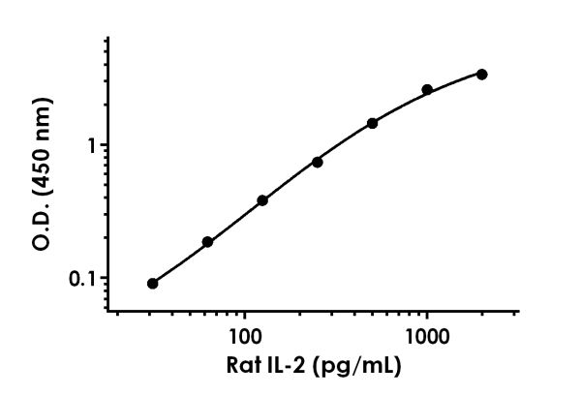

Standard Curve Measurements
Concentration (pg/mL) | O.D 450 nm |  | Mean  O.D
Concentration (pg/mL) | 1 | 2 | Mean  O.D
0 | 0.122 | 0.111 | 0.117
31.25 | 0.204 | 0.211 | 0.207
62.5 | 0.299 | 0.307 | 0.303
125 | 0.488 | 0.510 | 0.499
250 | 0.860 | 0.848 | 0.854
500 | 1.528 | 1.603 | 1.565
1,000 | 2.707 | 2.699 | 2.703
2,000 | 3.411 | 3.563 | 3.487
Figure 1. Example of rat IL-2 standard curve in Sample Diluent NS. The IL-2 standard curve was prepared as described in Section 10. Raw data values are shown in the table. Background-subtracted data values (mean +/- SD) are graphed.

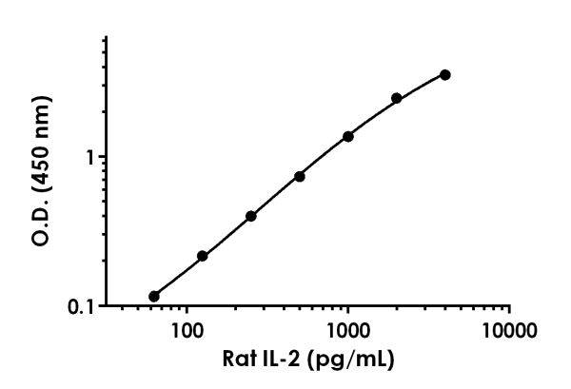

Standard Curve Measurements
Concentration (pg/mL) | O.D 450 nm |  | Mean  O.D
Concentration (pg/mL) | 1 | 2 | Mean  O.D
0 | 0.094 | 0.104 | 0.099
62.5 | 0.217 | 0.209 | 0.213
125 | 0.313 | 0.312 | 0.313
250 | 0.509 | 0.482 | 0.495
500 | 0.827 | 0.838 | 0.832
1,000 | 1.454 | 1.471 | 1.463
2,000 | 2.564 | 2.566 | 2.565
4,000 | 3.634 | 3.644 | 3.639
Figure 2. Example of rat IL-2 standard curve in Sample Diluent 60BS. The IL-2 standard curve was prepared as described in Section 10. Raw data values are shown in the table. Background-subtracted data values (mean +/- SD) are graphed.
- Typical Sample Values
SENSITIVITY –
The MDD was determined by calculating the mean of zero standard replicates and adding 2 standard deviations then extrapolating the corresponding concentration.
Sample Diluent Buffer | n= | Minimal Detectable Dose
Sample Diluent NS | 16 | 4.9 pg/mL
Sample Diluent 60BS | 17 | 12.5 pg/mL

RECOVERY –
Three concentrations of recombinant rat IL-2 protein were spiked in duplicate to the indicated biological matrix to evaluate signal recovery in the working range of the assay.
Acceptable recovery is observed in cell culture media containing FBS however lower recovery is observed in rat spleen cell culture supernatant. The reason for this low recovery are unknown (for example, IL-2 R alpha does not appear to interfere with the assay (see Interference section)).

Sample Type | Average % Recovery | Range (%)
50% Rat Serum | 93 | 89 - 100
50% Rat Plasma – Citrate | 86 | 84 - 88
100% RPMI Media + 10% FBS | 108 | 99 - 113
100% Unstimulated Rat Spleen Supernatant (2 days) | 45 | 43 - 48

Linearity of Dilution
Linearity of dilution is determined based on interpolated values from the standard curve. Linearity of dilution defines a sample concentration interval in which interpolated target concentrations are directly proportional to sample dilution.
Native IL-2 was measured in the following biological samples in a 2-fold dilution series. Sample dilutions are made in Sample Diluent NS.

Dilution  Factor | Interpolated value | 25% Concanavalin A Treated Rat Spleen Supernatant
Undiluted | pg/mL | 1631
Undiluted | % Expected value | 100
2 | pg/mL | 717.7
2 | % Expected value | 88
4 | pg/mL | 366.1
4 | % Expected value | 90
8 | pg/mL | 202.6
8 | % Expected value | 99
16 | pg/mL | 115.6
16 | % Expected value | 113

Recombinant IL-2 was spiked into the following biological samples and diluted in a 2-fold dilution series in Sample Diluent 60BS.
Dilution  Factor | Interpolated value | 50%  Rat  Serum | 50%  Rat  Plasma  (Citrate)
Undiluted | pg/mL | 501.0 | 410.6
Undiluted | % Expected value | 100 | 100
2 | pg/mL | 236.6 | 185.3
2 | % Expected value | 94 | 90
4 | pg/mL | 120.5 | 82.81
4 | % Expected value | 96 | 81
8 | pg/mL | 66.42 | 42.09
8 | % Expected value | 106 | 82
16 | pg/mL | 37.38 | 20.70
16 | % Expected value | 119 | 81

PRECISION –
Mean coefficients of variation of interpolated values from three concentrations of recombinant IL-2 protein spiked into neat serum within the working range of the assay.
 | Intra-  Assay | Inter-  Assay
n = | 3 | 5
CV(%) | 4.0 | 4.2

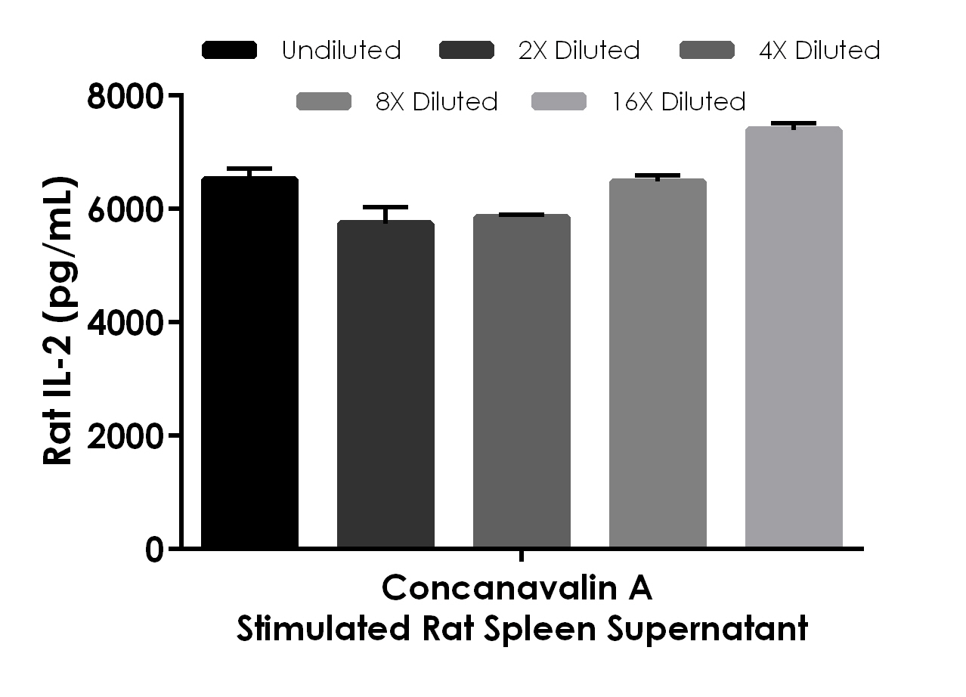

Figure 3. Interpolated concentrations of native IL-2 in Concanavalin A treated rat spleen (2 days) supernatant samples. The concentrations of IL-2 were measured in duplicates, interpolated from the IL-2 standard curves and corrected for sample dilution. Undiluted samples are as follows: spleen supernatant 25%. The interpolated dilution factor corrected values are plotted (mean +/- SD, n=2). The mean IL-2 concentration was determined to be 6401 pg/mL in Concanavalin A treated rat spleen supernatant.

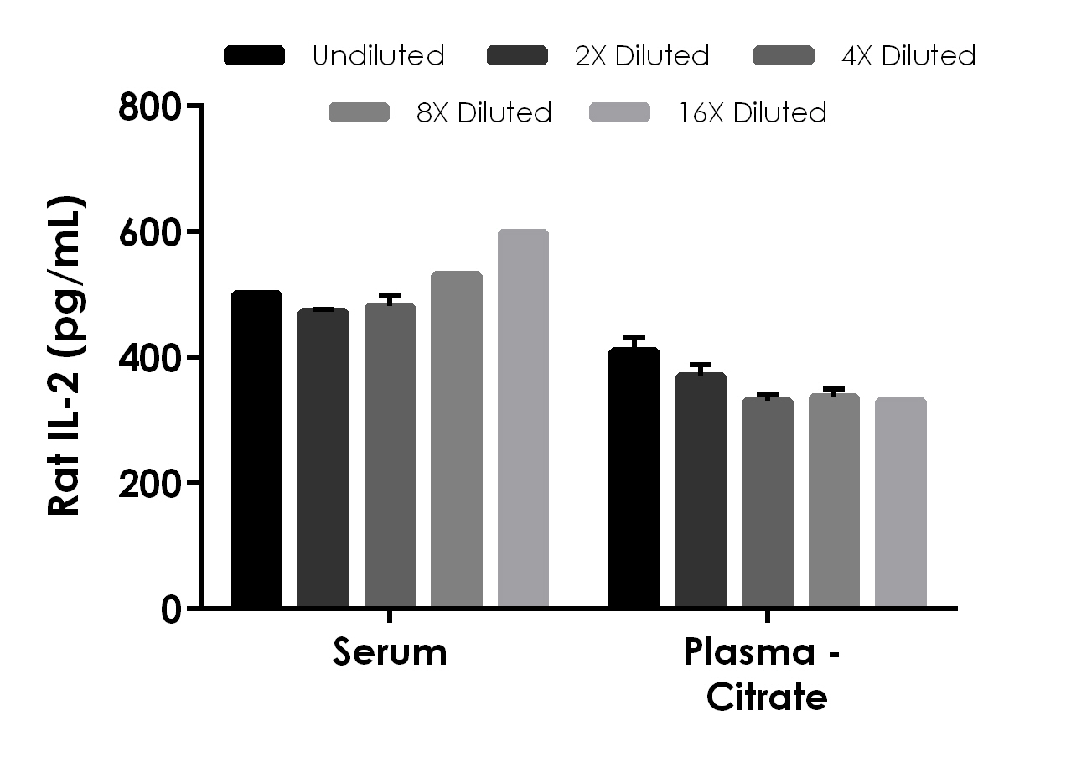

Figure 4. Interpolated concentrations of spiked IL-2 in rat serum and plasma samples. The concentrations of IL-2 were measured in duplicates, interpolated from the IL-2 standard curves and corrected for sample dilution. Undiluted samples are as follows: serum 50%, plasma (citrate) 50%. The interpolated dilution factor corrected values are plotted (mean +/- SD, n=2).

- Assay Specificity
This kit recognizes both native and recombinant rat IL-2 protein in serum, plasma citrate, and cell culture supernatant samples only. Urine, cell and tissue extract samples have not been tested with this kit. Plasma heparin and plasma EDTA samples are not compatible with this kit.
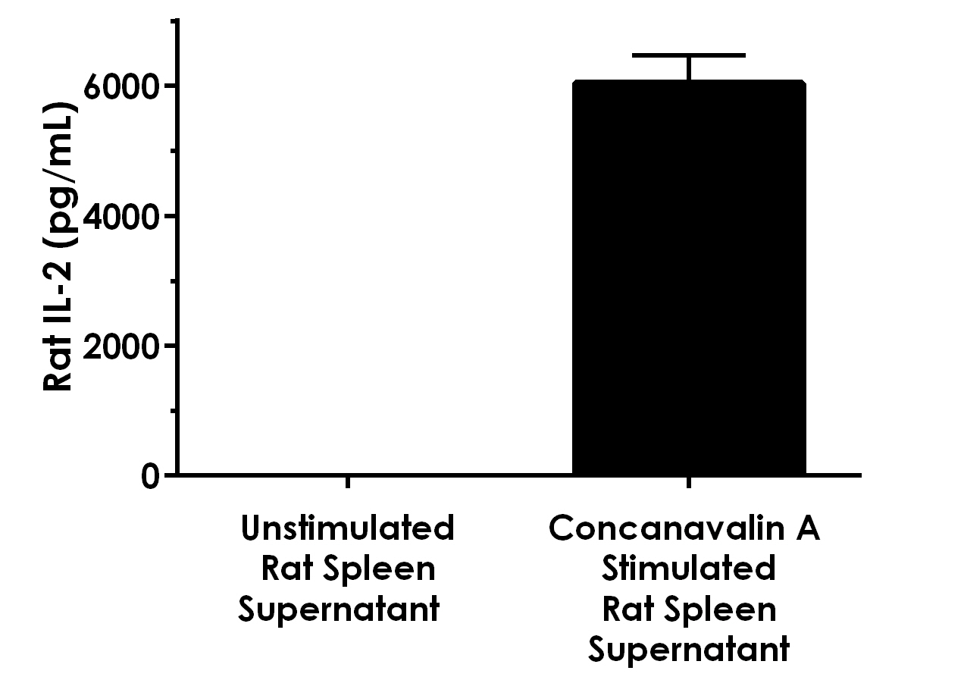

Figure 5. Comparison of IL-2 in unstimulated and Concanavalin A stimulated rat spleen supernatants. Rat spleen was cultured for 2 days in the presence or absence of 5 µg/mL Concanavalin A. The concentrations of IL-2 were measured in three different dilutions of the supernatant samples in duplicates and interpolated from the IL-2 standard curve. The interpolated values are plotted (mean +/- SD, n=3). The mean IL-2 concentration was determined to be 6042 pg/mL in Concanavalin A stimulated neat rat spleen supernatant and undetectable in unstimulated rat spleen supernatant and RPMI media (not shown).

INTERFERENCE
Recombinant rat IL-2 receptor alpha protein was prepared at 50 ng/mL and 1 ng/mL and tested for interference. No interference with was observed.

- Species Reactivity
This kit recognizes rat IL-2 protein.

Recombinant mouse IL-2 protein was prepared within the working range of the assay and assayed for cross reactivity. No cross-reactivity was observed.

Other species reactivity was not determined.

Please contact our Technical Support team for more information.
- Troubleshooting
Problem | Reason | Solution
Poor standard  curve | Inaccurate Pipetting | Check pipettes
Poor standard  curve | Improper standard  dilution | Prior to opening, briefly spin the stock standard tube and dissolve the powder thoroughly by gentle mixing
Low Signal | Incubation times too brief | Ensure sufficient incubation times; increase to 2 or 3 hour standard/sample incubation
Low Signal | Inadequate reagent volumes or improper dilution | Check pipettes and ensure correct preparation
Low Signal | Incubation times with TMB too brief | Ensure sufficient incubation time until blue color develops prior addition of Stop solution
Large CV | Plate is insufficiently washed | Review manual for proper wash technique. If using a plate washer, check all ports for obstructions.
Large CV | Contaminated wash buffer | Prepare fresh wash buffer
Low sensitivity | Improper storage of the ELISA kit | Store your reconstituted standards at -80°C, all other assay components 4°C. Keep TMB substrate solution protected from light.
Precipitate in Diluent | Precipitation and/or coagulation of components within the Diluent. | Precipitate can be removed by gently warming the Diluent to 37ºC.

- Notes

Technical Support
Copyright © 2020 Abcam, All Rights Reserved. The Abcam logo is a registered trademark. All information / detail is correct at time of going to print.
For all technical or commercial enquiries please go to:
www.abcam.com/contactus
www.abcam.cn/contactus (China)
www.abcam.co.jp/contactus (Japan)

