Version 6a, Last updated 5 June 2023

ab222942

Total Collagen Assay Kit (Perchlorate-Free)
For the sensitive and accurate measurement of total Collagen in tissue homogenates and biological fluids.
View kit datasheet: www.abcam.com/ab222942
(use www.abcam.cn/ab222942 for China, or www.abcam.co.jp/ab222942 for Japan)

This product is for research use only and is not intended for diagnostic use.

PLEASE NOTE: With the acquisition of BioVision by Abcam, we have made some changes to component names and packaging to better align with our global standards as we work towards environmental-friendly and efficient growth. You are receiving the same high-quality products as always, with no changes to specifications or protocols.
Table of Contents
1. Overview 1
2. Protocol Summary 2
3. Precautions 3
4. Storage and Stability 3
5. Limitations 4
6. Materials Supplied 4
7. Materials Required, Not Supplied 5
8. Technical Hints 6
9. Reagent Preparation 7
10. Standard Preparation 8
11. Sample Preparation 9
12. Assay Procedure 11
13. Calculations 13
14. Typical Data 15
15. Troubleshooting 18

- Overview
Total Collagen Assay Kit (Perchlorate-Free) (ab222942) provides a quick and convenient method to detect collagen in tissue lysates as well as biological fluids such as urine or serum. The assay is based on the Alkaline hydrolysis of samples to yield free Hydroxyproline. The released hydroxyproline gets oxidized to form a reaction intermediate, which further in reaction forms brightly-colored chromophore that can be easily detected at OD 560 nm. The assay employs a proprietary acidic developer solution to accurately measure collagen in hydrolysates without the use of hazardous perchloric acid, obviating the need for any special handling and waste-disposal protocols.

The assay can detect as low as 0.5 µg collagen/well.

Collagen peptide

10N NaOH, 120°C (Alkaline hydrolysis)

Oxidation Developer Solution
Hydroxyproline Intermediate Absorbance
(OD 560 nm)

Collagen is the most abundant insoluble protein found in the extracellular matrix and connective tissues. It can be found in skin, tendons, bone, cartilage, muscle, vitreous humor and ligaments, among other tissues. There are more than sixteen - well characterized types of collagens, but types I, II and III collagen comprise more than 80% content in mammals. The triple-helical structure of collagen is quite unique: it consists of a repeating pattern of a basic trimer: Glycine-Proline-Hydroxyproline. In cells, collagens are secreted as procollagens and these chains are transported into the Endoplasmic Reticulum, where, numerous post-translational modifications lead to the formation of a triple helix with disulfide bonds. Excessive production of collagen is linked to pathological conditions including liver cirrhosis, lung fibrosis, and tumor growth.
- Protocol Summary

Standard curve preparation (Alkaline hydrolysis step)

Sample preparation (Alkaline hydrolysis step)

Evaporate sample and standard wells

Add Oxidation reagent mix and
incubate at RT for 20 minutes

Add developer and incubate at 37°C for 5 minutes

Add DMAB concentrate and
incubate at 65°C for 45 minutes

Measure absorbance (OD560 nm)

- Precautions
Please read these instructions carefully prior to beginning the assay.
- All kit components have been formulated and quality control tested to function successfully as a kit.
- We understand that, occasionally, experimental protocols might need to be modified to meet unique experimental circumstances. However, we cannot guarantee the performance of the product outside the conditions detailed in this protocol booklet.
- Reagents should be treated as possible mutagens and should be handled with care and disposed of properly. Please review the Safety Datasheet (SDS) provided with the product for information on the specific components.
- Observe good laboratory practices. Gloves, lab coat, and protective eyewear should always be worn. Never pipette by mouth. Do not eat, drink or smoke in the laboratory areas.
- All biological materials should be treated as potentially hazardous and handled as such. They should be disposed of in accordance with established safety procedures.
- Storage and Stability
Store kit at -20°C (store Developer Solution I/Developer Solution and Collagen I Standard (3 mg/ml)/Collagen I Standard at 4°C) in the dark immediately upon receipt. Kit has a storage time of 1 year from receipt.
Refer to list of materials supplied for storage conditions of individual components. Observe the storage conditions for individual prepared components in the Materials Supplied section.
Aliquot components in working volumes before storing at the recommended temperature.

- Limitations
- Assay kit intended for research use only. Not for use in diagnostic procedures.
- Do not mix or substitute reagents or materials from other kit lots or vendors. Kits are QC tested as a set of components and performance cannot be guaranteed if utilized separately or substituted.
- Materials Supplied
Item | Quantity | Storage temperature (before preparation) | Storage temperature (after preparation)
Chloramine T Concentrate | 600 µL | -20°C | -20°C
Developer Solution I/Developer Solution | 5 mL | 4°C | 4°C
DMAB Concentrate | 5 mL | -20°C | -20°C
Collagen I Standard (3 mg/ml)/Collagen I Standard | 200 µL | 4°C | 4°C
AlumaSeal® Film/Microplate Sealing Film | 1 unit | -20°C | N/A
Oxidation Buffer | 10 mL | -20°C | -20°C

- Materials Required, Not Supplied
These materials are not included in the kit, but will be required to successfully perform this assay:
- Microplate reader capable of measuring absorbance at OD 560 nm
- Deionized water (ddH₂O)
- 10N Sodium hydroxide (NaOH)
- 10N Hydrochloric acid (HCl)
- Pipettes and pipette tips, including multi-channel pipette
- Assorted glassware for the preparation of reagents and buffer solutions
- Tubes for the preparation of reagents and buffer solutions
- Pressure-tight 1.5-2.0 mL screw top polypropylene tubes
- 96 well plate clear flat bottom
- Dounce or ultrasonic probe homogenizer (if using tissue)
- Hot plate or oven set at 120 °C
For urine samples:
- 4 mg Activated charcoal

- Technical Hints
- This kit is sold based on number of tests. A “test” simply refers to a single assay well. The number of wells that contain sample, control or standard will vary by product. Review the protocol completely to confirm this kit meets your requirements. Please contact our Technical Support staff with any questions.
- Selected components in this kit are supplied in surplus amount to account for additional dilutions, evaporation, or instrumentation settings where higher volumes are required. They should be disposed of in accordance with established safety procedures.
- Avoid foaming or bubbles when mixing or reconstituting components.
- Avoid cross contamination of samples or reagents by changing tips between sample, standard and reagent additions.
- Ensure plates are properly sealed or covered during incubation steps.
- Ensure all reagents and solutions are at the appropriate temperature before starting the assay.
- Make sure all necessary equipment is switched on and set at the appropriate temperature.
- Hot plate/dry heat block or microplate incubator
- Reagent Preparation
Briefly centrifuge small vials at low speed prior to opening.

Chloramine T Concentrate (600 µL)
Ready to use as supplied (provided as concentrated solution in ddH₂O). Warm to room temperature and vortex to ensure it is fully re-suspended before use. Aliquot so that you have enough volume to perform the desired number of assays. Store at -20°C protected from light. Do not perform more than 2 freeze/thaw cycles.
Developer Solution I/Developer Solution (5 mL)
Ready to use as supplied. Equilibrate to room temperature before use. After use, promptly retighten cap to minimize adsorption of airborne moisture. Store at 4°C.
DMAB Concentrate (5 mL, in DMSO):
Ready to use as supplied. Warm to room temperature and mix by vortexing. After use, promptly retighten cap to minimize adsorption of airborne moisture.
Δ Note: DMSO tends to be solid when stored at -20°C. Repeat this step every time concentrate is needed.
Aliquot so that you have enough volume to perform the desired number of assays. Store at -20°C protected from light. Do not perform more than 5 freeze/thaw cycles.
Oxidation Buffer (10 mL):
Ready to use as supplied. Equilibrate to room temperature before use. Aliquot so that you have enough volume to perform the desired number of assays. Store at -20°C.
Total Collagen Standard (200 µL, 3 mg/mL solubilized Type I collagen from rat tail tendon diluted in acetic acid):
Ready to use as supplied. Equilibrate to room temperature prior to use. Aliquot so that you have enough volume to perform the desired number of assays. Store at 4°C.
AlumaSeal® Film/Microplate sealing film (1 unit):
Ready to use as supplied. Equilibrate to room temperature before use. Do not reuse and discard after using.

- Standard Preparation
- Always prepare a fresh set of standards for every use.
- Discard working standard dilutions after use as they do not store well.

Hydrolyze Collagen I standard stock:
    - Transfer 50 µL of Collagen I Standard stock to a pressure-tight, screw-capped polypropylene vial and add 50 µL of 10 N concentrated NaOH (not provided). Securely tighten cap.
    - Hydrolyze at 120°C for 1 hour.
    - Cool vial on ice.
    - Neutralize by adding 50 µL of 10N concentrated HCl and thoroughly vortexing.
    - Centrifuge vial at 10,000 x g for 5 minutes to pellet any insoluble debris that may remain following hydrolysis – final volume of Collagen I standard will be ~ 150 µL at a final concentration of 1 mg/mL hydrolyzed collagen
Prepare Collagen I standard dilution:
    - Using 1 mg/mL hydrolyzed Collagen I standard (Step 10.1.5), prepare standard curve dilution as described in the table in a microplate or microcentrifuge tubes:

Standard# | Collagen I Standard (µL) | ddH₂O (µL) | Final volume standard in well (µL) | End amount Collagen I in well (µg)
1 | 0 | 30 | 10 | 0
2 | 6 | 24 | 10 | 2
3 | 12 | 18 | 10 | 4
4 | 18 | 12 | 10 | 6
5 | 24 | 6 | 10 | 8
6 | 30 | 0 | 10 | 10

Each dilution has enough amount of standard to set up duplicate readings (2 x 10 µL).
- Sample Preparation
General sample information:
- We recommend performing several dilutions of your sample to ensure the readings are within the standard value range.
- We recommend that you use fresh samples. If you cannot perform the assay at the same time, we suggest that you snap freeze your samples in liquid nitrogen upon extraction and store them immediately at -80°C. When you are ready to test your samples, thaw them on ice and proceed with the Sample Preparation step. Be aware however that this might affect the stability of your samples and the readings can be lower than expected.

Tissue lysates:
    - Harvest the amount of tissue necessary for each assay (initial recommendation ~10-100 mg).
    - Add 100 µL of dH₂O for every 10 mg of tissue and thoroughly homogenize with a glass bead (Dounce) or ultrasonic probe homogenizer.
    - Transfer 100 µL of sample homogenate to a pressure-tight, screw-capped polypropylene vial.
    - Add 100 µL of 10 N concentrated NaOH (not provided) to tissue homogenate. Ensure the cap is securely tightened and heat at 120°C for 1 hour.
Δ Note: Extremely tough samples (containing bone or exoskeletal tissue) may require heating for longer for complete hydrolysis.
    - Following alkaline hydrolysis, place vial on ice.
    - Allow vial to cool briefly before opening cap and adding 100 µL of 10 N concentrated HCl (not provided) to neutralize residual NaOH. Vortex vial.
    - Centrifuge vial at 10,000 x g for 5 minutes to pellet any insoluble debris that may remain following hydrolysis.
    - Collect supernatant and transfer to a new tube.
    - Keep on ice.
Δ Note: Hydrolysates of certain samples, such as fatty tissues, may contain lipid debris that is difficult to pellet by centrifugation. Take care when pipetting hydrolyzed samples to avoid transferring these insoluble globules.

Serum:
    - Mix serum with equal volume of 10 N concentrated NaOH (ie. 100 µL serum + 100 µL of 10N NaOH) in pressure-tight, screw-capped polypropylene vial. Mix well by pipetting up and down.
    - Hydrolyze mix at 120°C for 1 hour.
    - Cool vial on ice.
    - Neutralize hydrolysate by adding an equivalent volume of 10 N concentrated HCl to NaOH added (ie, 100 µL). Vortex vial.
    - Centrifuge vial at 10,000 x g for 5 minutes to pellet any insoluble debris that may remain following hydrolysis.
    - Collect supernatant and transfer to a new tube.
    - Keep on ice.
Urine:
    - Mix serum with equal volume of 10 N concentrated NaOH (ie. 100 µL serum + 100 µL of 10N NaOH) in pressure-tight, screw-capped polypropylene vial. Mix well by pipetting up and down.
    - Hydrolyze mix at 120°C for 1 hour.
    - Cool vial on ice.
    - Neutralize hydrolysate by adding an equivalent volume of 10 N concentrated HCl to NaOH added (ie, 100 µL). Vortex vial.
    - Decolorize sample by adding 4 mg of activated charcoal to the neutralized hydrolysate. Vortex vial.
    - Centrifuge vial at 10,000 x g for 5 minutes to remove precipitate and activated charcoal.
    - Collect clarified supernatant and transfer to a new tube.

Δ Note: We suggest using different volumes of sample to ensure readings are within the standard curve range.

- Assay Procedure
- Equilibrate all materials and prepared reagents to room temperature prior to use.
- We recommend that you assay all standards, controls and samples in duplicate.
- Prepare all reagents, working standards, and samples as directed in the previous sections.

Reaction wells set up:
- Standard wells = 10 µL standard dilutions
- Sample wells = 2-10 µL samples (adjust volume to 10 µL/well with ddH₂O)
Reaction mix:
    - Evaporate the sample hydrolysate and standard curve wells to dryness by heating the plate at 65°C on a hot plate/dry heat block or microplate incubator.
Δ Note: To prevent warping/etching of the plastic, do not expose microplate to extreme temperatures (>85°C).
    - Following evaporation of the hydrolysates, a crystalline residue will be left in the well. Gentle shaking will help dissolve the crystals in Oxidation Reagent Mix more quickly.
    - Prepare 100 µL of Oxidation Mix for each reaction. Prepare a master mix to ensure consistency:
Δ Note: Once diluted and exposed to light and air, Chloramine T is only stable for 1-2 hours. Discard after diluting.

Component | Reaction Mix (µL)
Chloramine T concentrate | 6
Oxidation Buffer | 94

    - Add 100 µL of the Oxidation Reagent Mix to each well and incubate the plate at room temperature for 20 minutes.
Δ Note: Hdrolysates from certain samples may impart a faint yellow tint to the Oxidation Reagent Mix. This slight colorization usually dissipates upon addition of Developer and does not interfere with the assay.
    - Add 50 µL of Developer to each reaction well and incubate the plate at 37°C for 5 minutes.
    - Add 50 µL of DMAB Concentrate solution to each reaction well and mix contents thoroughly.
    - Seal the plate with the provided microplate sealer film and incubate at 65°C on a hot plate/dry heat block or microplate incubator for 45 minutes.
Measurement:
    - Remove the plate from the heat source.
    - Measure absorbance at OD 560 nm on a microplate reader.
Δ Note: For maximum signal intensity, measure absorbance within 20 minutes of removing plate from the heat source.

- Calculations
- Samples producing signals greater than that of the highest standard should be further diluted in appropriate buffer/solution and reanalyzed, then multiply the concentration found by the appropriate dilution factor.

Measurement of Collagen I in the sample:
    - Subtract the mean absorbance value of the blank (Standard #1) from all standard and sample readings. This is the corrected absorbance.
    - Average the duplicate reading for each standard and sample.
    - Plot the corrected absorbance values for each standard as a final of the final amount of hydrolyzed Collagen.
    - Draw the best smooth curve through these points to construct the standard curve. Most plate reader software or Excel can plot this values and curve fit. Calculate the trend line equation based on your standard curve data (use the equation that provides the most accurate fit).
    - Concentration of Hydrolysate collagen (µg/µL) in the test samples is calculated as:
$$Hydrolysate Collagen concentration=\left(\frac{B}{V}\right)*D$$
Where:
B = amount of hydrolyzed collagen I in the sample well calculated from standard curve (µg).
V = sample volume added in the sample wells (µL).
D = sample dilution factor if sample is diluted to fit within the standard curve range.

    - Concentration of Total Collagen in the original sample (homogenate or biological fluid) is calculated as:

Total Collagen = Hydrolysate Collagen x 3

Where:
Hydrolysate Collagen = amount obtained from Step 13.1.5
3 = sample dilution fold that occurs during the generation of the hydrolysate.

- Typical Data
Typical standard curve – data provided for demonstration purposes only. A new standard curve must be generated for each assay performed.
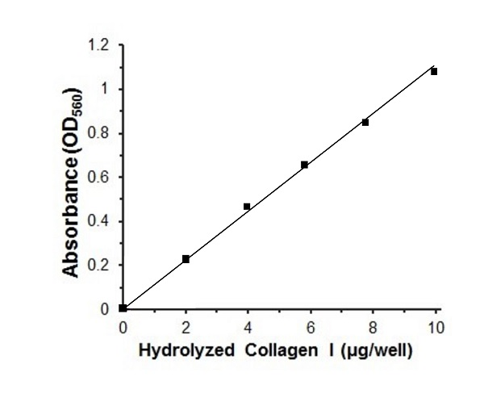
Figure 1. Typical hydrolyzed Collagen I standard calibration curve.

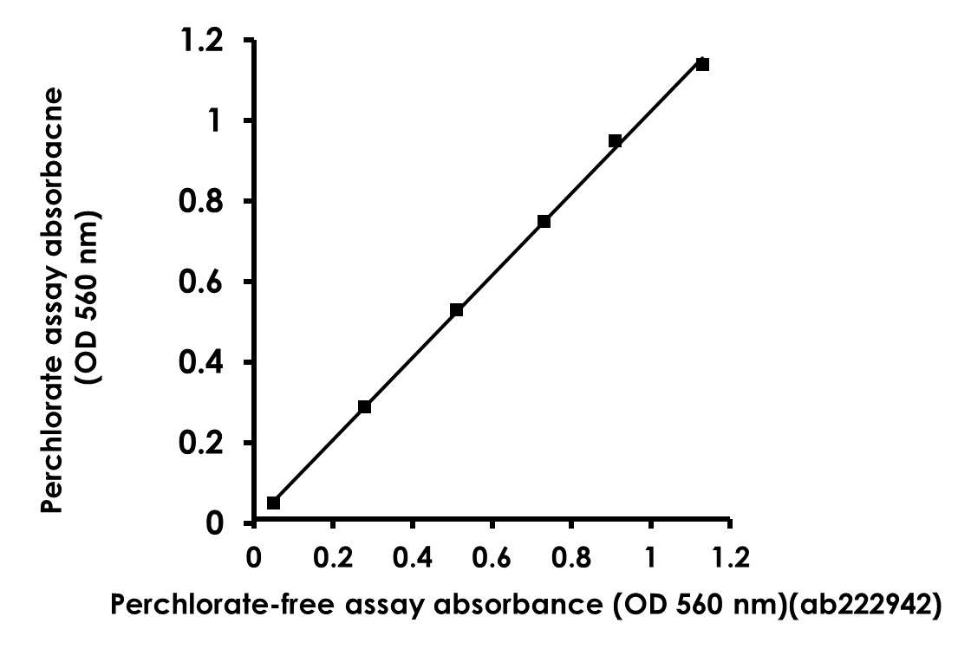

Figure 2. Correlation between collagen standard curve absorbance values obtained using a classical perchlorate-based assay kit and perchlorate-free Total Collagen Assay Kit (Colorimetric)(ab222942).

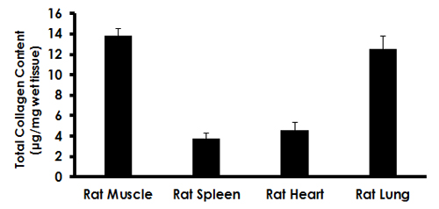
Figure 3. Estimation of total collagen content in rat tissues. Rat leg muscle, spleen, heart and lung samples were prepared followind the sample preparation procedure described in the protocol (homogenized in ddH₂O, hydrolyzed with 10 N NaOH for 1 hour at 120°C and neutralized with 10 N HCl). For each sample, 10 μL of the final neutralized hydrolysate was assayed. Total Collagen levels (calculated as μg collagen/mg wet tissue) for the samples were: 13.80 +- 0.73 ug/mg for muscle, 3.77 +- 0.54 ug/mg for spleen, 4.55 +- 0.81 ug/mg for heart and 12.51 +- 1.27 ug/mg for lung. Data are mean ± SEM of 3-4 replicates.

- Troubleshooting
Problem | Reason | Solution
Assay not working | Use of ice-cold buffer | Buffers must be at assay temperature
Assay not working | Plate read at incorrect wavelength | Check the wavelength and filter settings of instrument
Assay not working | Use of a different microplate | Colorimetric: clear plates  Colorimetric: black wells/clear bottom plates  Luminometric: white wells/clear bottom plates
Sample with erratic readings | Cells/tissue samples not homogenized completely | Use Dounce homogenizer, increase number of strokes
Sample with erratic readings | Samples used after multiple free/ thaw cycles | Aliquot and freeze samples if needed to use multiple times
Sample with erratic readings | Use of old or inappropriately stored samples | Use fresh samples or store at - 80°C (after snap freeze in liquid nitrogen) till use
Sample with erratic readings | Presence of interfering substance in the sample | Check protocol for interfering substances; deproteinize samples
Lower/higher readings in samples and standards | Improperly thawed components | Thaw all components completely and mix gently before use
Lower/higher readings in samples and standards | Allowing reagents to sit for extended times on ice | Always thaw and prepare fresh reaction mix before use
Lower/higher readings in samples and standards | Incorrect incubation times or temperatures | Verify correct incubation times and temperatures in protocol

Problem | Reason | Solution
Standard readings do not follow a linear pattern | Pipetting errors in standard or reaction mix | Avoid pipetting small volumes (< 5 µL) and prepare a master mix whenever possible
Standard readings do not follow a linear pattern | Air bubbles formed in well | Pipette gently against the wall of the tubes
Standard readings do not follow a linear pattern | Standard stock is at incorrect concentration | Always refer to dilutions described in the protocol
Unanticipated results | Measured at incorrect wavelength | Check equipment and filter setting
Unanticipated results | Samples contain interfering substances | Troubleshoot if it interferes with the kit
Unanticipated results | Sample readings above/ below the linear range | Concentrate/ Dilute sample so it is within the linear range

- Notes

Technical Support
Copyright © 2023 Abcam. All Rights Reserved. The Abcam logo is a registered trademark. All information / detail is correct at time of going to print.
For all technical or commercial enquiries please go to:
www.abcam.com/contactus
www.abcam.cn/contactus (China)
www.abcam.co.jp/contactus (Japan)

