Version 1d Last updated 27 February 2024

ab228555
Fluo-4 Assay Kit (Calcium)

For the measurement of intracellular calcium mobilization.

This product is for research use only and is not intended for diagnostic use.

Table of Contents
1. Overview 3
2. Materials Supplied and Storage 4
3. Materials Required, Not Supplied 5
4. Reagent Preparation 6
5. Sample Preparation 7
6. Assay Procedure 8
7. FAQs / Troubleshooting 9
8. Typical Data 10
9. Notes 11

- Overview
Fluo-4 Assay Kit (Calcium)(ab228555) provides a homogeneous fluorescence-based assay for detecting the intracellular calcium mobilization. The kit offers an optimized assay method for monitoring G-protein-coupled receptors (GPCRs) and calcium channels.
This product is intended to be used for monitoring calcium fluctuations in vivo in live cells using the following HTS imaging plate readers: FLIPR™, FDSS, BMG NOVOstar™, FLexStation, ViewLux, IN Cell Analyzer or Arrayscan.

Prepare cells in growth medium

Add 20 µL of Fluo-4 dye-loading solution (100 μL/well/96-well plate or 25 μL/well/384-well plate)

Incubate at 37oC for 1 hour

Prepare the compound plate with HHBS

Run the calcium flux assay by monitoring the fluorescence intensity at Ex/Em = 490/ 525 nm.
- Materials Supplied and Storage
Store kit at -20°C in the dark and desiccated immediately on receipt and check below for storage for individual components. Kit can be stored for 1 year from receipt, if components have not been reconstituted.
Avoid repeated freeze-thaws of reagents.
Item | Quantity | Storage temperature
Fluo-4 AM | 1 vial  (lyophilized) | - 20°C
10X F127 Plus | 1 bottle (10mL) | - 20°C
HHBS (Hanks’ Buffer with 20 mM Hepes) | 1 bottle  (100mL) | - 20°C

- Materials Required, Not Supplied
These materials are not included in the kit, but will be required to successfully perform this assay:

- A HTS fluorescence microplate reader with a filter set of Ex/Em = 490 to 525 nm. We recommend the following instruments: FLIPR™, FDSS, BMG NOVOstar™, FlexStation, ViewLux, IN Cell Analyzer or Arrayscan.

- Reagent Preparation
- Briefly centrifuge small vials at low speed prior to opening.
- Thaw all the kit components at room temperature before use.

  - Fluo-4 AM stock solution
- Add 200 µL of DMSO into the vial of Fluo-4 AM and mix well.

ΔNote: 20 µL of Fluo-4 NW stock solution is enough for one plate. Unused Fluo-4 AM stock solution can be aliquoted and stored at < -20 °C for more than one month if the tubes are sealed tightly. Protect from light and avoid repeated freeze-thaw cycles.

  - 1X Assay Buffer
- Make 1X assay buffer by adding 1 mL of 10 X F127 Plus into 9 mL of HHBS buffer and mix them well.

ΔNote: 10 mL of 1X assay buffer is enough for one plate.

  - Fluo-4 AM dye-loading solution
- Add 20 µL of Fluo-4 NW stock solution (from Step 5.1) into 10 mL of 1X assay buffer (from Step 5.2) and mix them well. This working solution is stable for at least 2 hours at room temperature.

- Sample Preparation
General sample information:
We recommend that you use fresh samples for the most reproducible assay.

  - For adherent cells
- Plate cells overnight in growth medium at 40,000 to 80,000 cells/well/100 µL for a 96-well plate or 10,000 to 20,000 cells/well/25 µL for a 384-well plate.

  - For non-adherent cells
- Centrifuge the cells from the culture medium and then suspend the cell pellet in cell growth medium or HHBS at 125,000 to 250,000 cells/well/100 µL for a 96-well poly-D lysine plate or 30,000 to 60,000 cells/well/25 µL for a 384-well poly-D lysine plate. Centrifuge the plate at 800 rpm for 2 minutes with brake off prior to the experiments.

ΔNote: Each cell line should be evaluated on the individual basis to determine the optimal cell density for the intracellular calcium mobilization.

- Assay Procedure
- Equilibrate all materials and prepared reagents to room temperature just prior to use and gently agitate.
- Assay all standards, controls and samples in duplicate.

- Add 100 µL/well (96-well plate) or 25 µL/well (384-well plate) of Fluo-4 AM dye-loading solution (from Step 5.3) into the cell plate.

- Incubate the dye-loading plate in a cell incubator for 1 hour, and then incubate the plate at room temperature for another 15 to 30 minutes.

ΔNote: If the assay requires 37°C, perform the experiment immediately without further room temperature incubation.

- Prepare the compound plate with HHBS or your desired buffer.

- Using your instrument that contains a pipettor (such as Flexstation from Molecular Devices), dispense compounds directly onto to the cell plate while collecting the data simultaneously (see next step for Ex/Em instructions).

ΔNote: Typically the instrument collects the data every second for 100 seconds. Use the max signal to generate the plot. You can use a fluorescence microscope by adding the stimuli while taking the picture simultaneously.

- Run the calcium flux assay by monitoring the fluorescence intensity at Ex/Em = 490/ 525 nm.

- FAQs / Troubleshooting
General troubleshooting points are found at www.abcam.com/assaykitguidelines.
- Typical Data
Data provided for demonstration purposes only.
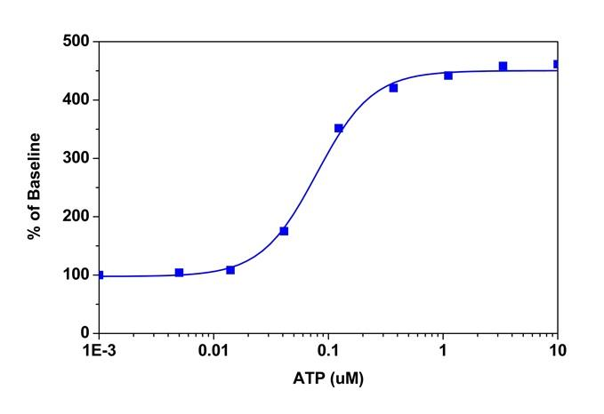
Figure 2. ATP dose response was measured in CHO-K1 cells with Fluo-4 Assay Kit (Calcium) (ab228555). CHO-K1 cells were seeded overnight at 60,000 cells/100 µL/well in a Costar black wall/clear bottom 96-well plate. The cells were incubated with 100 µL of dye-loading solution using the Fluo-4 Assay Kit (Calcium) for 1 hour at 37ºC, and then at room temperature for another 15 minutes. ATP (50µL/well) was added by Flexstation 3 to achieve the final indicated concentrations.

- Notes

Technical Support
For all technical and commercial enquires please go to:
www.abcam.com/contactus
www.abcam.cn/contactus (China)
www.abcam.co.jp/contactus (Japan)

