Version 2b, Last updated 31 January 2024

ab228558 Fructosamine Assay Kit

For the measurement of Fructosamine in serum.

This product is for research use only and is not intended for diagnostic use.

PLEASE NOTE: With the acquisition of BioVision by Abcam, we have made some changes to component names and packaging to better align with our global standards as we work towards environmental-friendly and efficient growth. You are receiving the same high-quality products as always, with no changes to specifications or protocols.

Table of Contents
1. Overview 1
2. Materials Supplied and Storage 2
3. Materials Required, Not Supplied 3
4. General guidelines, precautions, and troubleshooting 3
5. Reagent Preparation 4
6. Assay Procedure 5
7. Typical Data 7
8. Notes 9

- Overview
Fructosamine Assay Kit (ab228558) is a fast and convenient microplate-based colorimetric assay for the direct determination of fructosamine levels in serum. The assay is based on the ability of fructosamine to reduce nitroblue tetrazolium (NBT), forming a colored end-product (purple) under alkaline conditions. The formation rate of formazan is proportional to the concentration of fructosamine in samples and the increase in absorbance (OD 530nm) can be monitored using a spectrophotometer.
The kit includes a thiol blocking reagent and a sample cleaning mix that minimizes the interference of other endogenous reducing agents which ensures accurate measurements of Fructosamine in biological samples.
The assay is simple, reproducible and can detect as low as 20 µmol/L of fructosamine in samples. Assay time ~ 1 hour.

Prepare samples and reagents.

Add samples and calibrator to the wells.

Add Thiol Blocking Reagent and Sample Cleaning Mix to wells.

Add NBT to the relevant wells. Incubate at 37°C for 10 minutes. Protect from light.

Add Fructosamine Buffer B to the relevant wells. Incubate at 37°C for 5 minutes. Protect from light.

Measure absorbance at OD = 530 nM at two specific timepoints, then calculate Fructosamine concentration.

- Materials Supplied and Storage
Store kit at -20°C in the dark immediately on receipt and check below for storage for individual components. Kit can be stored for 1 year from receipt, if components have not been reconstituted.
Reconstituted components are stable for 2 months.
Aliquot components in working volumes before storing at the recommended temperature.
Avoid repeated freeze-thaws of reagents.
Item | Quantity | Storage temperature (before prep) | Storage temperature (after prep)
Fructosamine Buffer A | 25 ml | -20°C | 4°C
Fructosamine Buffer B | 40 ml | -20°C | 4°C
Fructosamine Calibrator/Fructosamine Calibrator (3.2 mM) | 180 µl | -20°C | 4°C
NBT/NBT (in DMF) | 580 µl | -20°C | -20°C
Sample Cleaning Mix/Sample Cleaning Mix (Lyophilized) | 1 vial | -20°C | -20°C
Thiol Blocking Reagent | 1 vial | -20°C | -20°C

- Materials Required, Not Supplied
These materials are not included in the kit, but will be required to successfully perform this assay:

- Microplate reader capable of measuring absorbance at OD 530 nm.
- 96 well plate with clear flat bottom

- General guidelines, precautions, and troubleshooting
Please observe safe laboratory practice and consult the safety datasheet.
For general guidelines, precautions, limitations on the use of our assay kits and general assay troubleshooting tips, particularly for first time users, please consult our guide: www.abcam.com/assaykitguidelines
For typical data produced using the assay, please see the assay kit datasheet on our website.

- Reagent Preparation
Briefly centrifuge small vials at low speed prior to opening.
Read entire protocol before performing the assay.

Fructosamine Buffer A (25 ml)
Ready to use as supplied. Bring to room temperature before use.

NBT/NBT (in DMF) (580 µl)
Ready to use as supplied. Bring to room temperature before use.

Thiol Blocking Reagent (1 vial)
Reconstitute with 400 µl Fructosamine Buffer A. Vortex and mix well. When dissolved, use within 2 months.

Sample Cleaning Mix/Sample Cleaning Mix (Lyophilized) (1 vial)
Reconstitute with 1 ml Fructosamine Buffer A. Allow contents to dissolve intensively. When dissolved, use within 2 months.

Fructosamine Buffer B (40 ml)
Ready to use as supplied. Bring to room temperature before use.

Fructosamine Calibrator/Fructosamine Calibrator (180 µl)
Ready to use as supplied.

- Assay Procedure
- Equilibrate all materials and prepared reagents to room temperature just prior to use and gently agitate.
- The test is very sensitive to temperature; pre-warm Fructosamine Buffer A and B to 37°C before adding to wells.

Sample and Fructosamine Calibrator Preparation:
- Add 10 µl of undiluted samples or 10 µl of dH₂O into wells of a clear 96-well plate and label as ‘Sample’ and ‘Background’.
- For positive control, add 3 µl of Fructosamine Calibrator into wells, adjust the volume to 10 µl with Fructosamine Buffer A and label as ‘Fructosamine Calibrators’.
Δ Note 3 µl of Fructosamine Calibrator is equivalent to 9.6 nmol Fructosamine (see Calculation step).

Thiol Blocking Reagent and Sample Cleaning Mix Preparation:
- Prepare Reagent Mix by adding 2 µl of Reconstituted Thiol Blocking Reagent, 5 µl of Reconstituted Sample Cleaning Mix with 30 µl Fructosamine Buffer A (total volume is 37 µl/per well).
- Add Prepared Reagent Mix (37 µl) to all wells containing ‘Sample’, ‘Background’ and ‘Fructosamine Calibrator’. Mix well.

NBT Preparation:
- Add 3 µl NBT to each well containing ‘Sample’, ‘Background’ and ‘Fructosamine Calibrator’. Partial volume of each well should be 50 µl. Mix well.
- Pre-Incubate the plate at 37 °C for 10 minutes to remove interferences, avoid light.

Fructosamine Reaction:
- Add 200 µl of Fructosamine Buffer B to each well containing the ‘Sample’, ‘Background’, ‘Fructosamine Calibrator’. Mix well. Total volume in every well should be 250 µl.
- Incubate the plate at 37°C for 5 minutes, avoid light.
Δ Note We suggest use a multichannel pipette to assay multiple samples/wells.
Measurement:
- After 5 minutes incubation, measure absorbance 530 nm at 37°C at two specific time points:
(t₁ = 5 minutes, OD₁ and t₂ = 15 minutes, OD₂).
Δ Note The first 5 minutes of incubation (after the addition of Fructosamine Assay Buffer B) minimizes the effect of non-specific reducing substances for calculating Fructosamine levels. Do not use the first 5 minutes OD 530 nm readings for calculating Fructosamine concentrations.

Calculation:
- Calculate the change in absorbance during the 10 minute interval (A=OD₂-OD₁) of each well labeled as Sample, Calibrator and Background. Subtract ‘Background’ readings from ‘Sample’ and from ‘Calibrator’, respectively.

Fructosamine amounts in sample =

[A (Sample) – A(Background)] / [A(Calibrator) – A(Background)] * 9.6 = B (nmol)

Fructosamine concentration in sample= B/V (nmol/ml, µM)

Where:
B = Fructosamine amount (nmol)
V = the sample volume added into reaction well (ml)
9.6 = Fructosamine amounts (nmol) of 3 µl of Fructosamine Calibrator

Sample Fructosamine concentration can be expressed in µmol/L (µM).
- Typical Data
Data provided for demonstration purposes only.

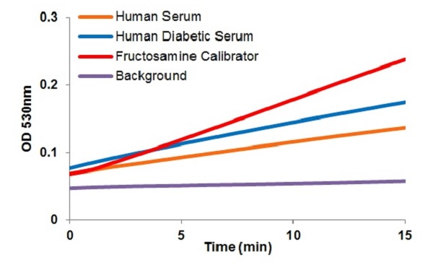
Figure 1. Fructosamine concentrations (µmol/L): Estimated Fructosamine concentrations are 222.4 ± 20.7 µmol/L in healthy human Serum (10 µl) and 458.8 ± 43.9 µmol/L in Human Diabetic Serum (10 µl), respectively. Assays were performed following the kit protocol.
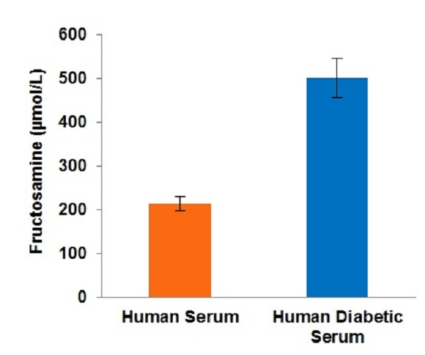
Figure 2. Fructosamine reaction curves.

- Notes

Technical Support
Copyright © 2024 Abcam. All Rights Reserved. The Abcam logo is a registered trademark. All information / detail is correct at time of going to print.
For all technical or commercial enquiries please go to:
www.abcam.com/contactus
www.abcam.cn/contactus (China)
www.abcam.co.jp/contactus (Japan)

