Version 3c, Last updated 7 May 2024

ab233471

Lipid Peroxidation (MDA) Assay Kit (Colorimetric)

For the measurement of lipid peroxidation.

This product is for research use only and is not intended for diagnostic use.

Table of Contents
1. Overview 1
2. Materials Supplied and Storage 2
3. Materials Required, Not Supplied 3
4. General guidelines, precautions, and troubleshooting 4
5. Reagent Preparation 5
6. Standard Preparation 6
7. Sample Preparation 6
8. Assay Procedure 7
9. Data Analysis 9
10. FAQs / Troubleshooting 10
11. Typical Data 12
12. Notes 13

- Overview
Lipid Peroxidation (MDA) Assay Kit (Colorimetric)(ab233471) offers the most rapid and convenient method to measure malondialdehyde (MDA) without TBARS heating steps. MDA Color Reagent reacts with MDA to generate a blue color product which is measured at 695 nm with absorbance microplate readers. This assay is very fast and specific to MDA with little interference from other aldehydes.

Prepare serially diluted MDA standards and test samples.

Add 10 µl of MDA Color Reagent stock solution into each well of MDA standard.

Incubate at room temperature for 10-30 minutes.

Add 40 µl of Reaction Solution and incubate at room temperature for 30-60 minutes.

Monitor absorbance increase at 695 nm.

- Materials Supplied and Storage
Store kit at -20°C immediately upon receipt. Kit can be stored for 1 year from receipt, if components have not been reconstituted.
Aliquot components in working volumes before storing at the recommended temperature.
Avoid repeated freeze-thaws of reagents.
Item | Quantity | Storage temperature (before prep) | Storage temperature (after prep)
MDA Color Reagent | 1 vial | -20°C | -20°C
Dilution Buffer | 10 mL | -20°C | -20°C
MDA Standard | 1 vial | -20°C | -20°C
Reaction Solution | 10 mL | -20°C | -20°C

- Materials Required, Not Supplied
These materials are not included in the kit, but will be required to successfully perform this assay:
- Ultra pure and sterile water (ddH₂O).
- 96-well clear bottom microplates.
- Microplate reader capable of reading absorbance at 695 nm.

- General guidelines, precautions, and troubleshooting
Please observe safe laboratory practice and consult the safety datasheet.
For general guidelines, precautions, limitations on the use of our assay kits and general assay troubleshooting tips, particularly for first time users, please consult our guide: www.abcam.com/assaykitguidelines
For typical data produced using the assay, please see the assay kit datasheet on our website.

- Reagent Preparation
Briefly centrifuge small vials at low speed prior to opening.

MDA Color Reagent
Ready to use as supplied.

ΔNote: Aliquot into single use size and store at -20°C protected from light.

Dilution Buffer
Ready to use as supplied.

MDA Standard
Add 100 µL of ddH₂O into MDA Standard vial to make 100 mM MDA stock solution.

Reaction Solution
Ready to use as supplied.

- Standard Preparation
Prepare serially diluted MDA standards

- Prepare 100 mM MDA stock solution as described above (Reagent Preparation 5.3).
- Add 10 μL of MDA standard (100 mM) into 990 μL of Dilution Buffer (Component B) to get MDA standard solution (1000 μM).
- Perform serial dilutions in Dilution Buffer to obtain 800, 600, 400, 200, 100, 50 and 0 μM serially diluted MDA standards.

- Sample Preparation
- Prepare serially diluted Test Samples in Dilution Buffer.

- Assay Procedure
- Equilibrate all materials and prepared reagents to room temperature just prior to use and gently agitate.
- Assay all standards, controls and samples in duplicate.

Prepare assay plate

Add 50 µl of test samples and serially diluted MDA standards into a 96-well clear bottom microplate as describled in the table, below.

Blank Control | Blank Control | Test Sample | Test Sample
MDA 1 | MDA 1 | … | …
MDA 2 | MDA 2 | …
MDA 3 | MDA 3
MDA 4 | MDA 4
MDA 5 | MDA 5
MDA 6 | MDA 6
MDA 7 | MDA 7

Blank Control = Dilution Buffer.
MDA 1…MDA 7 = Serially diluted MDA Standard (1000 to 50 μM, respectively).

Run MDA assay

- Add 10 μL MDA Color Reagent solution into each well of MDA Standard, Blank Control, and Test Samples.

ΔNote: For a 384-well plate, add 25 μL of MDA Standard /Test Sample and 5 μL of MDA Color Reagent stock solution into each well.

- Incubate the reaction mixture at room temperature for 10-30 minutes protected from light.
- Add 40 μL of Reaction Solution to make the total assay volume to 100 µL/well.

ΔNote: For a 384-well plate, add 20 μL of Reaction Solution to make the total assay volume 50 µL/well.

- Incubate the final reaction mixture at room temperature for 30-60 minutes.
- Measure end-point absorbance with an absorbance plate reader with path-check correction at OD 695-700 nm.

- Data Analysis
The absorbance reading in blank wells (with Dilution Buffer only) is used as a control, and is subtracted from the value of those wells with the standards and test samples.
Calculate Test Sample MDA concentrations by reference to the MDA Standard Curve correcting for the Test Sample dilution.

- FAQs / Troubleshooting
General troubleshooting points are found at www.abcam.com/assaykitguidelines.
1. How many cells should I start with?
For the suspension cells, please start with 1x10^6 cells/well.
For adherent cells, we suggest start with 50, 000 cells/well.
You can use a 0.5% Triton X-100 lysis buffer but avoid RIPA.
Our kit is also compatible with lysis buffer containing 10 mM Tris-HCl, pH 8, 150 mM NaCl, a protease inhibitor cocktail.

2. Do you have any experience using serum or plasma samples?
We don't have direct experiences using the kit with blood samples, it should be OK theoretically. Suggested sample preparation:
Plasma preparation
1. Collect blood using an anticoagulant such as heparin, or citrate.
2. Centrifuge the blood at 700-1,000 x g for 10 minutes at 4°C. Pipette off the yellow plasma layer without disturbing the white buffy layer.. Store plasma on ice until assaying or freeze at -80°C. The plasma sample will be stable for at least one month. Avoid repeated and freeze/thaw cycles.
Serum preparation
1. Collect blood without using an anticoagulant such as heparin or citrate.
2. Allow blood to clot for 30 minutes at 25°C.
3. Centrifuge the blood at 2,000 x g for 15 minutes at 4°C. Pipette off the top yellow serum layer without disturbing the white buffy layer. Store serum on ice. If not assaying the same day, freeze at -80°C. The sample will be stable for at least one month. Avoid repeated and freeze/thaw cycles.

3. How can I prepare tissue samples?
For tissue extracts preparation, please use 20mM Na Phosphate buffer pH~ 3-3.2+ 0.5% TritonX-100. As long as your sample is at pH 3-3.2, the presence of nonspecific aldehydes in the sample will not affect the absorbance reading of 695nm. One should be able to have right color at 695 nm if your samples have MDA.

- Typical Data
Data provided for demonstration purposes only.
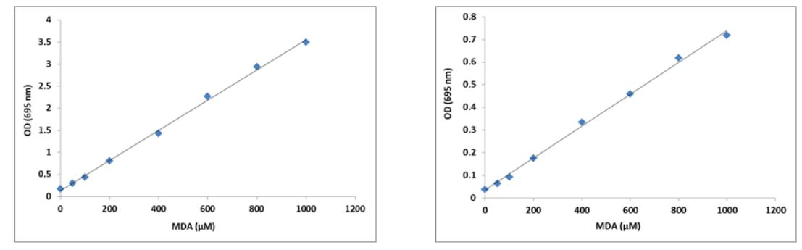
Figure 1 MDA dose response was measured with AB233471 on a 96-well clear bottom microplate using a SpectraMax microplate reader (Molecular Devices). (Pathcheck on (Left image); Pathcheck off (Right image)).
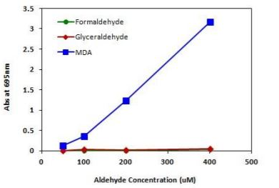
Figure 2 Signal comparison of MDA, Formaldehyde and Glyceraldehyde (right).

- Notes

Technical Support
Copyright © 2024 Abcam. All Rights Reserved. The Abcam logo is a registered trademark. All information / detail is correct at time of going to print.
For all technical or commercial enquiries please go to:
www.abcam.com/contactus
www.abcam.cn/contactus (China)
www.abcam.co.jp/contactus (Japan)

