Version 1c Last updated 16 August 2021

ab233486

Global DNA Methylation Assay Kit (5 Methyl Cytosine, Colorimetric)

For detecting global DNA methylation levels using DNA isolated from any species including mammals, plants, fungi, bacteria, and viruses in cultured cells, fresh and frozen tissues, paraffin-embedded tissues, plasma/serum samples, and body fluid samples.

This product is for research use only and is not intended for diagnostic use.
Table of Contents
1. Overview 1
2. Materials Supplied and Storage 2
3. Materials Required, Not Supplied 3
4. General guidelines, precautions, and troubleshooting 4
5. Reagent Preparation 5
6. Standard Preparation 7
7. Sample Preparation 8
8. Assay Procedure 9
9. Data Analysis 12
10. Typical Data 13
11. Troubleshooting 15
12. Appendix 18
13. Notes 22

- Overview
Global DNA Methylation Assay Kit (5 Methyl Cytosine, Colorimetric) (ab233486) contains all reagents necessary for the quantification of global DNA methylation. In this assay, DNA is bound to strip-wells that are specifically treated to have a high DNA affinity. The methylated fraction of DNA is detected using capture and detection antibodies and then quantified colorimetrically by reading the absorbance in a microplate spectrophotometer. The percentage of methylated DNA is proportional to the OD intensity measured.

Bind DNA to assay wells.

Wash wells, then add detection complex solution.

Wash and add color developer solution.

Measure absorbance at 450 nm.

- Materials Supplied and Storage
Store Negative Control, Positive Control, Signal Indicator and Enhancer Solution at –20°C away from light. Store 10X Wash Buffer, 5-mC Antibody, 1000X, Developer Solution, and 8Well Assay Strips at 4°C away from light. Store Binding Solution and Stop Solution at room temperature away from light. Kit can be stored for 1 year from receipt, if components have not been reconstituted.
Aliquot components in working volumes before storing at the recommended temperature.
Avoid repeated freeze-thaws of reagents.
Item | 48 tests Quantity | 96 tests Quantity | Storage temperature (before prep)
10X Wash Buffer | 14 mL | 28 mL | 4°C
Binding Solution | 5 mL | 10 mL | RT
Negative Control containing 0% 5mC, 50 µg/mL | 50 µL | 100 µL | -20°C
Positive Control containing 5% 5mC, 50 µg/mL | 10 µL | 20 µL | -20°C
5-mC Antibody, 1000X | 5 µL | 10 µL | 4°C
Signal Indicator, 1000X | 5 µL | 10 µL | -20°C
Enhancer Solution, 1000X | 5 µL | 10 µL | -20°C
Developer Solution | 5 mL | 10 mL | 4°C
Stop Solution | 5 mL | 10 mL | RT
8-Well Assay Strips (With Frame) | 6 | 12 | 4°C

- Materials Required, Not Supplied
These materials are not included in the kit, but will be required to successfully perform this assay:

- Microplate reader capable of reading absorbance at 450 nm.
- Incubator for 37°C incubation.
- Plate seal or Parafilm M.
- Distilled water.
- 1X TE buffer pH 7.5 to 8.0.
- Isolated DNA of interest.

- General guidelines, precautions, and troubleshooting
Please observe safe laboratory practice and consult the safety datasheet.
For general guidelines, precautions, limitations on the use of our assay kits and general assay troubleshooting tips, particularly for first time users, please consult our guide: www.abcam.com/assaykitguidelines
For typical data produced using the assay, please see the assay kit datasheet on our website.

- Reagent Preparation
Briefly centrifuge small vials at low speed prior to opening.

10X Wash Buffer
    - For a 48-reaction size kit, prepare diluted 1X Wash Buffer by adding 13 mL of 10X Wash Buffer to 117 mL of distilled water and adjust pH to 7.2-7.5.
    - For the 96-reaction size kit, add 26 mL of 10X Wash Buffer to 234 mL of distilled water and adjust pH to 7.2-7.5.
Δ Note Diluted 1X Wash Buffer can now be stored at 4°C for up to six months.

Binding Solution
Ready to use as supplied.

Negative Control containing 0% 5mC, 50 µg/mL
Ready to use as supplied.

Positive Control containing 5% 5mC, 50 µg/mL
Ready to use as supplied.

5-mC Antibody, 1000X
Ready to use as supplied.

Signal Indicator, 1000X
Ready to use as supplied.

Enhancer Solution, 1000X
Ready to use as supplied.

Developer Solution
Ready to use as supplied.

Stop Solution
Ready to use as supplied.
8-Well Assay Strips (With Frame)
Ready to use as supplied.

- Standard Preparation
- Always prepare a fresh set of standards for every use.
- Discard working standard dilutions after use as they do not store well.

- Dilute 1 µL of Positive Control with 9 µL of Negative Control to make Diluted Positive Control. Mix well.
- Then, prepare 6 concentration points for the control by combining Positive Control, Diluted Positive Control, and Negative Control according to the following chart. Mix well to ensure the accuracy of the concentration.

Control | Positive Control (PC) (5.0%) | Diluted Positive Control (0.5%) | Negative Control (NC)
0.1% PC/well | 0.0 µL | 1.0 µL | 9.0 µL
0.2% PC/well | 0.0 µL | 1.0 µL | 4.0 µL
0.5% PC/well | 0.0 µL | 3.0 µL | 3.0 µL
1.0% PC/well | 1.0 µL | 0.0 µL | 9.0 µL
2.0% PC/well | 1.0 µL | 0.0 µL | 4.0 µL
5.0% PC/well | 3.0 µL | 0.0 µL | 3.0 µL

Δ Note The above volumes will be sufficient for one standard curve in duplicate (12 wells total). The Positive Control concentrations are based on per assay well, not per microliter.

- Sample Preparation
General sample information:
Input DNA Quality and Amount:
Input DNA should be relatively pure with 260/280 ratio >1.6 and can be diluted with water or TE buffer. The DNA amount can range from 20 ng to 200 ng per reaction. However, we recommend using 100 ng of DNA, which is the optimized input amount for the best results.

DNA Isolation:
You can use your method of choice for DNA isolation. Abcam offers a series of genomic DNA isolation kits for your convenience.

DNA Storage:
Isolated genomic DNA can be stored at 4°C (short term) or –20°C (long term) until use.

- Assay Procedure
- Equilibrate all materials and prepared reagents to room temperature just prior to use and gently agitate.
- Assay all standards, controls and samples in duplicate.
- Review the configuration of the strip-well plate setup for standard curve preparation in a 48-assays format below (for a 96-reaction format, strips 7 through 12 can be configured as Sample). The controls and samples can be measured in duplicate, loaded vertically instead of horizontally.

Well | Strip 1 | Strip 2 | Strip 3 | Strip 4 | Strip 4 | Strip 4
A | NC | 1% PC | Sample 2 | Sample 6 | Sample 10 | Sample 14
B | NC | 1% PC | Sample 2 | Sample 6 | Sample 10 | Sample 14
C | 0.1% PC | 2% PC | Sample 3 | Sample 7 | Sample 11 | Sample 15
D | 0.1% PC | 2% PC | Sample 3 | Sample 7 | Sample 11 | Sample 15
E | 0.2% PC | 5% PC | Sample 4 | Sample 8 | Sample 12 | Sample 16
F | 0.2% PC | 5% PC | Sample 4 | Sample 8 | Sample 12 | Sample 16
G | 0.5% PC | Sample 1 | Sample 5 | Sample 9 | Sample 13 | Sample 17
H | 0.5% PC | Sample 1 | Sample 5 | Sample 9 | Sample 13 | Sample 17

DNA Binding:
- Predetermine the number of strip-wells required for your experiment. Carefully remove un-needed strip-wells from the plate frame and place them back in the bag (seal the bag tightly and store at 4°C).
- For negative control wells: Add 100 µL of Binding Solution and 2 µL of Negative Control.
- For positive control wells: Add 100 µL of Binding Solution and 2 µL of Positive Control at different concentrations (0.1%-5%) to generate a standard curve (See Section 6).
- For sample wells: Add 100 µL of Binding Solution and 100 ng of your sample DNA (2-4 µL).
Δ Note To reduce cross variation between replicates, it is important to load the wells in vertical formation according to the plate layout depicted above.
Δ Note For the positive controls, total DNA is 100 ng per well with different methylation percentages (0.1%, 0.2%, 0.5%, 1%, 2%, and 5%). The positive controls should be assayed in parallel with the samples in the same plate and a new positive control standard curve should be generated for each assay.
Δ Note For optimal binding and to reduce pipetting error, sample DNA volume added should be 2 µl or more, but should not exceed 5 µl. If the sample DNA is not 100 ng per well, the amount of positive control DNA should be adjusted accordingly to be equal to the amount of the sample DNA that is used to ensure the accuracy of 5-mC quantification.
Δ Note To ensure that NC, PC, and sample DNA are completely added into the wells, the DNA should be mixed well before use and the pipette tip should be placed into the BS solution in the well and aspirated in/out 1-2 times. Changing the tips each time when adding the sample will increase sample volume accuracy added into each well.
- Mix solution by gently tilting from side to side or by gently shaking the plate several times to ensure the solution coats the bottom of the well evenly. Cover strip plate with plate seal or Parafilm M and incubate at 37°C for 60 minutes
- During the last 10 minutes of sample incubation, prepare the 5-mC Detection Complex Solution: In each 1 ml of diluted 1X Wash Buffer add 1 µL of 5-mC Antibody, 1000X, mix and then add 1 µL of Signal Indicator, 1000X and 0.5 µL of Enhancer Solution, 1000X. Mix well.
- Remove the Binding Solution from each well after 60 minute incubation. Wash each well with 150 µL of the diluted 1X Wash Buffer each time for three times. This can be done by simply pipetting diluted 1X Wash Buffer in and out of the wells.

Methylated DNA Detection and Signal Measurement:
- Add 50 µL of the 5-mC Detection Complex Solution to each well, then cover and incubate at room temperature for 50 minutes.
- Remove the 5-mC Detection Complex Solution from each well.
- Wash each well with 150 µL of the diluted 1X Wash Buffer each time for five times.
- Add 100 µL of Developer Solution to each well in a column, not row, simultaneously in a vertical fashion with a multichannel pipette so that replicates are developed at the same time. Gently shake the plate against a flat surface for 5-10 seconds and incubate at room temperature for 3-4 minutes. Monitor color development in the sample wells and control wells. After a few minutes, the Developer Solution will turn blue in the presence of sufficient methylated DNA. The color in the Negative Control wells will remain generally unchanged.
- When the color in the 5% Positive Control wells turns deep blue, stop the enzyme reaction by adding 100 µL of Stop Solution to each well in a column, not row, simultaneously in a vertical fashion with a multi-channel pipette so that replicates are stopped at the same time. Mix the solution by gently shaking the plate against a flat surface and wait 1-2 minutes to allow the color reaction to be completely stopped. The color will change to yellow after adding Stop Solution and the absorbance should be read on a microplate reader at 450 nm within 2-15 minutes.
Δ Note The color development time may vary from 1-10 minutes based on the speed of color change, but is typically 4-5 minutes.
Δ Note If the strip-well plate frame does not fit in the microplate reader, transfer the solution to a standard 96-well microplate.

- Data Analysis
To calculate percentage of methylated DNA, first generate a standard curve and plot the OD values versus the PC at each percentage point. Next, determine the slope (OD/1%) of the standard curve using linear regression (Microsoft Excel can be used) and the most linear part (at least 4 concentration points including 0 point) of the standard curve for optimal slope calculation. Now, calculate the percentage of methylated DNA (5-mC) in total DNA using the following formula:

$$5-mC\%=\frac{Sample OD-Negative Control OD}{Slope x S}*100\%$$

S is the amount of input sample DNA in ng.

Example Calculation:
Average OD450 of Negative Control is 0.065
Average OD450 of sample is 0.305
Slope is 0.15 OD/1%
S is 100 ng

$$5-mC\%=\frac{0.305-0.065}{0.15 x 100}*100\%=1.60\%$$

Δ Note The calculated 5-mC% is 5-mC/total DNA (A+G+C+T). If the 5-mC% would be presented as 5-mC/(5-mC+C), simply divide the calculated 5-mC% by cytosine content of the species if it is available. For example, cytosine content is 21% in human DNA, thus 5mC/(5-mC+C) is 1.6% ÷ 0.21 = 7.62%.
Δ Note In the event that the standard curve is flat due to high ODs starting from the lowest %PC or is flat at high %PCs because of a saturated signal intensity due to extended color development time, the 5-mC% can be calculated with logarithmic or polynomial second order regression, respectively (see the Appendix).
- Typical Data
Data provided for demonstration purposes only.

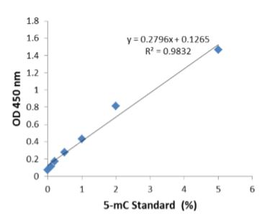

Figure 1. An example of an optimal standard curve generated with 5-mC standard control.

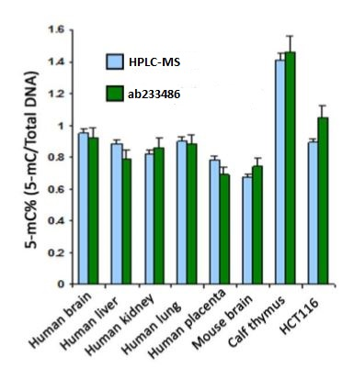

Figure 2. Accurate quantification of 5-mC content of various DNA samples from different species using Global DNA Methylation Assay Kit (5 Methyl Cytosine, Colorimetric. The results are closely correlated with those obtained by HPLC-MS.

- Troubleshooting
Problem | Reason | Solution
No signal in both the positive control and sample wells | Reagents are added incorrectly. | Check if reagents are added in the proper order and if any steps in the protocol may have been omitted by mistake.
No signal in both the positive control and sample wells | The well is incorrectly washed  before DNA binding. | Ensure the well is not washed prior to adding the positive control and sample.
No signal in both the positive control and sample wells | The bottom of the well is not completely covered by the Binding Solution. | Ensure the solution coats the bottom of the well by gently tilting from side to side or gently shaking the plate several times.
No signal in both the positive control and sample wells | Incubation time and temperature are incorrect. | Ensure the incubation time and temperature described in the protocol are followed correctly.
No signal in both the positive control and sample wells | Insufficient input materials. | Ensure that a sufficient amount of positive control and samples are added into the wells.
No signal in both the positive control and sample wells | Incorrect absorbance reading. | Check if appropriate absorbance wavelength (450 nm) is used.
No signal in both the positive control and sample wells | Kit was not stored or handled properly. | Ensure all components of the kit were stored at the appropriate temperature and the caps are tightly capped after each opening or use.
No signal or weak signal in only the positive control wells | The Positive Control DNA is insufficiently added to the well. | Ensure a sufficient amount of positive control DNA is added.
No signal or weak signal in only the positive control wells | The Positive Control is degraded due to improper storage conditions. | Follow the Shipping & Storage guidance in this User Guide for storage of Positive Control.
High background present in the negative control wells | Insufficient washing of wells. | Check if washing recommendations at each step are performed according to the protocol.
High background present in the negative control wells | Contaminated by sample or positive control DNA. | Ensure the well is not contaminated from adding sample or positive control DNA accidentally or from using contaminated tips.
High background present in the negative control wells | Incubation time is too long. | The incubation time at Step 8.2.1 should not exceed 2 hours.
High background present in the negative control wells | Over development of color. | Decrease the development time in Step 8.2.4 before adding Stop Solution in Step 8.2.5.
Large variation between replicate wells | Horizontal positioning of well replicates causes inconsistent delays in pipetting and loading of reagents. | Follow the vertical layout example provided. Ensure loading of reagents is also in vertical order with a multi-channel pipette, especially when adding Developer Solution and Stop Solution in Step 8.2.
Large variation between replicate wells | Color reaction is not evenly stopped due to an inconsistency in pipetting time or in pipetting volume. | Ensure Developer Solution and Stop Solution is added at the same time between replicates or otherwise maintains a consistent timing in between each addition of solutions. Ensure the solution in each pipette tip is equal in the multi-channel pipette. Equilibrate the pipette tip in any solutions before adding them. Ensure the solutions, especially those with small volumes (e.g., 1 µL) are completely added into the wells. Pay special attention at the steps of adding DNA samples and preparing 5-mC Detection Complex Solution.
Large variation between replicate wells | Color reaction is not evenly stopped due to an inconsistent order of adding solutions. | Ensure all solutions, particularly Developer Solution and Stop Solution, are added in the same order each time as all other solutions.
Large variation between replicate wells | Residue wash buffer is present in some of the wells. | Ensure the wash buffer is completely removed at each wash step.
Large variation between replicate wells | Solutions or antibodies were not actually added into the wells. | Do not allow pipette tip to touch the outer edges or inner sides of the wells to prevent solutions from sticking to the surface
Large variation between replicate wells | Did not sufficiently shake the solutions in the wells at Step 8.2.4 and Step 8.2.5. | Gently and evenly shake the plate frame across a flat surface so that the solutions in the wells are better distributed. Do not stir.
Large variation between replicate wells | Did not use the same pipette device throughout the experiment. | Use the same multi-channel pipette device throughout the entire experiment, as different pipette devices may have slight variations in performance.
Large variation between replicate wells | Splashing of reagents between wells. | Pipette carefully against the sides of the wells to avoid splashing
Large variation between replicate wells | Temperature variations across the plate. | Ensure plates are evenly and fully covered during incubation steps in a stable temperature environment, away from drafts.
Large variation between sample replicate wells only | Sample DNA is sedimented or uneven prior to loading to wells. | Mix your sample DNA sufficiently and evenly prior to loading it into wells.
5-mC Antibody vial appears to be empty or insufficient in volume | Buffer evaporated due to the very small volumes, resulting in a higher concentrated antibody. | Add 1X PBS buffer into the 5-mC Antibody vial until you restore the correct, intended volume according to the Kit Contents described in this User Guide. Mix and centrifuge prior to use.

- Appendix
Method 1: 5-mC% Calculation Using Logarithmic Second Order Regression
Use this method when the standard curve is flat due to high ODs starting from the lowest %PC.

    - Plot the average OD value on the Y-axis versus the known 5-mC percentage of each PC point on the X-axis.
    - Graph the second order logarithmic curve* (also see “Example Calculation” below) and obtain second order logarithmic regression equation:

$$Y=a ln(X) + b$$

Here, X = 5-mC%; Y = <Sample OD>; a is Slope and b is Y-intercept, respectively.

    - Calculate 5-mC% of the samples based on the following equation, derived from the above equation

$$5-mC\% = e^{[(Y-b)/a]} ÷ S x 100\%$$

Here, S is the amount of input sample DNA in ng.

Example Calculation

The example positive control ODs are as follows:

PC% Mean OD
0.1 0.55
0.2 0.76
0.5 0.92
1.0 1.15
2.0 1.29
5.0 1.55

The average Negative Control OD is 0.06 and the sample OD is 1.274
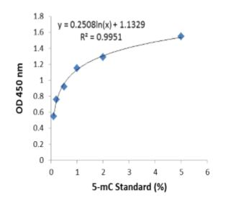
Standard curve generated with use of the positive controls.

Data was graphed using a Standard Scatter (XY) Chart in Microsoft Excel. In the figure above, a = 0.2508, b = 1.1329, Y = 1.274. Input DNA amount was 100 ng.

5-mC% of the sample was calculated accordingly:

$$5-mC\% = e^{\left[\frac{1.274-1.1329}{a}=0.2508\right]} ÷ 100 x 100\%=1.75\%$$

  - Method 2: 5-mC% Calculation Using Polynomial Second Order Regression
Use this method when the standard curve is flat due to a saturated signal intensity at high %PCs.

    - Plot the average delta OD values on the Y-axis versus the known 5-mC percentage of each PC point on the X-axis
    - Graph the second order polynomial curve* (also see “Example Calculation” below) and obtain second order polynomial regression equation:

$$Y={aX}^{2} + bX$$

Here, X = 5-mC%; Y = <Sample OD> – <NC OD>; a and b is known Slope 1 and Slope 2, respectively.

    - Calculate 5-mC% of the samples based on the following equation, derived from the above equation

$$5-mC\% = \frac{{\left(b^{2}+4aY\right)}^{0.5}-b}{2a} ÷ S x 100\%$$

Here, S is the amount of input sample DNA in ng.

Example Calculation

The example positive control ODs are as follows:

PC% Mean OD
0.1 0.55
0.2 0.76
0.5 0.92
1.0 1.15
2.0 1.29
5.0 1.55

The average Negative Control OD is 0.06 and the sample OD is 1.274.
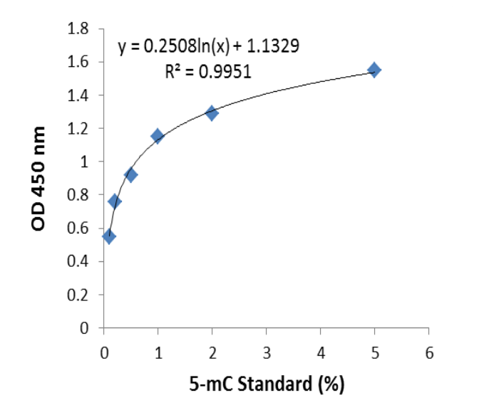
Standard curve generated with use of the positive controls.

Data was graphed using a Standard Scatter (XY) Chart in Microsoft Excel. In the figure above, a = 0.2508, b = 1.1329, Y = 1.274. Input DNA amount was 100 ng.

5-mC% of the sample was calculated accordingly:

$5-mC\% = e^{[\left(1.274-1.1329\right)/0.2508]} ÷ 100 x 100\%=1.75\%$

- Notes

Technical Support
Copyright © 2012-2018 Abcam. All Rights Reserved. The Abcam logo is a registered trademark. All information / detail is correct at time of going to print.

For all technical and commercial enquires please go to:
www.abcam.com/contactus
www.abcam.cn/contactus (China)
www.abcam.co.jp/contactus (Japan)

