Version 2a, Last updated 6 June 2023

ab234051

Chymotrypsin Assay Kit (Fluorometric)

For the measurement of chymotrypsin activity in cell and tissue lysates.

This product is for research use only and is not intended for diagnostic use.

PLEASE NOTE: With the acquisition of BioVision by Abcam, we have made some changes to component names and packaging to better align with our global standards as we work towards environmental-friendly and efficient growth. You are receiving the same high-quality products as always, with no changes to specifications or protocols.

Table of Contents
1. Overview 1
2. Materials Supplied and Storage 2
3. Materials Required, Not Supplied 3
4. General guidelines, precautions, and troubleshooting 4
5. Reagent Preparation 5
6. Standard Preparation 6
7. Sample Preparation 7
8. Assay Procedure 8
9. Data Analysis 10
10. FAQs / Troubleshooting 12
11. Typical Data 13
12. Notes 16

- Overview
Chymotrypsin Assay Kit (Fluorometric) (ab234051) uses a synthetic fluorogenic substrate, enabling kinetic measurement of chymotrypsin activity in cell and tissue lysates. A chymotrypsin activator cleaves chymotrypsinogen to form active chymotrypsin, which then hydrolyzes the non-fluorescent substrate to release a stable fluorophore. The kit includes a selective chymotrypsin inhibitor that can be used to measure specific chymotrypsin activity in samples containing non-specific proteases and endopeptidases that may also metabolize the substrate. The assay can detect as low as 0.01 mU of Chymotrypsin.

Homogenize sample with ice-cold Assay Buffer I/Chymotrypsin Assay Buffer and keep on ice for 10 minutes.

Prepare sample wells and Chymotrypsin Positive Control well and add Assay Buffer I/Chymotrypsin Assay Buffer for background control well.

Generate a Standard Curve using the AMC Standard/Coumarin Standards Stock solution.

Prepare reaction mixes for test sample and sample background control wells. Add sample background control mix to each of the sample background control wells and add reaction mix to wells containing samples, sample + inhibitor, positive control and reagent background control.

Record the fluorescence Ex/Em= 380/460 nm in kinetic mode for 30-60 minutes at 25 °C.

- Materials Supplied and Storage
Store kit at -20°C protected from light immediately on receipt and check below for storage for individual components. Kit can be stored for 1 year from receipt, if components have not been reconstituted.
Reconstituted components are stable for 2 months.
Aliquot components in working volumes before storing at the recommended temperature.
Avoid repeated freeze-thaws of reagents.
Item | Quantity | Storage temperature (before prep) | Storage temperature (after prep)
Assay Buffer I/Chymotrypsin Assay Buffer | 25 mL | -20°C | -20°C
Chymotrypsin Substrate | 200 µL | -20°C | -20°C
Chymotrypsin Activator | 1 vial | -20°C | -80°C
Chymotrypsin Inhibitor I/Chymotrypsin Inhibitor | 80 µL | -20°C | -20°C
AMC Standard/Coumarin Standard (1 mM) | 100 µL | -20°C | -20°C
Chymotrypsin Positive Control | 1 vial | -20°C | -80°C

- Materials Required, Not Supplied
These materials are not included in the kit, but will be required to successfully perform this assay:
- 96-well clear or white plate with flat bottom.
- Multi-well spectrophotometer.
- Anhydrous DMSO.
- General guidelines, precautions, and troubleshooting
Please observe safe laboratory practice and consult the safety datasheet.
For general guidelines, precautions, limitations on the use of our assay kits and general assay troubleshooting tips, particularly for first time users, please consult our guide: www.abcam.com/assaykitguidelines
For typical data produced using the assay, please see the assay kit datasheet on our website.

- Reagent Preparation
Briefly centrifuge small vials at low speed prior to opening.

Assay Buffer I/Chymotrypsin Assay Buffer
- Warm to room temperature before use.

Chymotrypsin Substrate
- Thaw completely before use.
- Mix well.

Chymotrypsin Activator
- Reconstitute with 220 µL Assay Buffer I/Chymotrypsin Assay Buffer immediately before use.
- Aliquot remainder and store at -80 ºC.
- Once reconstituted, use within 2 months.

Chymotrypsin Inhibitor I/Chymotrypsin Inhibitor
- Thaw completely before use.
- Mix well.

AMC Standard/Coumarin Standard
- Thaw completely before use.
- Mix well.

Chymotrypsin Positive Control
- Reconstitute with 22 µL Assay Buffer I/Chymotrypsin Assay Buffer immediately before use.
- Aliquot remainder and store at -80 ºC.
- Once reconstituted, use within 2 months.

- Standard Preparation
- Always prepare a fresh set of standards for every use.
- Discard working standard dilutions after use as they do not store well.

- Add 0, 2, 4, 6, 8 and 10 µL from the provided 1 Mm AMC Standard/Coumarin Standard stock solution into a series of wells in a clear 96-well plate.
- Bring the total volume up to 100 µL per well with Assay Buffer I/Chymotrypsin Assay Buffer to generate 0, 2, 4, 6, 8 and 10 nmol/well of AMC Standard/Coumarin Standard.
- Mix by pipetting, making sure that no bubbles are introduced in the wells.

Δ Note: If sample activity is low (outside standard curve RFU values), another standard curve ranging from 0.1 to 1 nmol/well may be generated. For this, dilute the provided AMC Standard/Coumarin Standard 1:10 in DMSO to obtain a 100 µM AMC Standard/Coumarin Standard solution. Add 0, 2, 4, 6, 8 and 10 µL of the 100 µM solution into a series of wells in a 96 well plate and bring the total volume up to 100 µL with Assay Buffer I/Chymotrypsin Assay Buffer to generate 0, 0.2, 0.4, 0.8 and 1 nmol/well of AMC Standard/Coumarin Standard.

- Sample Preparation
General sample information:
We recommend that you use fresh samples for the most reproducible assay.

- Homogenize cells (1 x 10⁶) or tissue (20 mg) with 100 μL ice-cold Assay Buffer I/Chymotrypsin Assay Buffer and keep on ice for 10 minutes.
- Centrifuge at 10,000 x g for 10 minutes at 4°C and transfer the supernatant to a fresh tube.
- Determine protein concentration.
Δ Note: Protein concentration should range between 5-20 mg/mL. Concentrated samples may be diluted with Assay Buffer I/Chymotrypsin Assay Buffer. Aliquot and store lysates at -80°C unless being used immediately.
- Use 5-20 μL sample per well using a clear 96-well plate.
- Prepare two identical wells for each sample labeled “Sample Background Control” and “Sample”.
- An additional well called “Sample + Inhibitor” may be prepared for samples in which nonspecific chymotrypsin-like protease activity is likely to be present. For this, add 2 μL of Chymotrypsin Inhibitor I/chymotrypsin inhibitor in addition to sample.
- Adjust volume in each well to 50 μL with Assay Buffer I/Chymotrypsin Assay Buffer.
Δ Note: For unknown samples, we suggest testing several concentrations to ensure the readings are within the Standard Curve range.

- Assay Procedure

- Equilibrate all materials and prepared reagents to room temperature just prior to use and gently agitate.
- Assay all standards, controls and samples in duplicate.

Positive Control
- Add 1-4 μL of Chymotrypsin Positive Control into desired well(s) and adjust the final volume to 50 μL with Assay Buffer I/Chymotrypsin Assay Buffer.

Reagent background control
- Add 50 μL of Assay Buffer I/Chymotrypsin Assay Buffer to a well.

Reaction Mix
- Mix enough reagents for the number of assay to be performed (50 µL/well).
- Add 50 μL of the Sample Background Control Mix to each of the “Sample Background Control” well and 50 μL of the Reaction Mix to wells containing samples, sample + inhibitor, positive control and reagent background control for a final volume of 100 μL per well.
Δ Note: Turbidity upon addition of Chymotrypsin Substrate to
Assay Buffer I/Chymotrypsin Assay buffer is normal and will disappear following vortexing.

Component | Reaction Mix (µL) | Sample Background Control Mix (µL)
Assay Buffer I/Chymotrypsin Assay Buffer | 46 µL | 48 µL
Chymotrypsin Substrate | 2 µL | -
Chymotrypsin Activator | 2 µL | 2 µL

Measurement
- Immediately start recording the fluorescence (Ex/Em = 380/460 nm) in kinetic mode (i.e. at 30 second intervals) for 30-60 minutes at 25°C.
Δ Note: Ideal measurement time depends on the chymotrypsin activity in samples. We recommend running the assay in kinetic mode to ensure that the linear reaction phase is recorded. The AMC Standard/Coumarin Standard curve can be read in endpoint mode.

- Data Analysis
- Average the duplicate reading for each standard, control and sample.
- Subtract the mean value of the blank (the 0 pmol/well reading) from all other AMC Standard/Coumarin standards. This is the corrected absorbance.
- Plot the standard curve.
- For sample reaction wells (including paired inhibitor control wells), choose two time points (t₁ and t₂) in the linear phase of the reaction progress curve, obtain the corresponding fluorescence values at those points (RFU₁ and RFU₂) and determine the change in fluorescence over the time interval: ΔF = RFU₂ – RFU₁.
- Subtract the reagent background control ΔF value from the respective sample ΔF values.
Δ Note: If sample background control ΔF values are higher than reagents background control, subtract the sample background control from the corresponding sample (rather than subtracting the reagent background control).
- Chymotrypsin specific activity is obtained by applying the background-corrected ΔF values to the AMC Standard/Coumarin Standard curve to get B pmol of substrate metabolized during the reaction time.

$$Chymotrypsin Specific Activity=\frac{ΔB}{(Δt*p)}= = pmol/min/mg = µU/mg$$
Where:
ΔB = change in Coumarin concentration during reaction (in pmol)
Δt = t₂-t₁ (in min)
p = sample protein content added to well (in mg)
If Chymotrypsin inhibitor I/Chymotrypsin inhibitor is being used, calculate chymotrypsin activity as follows:
$$Chymotrypsin Activity= Total activity in sample – Activity with Chymotrypsin Inhibitor$$
Unit Definition: One unit of Chymotrypsin is the amount of enzyme that generates 1.0 µmol of coumarin per minute at pH 8 at 25°C.

- FAQs / Troubleshooting
General troubleshooting points are found at www.abcam.com/assaykitguidelines.
- Typical Data
Data provided for demonstration purposes only.
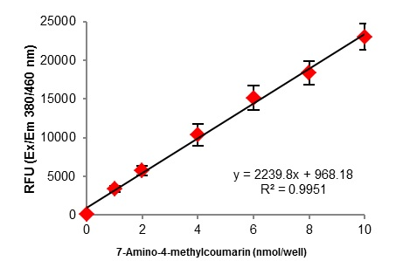
Figure 1. AMC Standard/Coumarin standard curves showing a range of 0-10 nmol/well.

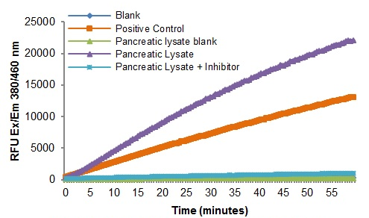

Figure 2. Reaction kinetics for positive control and rat pancreatic lysate (9 µg).

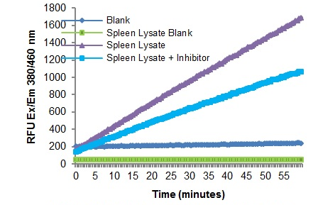

Figure 3. Reaction kinetics for rat spleen lysate (160 µg).

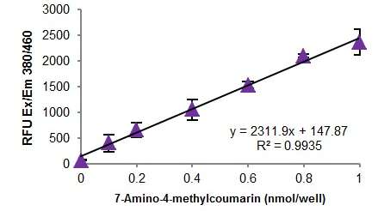

Figure 3. AMC Standard/Coumarin standard curves showing a range od 0-1 nmol/well.

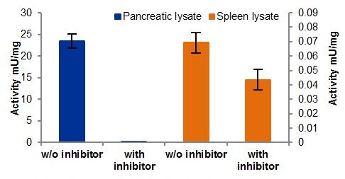

Figure 4. Chymotrypsin activity with and without inhibitor in rat pancreas and rat spleen. The presence of non-specific chymotrypsin-like proteases in spleen leads to some activity in presence of the selective chymotrypsin inhibitor.

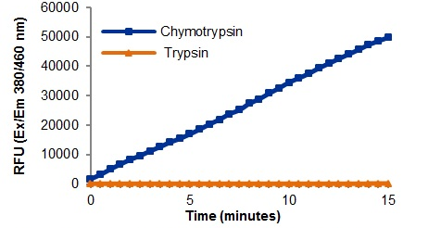

Figure 5. Reaction kinetics using substrate in the presence of Chymotrypsin or Trypsin. The substrate is cleaved by chymotrypsin but not trypsin, making the assay free from trypsin interference.

- Notes

Technical Support
Copyright © 2023 Abcam. All Rights Reserved. The Abcam logo is a registered trademark. All information / detail is correct at time of going to print.
For all technical or commercial enquiries please go to:
www.abcam.com/contactus
www.abcam.cn/contactus (China)
www.abcam.co.jp/contactus (Japan)

