Version 2a, Last updated 9 June 2023

ab235613 Lithium Assay Kit (Colorimetric)

For the measurement of lithium levels in human biological fluids.

This product is for research use only and is not intended for diagnostic use.

PLEASE NOTE: With the acquisition of BioVision by Abcam, we have made some changes to component names and packaging to better align with our global standards as we work towards environmental-friendly and efficient growth. You are receiving the same high-quality products as always, with no changes to specifications or protocols.
Table of Contents
1. Overview 1
2. Materials Supplied and Storage 2
3. Materials Required, Not Supplied 3
4. General guidelines, precautions, and troubleshooting 3
5. Reagent Preparation 4
6. Standard Preparation 5
7. Sample Preparation 6
8. Assay Procedure 7
9. Data Analysis 8
10. Typical Data 9
11. Notes 12

- Overview
Lithium Assay Kit (Colorimetric)(ab235613) is designed for the quantification of lithium levels in biological fluids such as serum and plasma.
The assay uses a lithium-selective bi-chromatic probe that undergoes an absorbance change at two distinct wavelengths upon binding to Li⁺ (λ₁ = 540 nm, λ₂ = 630 nm). The ratio of the two optical measurements is used to accurately calculate sample Li⁺ concentration. The kit also includes a sodium masking reagent to prevent the possibility of interference by supra-physiological levels of serum Na⁺ (hypernatremia). Endogenous mono-, di-, and trivalent ions do not interfere with the assay.
The assay is quick, is high-throughput adaptable and has a linear range from 0.5 – 10 nmole lithium per well (corresponding to 0.1 – 2 mM serum lithium). The kit can detect lithium concentration as low as 100 µM in human serum.

Prepare samples

Prepare standards

Add Lithium Assay Buffer to all sample and standard wells

Add Probe Solution to all sample and standard wells

Incubate plate at RT for 5 minutes with gently orbital shaking

Measure absorbance at 540 nm and 630 nm in endpoint mode

- Materials Supplied and Storage
Store kit at -20°C in the dark immediately on receipt and check below for storage for individual components. Kit can be stored for 1 year from receipt, if components have not been reconstituted.
Aliquot components in working volumes before storing at the recommended temperature.
Avoid repeated freeze-thaws of reagents.
Item | Quantity | Storage temperature (before prep) | Storage temperature (after prep)
Lithium Assay Buffer | 25 mL | -20°C | -20°C
Lithium Standard/Lithium Standard (10 mM) | 500 µl | -20°C | -20°C
Li Probe Solution/Probe Solution | 10 mL | -20°C | -20°C
Sodium Masking Solution/Sodium-Masking Solution | 1.5 mL | -20°C | -20°C

- Materials Required, Not Supplied
These materials are not included in the kit, but will be required to successfully perform this assay:
- Microplate reader capable of measuring absorbance at O.D. 540 nm and 630 nm
- 96 well plate with clear flat bottom

- General guidelines, precautions, and troubleshooting
Please observe safe laboratory practice and consult the safety datasheet.
For general guidelines, precautions, limitations on the use of our assay kits and general assay troubleshooting tips, particularly for first time users, please consult our guide: www.abcam.com/assaykitguidelines
For typical data produced using the assay, please see the assay kit datasheet on our website.

- Reagent Preparation
Briefly centrifuge small vials at low speed prior to opening.

Lithium Assay Buffer
- Ready to use as supplied.
- Warm to room temperature prior to use.

Lithium Standard/Lithium Standard (10 mM)
- Provided as a 10 mM stock solution of LiCl in ddH₂O.
- Prior to use, warm solution to room temperature and vortex thoroughly.

Li Probe Solution/Probe Solution
- Ready to use as supplied.
- Divide into aliquots and store at -20°C, protected from light.
- Prior to use, warm solution to room temperature and vortex thoroughly.

Sodium Masking Solution/Sodium-Masking Solution
- Ready to use as supplied.
- Divide into aliquots and store at -20°C, protected from light.
- Prior to use, warm solution to room temperature and vortex thoroughly.

- Standard Preparation
- Always prepare a fresh set of standards for every use.
- Discard working standard dilutions after use as they do not store well.

- Prepare a 500 µM solution of lithium by adding 50 µL of the Lithium Standard/10 mM Lithium Standard to 950 µL of dH₂O.
- Using the 500 µM standard, prepare standard curve dilution as described in the table in a microplate or microcentrifuge tubes:

Standard# | 500 µM  Standard (µL) | Assay Buffer (µL) | Final volume standard in well (µL) | End amount lithium standard in well (nmol/well)
1 | 0 | 40 | 20 | 0
2 | 8 | 32 | 20 | 2
3 | 16 | 24 | 20 | 4
4 | 24 | 16 | 20 | 6
5 | 32 | 8 | 20 | 8
6 | 40 | 0 | 20 | 10

Each dilution has enough standard to set up duplicate readings (2 x 20 µL).

- Sample Preparation
General sample information:
We recommend performing several dilutions of your sample to ensure the readings are within the standard value range.
We recommend that you use fresh samples for the most reproducible assay.

Biological samples:
- Collect serum or plasma samples by standard methods (see note regarding compatible blood collection tubes below). Samples exhibiting lipemia or excessive turbidity should be clarified by centrifugation at 10,000 x g for 5 minutes to separate lipid globules.
- Add 5 µL of undiluted serum/plasma sample to desired well(s) in a clear, flat bottom 96-well plate.
- To each sample well, add 15 µL of the Sodium Masking Solution/Sodium-Masking Solution, bringing the volume up to 20 µL per well.

Δ Note: For blood lithium level determination, we recommend using serum collected in tubes that are free of additives or preservatives (“off- the-clot” serum). If plasma is used, it should be collected in K₂EDTA-coated tubes that are free of lithium- or sodium-based anticoagulants or preservatives (e.g. lithium/sodium heparin, sodium citrate), as these additives will interfere with the assay.

Δ Note: For unknown samples, we recommend performing a pilot experiment to ensure readings are within the standard curve range. Samples that are outside of the standard curve range may be diluted with ddH₂O and retested (in this case, use 5 µL of the pre- diluted sample and add 15 µL Sodium Masking Solution/Sodium-Masking Solution to each well).

- Assay Procedure
- Equilibrate all materials and prepared reagents to room temperature just prior to use and gently agitate.
- Assay all standards and samples in duplicate.

Reaction Preparation:
- Add 130 µL of Lithium Assay Buffer to all sample and standard curve wells.
- Add 100 µL of Li Probe Solution/Probe Solution to all sample and standard curve wells (bringing the final volume to 250 µL per well).
- Incubate the plate at room temperature for 5 minutes with gentle orbital shaking to ensure well contents are effectively mixed.

Measurement:
- Measure the absorbance of all sample and standard curve wells at both 540 nm and 630 nm in endpoint mode.

- Data Analysis
Samples producing signals greater than that of the highest standard should be further diluted in appropriate buffer and reanalyzed, then multiply the concentration found by the appropriate dilution factor.

- For all standard curve and test sample wells, calculate the absorbance ratio (A_{ratio}) by dividing the well OD₅₄₀ value by the OD₆₃₀ value (A_{ratio} = OD₅₄₀/OD₆₃₀).
- For the Lithium Standard curve, subtract the absorbance ratio obtained for the reagent blank (0 nmol/well standard) from the standard absorbance ratios, plot the background-subtracted A_{ratio} values and calculate the slope of the standard curve.
- For test samples, calculate the corrected sample absorbance ratio (A_{C}) by subtracting the reagent blank (0 nmol/well standard) from the calculated sample ratio:
A_{C} = (OD₅₄₀/OD₆₃₀) _{sample} – (OD₅₄₀/OD₆₃₀) _{blank}.
- Apply the A_{C} values to the standard curve to get B nmol of lithium in the well.
- Concentration of lithium in the test samples is calculated as:
$$Sample lithium concentration=\frac{B}{V}*D=\frac{nmol}{µl}=mM$$
Where:
B = amount of lithium in the sample well calculated from standard curve in nmol.
V = sample volume added in the sample wells (5 µL).
D = sample dilution factor if sample is diluted to fit within the standard curve range (prior to reaction well set up). (D=1 for undiluted samples).

- Typical Data
Data provided for demonstration purposes only.

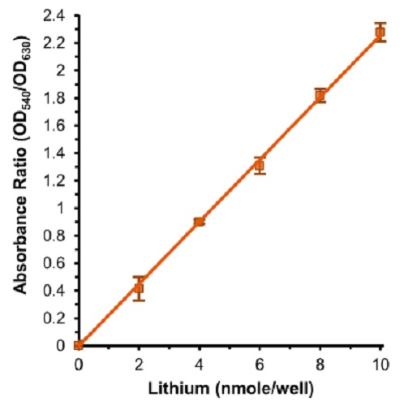

Figure 1. Lithium Standard curve. Lithium concentration is directly proportional to the ratio of absorbance measured at 540 nm and 630 nm.

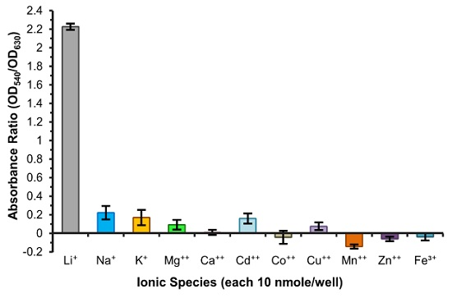

Figure 2. Specificity for detection of lithium (Li⁺) over other common monovalent, divalent and trivalent ions (each 10 nmole/well). All other cations tested contribute ≤10% interference when normalized to the signal generated by 10 nmole lithium.

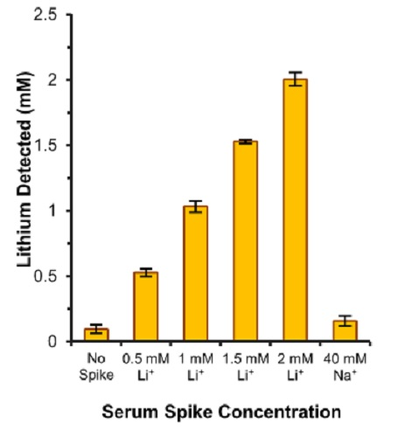
Figure 3. Estimation of lithium in human serum. Normal “off-the-clot” pooled serum (5 μL, undiluted) was spiked with 0.5 mM, 1.0 mM, 1.5 mM and 2.0 mM lithium standard. Mean lithium concentrations detected in the spiked samples were 0.52 mM, 1.03 mM, 1.53 mM and 2.01 mM, respectively (mean spike recovery rates across all spiked concentrations ranged from 100.3 – 105.5%). Potential interference by excessive serum sodium (hypernatremia) was also tested. Normal human serum (5 μL, undiluted) was spiked with an additional 40 mM NaCl to simulate hypernatremic conditions (serum Na⁺ ≥175 mM). The signal imparted by the additional 40 mM Na⁺ was equivalent to that of 0.062 mM lithium (≤10% interference for the typical therapeutic range). Data are mean ± SEM of 3 replicates, assayed according to the kit protocol.

- Notes

Technical Support
Copyright © 2023 Abcam. All Rights Reserved. The Abcam logo is a registered trademark. All information / detail is correct at time of going to print.
For all technical or commercial enquiries please go to:
www.abcam.com/contactus
www.abcam.cn/contactus (China)
www.abcam.co.jp/contactus (Japan)

