Version 2a, Last updated 6 June 2023

ab235628 Albumin (BCG) Assay Kit (Colorimetric)

For the measurement of albumin in serum.

This product is for research use only and is not intended for diagnostic use.

PLEASE NOTE: With the acquisition of BioVision by Abcam, we have made some changes to component names and packaging to better align with our global standards as we work towards environmental-friendly and efficient growth. You are receiving the same high-quality products as always, with no changes to specifications or protocols.

Table of Contents
1. Overview 1
2. Materials Supplied and Storage 2
3. Materials Required, Not Supplied 3
4. General guidelines, precautions, and troubleshooting 3
5. Reagent Preparation 4
6. Standard Preparation 5
7. Sample Preparation 7
8. Assay Procedure 8
9. Data Analysis 9
10. Typical Data 10
11. Notes 13

- Overview
Albumin (BCG) Assay Kit (Colorimetric) (ab235628) is a simple high-throughput assay that detects Albumin concentration in serum.
The assay is based on the selective interaction between Bromocresol Green (BCG) and albumin forming a chromophore that can be detected at 620 nm. The signal is directly proportional to the amount of albumin present in the serum. BCG does not react with other abundant plasma proteins like IgG.
The assay can detect as low as 5 µg (0.01 g/dL) of albumin in serum samples.

Prepare samples

Prepare standards

Prepare BCG solution, add to standard and sample wells

Incubate plate at RT for 20 minutes protected from light

Measure absorbance at 620 nm

- Materials Supplied and Storage
Store kit at -20°C in the dark immediately on receipt and check below for storage for individual components. Kit can be stored for 1 year from receipt, if components have not been reconstituted.
Aliquot components in working volumes before storing at the recommended temperature.
Avoid repeated freeze-thaws of reagents.
Item | Quantity | Storage temperature (before prep) | Storage temperature (after prep)
Albumin Assay Buffer I/Albumin Assay Buffer | 25 mL | -20°C | -20°C
Bromocresol Green/Bromocresol Green (BCG) | 100 µL | -20°C | -20°C
BSA Standard I/Bovine Serum Albumin (BSA, 50 mg/mL) | 0.5 mL | -20°C | -20°C

- Materials Required, Not Supplied
These materials are not included in the kit, but will be required to successfully perform this assay:
- Microplate reader capable of measuring absorbance at O.D. 620 nm.
- 96 well plate with clear flat bottom.

- General guidelines, precautions, and troubleshooting
Please observe safe laboratory practice and consult the safety datasheet.
For general guidelines, precautions, limitations on the use of our assay kits and general assay troubleshooting tips, particularly for first time users, please consult our guide: www.abcam.com/assaykitguidelines
For typical data produced using the assay, please see the assay kit datasheet on our website.

- Reagent Preparation
Briefly centrifuge small vials at low speed prior to opening.

Albumin Assay Buffer I/Albumin Assay Buffer
- Ready to use as supplied.
- Bring to room temperature before use.

BSA Standard I/Bovine Serum Albumin (BSA, 50 mg/ml)
- Ready to use as supplied.
- Bring to room temperature before use.

Bromocresol Green/Bromocresol Green (BCG)
- Ready to use as supplied.
- Bring to room temperature before use.

- Standard Preparation
- Always prepare a fresh set of standards for every use.
- Discard working standard dilutions after use as they do not store well.

- Using BSA Standard I/Bovine Serum Albumin (BSA, 50 mg/mL) standard, prepare standard curve dilution as described in the table in a microplate or microcentrifuge tubes:

Standard# | 50 mg/mL BSA  Standard (µL) | Assay Buffer (µL) | Final volume standard in well (µL) | End amount of BSA standard in well (µg/well)
1 | 0 | 100 | 50 | 0
2 | 4 | 96 | 50 | 100
3 | 8 | 92 | 50 | 200
4 | 12 | 88 | 50 | 300
5 | 16 | 84 | 50 | 400
6 | 20 | 80 | 50 | 500

Each dilution has enough standard to set up duplicate readings (2 x 50 µL).

- Optional - For a more sensitive assay (linear range), prepare 7.5 mg/mL BSA Standard by adding 15 µL of 50 mg/mL Standard into 85 µL ddH₂O.
- Using 7.5 mg/mL BSA Standard, prepare standard curve dilution as described in the table in a microplate or microcentrifuge tubes:

Standard# | 7.5 mg/mL BSA  Standard (µL) | Assay Buffer (µL) | Final volume standard in well (µL) | End amount of BSA standard in well (µg/well)
1 | 0 | 100 | 50 | 0
2 | 4 | 96 | 50 | 15
3 | 8 | 92 | 50 | 30
4 | 12 | 88 | 50 | 45
5 | 16 | 84 | 50 | 60
6 | 20 | 80 | 50 | 75

Each dilution has enough standard to set up duplicate readings (2 x 50 µL).

- Sample Preparation
General sample information:
We recommend performing several dilutions of your sample to ensure the readings are within the standard value range.
We recommend that you use fresh samples for the most reproducible assay.

Serum:
- Add 2-50 µL of undiluted serum into desired well(s) in a 96-well plate.
- Adjust the volume to 50 µL/well with Albumin Assay Buffer I/Albumin Assay Buffer.

Δ Note: Albumin concentration is over a wide range depending on the sample and species, for example, in healthy humans it is between 3.5-5 g/dL. Patients with hypoalbuminemia and hyperalbuminemia shows albumin levels less than 3.5 g/dL and greater than 5 g/dL, respectively.

- Assay Procedure
- Equilibrate all materials and prepared reagents to room temperature just prior to use and gently agitate.
- Assay all standards, controls and samples in duplicate.

Δ Note: If sample has intrinsic high absorbance at 620 nm, prepare parallel sample well(s) as sample background control(s) and adjust the volume to 50 µL/well with Albumin Assay Buffer I/Albumin Assay Buffer.

Reaction mix:
- Dilute Bromocresol Green/Bromocresol Green (BCG) stock solution 1:10 by adding 10 µL of stock solution to 90 µL of ddH₂O as needed.
- Mix enough reagents for the total number of well(s) to be assayed including Standards and samples.

Component | Reaction Mix (µL) | Background Reaction Mix (µL)
Albumin Assay Buffer I/Albumin Assay Buffer | 96 | 100
Diluted BCG solution | 4 | ---

- Add 100 µL of Reaction Mix into each standard and sample wells.
- Add 100 µL of Background Reaction Mix into the background control sample wells.
- Incubate plate at RT (~25°C) for 20 minutes protected from light.
- Measure absorbance at 620 nm in a plate reader.

- Data Analysis
Samples producing signals greater than that of the highest standard should be further diluted in appropriate buffer and reanalyzed, then multiply the concentration found by the appropriate dilution factor.

- Average the duplicate reading for each standard, control and sample.
- Subtract the mean value of the blank (Standard #1) from all standards, controls and sample readings. This is the corrected absorbance.
- If significant, subtract the sample background control from sample readings.
- Plot the corrected values for each standard as a function of the final concentration of BSA.
- Draw the best smooth curve through these points to construct the standard curve. Most plate reader software or Excel can plot these values and curve fit. Calculate the trendline equation based on your standard curve data (use the equation that provides the most accurate fit).
- Apply the corrected sample O.D. reading to the standard curve to get Albumin (B) amount in the sample wells.
- Concentration of Albumin in µg/µL in the test samples is calculated as:
$$Sample Albumin concentration=\frac{B}{V}*D$$
Where:
B = amount of Albumin in the sample well calculated from standard curve in µg.
V = sample volume added in the sample wells µL.
D = sample dilution factor if sample is diluted to fit within the standard curve range (prior to reaction well set up).

- Typical Data
Data provided for demonstration purposes only.

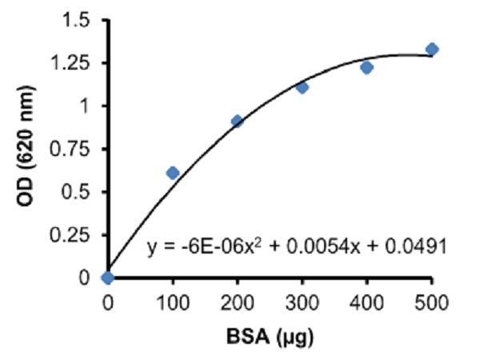
Figure 1. BSA Standard Curve (0-500 µg).

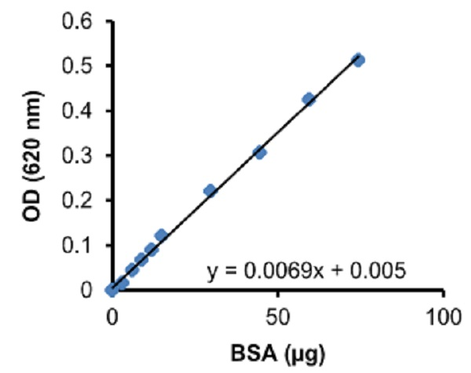

Figure 2. BSA Standard Curve (0-75 µg).

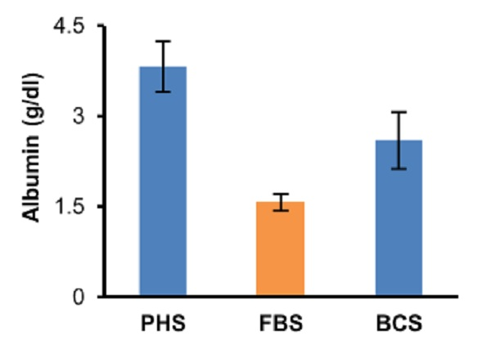
Figure 3. Albumin concentration in pooled human serum (PHS), fetal bovine serum (FBS) and bovine calf serum (BCS). Sample volumes (0-20 µL) were assayed following the kit protocol. Albumin concentration (g/dL): PHS: 3.8 ± 0.4; FBS: 1.6 ± 0.1; BCS: 2.6 ± 0.5.

- Notes

Technical Support
Copyright © 2023 Abcam. All Rights Reserved. The Abcam logo is a registered trademark. All information / detail is correct at time of going to print.
For all technical or commercial enquiries please go to:
www.abcam.com/contactus
www.abcam.cn/contactus (China)
www.abcam.co.jp/contactus (Japan)

