Version 1b Last updated 7 June 2023

ab236212

Cholesterol Uptake Assay Kit

For the measurement of cholesterol absorption in cell cultures.

This product is for research use only and is not intended for diagnostic use.

Table of Contents
1. Overview 1
2. Materials Supplied and Storage 2
3. Materials Required, Not Supplied 3
4. General guidelines, precautions, and troubleshooting 4
5. Reagent Preparation 5
6. Assay Procedure 6
7. FAQs / Troubleshooting 7
8. Typical Data 8
9. Notes 11

- Overview

The Cholesterol Uptake Assay Kit (ab236212) provides a convenient tool for studying cellular cholesterol trafficking. The kit employs NBD Cholesterol, a fluorescently-tagged cholesterol, as a probe for the detection of cholesterol taken up by cultured cells. U-18666A, which increases cholesterol uptake by inhibiting trafficking of synthesized cholesterol, is included as a positive control. The kit provides enough NBD Cholesterol to test 250 samples in a 96-well format.

Culture cells as your experiment requires.

Treat cells in NBD Cholesterol-containing serum-free culture medium.

Incubate cells for 24-72 hours.

Analyze cells by flow cytometry (FL1) or microscopy (FITC/GFP).

- Materials Supplied and Storage
Store kit at -20°C in the dark immediately on receipt and check below for storage for individual components. Kit can be stored for 1 year from receipt, if components have not been reconstituted.
Aliquot components in working volumes before storing at the recommended temperature.
Avoid repeated freeze-thaws of reagents.
Item | Quantity | Storage temperature (before prep) | Storage temperature (after prep)
Cell-Based Assay NBD Cholesterol | 500 µL | -20°C | -20°C
Cell-Based Assay Buffer Tablet | 1 tablet | RT | RT
Cell-Based Assay U-18666A | 100 µL | -20°C | -20°C

- Materials Required, Not Supplied
These materials are not included in the kit, but will be required to successfully perform this assay:
- Tissue culture plates for culturing cells (black, clear bottom if using a plate reader).
- Cells that will take up cholesterol, and the appropriate serum-free medium for the assay.
- A flow cytometer, microscope, or plate reader capable of detecting fluorescence at excitation and emission wavelengths of 485 nm and 535 nm, respectively.
- General guidelines, precautions, and troubleshooting
Please observe safe laboratory practice and consult the safety datasheet.
For general guidelines, precautions, limitations on the use of our assay kits and general assay troubleshooting tips, particularly for first time users, please consult our guide: www.abcam.com/assaykitguidelines
For typical data produced using the assay, please see the assay kit datasheet on our website.

- Reagent Preparation
Briefly centrifuge small vials at low speed prior to opening.

Cell-Based Assay Buffer Tablet
- Dissolve the Cell-Based Assay Buffer Tablet in 100 mL of distilled water.

Cell-Based Assay NBD Cholesterol
- This fluorescently-tagged cholesterol derivate is supplied as a solution in ethanol at 1 mg/mL.
- Dilute this solution 1:50 in the serum-free culture medium used for your experiments. The final concentration of NBD Cholesterol in the culture medium is 20 µg/mL.

Cell-Based Assay U-18666A
- This cholesterol transport inhibitor is provided at a concentration of 2.5 mM in DMSO.

- Assay Procedure
- Equilibrate all materials and prepared reagents to room temperature just prior to use and gently agitate.
- Assay all controls and samples in duplicate.

Cell treatment
- Culture cells as your experiment requires: for plate reader detection, a black clear-bottom 96-well plate is recommended; for microscopy or flow cytometry, any size wells can be used for culture. Flow cytometric readout is ideal for suspension cells, while plate reader or microscopy are better suited for adherent cell lines. While optimal cell numbers must be determined for each application, cells should not be more that 80% confluent by the end of the assay.
- Treat the cells qith experimental compounds or vehicle control in 100 µL serum-free culture medium containing 20 µg/mL NBD Cholesterol.
- Incubate the cells for 24-72 hours. To use the included U-18666A as a positive control, dilute 1:1000-1:4000 in serum-free culture medium.

Measurement
- For flow cytometry: Collect cells into FACS tubes or v-bottom plates. Centrifuge at 250 x g for 5 minutes, and remove supernatant. Add 100-500 µL Assay Buffer and analyze with the flow cytometer immediately, typically using an FL1 (FITC) channel.
- For microscopy or plate reader: Remove medium and replace with an appropriate volume of Assay Buffer. Analyze immediately, with filter sets designed for FITC/GFP.

- FAQs / Troubleshooting
General troubleshooting points are found at www.abcam.com/assaykitguidelines.

Problem | Reason | Solution
No cholesterol uptake in all treatments, including positive control | Cells are not healthy | Use only healthy cells
No significant difference in fluorescent staining intensity among treatments | Culture medium contains high level of serum | Use culture medium which contains no serum

- Typical Data
Data provided for demonstration purposes only.

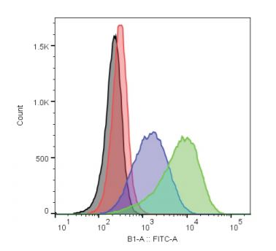

Figure 1. U-18666A increases cholesterol uptake in Jurkat cells as measured by flow cytometry. Jurkat cells were seeded at a density of 5x10⁵ cells/mL and incubated overnight in serum-free RPMI with U-18666A or vehicle and 20 µg/mL NBD Cholesterol in a cell culture incubator at 37°C. The next day, cells were transferred to a v-bottom plate for washing and reading on a flow cytometer. Cholesterol uptake was evaluated in the live cell gate using FlowJo analysis software. U-18666A at both 2.5 µM (green) and 1.25 µM (blue) showed a significant (p<0.05, t-test) shift in mean fluorescence as compared to the vehicle control (black) and the untreated (red) cells.

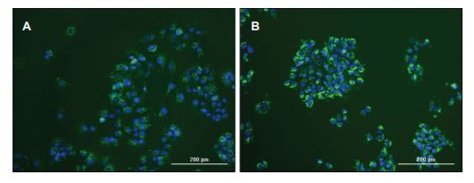

Figure 2. Blocking intracellular cholesterol transport with U-18666A increases NBD cholesterol uptake. Huh-7 hepatocytes seeded at 3x10³ cells/well were treated overnight with (Panel B) or without (Panel A) 1.25 µM U-18666A in the presence of 20 µg/mL NBD cholesterol in serum-free media. Hoechst was added to a final concentration of 4 µM for the final 30 minutes, after which media was exchanged for Assay Buffer. Cells were imaged using a CytationTM 5 Cell Imaging Multi-Mode Reader, using a GFP LED/filter set for NBD cholesterol (green) and a DAPI LED/filter set for Hoechst (blue).

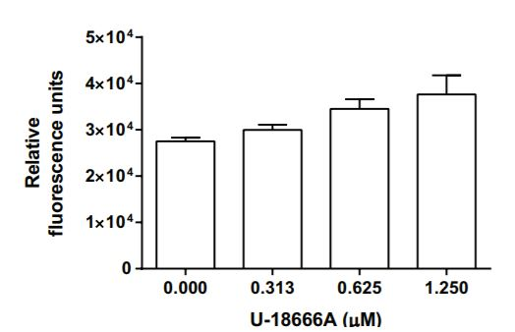

Figure 3. 212. Caco-2 cells were seeded at a density of 10,000 cells/well and incubated overnight at 37°C. The next day, cells were treated with vehicle or the indicated concentrations of U-18666A in serum-free culture medium with 20 µg/mL NBD Cholesterol for three days. At the end of the experiment, the degree of NBD Cholesterol uptake was analysed using a plate reader.

- Notes

Technical Support
Copyright © 2023 Abcam. All Rights Reserved. The Abcam logo is a registered trademark. All information / detail is correct at time of going to print.
For all technical or commercial enquiries please go to:
www.abcam.com/contactus
www.abcam.cn/contactus (China)
www.abcam.co.jp/contactus (Japan)

