Version 2b Last updated 23 July 2021

ab238544

Comet Assay Kit (3-well slides)

For the measurement of cellular DNA damage.

This product is for research use only and is not intended for diagnostic use.

Table of Contents
1. Overview 3
2. Protocol Summary 4
3. General guidelines, precautions, and troubleshooting 6
4. Materials Supplied, and Storage and Stability 6
5. Materials Required, Not Supplied 6
6. Reagent Preparation 8
7. Sample and Slide Preparation 10
8. Assay Procedure 12
9. Data Analysis 14
10. Typical Data 15
11. Notes 16

- Overview
Comet Assay Kit (3-well slides) (ab238544) is a fast and sensitive kit for the measurement of cellular DNA damage.
The Assay is a single cell gel electrophoresis assay (SCGE) for simple evaluation of cellular DNA damage. It is a convenient way to screen for general DNA damage, regardless of the source or nature of the damage. Kits include Comet Slides, reagents, and a fluorescent dye to visualize cells under an epifluorescence microscope.

- Protocol Summary
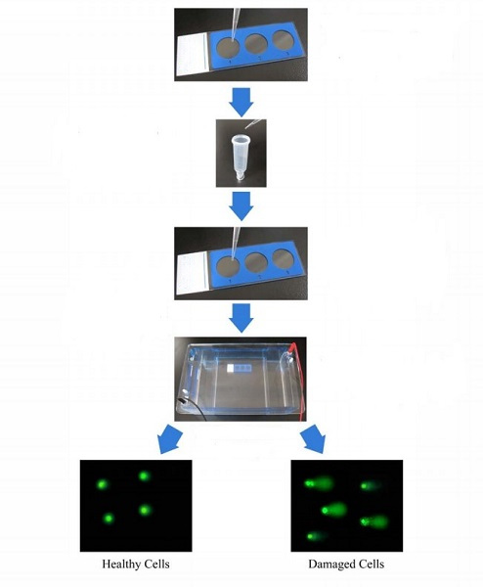

Figure 1: Comet Assay Principle

Pipette Comet Agarose onto the Comet Slide to form a Base Layer

Combine cells with Comet Agarose at 37 ºC

Pipette Agarose/cell mixture onto the top of the base layer

Treat cells with lysis buffer and alkaline solution

Perform electrophoresis under alkaline or neutral conditions

Stain cells with DNA dye

- General guidelines, precautions, and troubleshooting
- Please observe safe laboratory practice and consult the safety datasheet.
- For general guidelines, precautions, limitations on the use of our assay kits and general assay troubleshooting tips, particularly for first time users, please consult our guide: www.abcam.com/assaykitguidelines
- For typical data produced using the assay, please see the assay kit datasheet on our website.

- Materials Supplied, and Storage and Stability
- Store kit at room temperature immediately upon receipt and check below for storage for individual components. Kit can be stored for 1 year from receipt, if components have not been reconstituted.
- Aliquot components in working volumes before storing at the recommended temperature.
- Avoid repeated freeze-thaws of reagents.
Item | Quantity |  | Storage condition
Item | 15 test | 75 test | Storage condition
3-Well Comet Slides | 5 | 25 | RT
Comet Agarose | 15 mL | 15 mL | RT
Vista Green DNA Dye, 10000X | 5 µL | 5 µL | -20°C
EDTA Solution, 500 mM | 50 mL | 250 mL | RT
10X Lysis Solution | 20 mL | 100 mL | RT
- Materials Required, Not Supplied
These materials are not included in the kit, but will be required to successfully perform this assay:
- NaCl powder
- NaOH pellets
- 10 N NaOH for pH adjustment
- DMSO (optional)
- 70% Ethanol
- TE Buffer (10 mM Tris, pH 7.5, 1 mM EDTA)
- PBS (without Mg²⁺ and Ca²⁺)
- EDTA (disodium salt)
- Horizontal electrophoresis chamber
- Epifluorescence microscope with FITC filter
- Reagent Preparation
- Prepare only as much reagent as is needed on the day of the experiment.

Comet Agarose:
    - Heat the Comet Agarose bottle at 90-95ºC in a water bath for 20 mins, or until agarose liquefies. Transfer the bottle to a 37ºC water bath for 20 mins and maintain until needed. Stir to homogeneity.
  - Vista Green DNA Dye:
    - Prepare a 1X Vista Green DNA Staining Solution by diluting the provided stock 1/10000 in TE Buffer (10 mM Tris, pH 7.5, 1 mM EDTA). The solution can be stored at 4ºC for up to 3 weeks, protected from light. Mix well.
  - Lysis Buffer:
    - To prepare 100 mL of 1X Lysis Buffer:
Component | Quantity
NaCl | 14.6 g
EDTA Solution (provided) | 20 mL
10X Lysis Solution (provided) | 10 mL
DMSO | 10 mL
DI H₂O | Adjust volume to 90 mL
    - Mix thoroughly to dissolve NaCl. Slowly adjust the Lysis Buffer to pH 10.0 with 10 N NaOH, then adjust to 100 mL with DI H₂O. Chill Lysis Buffer to 4ºC before use.
Δ Note: Buffer will appear cloudy at room temperature, but will clear at 4ºC. pH will also remain ~10.0.

  - Alkaline Solution:
    - To prepare 100 mL of Alkaline Solution:
Component | Quantity
NaOH | 1.2 g
EDTA Solution (provided) | 0.2 mL
DI H₂O | Adjust volume to 100 mL
    - Mix thoroughly to dissolve NaOH. Chill Alkaline Solution to 4ºC before use.
Electrophoresis Running Solution:
Δ Note: Choose the appropriate electrophoresis solution based on the desired running conditions and assay sensitivity. TBE is preferred for analysis of apoptosis and enables use of the tail length, rather than the tail moment, for data analysis. TBE electrophoresis will detect single-stranded and double-stranded DNA breaks, and may detect a few AP sites. Alkaline electrophoresis is more sensitive and will detect smaller amounts of DNA damage. Alkaline electrophoresis will detect single-stranded and double-stranded DNA breaks, the majority of AP sites, and alkali labile DNA adducts.
    - To prepare 1 L of Electrophoresis Solution:
- TBE Electrophoresis Solution:
Component | Quantity
Tris Base | 10.8 g
Boric Acid | 5.5 g
EDTA (disodium salt) | 0.93 g
DI H₂O | Adjust volume to 1 L
    - Mix thoroughly to dissolve solids. Chill TBE Running Solution to 4ºC before use.
OR

- Alkaline Electrophoresis Solution (300 mM NaOH, pH >13, 1 mM EDTA)
Component | Quantity
NaOH | 12 g
EDTA Solution (provided) | 2 mL
DI H₂O | Adjust volume to 1 L
    - Mix thoroughly to dissolve NaOH. Chill Alkaline Running Solution to 4ºC before use.
Δ Note: Special Precautions -
To avoid ultraviolet light damage to cell samples, perform the assay under low/dim light conditions.
- Sample and Slide Preparation
Prepare Lysis Buffer, Alkaline Solution, and Electrophoresis Running Solution (see Section 6) prior to performing the assay. Chill all solutions to 4ºC thoroughly.
Heat Comet Agarose to 90-95ºC in a water bath for 20 mins, or until agarose liquefies. Cool the agarose by transferring the bottle to a 37ºC water bath for 20 mins.
Add 75 µL of Comet Agarose per well onto the Comet Slide to create a Base Layer. Ensure complete well coverage by spreading the solution over the well with the pipette tip.
Maintaining the slide horizontally, transfer the slide to 4ºC for 15 mins.
Prepare cell samples, including controls, as follows:
    - Suspension Cells: Centrifuge cells at 700 x g for 2 mins and discard supernatant. Wash cell pellet once with ice-cold PBS (without Mg²⁺ and Ca²⁺), centrifuge, and discard the supernatant. Finally, resuspend the cells at 1 x 10⁵ cells/mL in ice-cold PBS (without Mg²⁺ and Ca²⁺).
    - Adherent Cells: Gently remove cells from flask/dish by scraping with a rubber policeman. Transfer cell suspension to a conical tube and centrifuge at 700 x g for 2 mins, discarding the supernatant. Wash cell pellet once with ice-cold PBS (without Mg²⁺ and Ca²⁺), centrifuge, and discard the supernatant. Finally, resuspend the cells at 1 x 10⁵ cells/mL in ice-cold PBS (without Mg²⁺ and Ca²⁺).
    - Tissue Preparation: Using dissection scissors, mince a small piece of tissue in 1-2 mL of ice cold PBS containing 20 mM EDTA (without Mg²⁺ and Ca²⁺). Allow the tissue/cell suspension to stand for 5 mins before transferring the supernatant to a centrifuge tube; avoid transferring debris. Centrifuge, discarding the supernatant, and then resuspend the cells at 1 x 10⁵ cells/mL in ice-cold PBS (without Mg²⁺ and Ca²⁺).
  - Combine cell samples with Comet Agarose (step 7.2) at 1/10 ratio (v/v), mix well by pipetting, and immediately transfer 75 µL/well onto the top of the Comet Agarose Base Layer (step 7.3). Ensure complete well coverage by spreading the suspension very gently and carefully with the pipette tip, without disturbing the Base Layer.
Δ Note: For multiple samples, maintain suspensions at 37ºC to avoid gelation. Titrate samples again just prior to slide addition.
  - Maintaining the slide horizontally, transfer the slide to 4ºC in the dark for 15 mins.
  - Carefully, transfer the slide to a small basin/container containing pre-chilled Lysis Buffer (~25 mL/slide). Immerse the slide in the buffer for 30-60 mins at 4ºC in the dark.
  - Carefully, aspirate the Lysis Buffer from the container and replace with pre-chilled Alkaline Solution (~25 mL/slide). Immerse the slide in the solution for 30 mins at 4ºC in the dark.

- Assay Procedure
TBE Electrophoresis
    - Aspirate the Alkaline Solution from the container and replace with pre-chilled TBE Electrophoresis Solution. Immerse the slide for 5 mins, and then repeat once more.
    - Maintaining the slide horizontally, carefully transfer the slide to a horizontal electrophoresis chamber. Fill the chamber with cold TBE Electrophoresis Solution until the buffer level covers the slide.
    - Apply voltage to the chamber for 10-15 mins at 1 volt/cm (e.g. if the chamber electrodes are 35 cm apart, you would then apply 35 volts to the slide).
    - Maintaining the slide horizontally, carefully transfer the slide from the electrophoresis chamber to a clean, small basin/container containing pre-chilled DI H₂O (~25 mL/slide). Immerse the slide for 2 mins, aspirate, and then repeat twice more.
    - Aspirate the final water rinse and replace with cold 70% Ethanol for 5 mins.
    - Maintaining the slide horizontally, remove the slide from the 70% Ethanol and allow to air dry.
    - Once the agarose and slide is completely dry, add 100 µL/well of diluted Vista Green DNA Dye (see Section 6). Incubate at room temperature for 15 mins.
    - View slides by epifluorescence microscopy using a FITC filter.
Alkaline Electrophoresis
    - Maintaining the slide horizontally, carefully transfer the slide from the Alkaline Solution to a horizontal electrophoresis chamber. Fill the chamber with cold Alkaline Electrophoresis Solution until the buffer level covers the slide.
    - Apply voltage to the chamber for 15-30 mins at 1 volt/cm (e.g. if the chamber electrodes are 35 cm apart, you would then apply 35 volts to the slide). Additionally, adjust the volume of Alkaline Electrophoresis Solution to produce a current setting of 300 mA.
    - Maintaining the slide horizontally, carefully transfer the slide from the electrophoresis chamber to a clean, small basin/container containing pre-chilled DI H²O (~25 mL/slide). Immerse the slide for 2 mins, aspirate, and then repeat twice more.
    - Aspirate the final water rinse and replace with cold 70% Ethanol for 5 mins.
    - Maintaining the slide horizontally, remove the slide from the 70% Ethanol and allow to air dry.
    - Once the agarose and slide is completely dry, add 100 µL/well of diluted Vista Green DNA Dye (see Section 6). Incubate at room temperature for 15 mins.
    - View slides by epifluorescence microscopy using a FITC filter.

- Data Analysis
The DNA damage is quantified by measuring the displacement between the genetic material of the nucleus ('comet head') and the resulting 'tail'. Tail Moment and Tail DNA% are the two most common parameters to analyze Comet assay results. At least 50 -100 cells should be analyzed per sample. The Tail Moment has been suggested to be an appropriate index of induced DNA damage in considering both the migration of the genetic material as well as the relative amount of DNA in the tail.
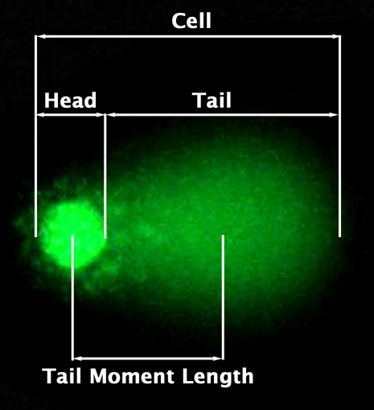

Figure 2: Epifluorescence Microscopy Visualization of DNA Damage.

- Tail DNA% = 100 x Tail DNA Intensity/Cell DNA Intensity
- Tail Moment can be measured using one of the following methods:
(a) Olive Tail Moment = Tail DNA% x Tail Moment Length*
(b) Extent Tail Moment = Tail DNA% x Length of Tail (see Figure 2)
- A number of Comet Assay analysis software programs are commercially available, such as Comet Assay IV (Perceptive Instruments) and CASPlab.
*Tail Moment Length is measured from the center of the head to the center of the tail (see Figure 2)
- Typical Data
- The following figures demonstrate typical Comet Assay Kit results. One should use the data below for reference only. This data should not be used to interpret actual results.
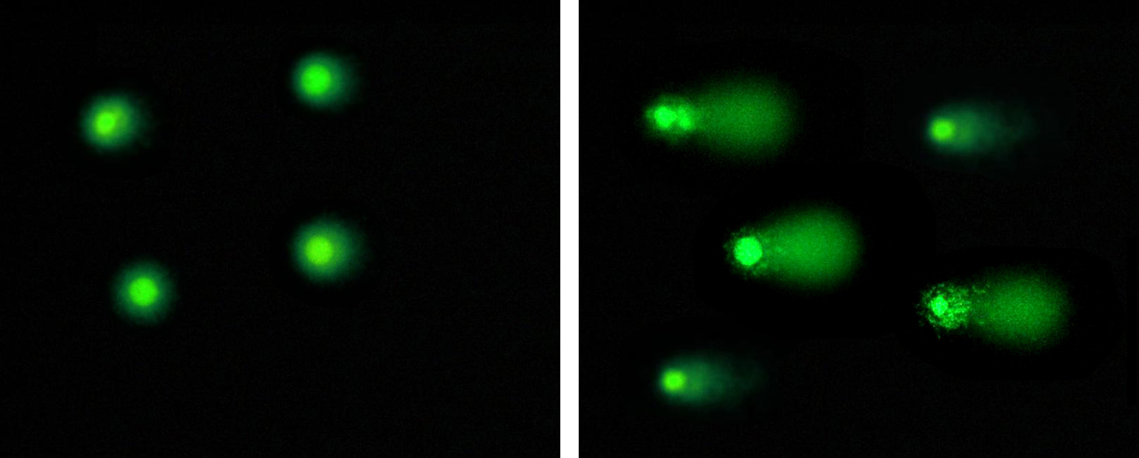

Figure 3. Etoposide Treatment of Jurkat Cells. Jurkat cells were untreated (left) or treated (right) with 20 µM Etoposide for 4 hrs before performing Comet Assay (alkaline electrophoresis conditions, 33 V/300 mA for 15 mins).

- Notes

Technical Support
Copyright © 2021 Abcam. All Rights Reserved. The Abcam logo is a registered trademark. All information / detail is correct at time of going to print.
For all technical or commercial enquiries please go to:

www.abcam.com/contactus
www.abcam.cn/contactus (China)
www.abcam.co.jp/contactus (Japan)

