Version 2b Last updated 13 May 2020

ab239704

Mitochondrial Permeability Transition Pore Assay Kit

For the measurement of mitochondrial permeability transition pore activity in suspension and adherent cells.

This product is for research use only and is not intended for diagnostic use.

Table of Contents
1. Overview 1
2. Protocol Summary 2
3. General guidelines, precautions, and troubleshooting 3
4. Materials Supplied, and Storage and Stability 4
5. Materials Required, Not Supplied 4
6. Reagent Preparation 5
7. Sample Preparation 5
8. Assay Procedure 6
9. Data Analysis 7
10. Typical Data 8
12. Notes 9

- Overview
Mitochondrial Permeability Transition Pore Assay Kit (ab239704) provides a fast, direct method of measuring cell death by measuring MPTP opening rather than relying on mitochondrial membrane potential alone.
Mitochondria are the power centrals of the cell and play an essential role in energy production. Damage to mitochondria activates signaling pathways that induce apoptosis. The mitochondrial permeability transition pore (MPT pore or MPTP) is a non-specific channel formed by components of the inner and outer mitochondrial membranes and appears to be involved in the release of mitochondrial components during cell death. In healthy cells, MPTP’s flicker between open and closed states but during cell death MPTP’s dramatically alter the permeability of the mitochondria. Cytochrome c release and loss of mitochondrial membrane potential are subsequent to continuous pore activation.

- Protocol Summary
Prepare cells to a final concentration of 10⁶ cells/mL and aliquot 1 mL into four separate tubes.

Dilute the MPTP Staining Dye 1:500 with pre-warmed MPTP Wash Buffer.

To tube 2, 3 and 4, add 5 µL of diluted MPTP Staining Dye.

To tube 3 and 4, add 5 µl of CoCl₂ and mix well.

To tube 4, add 5 µl of Ionomycin and mix well.

Incubate cells at 37°C for 15 minutes protected from light.

After incubation, centrifuge cells and then re-suspend in 1 mL of MPTP Wash Buffer. Keep cells on ice and analyze within 1 h using a flow cytometer with 488 nm excitation filter.

- General guidelines, precautions, and troubleshooting
- Please observe safe laboratory practice and consult the safety datasheet.
- For general guidelines, precautions, limitations on the use of our assay kits and general assay troubleshooting tips, particularly for first time users, please consult our guide: www.abcam.com/assaykitguidelines
- For typical data produced using the assay, please see the assay kit datasheet on our website.

- Materials Supplied, and Storage and Stability
- Store kit at -20°C in the dark immediately upon receipt and check below in Section 6 for storage for individual components. Kit can be stored for 1 year from receipt, if components have not been reconstituted.
- Aliquot components in working volumes before storing at the recommended temperature.
Item | Quantity | Storage condition
MPTP Staining Dye | 5 x 50 µg | -20°C
CoCl₂ | 1 mL | -20°C
Ionomycin | 1 mL | -20°C
MPTP Wash Buffer | 100 mL | -20°C
- Materials Required, Not Supplied
These materials are not included in the kit, but will be required to successfully perform this assay:

- Flow Cytometer with 488 nm excitation source
- Reagent Preparation
- Before using the kit, spin tubes and bring down all components to the bottom of tubes.
- Prepare only as much reagent as is needed on the day of the experiment.

  - MPTP Staining Dye:
Dissolve one-vial content in 50 µL DMSO. Store at -20°C protected from light. Stable for one year as provided (powder). Once dissolved in DMSO, use within a short time for one series of experiments. (Dye degrades slowly over time, can be used for up to a week but best results obtained when used same day.).
  - CoCl₂:
Ready to use as supplied.
  - Ionomycin:
Ready to use as supplied.
  - MPTP Wash Buffer:
Ready to use as supplied. Bring to 37°C before use.

- Sample Preparation
Grow cells of interest in desired medium and culture conditions preferably as a single-cell suspension.
Resuspend cells in pre-warmed MPTP Wash Buffer at a final concentration of 10⁶ cells/mL.
For each sample, prepare 1 mL aliquots of cell suspension in four separate tubes using MPTP Wash Buffer - one tube without any treatment (tube 1), one tube with MPTP Staining Dye only (tube 2), one tube with MPTP Staining Dye and CoCl₂ (tube 3) and one tube with MPTP Staining Dye, CoCl₂ and Ionomycin (tube 4).

- Assay Procedure

Dilute MPTP Staining Dye 1:500 in MPTP Wash Buffer (i.e. mix 5 µL of MPTP Staining Dye Stock with 2.495 mL of MPTP Wash Buffer) and mix well.
To tube 2, 3 and 4, add 5 µL of diluted MPTP Staining Dye and mix.
To tube 3 and 4, add 5 µL of CoCl₂ and mix well.
To tube 4, add 5 µL of Ionomycin and mix well.
Incubate cells at 37°C for 15 min protected from light.
After incubation, centrifuge cells at 1,000 xg for 5 min to pellet cells.
Re-suspend in 1 mL of MPTP Wash Buffer to remove excess staining and quenching reagents.
After staining, keep cells on ice and analyze within 1 hour.

Δ Note: This protocol is optimized for Jurkat cells. If using different cell type, optimize the final concentration of Ionomycin.

- Data Analysis
Analyze the samples using a flow cytometer with 488 nm excitation filter.
Use untreated sample (tube 1) to set up the instrument (Figure 1, tube 1).
Samples stained with MPTP Staining Dye only shows high fluorescence signal from both cytoplasm and mitochondria (Figure1, tube 2).
Samples stained with MPTP Staining Dye and treated with CoCl₂ shows only mitochondrial fluorescence as treatment with CoCl₂ quenches the cytosolic signal and shows intermediate fluorescence (Figure1, tube 3).
Samples having all reagents show the lowest fluorescence as signal gets quenched from both cytoplasm and mitochondria (Figure 1, tube 4).
The difference in fluorescence intensity between tubes 3 and 4 indicates the degree of MPTP activation and subsequent depolarization of the mitochondrial membrane.
Complete depolarization, as is achieved with ionomycin, results in a complete abolishment of the fluorescence signal (essentially identical to tube 1) and giving the greatest difference between tube 3 and 4.
Completely ineffective treatment would cause no depolarization and a fluorescence signal in treated tube (tube 4) identical to tube 3.

- Typical Data
Typical data provided for demonstration purposes only.
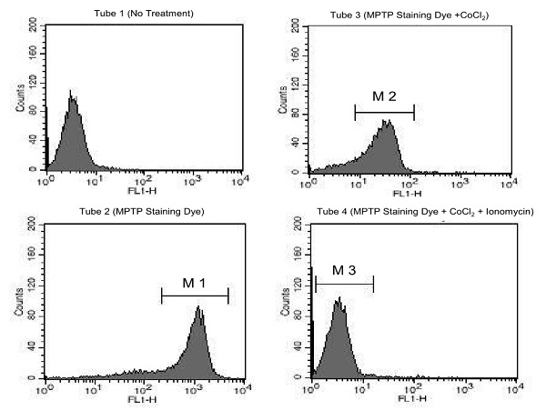

Figure 1. Jurkat cells were incubated with the reagents of the Mitochondrial Permeability Transition Pore Assay Kit (ab239704) and analyzed by flow cytometer. Tube 1: sample without treatment - used for instrument setup; Tube 2: sample stained with MPTP Staining Dye showing cumulative fluorescence signal from both cytoplasm and mitochondria; Tube 3: sample stained with MPTP Staining Dye and treated with CoCl₂ showing mitochondrial fluorescence only; Tube 4: samples with all reagents showing the lowest fluorescence. The difference in fluorescence between tubes 3 and 4 indicates the degree of MPTP activation and subsequent depolarization of the mitochondrial membrane.

- Notes

Technical Support
Copyright © 2020 Abcam. All Rights Reserved. The Abcam logo is a registered trademark. All information / detail is correct at time of going to print.
For all technical or commercial enquiries please go to:
www.abcam.com/contactus
www.abcam.cn/contactus (China)
www.abcam.co.jp/contactus (Japan)

