Version 2b, Last updated 15 March 2024

ab239705

Dihydrofolate Reductase Assay Kit (Colorimetric)

For the detection of Dihydrofolate Reductase activity in various tissues and cells.

This product is for research use only and is not intended for diagnostic use.

PLEASE NOTE: With the acquisition of BioVision by Abcam, we have made some changes to component names and packaging to better align with our global standards as we work towards environmental-friendly and efficient growth. You are receiving the same high-quality products as always, with no changes to specifications or protocols.
Table of Contents
1. Overview 3
2. Protocol Summary 3
3. General guidelines, precautions, and troubleshooting 4
4. Materials Supplied, and Storage and Stability 4
5. Materials Required, Not Supplied 5
6. Reagent Preparation 5
7. Standard Preparation 6
8. Sample Preparation 7
9. Assay Procedure 8
10. Data Analysis 9
11. Typical Data 10
12. Notes 12

- Overview
Dihydrofolate Reductase Assay Kit (Colorimetric) (ab239705) is based on the ability of DHFR to catalyze the oxidation of NADPH. The reaction progress is followed by monitoring the decrease in absorbance at 340 nm. Our assay has been optimized to be carried out in a 96-well plate. It is simple, sensitive and can detect as low as 4 mU/mL in a variety of samples.

- Protocol Summary
Prepare tissue or cell samples, sample background controls, DHFR positive controls, DHFR background controls and add to appropriate wells.

Prepare standard curve.

Prepare NADPH probe and add to test samples, sample background control, DHFR positive control and DHFR background control wells.

Prepare DHFR substrate and add to test samples, DHFR background control and DHFR positive control wells.

Add DHFR Assay Buffer to sample background control wells.

Measure absorbance immediately at 340 nm in kinetic mode for 10-20 min at room temperature.

- General guidelines, precautions, and troubleshooting
- Please observe safe laboratory practice and consult the safety datasheet.
- For general guidelines, precautions, limitations on the use of our assay kits and general assay troubleshooting tips, particularly for first time users, please consult our guide: www.abcam.com/assaykitguidelines
- For typical data produced using the assay, please see the assay kit datasheet on our website.

- Materials Supplied, and Storage and Stability
- Store kit at -20°C in the dark immediately upon receipt and check below in Section 6 for storage for individual components. Store DHFR Substrate at -80°C. Kit can be stored for 1 year from receipt, if components have not been reconstituted.
- Aliquot components in working volumes before storing at the recommended temperature.
Item | Quantity | Storage condition
DHFR Assay Buffer | 35 mL | -20°C
DHFR Substrate | 450 µL | -80°C
Dihydrofolate Reductase | 10 µL | -20°C
NADPH III/NADPH | 1 vial | -20°C

- Materials Required, Not Supplied
These materials are not included in the kit, but will be required to successfully perform this assay:

- 96-well plate with flat bottom
- Multi-well spectrophotometer

- Reagent Preparation
- Before using the kit, spin tubes and bring down all components to the bottom of tubes.
- Prepare only as much reagent as is needed on the day of the experiment.

  - DHFR Assay Buffer:
Ready to use as supplied. Warm to room temperature before use. Store at 4ºC or -20ºC.
  - DHFR Substrate:
Ready to use as supplied. Aliquot and store at -80°C, protected from light. Avoid repeated freeze/thaw cycles.
  - Dihydrofolate Reductase:
Ready to use as supplied. Store at -20°C. Avoid repeated freeze/thaw cycles. Keep on ice while in use.
  - NADPH III/NADPH:
Reconstitute with 200 μL DHFR Assay Buffer to generate a 20 mM NADPH III/NADPH Stock Solution. Aliquot and store at –20°C. Keep on ice while in use.

- Standard Preparation
- Always prepare a fresh set of standards for every use.

Dilute 20 µL of the 20 mM NADPH III/NADPH solution with 780 µL DHFR Assay Buffer to generate 0.5 mM NADPH III/NADPH solution.
Add 0, 20, 40, 60, 80, 120, 200 µL of the 0.5 mM NADPH III/NADPH Standards into a series of wells in 96 well clear plate to generate 0, 10, 20, 30, 40, 60, 100 nmol/well of NADPH III/NADPH Standard.
Adjust the volume to 200 µL/well with DHFR Assay Buffer.

Standard # | 0.5 mM NADPH III/NADPH Standard (μL) | DHFR Assay Buffer  (μL) | NADPH III/NADPH Standard nmol/well
1 | 0 | 200 | 0
2 | 20 | 180 | 10
3 | 40 | 160 | 20
4 | 60 | 140 | 30
5 | 80 | 120 | 40
6 | 120 | 80 | 60
7 | 200 | 0 | 100

- Sample Preparation
Rapidly homogenize tissue (10-50 mg) or cells (1 x 10⁶) with 100 µL ice-cold DHFR Assay Buffer, and keep on ice for 10 min.
Centrifuge at 10,000 x g for 10 min at 4 °C to remove cell debris.
Transfer the supernatant to a fresh tube.
Add 5-50 μL sample per well and adjust the volume to 100 µL with DHFR Assay Buffer.
Prepare parallel sample well(s) as sample background control (See Step 9.5).
For the DHFR positive control, prepare a 5-fold dilution of Dihydrofolate Reductase (i.e. Dilute 1 µL of Dihydrofolate Reductase with 4 µL DHFR assay buffer).
Add 2-4 μL of diluted Dihydrofolate Reductase into desired well(s) and adjust the final volume to 100 µL with DHFR Assay Buffer.
For the DHFR background control, add 100 µL DHFR Assay Buffer into desired well(s).

Δ Note: For unknown samples, we suggest testing several doses to ensure the readings are within the Standard Curve range.

- Assay Procedure

Prepare a 40-fold dilution of NADPH III/NADPH stock solution by diluting it in DHFR Assay Buffer, vortex briefly and keep on ice.
Add 40 µL of Prepared NADPH III/NADPH to each well containing the test samples, sample background control, DHFR positive control and DHFR background control. Mix well.
Prepare a 15-fold dilution of DHFR substrate (i.e. Dilute 40 µL of DHFR stock substrate with 560 µL DHFR Assay Buffer), vortex briefly and keep on ice.
Add 60 µL of Prepared DHFR substrate to each well containing the test samples, DHFR positive control and DHFR background control. Mix well.
For sample background control, add 60 µL DHFR Assay Buffer into well(s) containing sample background control.
The total volume in every well (i.e. standards, samples, background controls) should be 200 µL.
Measure absorbance immediately at 340 nm in kinetic mode for 10-20 min at room temperature. Choose two time points (t1 and t2) in the linear range of the plot and obtain the corresponding values for the absorbance (OD1 and OD2). The NADPH Standard Curve can be read in End-point mode.

Δ Note: DHFR substrate is light sensitive and must be protected from light as much as possible during the experiment. We suggest using an aluminum foil to wrap-around the vial or using an amber tube for this purpose.
Δ Note: Do not store the diluted substrate solutions.

- Data Analysis
Subtract 0 NADPH Standard slope from all Standard readings. Plot the NADPH Standard Curve.
Calculate the Dihydrofolate Reductase activity of the test sample: ∆OD = A1 – A2.
Apply the ∆OD to the NADPH Standard Curve to get B nmol of NADPH generated during the reaction time (∆t = t2 - t1).
Subtract the sample background control reading from its paired sample reading (B test sample-B sample background control)/∆t).

$$Sample Dihydrofolate Reductase Activity=$$

$$\frac{B test sample-B sample control}{∆t ×M} =nmol/min/mg =mU/mg$$

Where: B = NADPH amount from Standard Curve (nmol).
V = Reaction time (min).
M = Sample total protein amount added into the reaction well (mg).

Unit Definition: One unit of Dihydrofolate Reductase is the amount of enzyme that oxidizes 1.0 µmol of NADPH per minute at pH 7.5 at room temperature.
- Typical Data
Typical data provided for demonstration purposes only.

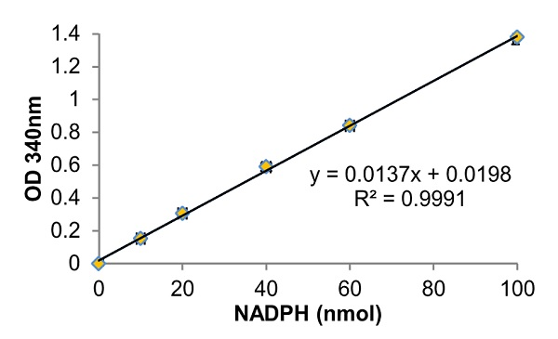

Figure 1. NADPH standard curve.

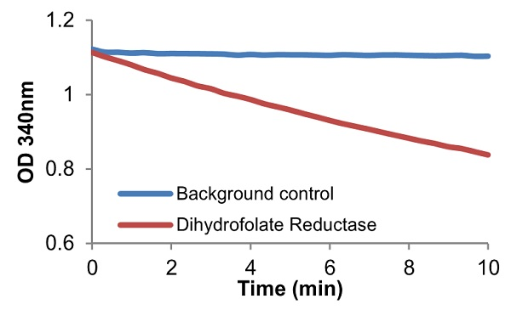

Figure 2. Purified Dihydrofolate Reductase activity.

Typical data provided for demonstration purposes only.

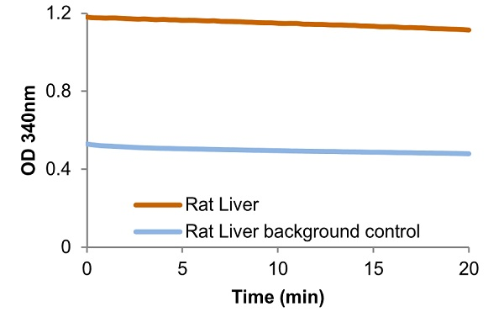

Figure 3. Dihydrofolate Reductase activity in Rat Liver (100 µg).

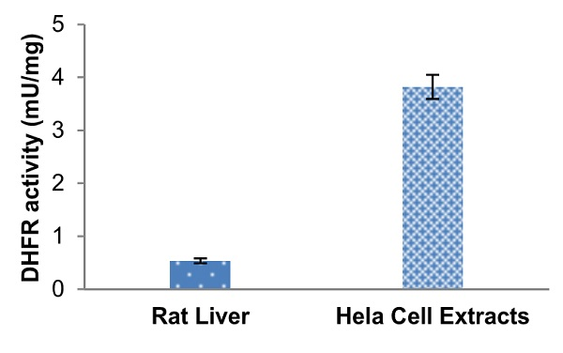

Figure 4. Dihydrofolate Reductase specific activity was calculated from rat liver (100 µg) or HeLa (Human epithelial cell line from cervix adenocarcinoma) cells (80 µg).

- Notes

Technical Support
Copyright © 2024 Abcam. All Rights Reserved. The Abcam logo is a registered trademark. All information / detail is correct at time of going to print.
For all technical or commercial enquiries please go to:
www.abcam.com/contactus
www.abcam.cn/contactus (China)
www.abcam.co.jp/contactus (Japan)

