Version 2a, Last updated 24 August 2023

ab241016

6-Phosphogluconate Dehydrogenase Assay Kit

For the detection of 6-PGD in tissue homogenates and adherent/suspension cells.

This product is for research use only and is not intended for diagnostic use.

PLEASE NOTE: With the acquisition of BioVision by Abcam, we have made some changes to component names and packaging to better align with our global standards as we work towards environmental-friendly and efficient growth. You are receiving the same high-quality products as always, with no changes to specifications or protocols.
Table of Contents
1. Overview 1
2. Protocol Summary 2
3. General guidelines, precautions, and troubleshooting 3
4. Materials Supplied, and Storage and Stability 4
5. Materials Required, Not Supplied 5
6. Reagent Preparation 6
7. Standard Preparation 7
8. Sample Preparation 8
9. Assay Procedure 9
10. Data Analysis 10
11. Typical Data 11
13. Notes 13

- Overview
6-Phosphogluconate Dehydrogenase Assay Kit (ab241016) provides a quick, sensitive and easy way for measuring 6-PGD activity in various biological samples.
In this assay, 6-PGD converts 6-phosphogluconate into an intermediate, generating NADPH, which subsequently reduces a colorless probe into a strongly colored product detectable by absorbance at 460 nm.
The assay is high- throughput adaptable and can detect less than 0.05 mU of 6-PGD activity.

- Protocol Summary

Prepare tissue or cell samples and background/positive controls.

Prepare standard curve.

Prepare Reaction Mix and add to standards, positive control and sample wells.

Measure absorbance immediately at 460 nm in kinetic mode for 45-60 min at 37°C.

- General guidelines, precautions, and troubleshooting
- Please observe safe laboratory practice and consult the safety datasheet.
- For general guidelines, precautions, limitations on the use of our assay kits and general assay troubleshooting tips, particularly for first time users, please consult our guide: www.abcam.com/assaykitguidelines
- For typical data produced using the assay, please see the assay kit datasheet on our website.

- Materials Supplied, and Storage and Stability
- Store kit at -20°C in the dark immediately upon receipt and check below in Section 6 for storage for individual components. Kit can be stored for 1 year from receipt, if components have not been reconstituted.
- Aliquot components in working volumes before storing at the recommended temperature.

Item | Quantity | Storage condition
Assay Buffer V/6-PGD Assay Buffer | 25 mL | -20°C
6-PGD Substrate | 1 vial | -20°C
NADP Detection Probe/6-PGD Developer | 1 vial | -20°C
NADPH Standard | 1 vial | -20°C
6-PGD Positive Control | 1 vial | -20°C

- Materials Required, Not Supplied
These materials are not included in the kit, but will be required to successfully perform this assay:

- 96-well clear plate with flat bottom
- Multi-well spectrophotometer

- Reagent Preparation
- Before using the kit, spin tubes and bring down all components to the bottom of tubes.
- Prepare only as much reagent as is needed on the day of the experiment.

  - Assay Buffer V/6-PGD Assay Buffer:
Warm to room temperature before use. Store at either 4°C or -20°C.
  - 6-PGD Substrate:
Reconstitute with 220 μL dH₂O. Aliquot and store at -20°C. Keep on ice while in use. Use within two months.
  - NADP Detection Probe/6-PGD Developer:
Reconstitute with 900 μL dH₂O. Gently pipette up and down to dissolve the pellet completely (do not vortex). Aliquot and store at -20°C. Keep on ice while in use. Use within two months.
  - NADPH Standard:
Reconstitute with 200 μL dH₂O to generate 1 mM NADPH Standard solution. Aliquot and store at –20°C. Keep on ice while in use. Use within two months.
  - 6-PGD Positive Control:
Reconstitute with 20 μL Assay Buffer V/6-PGD Assay Buffer and mix thoroughly. Aliquot and store at –20°C. Use within two months. Keep on ice while in use.

- Standard Preparation
- Always prepare a fresh set of standards for every use.

Add 0, 2, 4, 6, 8 and 10 μL of 1 mM NADPH Standard into a series of wells in 96 well clear plate to generate 0, 2, 4, 6, 8 and 10 nmol/well of NADPH Standard.
Adjust the volume to 50 μL/well with Assay Buffer V/6-PGD Assay Buffer.

Standard # | 1 mM NADPH Standard (μL) | Assay Buffer V/6-PGD Assay Buffer (μL) | NADPH Standard nmol/well
1 | 0 | 50 | 0
2 | 2 | 48 | 2
3 | 4 | 46 | 4
4 | 6 | 44 | 6
5 | 8 | 42 | 8
6 | 10 | 40 | 10

- Sample Preparation

Rapidly homogenize tissue (10 mg) or cells (1 x 10⁶) with 100 µL ice-cold Assay Buffer V/6-PGD Assay Buffer, and keep on ice for 10 min.
Centrifuge at 10,000 x g for 20 mins and transfer the supernatant to a fresh tube.
Add 5-50 μL sample per well in a clear 96 well plate and adjust the volume to 50 µL with Assay Buffer V/6-PGD Assay Buffer.
For the 6-PGD positive control, dilute the required amount 10 times with assay buffer, add 2 μL of the diluted 6-PGD Positive Control per well into the desired well(s) and adjust the final volume to 50 µL with Assay Buffer V/6-PGD Assay Buffer.

Δ Note:
- For unknown samples, we suggest testing several doses to ensure the readings are within the Standard Curve range.
- Residual NADPH in samples will generate a background. This background can be corrected for by making a background control mix (omitting the 6-PGD substrate in the reaction) and running a parallel sample background control.
- Assay Procedure

Mix enough reagents for the number of assays to be performed. For each well, prepare 50 µL Reaction Mix containing:

 | Reaction Mix (µL) | Background Control Mix (µL)
Assay Buffer V/6-PGD Assay Buffer | 40 | 42
NADP Detection Probe/6-PGD Developer | 8 | 8
6-PGD Substrate | 2 | ---

Mix and add 50 µL of the Reaction Mix to each well containing the Standard, Positive Control and test samples.
For background correction, add 50 µL of Background Control Mix (without substrate) to sample background control well(s) and mix well.
Measure absorbance immediately at 460 nm in kinetic mode for 45-60 min at 37°C.
Measurement time for the linear phase of the reaction depends on the 6-PGD activity in samples. We recommend measuring the absorbance in kinetic mode and choosing two time points (t1 and t2) in the linear range to calculate the 6-PGD activity of the samples. The NADPH Standard Curve can be read in endpoint mode (i.e. at the end of the incubation time).

- Data Analysis
Subtract the 0 nmol Standard reading from all Standard Curve readings.
Plot the NADPH Standard Curve.
If sample background control reading is significant, subtract the background control reading from its paired sample reading.
Calculate ∆OD₄₆₀ = A₂ – A₁ from the linear phase of the test sample reaction.
Apply the ∆OD value to the NADPH Standard Curve to get B nmol of NADPH generated during the reaction time (∆T = t₂ - t₁).

Sample 6-PGD Activity = B/(∆t X V) x D = nmol/min/ml = mU/ml

Where:

B is the NADPH amount from Standard Curve (nmol).
∆t is the reaction time (min).
V is the sample volume added into the reaction well (mL)
D is the sample dilution factor

Unit Definition: One unit of 6-phosphogluconate dehydrogenase is the amount of enzyme that generates 1.0 µmole of NADPH per min at pH 8.0 at 37°C.
- Typical Data
Typical data provided for demonstration purposes only.

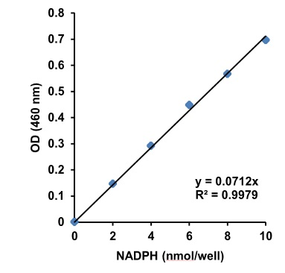

Figure 1. NADPH Standard Curve.

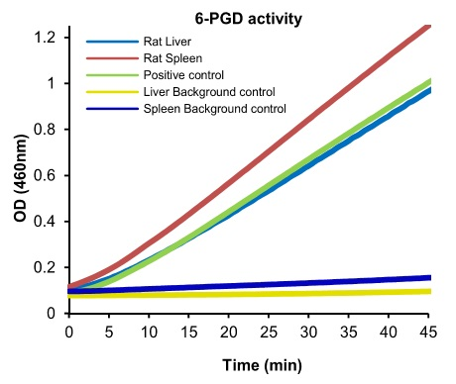

Figure 2. Reaction kinetics of 6-Phosphogluconate dehydrogenase activity in positive control, rat liver (66 µg protein) and rat spleen (56 µg protein) using appropriate background controls.

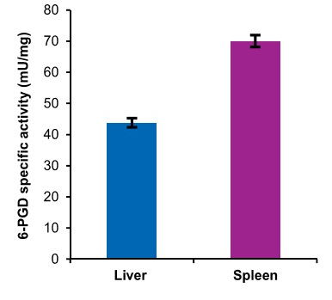

Figure 3. 6-Phosphogluconate dehydrogenase specific activity calculated in rat liver and spleen tissue lysates.

- Notes

Technical Support
Copyright © 2023 Abcam. All Rights Reserved. The Abcam logo is a registered trademark. All information / detail is correct at time of going to print.
For all technical or commercial enquiries please go to: www.abcam.com/contactus
www.abcam.cn/contactus (China)
www.abcam.co.jp/contactus (Japan)

