Version 2a Last updated 6 April 2020

ab241030

Gamma Glutamyl Transferase Assay Kit (Fluorometric)

For the detection of Gamma Glutamyl Transferase activity in serum, tissue, adherent cells and suspension cells.

This product is for research use only and is not intended for diagnostic use.

Table of Contents
1. Overview 1
2. Protocol Summary 1
3. General guidelines, precautions, and troubleshooting 2
4. Materials Supplied, and Storage and Stability 2
5. Materials Required, Not Supplied 2
6. Reagent Preparation 3
7. Standard Preparation 4
8. Sample Preparation 5
9. Assay Procedure 6
10. Data Analysis 7
11. Typical Data 8
12. Notes 9

- Overview
Gamma Glutamyl Transferase (GGT) Assay Kit (Fluorometric) (ab241030) provides a convenient tool for sensitive detection of the GGT in a variety of samples.
The GGT in sample will recognize L-γ-Glutamyl-AMC as a specific substrate leading to proportional fluorescence development. The activity of GGT can be easily quantified fluorometrically (Ex/Em = 365/460 nm).
This assay detects GGT activity as low as 0.02 mIU in sample.

- Protocol Summary

Prepare tissue or cell samples and positive control.

Prepare standard curve.

Add test samples and positive control to wells.

Add GGT Substrate Mix to test samples and positive control wells, incubate for 3 mins before measuring fluorescence.

Measure fluorescence (Ex/Em = 365/460 nm) of standard curve, test samples and positive controls.

For the samples and positive controls, incubate plate at 37°C for 30 mins to 2 hours, then read again.

- General guidelines, precautions, and troubleshooting
- Please observe safe laboratory practice and consult the safety datasheet.
- For general guidelines, precautions, limitations on the use of our assay kits and general assay troubleshooting tips, particularly for first time users, please consult our guide: www.abcam.com/assaykitguidelines
- For typical data produced using the assay, please see the assay kit datasheet on our website.
- Materials Supplied, and Storage and Stability
- Store kit at -20°C in the dark immediately upon receipt and check below in Section 6 for storage for individual components. Kit can be stored for 1 year from receipt, if components have not been reconstituted.
- Aliquot components in working volumes before storing at the recommended temperature.

Item | Quantity | Storage condition
GGT Assay Buffer | 25 mL | -20°C
GGT Substrate | 1 bottle | -20°C
GGT Positive Control | 1 vial | -20°C
AMC Standard (1 mM) | 100 µL | -20°C

- Materials Required, Not Supplied
These materials are not included in the kit, but will be required to successfully perform this assay:

- 96-well plate
- Multi-well spectrophotometer
- Reagent Preparation
- Before using the kit, spin tubes and bring down all components to the bottom of tubes.
- Prepare only as much reagent as is needed on the day of the experiment.

  - GGT Assay Buffer:
Ready to use as supplied. Bring to room temperature before use.
  - GGT Substrate:
Reconstitute with 5.5 mL GGT Assay Buffer to prepare substrate solution. Avoid keeping the reconstituted substrate at room temperature for more than 1 hour and aliquot and store at -20°C after use. It is stable for up to 1 month at -20°C after reconstitution or freeze-thaw cycles (< 3 times).
  - GGT Positive Control:
Reconstitute with 1 mL dH₂O. Pipette up and down several times to completely dissolve the pellet into solution (Don’t vortex). Aliquot enough GGT Positive Control (2 µL per assay) for the number of assays to be performed in each experiment and freeze immediately at -20°C for future use. The GGT Positive Control is stable for up to 1 month at -20°C after reconstitution or freeze-thaw cycles (< 5 times). Keep the GGT Positive Control on ice during the preparation.
  - AMC Standard (1 mM):
Please see Section 7.

- Standard Preparation
- Always prepare a fresh set of standards for every use.

Dilute10 μL of the 1 mM AMC Standard with 990 μL of GGT Assay Buffer to generate a 10 µM AMC Standard Solution.
Add 0, 2, 4, 6, 8, 10 µL of the diluted 10 µM AMC Standard Solution into a 96-well plate in duplicate to generate 0, 20, 40, 60, 80, 100 pmol/well standard.
Adjust the final volume to 100 µL with GGT Assay Buffer.

Standard # | AMC 10 µM Standard (μL) | GGT Assay Buffer (μL) | AMC Standard pmol/well
1 | 0 | 100 | 0
2 | 2 | 98 | 20
3 | 4 | 96 | 40
4 | 6 | 94 | 60
5 | 8 | 92 | 80
6 | 10 | 90 | 100

- Sample Preparation
Tissues (10 mg) or cells (1 x 10⁶) can be homogenized in 200 µL of GGT Assay Buffer then centrifuged (13,000 x g, 10 min.) to remove insoluble material.
10-20 µL serum samples can be directly added into each well.
Adjust test samples and Positive Control to 50 μL/well with GGT Assay Buffer in a 96-well plate.

Δ Note: We suggest testing several doses of your sample to make sure the readings are within the linear range of the standard curve.

- Assay Procedure

Add 50 μL GGT Substrate Mix into each well containing the test samples and positive controls. Mix well.

Do Not Add Substrate Mix to AMC Standards.

For AMC Standard Curve, measure the fluorescence at Ex/Em = 365/460 nm in a microplate reader.
For samples and positive controls, incubate the mix for 3 mins. at 37°C, then measure fluorescence at Ex/Em = 365/460 nm in a microplate reader (RFU₀).
Incubate for another 30 mins to 2 hours at 37°C to measure again (RFU₁).

Δ Note: We recommend measuring the fluorescence in a kinetic mode method (preferably every 3-5 mins). Choose a linear range which falls within the AMC Standard Curve to calculate the GGT activity of the samples.

Δ Note: Incubation time depends on the GGT activity in the samples. Longer incubation time may be required for samples having low GGT activity.

- Data Analysis
Subtract 0 standard from all readings.
Plot the AMC standard Curve, then calculate the GGT activity of the test samples:

∆RFU = RFU₁ - RFU₀

Apply the ∆RFU to the AMC standard curve to get B pmol of AMC generated by GGT in the given time.

Sample GGT Activity = {B/(T x V)} x D = pmol/min/mL = μU/mL

Where:

B is AMC amount in the sample well from Standard Curve (pmol).
T is reaction time (min).
V is sample volume added into the reaction well (mL)
D is sample dilution factor (D=1 when samples are undiluted)

Unit Definition: One unit is the amount GGT to generate 1.0 μmol of AMC per min at 37°C. One AMC unit is equal to 3.93 IU.
- Typical Data
Typical data provided for demonstration purposes only.

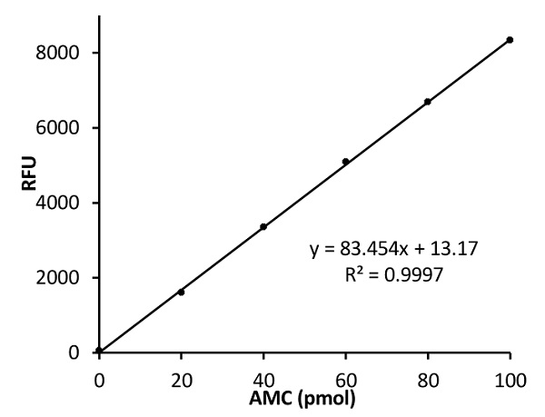

Figure 1. AMC Standard Curve.

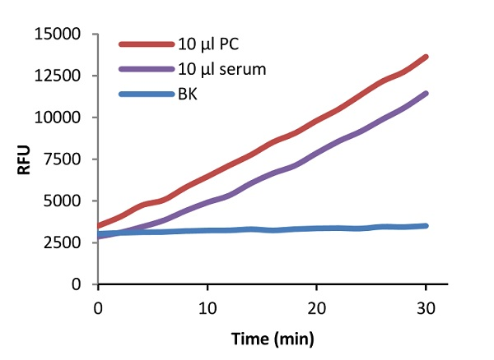

Figure 2. GGT Positive Control and serum sample.

- Notes

Technical Support
Copyright © 2018 Abcam. All Rights Reserved. The Abcam logo is a registered trademark. All information / detail is correct at time of going to print.
Austria
wissenschaftlicherdienst@abcam.com | 019-288-259
France
supportscientifique@abcam.com | 01.46.94.62.96
Germany
wissenschaftlicherdienst@abcam.com | 030-896-779-154
Spain
soportecientifico@abcam.com | 91-114-65-60
Switzerland
technical@abcam.com
Deutsch: 043-501-64-24 | Français: 061-500-05-30
UK, EU and ROW
technical@abcam.com | +44(0)1223-696000
Canada
ca.technical@abcam.com | 877-749-8807
US and Latin America
us.technical@abcam.com | 888-772-2226
Asia Pacific
hk.technical@abcam.com | (852) 2603-6823
China
cn.technical@abcam.com | 400 921 0189 / +86 21 2070 0500
Japan
technical@abcam.co.jp | +81-(0)3-6231-0940
Singapore
sg.technical@abcam.com | 800 188-5244
Australia
au.technical@abcam.com | +61-(0)3-8652-1450
New Zealand
nz.technical@abcam.com | +64-(0)9-909-7829

