Version 3a, Last updated 13 June 2023

ab241040

Taurine Assay Kit

For the detection of Taurine activity in urine, other body fluids, energy drinks and other food extracts.

This product is for research use only and is not intended for diagnostic use.

PLEASE NOTE: With the acquisition of BioVision by Abcam, we have made some changes to component names and packaging to better align with our global standards as we work towards environmental-friendly and efficient growth. You are receiving the same high-quality products as always, with no changes to specifications or protocols.
Table of Contents
1. Overview 1
2. Protocol Summary 2
3. General guidelines, precautions, and troubleshooting 3
4. Materials Supplied, and Storage and Stability 4
5. Materials Required, Not Supplied 4
6. Reagent Preparation 5
7. Working Solution Preparation 6
8. Standard Preparation 6
9. Sample Preparation 7
10. Assay Procedure 8
11. Data Analysis 9
12. Typical Data 10
13. Notes 11

- Overview
Taurine Assay Kit (ab241040) utilizes the ability of an enzyme to convert Taurine into aminoacetaldehyde and sulfite. The produced sulfite is measured using DTNB/a probe which can be detected using a microplate reader (OD 415 nm).
This assay kit is simple, high-throughput compatible and can detect as low as 5 nmols of Taurine.

- Protocol Summary

Prepare samples and background control.

Prepare standard curve.

Prepare taurine enzyme mix/enzyme mix and add to all wells except background control, (add assay buffer instead).

Add DTNB/sulfite probe to sample, background control and standard wells, incubate for 5 mins.

Measure absorbance in an endpoint mode at 415 nm using a microplate reader.

- General guidelines, precautions, and troubleshooting
- Please observe safe laboratory practice and consult the safety datasheet.
- For general guidelines, precautions, limitations on the use of our assay kits and general assay troubleshooting tips, particularly for first time users, please consult our guide: www.abcam.com/assaykitguidelines
- For typical data produced using the assay, please see the assay kit datasheet on our website.

- Materials Supplied, and Storage and Stability
- Store kit at -20°C in the dark immediately upon receipt and check below in Section 6 for storage for individual components. Kit can be stored for 1 year from receipt, if components have not been reconstituted.
- Aliquot components in working volumes before storing at the recommended temperature.

Item | Quantity | Storage condition
Taurine Assay Buffer/Taurine Assay Buffer (4X) | 30 mL | -20°C
Sulfite Probe Buffer | 6 mL | -20°C
Ferrous Cofactor/Enzyme Cofactor | 2 x 3.6 mg | -20°C
Ascorbic Acid/Ascorbic Acid (200 mM) | 1.5 mL | -20°C
Taurine Enzyme Mix/Enzyme Mix | 2 x 1 mL | -20°C
Taurine Standard/Taurine (5 mM) | 1 mL | -20°C
DTNB/Sulfite Probe | 3 x 5 mg | -20°C

- Materials Required, Not Supplied
These materials are not included in the kit, but will be required to successfully perform this assay:

- 96-well plate with clear bottom
- Multi-well spectrophotometer

- Reagent Preparation
- Before using the kit, spin tubes and bring down all components to the bottom of tubes.
- Prepare only as much reagent as is needed on the day of the experiment.

  - Taurine Assay Buffer/Taurine Assay Buffer (4X):
Dilute the buffer to 1X using dH₂O (i.e. mix 2 mL of Taurine Assay Buffer with 6 mL of dH₂O to make 8 mL 1X Assay Buffer). Store at 4 °C or -20 °C. Bring to room temperature before use.
  - Sulfite Probe Buffer:
Ready to use as supplied. Store at 4 °C or -20 °C. Bring to room temperature before use.
  - Ferrous Cofactor/Enzyme Cofactor:
Keep at -20ºC. Before use, add 100 µL dH₂O to one vial, mix well. Avoid aerial exposure. Once reconstituted, use within 1 week.
  - Ascorbic Acid:
Ready to use as supplied. Aliquot and store at -20°C. Avoid aerial exposure and multiple freeze thaw cycle. Use aliquot within a week after thawing.
  - Taurine Enzyme Mix/Enzyme Mix:
Ready to use as supplied. Aliquot and Store at -20°C. Avoid multiple freeze/thaw of the enzyme. Use within 3 months.
  - Taurine Standard/Taurine:
Ready to use as supplied. Store at -20°C or 4ºC. Thaw before use.
  - DTNB/Sulfite Probe:
Store at -20°C. Before use, add 1.4 mL of Sulfite Probe Buffer to each tube and reconstitute the lyophilized DTNB/probe by gentle pipetting, wait until it is completely dissolved. Store at –20°C, stable for 2 months.

- Working Solution Preparation
- Always prepare fresh Working Solution (WS). Use the WS within an hour after being prepared

Before experiment, prepare the WS. To prepare 2 mL of WS: add 2 µL of Ferrous Cofactor/Enzyme cofactor solution and 15 µL of Ascorbic acid to 2 mL of Taurine assay buffer and mix well.

- Standard Preparation
- Always prepare a fresh set of standards for every use.

Add 0, 2, 4, 6, 8 and 10 µL of Taurine Standard/5 mM Taurine into a series of wells in a 96-well plate and adjust the final volume to 180 µL/well with WS to generate 0, 10, 20, 30, 40 and 50 nmol/well of Taurine Standards respectively.

Standard # | 5 mM Taurine Standard (μL) | Working solution (μL) | Taurine Standard nmol/well
1 | 0 | 180 | 0
2 | 2 | 178 | 10
3 | 4 | 176 | 20
4 | 6 | 174 | 30
5 | 8 | 172 | 40
6 | 10 | 170 | 50

- Sample Preparation
Centrifuge urine sample at 14,000 x g for 10 mins at 4°C.
Take the supernatant and filter through a 10 kDa Spin Filter. The filtered urine sample is ready to be assayed.
Add 5-25 μL of filtered urine into desired well(s) in a clear 96-well plate.
Energy drinks: samples can be used directly. If necessary, dilute the sample with water.
For Background Control (BC), add similar amount of sample in separate wells.
Then adjust the final volume to 180 µL in all wells using WS.

Δ Note: Taurine concentration varies over a wide range depending on the sample. For unknown samples, we recommend doing a pilot experiment & testing several doses to ensure the readings are within the Standard Curve range.

Δ Note: For samples having high protein content, we recommend deproteinizing the samples (tissue or cell lysate or biological fluids) using 10 kDa Spin Column. Add sample to the spin column, centrifuge at 10,000 X g, 4°C for 10 min. collect and use the filtrate.

Δ Note: To ensure accurate determination of Taurine in the test samples or for samples having low concentrations of Taurine, we recommend spiking samples with a known amount of Taurine Standard (e.g. 15 nmol).

Δ Note: Thiol present in biological samples might show high background signal. To quantify the signal contribution from taurine-generated sulfite only, add formaldehyde to 5 mM final concentration before adding the DTNB/probe. This will complex with the sulfite and prevent signal generation. The difference of signal (with and without formaldehyde) will correspond to the signal from sulfite only.

- Assay Procedure

To each well of Sample(s) and Taurine Standards, add 20 µL of Taurine Enzyme Mix/Enzyme Mix, mix properly, and then incubate the 96 well plate at 30ºC for 30 mins.
For BC, replace Taurine Enzyme Mix/Enzyme mix with 20 µL of Taurine Assay Buffer.
Add 30 μL of the DTNB/Sulfite Probe to each well containing Sample, Background Control, and Taurine Standards. Mix well, incubate for 5 mins.
Measure absorbance in an endpoint mode at 415 nm using a microplate reader.

- Data Analysis
Subtract 0 Standard reading from all readings.
Plot the Taurine-Standard Curve and obtain the slope of the curve (ΔAbsorbance/nmol).
If the background control reading is significant then subtract the background control reading from sample reading.

[Taurine] = B x D/V = nmol/mL

Where:

B is Taurine amount in the sample well from Standard Curve (nmol).
V is sample volume added into the reaction well (mL)
D is sample dilution factor (D=1 when samples are undiluted)

Δ Note: For spiked samples, correct for any sample interference by subtracting the sample reading from spiked sample reading.

[Taurine] = (OD _{Sample corrected})/
{(OD _{Sample} _{+ Tau Standard})-(OD _{Sample corrected})} x Taurine spike (nmole)

Taurine MW: 125.15.
- Typical Data
Typical data provided for demonstration purposes only.

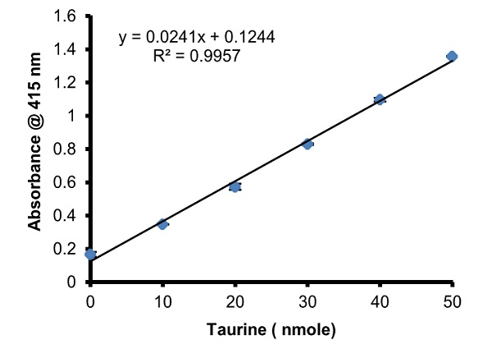

Figure 1. Taurine Standard Curve (5 nmoles-25 nmoles), error bars indicate SD (n=3).

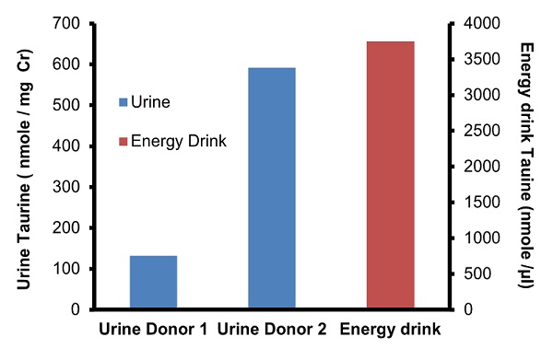

Figure 2. Taurine in urine and energy drink: Taurine present in Donor 1 urine sample was 134 nmoles/ mg Creatinine (Cr) and in Donor 2 was 592 nmoles/ mg Creatinine. Energy drink was diluted 10x with water before performing the assay.

- Notes

Technical Support
Copyright © 2023 Abcam. All Rights Reserved. The Abcam logo is a registered trademark. All information / detail is correct at time of going to print.
For all technical or commercial enquiries please go to:
www.abcam.com/contactus
www.abcam.cn/contactus (China)
www.abcam.co.jp/contactus (Japan)

