Version 1a Last updated 30 March 2021

ab242285

Wound Healing Assay
View Wound Healing Assay datasheet:
www.abcam.com/ab242285

For the generation of a defined wound field or gap in cultured cells and the subsequent analysis (percent closure).

This product is for research use only and is not intended for diagnostic use.

Table of Contents
1. Overview 3
2. Protocol Summary 4
3. General guidelines, precautions, and troubleshooting 5
4. Materials Supplied, and Storage and Stability 5
5. Materials Required, Not Supplied 6
6. Reagent Preparation 6
7. Assay Procedure 7
8. Calculation of Results 10
9. Notes 11

- Overview
Wound Healing Assay (ab242285) contains 2 x 24-well plates each containing 12 proprietary treated plastic inserts. The inserts create a wound field with a defined gap of 0.9 mm for measuring the migratory and proliferation rates of cells. Migratory cells are able to extend protrusions and ultimately invade and close the wound field.
Cell proliferation and migration rates can be determined using manual fixing and microscopic imaging. A fixing solution is provided for stopping cells at specific time points. Cell stain and DAPI stain are also provided for viewing results with light and fluorescence microscopy.

- Protocol Summary

Cell suspension is added to the well with insert in place and then incubated for 24-48 hours.

Cells are cultured until a monolayer forms, then the insert is removed to generate a 0.9 mm wound field.

Cells may be treated and monitored for migration into the wound field.

Cells migrate from either side of the gap until they close the wound field.

Monitor the wound closure with a light microscope or imaging software; wound healing results can be visualized with phase contrast, DAPI fluorescence labeling or cell staining.

- General guidelines, precautions, and troubleshooting
- Please observe safe laboratory practice and consult the safety datasheet.
- For general guidelines, precautions, limitations on the use of our assay kits and general assay troubleshooting tips, particularly for first time users, please consult our guide: www.abcam.com/assaykitguidelines
- For typical data produced using the assay, please see the assay kit datasheet on our website.

- Materials Supplied, and Storage and Stability
- Store kit at -20°C immediately upon receipt and check below for storage for individual components. Kit can be stored for 1 year from receipt, if components have not been reconstituted.
- Aliquot components in working volumes before storing at the recommended temperature.
- Avoid repeated freeze-thaws of reagents.
Item | Quantity | Storage condition
24-well Wound Healing Assay Plate | 2 units | 4°C
Cell Stain Solution | 10 mL | 4°C
DAPI Fluorescence Stain (1000X) | 30 µL | -20°C
Fixation Solution | 20 mL | 4°C

- Materials Required, Not Supplied
These materials are not included in the kit, but will be required to successfully perform this assay:
- Migratory cell lines and culture medium
- Imaging software for measuring wound closure
- Forceps
- PBS
- Light/Fluorescence microscope with DAPI filter (350nm/470nm)

- Reagent Preparation
- Equilibrate all reagents to room temperature (18-25°C) prior to use. Before using the kit, spin tubes and bring down all components to the bottom of tubes.
- Prepare only as much reagent as is needed on the day of the experiment.
- Any components not listed here are ready to use as supplied.

DAPI Fluorescence Stain (1000X):
    - Dilute DAPI 1:1000 in PBS.

- Assay Procedure
  - Cell Migration
    - Using sterile forceps, orient the desired number of inserts in the plate wells with their ‘wound field’ aligned in the same direction. Ensure that the inserts have firm contact with the bottom of the plate well.
Δ Note: It is recommended that all samples be tested in triplicate.
    - Create a cell suspension containing 0.5 - 1.0 x 10⁶ cells/mL in media containing 10% fetal bovine serum (FBS).
    - Add 500 µL of cell suspension to each well by carefully inserting the pipet tip through the open end at the top of the insert. For optimal cell dispersion, add 250 µL of cell suspension to either side of the open ends at the top of the insert. Take care to avoid bumping and moving the inserts.
Δ Note: Adding too much liquid to the well can decrease the quality of the wound field.
    - Incubate cells in a cell culture incubator overnight or until a monolayer forms.
    - Carefully remove the insert from the well to begin the wound healing assay. Use sterile forceps to grab and lift the insert slowly from the plate well. Avoid twisting the insert as this will damage the wound field.
    - Slowly aspirate and discard the media from the wells. Wash wells with media to remove dead cells and debris. Finally, add media to wells to keep cells hydrated.
    - Visualize wells under a light microscope. Repeat wash if wells still have debris or unattached cells.
    - When washing is complete, add media with FBS and/or compounds to continue cell culture and wound healing process. Agents that inhibit or stimulate cell migration can be added directly to the wells.
    - Incubate cells in a cell culture incubator.
    - For best results, use a reticle with micrometer measurements to create a defined surface area in order to monitor the closing, or ‘healing’ of the wound. Focus on the center of the wound field. Create the defined surface area by multiplying the width of the wound field (0.9 mm) by the length. See the example in Figure 1.
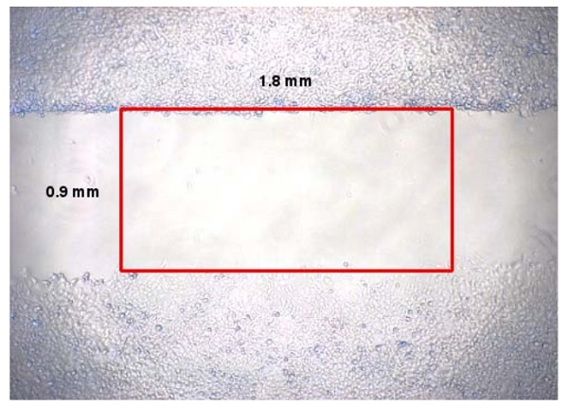

Figure 1. Example of Wound Field Surface Area.

    - Monitor the wound closure with a light microscope or imaging software. Measure the percent closure or the migration rate of the cells into the wound field. Wound healing results can be visualized with phase contrast, DAPI fluorescence labeling, or cell staining.

(Optional) DAPI Fluorescence labeling
    - Cells can be fixed by removing media and adding 0.5 mL of Fixing Solution to each well.
    - Allow the cells to fix for 10 mins at room temperature. Aspirate and discard the solution.
    - Carefully wash each well 3X with PBS.
    - Add 0.5 mL of the diluted DAPI solution from step 6.1.1 to each well to be stained. Incubate for 15 mins at room temperature.
    - Carefully wash each well 3X with PBS. Add 1mL PBS to each well to keep cells hydrated

(Optional) Cell Staining
    - Remove the media or solution and add 400 µL of Cell Stain Solution to each well.
    - Allow the stain to incubate with the cells for 15 mins at room temperature. Aspirate and discard the solution.
    - Carefully wash each stained well 3X with deionized water. Discard washes and allow cells to dry at room temperature.

- Calculation of Results
Percent Closure:
    - Determine the surface area of the defined wound area (see Figure 1): Total Surface Area = 0.9 mm x length.

    - Determine the surface area of the migrated cells in to the wound area: Migrated Cell Surface Area = length of cell migration (mm) x 2 x length.

    - Percent Closure (%) = Migrated Cell Surface Area / Total Surface Area x 100.

Migration Rate:
    - Determine the migration rate of cells into the defined wound area: Migration Rate = length of cell migration (nm) / migration time (hr).

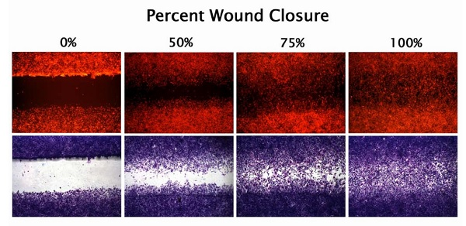

Figure 2. Percent Closure of MEF/STO Cells. STO cells were tested using ab242285. Cells were cultured 24 hours until a monolayer formed at which time the inserts were removed to begin the wound healing assay. Cells were monitored under phase contrast (not shown), DAPI labeling, and cell staining for determining percent closure (0, 50, 75, and 100%).
- Notes

Technical Support
Copyright © 2021 Abcam. All Rights Reserved. The Abcam logo is a registered trademark. All information / detail is correct at time of going to print.
For all technical or commercial enquiries please go to:
www.abcam.com/contactus
www.abcam.cn/contactus (China)
www.abcam.co.jp/contactus (Japan)

