Version 1a, Last updated 29 June 2023

ab242300

Cellular Antioxidant Assay Kit
View Cellular Antioxidant Assay Kit datasheet:
www.abcam.com/ab242300

For the quantitative measurement of antioxidant activity in adherent cells.

This product is for research use only and is not intended for diagnostic use.

Table of Contents
1. Overview 3
2. Protocol Summary 4
3. General guidelines, precautions, and troubleshooting 5
4. Materials Supplied, and Storage and Stability 6
5. Materials Required, Not Supplied 7
6. Reagent Preparation 8
7. Standard Preparation 9
8. Sample Preparation 10
9. Assay Procedure 11
10. Data Analysis 12
11. Typical Data 13
12. Notes 14

- Overview
Cellular Antioxidant Assay Kit (ab242300) is a cell-based assay for measuring antioxidant activity within adherent cells.
Cells are first cultured in a 96-well black fluorescence cell culture plate until confluent. Then the cells are pre-incubated with a cell-permeable DCFH-DA fluorescence probe dye and the bioflavonoid Quercetin, or the antioxidant sample being tested. After a brief incubation, the cells are washed, and the reaction started by adding the Free Radical Initiator. The Free Radical Initiator creates free radicals that convert the probe to highly fluorescent DCF. The Quercetin inhibits the formation of free radicals, and thus DCF formation, in a concentration dependent manner.
Fluorescence is measured over time in a standard microplate fluorometer. This fluorescence correlates to the Quercetin’s ability to quench free radicals. Test antioxidant values can be compared to Quercetin to determine antioxidant activity within the cell.

- Protocol Summary

Culture cells in the microplate till 90-100% confluency.

Remove media, wash and add DCFH-DA Probe to all wells to be tested.

Add standard or prepared sample to wells.

Incubate at 37°C for 60 minutes.

Remove solution, wash and add Free Radical Initiator Solution to all wells.

Immediately begin reading wells with a fluorescent microplate reader at 37ºC at 480/530 nm. Read the wells in increments between 1-5 minutes for a total of 60 minutes.

- General guidelines, precautions, and troubleshooting
- Please observe safe laboratory practice and consult the safety datasheet.
- For general guidelines, precautions, limitations on the use of our assay kits and general assay troubleshooting tips, particularly for first time users, please consult our guide: www.abcam.com/assaykitguidelines
- For typical data produced using the assay, please see the assay kit datasheet on our website.

- Materials Supplied, and Storage and Stability
- Store kit at -20°C immediately upon receipt and check below for storage for individual components. Kit can be stored for 1 year from receipt, if components have not been reconstituted.
- Aliquot components in working volumes before storing at the recommended temperature.
- Avoid repeated freeze-thaws of reagents.

Item | Quantity | Storage condition
96-well Cell Culture Microtiter Plate | 2 x 96 well | +4°C
DCFH-DA Probe (1000X) | 100 µL | -20°C
Free Radical Initiator | 200 mg | +4°C
Quercetin | 250 µL | -20°C

- Materials Required, Not Supplied
These materials are not included in the kit, but will be required to successfully perform this assay:

- Adherent cell lines and test samples
- Sterile DPBS or HBSS for washes and component dilutions
- 10 μL to 1000 μL adjustable single channel micropippettes with disposable tips
- 50 μL to 300 μL adjustable multichannel micropipette with disposable tips
- Mulitchannel micropipette reservoir
- Cell culture incubator (37ºC, 5% CO₂ atmosphere)
- Cell culture medium (i.e. DMEM +/- 10% FBS)
- Fluorescence microplate reader equipped with a 480 nm excitation filter and 530 nm emission filter

- Reagent Preparation
- Equilibrate all reagents to room temperature (18-25°C) prior to use. Before using the kit, spin tubes and bring down all components to the bottom of tubes.
- Prepare only as much reagent as is needed on the day of the experiment.
- Any components not listed here are ready to use as supplied.

Free Radical Initiator:
    - Freshly weigh out and prepare a 2.8 % solution of the Free Radical Initiator in 1X sterile DPBS. (e.g. Reconstitute 28 mg of powder in 1000 µL DPBS). This is a 100X solution. Prior to use, dilute the Free Radical Initiator 1:100 in DPBS. Vortex thoroughly. The 100X Free Radical Initiator solution is stable for 1 week when stored at -20ºC.
Fluorescent Probe:
    - Dilute the DCFH-DA Probe (1000X) stock solution to 2X in cell culture media, preferably without FBS. Stir or vortex to homogeneity. Label this as 2X DCFH-DA Probe/Media Solution. Prepare only enough for immediate applications.

Δ Note: Due to light-induced auto-oxidation, DCFH-DA fluorescence probe solutions at any concentration must be protected from light.

- Standard Preparation
- Always prepare a fresh set of standards for every use.
- Each Antioxidant Standard and sample should be assayed in duplicate or triplicate

Immediately before use, prepare a 1:25 dilution of the stock Quercetin in cell culture media.
Use this Quercetin solution to prepare a series of Quercetin standards in the concentration range of 0 µM – 2000 µM in cell culture media according to the table below.

Standard # | Quercetin Standard (μL) | Cell Culture Media (μL) | Quercetin  (µM)
1 | 40 | 960 | 2000
2 | 500 of Tube #1 | 500 | 1000
3 | 500 of Tube #2 | 500 | 500
4 | 500 of Tube #3 | 500 | 250
5 | 500 of Tube #4 | 500 | 125
6 | 500 of Tube #5 | 500 | 62.5
7 | 500 of Tube #6 | 500 | 31.3
8 | 0 | 1000 | 0

- Sample Preparation
General sample information:
- We recommend performing several dilutions of your sample to ensure the readings are within the standard value range.
- We recommend that you use fresh samples for the most reproducible assay.
- Prepare all samples by diluting and titrating in cell culture media. Samples will be diluted 1:2 final within the assay.

Nutrition Extracts:
    - Weigh solid sample and then blend with a Waring blender for 5 min. in chilled 80% acetone (1:2 w/v, e.g. 1 g sample in 2 mL of 80% acetone).
    - Next, homogenize the samples for 3 min.
    - Filter through Whatman paper and evaporate filtrate under vacuum.
    - Reconstitute samples in 70% methanol and store at -80ºC.
    - Before use, evaporate methanol, preferably under nitrogen, and reconstitute extracts with deionized water or DPBS.
    - Samples may also be diluted in cell culture medium.
    - Final treatment solutions should contain 2% or less of solvent to prevent cytotoxicity.

- Assay Procedure
- Equilibrate all materials and prepared reagents to room temperature prior to use.
- We recommend that you assay all standards, controls and samples in duplicate.

  - Culture cells such as HepG2 or HeLa in the 96-well Cell Culture Microtiter Plate until cells are 90% to 100% confluent.
  - Carefully remove media from all wells and discard. Wash cells gently 3 times with DPBS or HBSS. Remove the last wash and discard.
  - Add 50 µL of DCFH-DA Probe solutions to all wells with confluent cells to be tested.
  - Add 50 µL of Quercetin Standard or prepared sample to each well with confluent cells to be tested. Incubate at 37ºC for 60 minutes.
  - Carefully remove the solution. Wash 3 times with DPBS or HBSS. Remove the last wash and discard.
  - Add 100 µL of the Free Radical Initiator solution to all wells.
  - Immediately begin reading wells with a fluorescent microplate reader at 37ºC with an excitation wavelength of 480nm and an emission wavelength of 530nm. Read the wells in increments between 1 and 5 minutes for a total of 60 minutes. Save values for Calculation of Results.

- Data Analysis
Samples producing signals greater than that of the highest standard should be further diluted in appropriate buffer and reanalyzed, then multiply the concentration found by the appropriate dilution factor.
  - Calculate the integrated area under the curve (AUC) for each sample and standard using the final assay values and the linear regression formula below. The AUC can be calculated from the equation below:

AUC = 1 + RFU1/RFU0 + RFU2/RFU0 +……+ RFU59/RFU0 + RFU60/RFU0

RFU0 = relative fluorescence value of time point zero.
RFUx = relative fluorescence value of time points (e.g. RFU5 is relative fluorescence value at minute five).

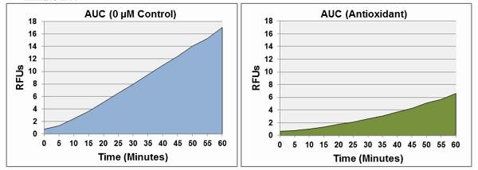

  - Use the AUC values to determine the Cellular Antioxidant Activity values according to the formula.

CAA Units = 100 – (AUC_{Antioxidant} / AUC_{Control}) x 100

  - Plot a dose-response curve by graphing CAA units versus Quercetin concentration. Based on the Quercetin antioxidant standard curve, determine the equivalent Quercetin Equivalents (QE) value of unknown samples.

- Typical Data
Typical standard curve - data provided for demonstration purposes only. A new standard curve must be generated for each assay performed.

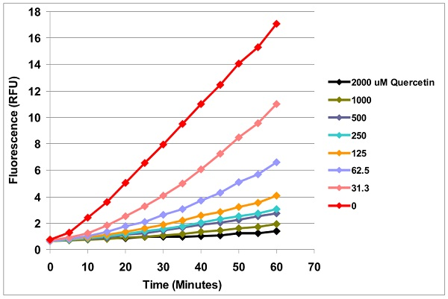

Figure 1. Cellular Antioxidant Activity of Quercetin in HeLa Cells. 60,000 HeLa cells were seeded and cultured in a 96-well plate until confluent. Cells were then pretreated with DCFH-DA and Quercetin for 60 minutes at 37ºC. Free Radical Initiator was then added to the cells to begin the assay, which was read every five minutes for 1 hour at 37ºC.
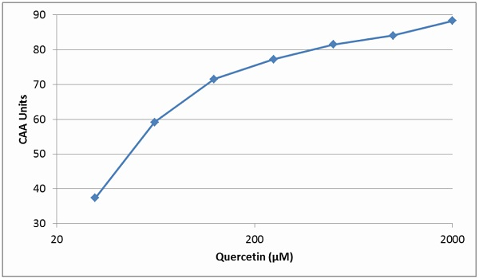

Figure 2. Dose-Response Curve of Quercetin Standard.

- Notes

Technical Support
Copyright © 2023 Abcam. All Rights Reserved. The Abcam logo is a registered trademark. All information / detail is correct at time of going to print.
For all technical or commercial enquiries please go to:
www.abcam.com/contactus
www.abcam.cn/contactus (China)
www.abcam.co.jp/contactus (Japan)

