Version 2 Last updated 12 August 2019

ab243377

Lipid Peroxidation Assay Kit (Cell-based)
View Lipid Peroxidation Assay Kit (Cell-based) datasheet:
www.abcam.com/ab243377

For the measurement of lipid peroxidation in cultured mammalian cells.

This product is for research use only and is not intended for diagnostic use.

Table of Contents
1. Overview 3
2. Materials Supplied and Storage 4
3. Materials Required, Not Supplied 5
4. General guidelines, precautions, and troubleshooting 6
5. Reagent Preparation 7
6. Sample Preparation 8
7. Assay Procedure 9
8. Data Analysis 10
9. Typical Data 11
10. Notes 13

- Overview
Lipid Peroxidation Assay Kit (Cell-based) (ab243377) uses a sensitive ratiometric Lipid Peroxidation Sensor that changes its fluorescence from red to green upon peroxidation by ROS in cells, this peroxidation-dependent shift enables the ratiometric measurement of lipid peroxidation. Our kit includes H₂O₂ as a positive control treatment to induce lipid peroxidation.

Grow cells at desired density and incubate overnight in a humidified chamber at 37°C with 5% CO₂ .

Treat cells with test compounds or H₂O₂ (positive control).

Add Lipid Perixidation Sensor to the cells.

Incubate the cells for 30 minutes at 37°C with 5% CO₂ cell incubator.

Wash cells 3 times with HHBS (or DPBS).

Monitor fluorescence of cells with a fluorescence microscope or flow cytometer through FITC/TRITC or FITC/PE channels within 2 hours of staining.

- Materials Supplied and Storage
Store kit at -20°C in the dark immediately on receipt and check below for storage for individual components. Kit can be stored for 1 year from receipt, if components have not been reconstituted.
Aliquot components in working volumes before storing at the recommended temperature.
Avoid repeated freeze-thaws of reagents.
Item | Quantity | Storage temperature (before prep)
Lipid Peroxidation Sensor | 50 µL | -20°C
HHBS | 50 mL | +4°C
3% H₂O₂ (1 M, 4000X) | 100 µL | +4°C

- Materials Required, Not Supplied
These materials are not included in the kit, but will be required to successfully perform this assay:
- Fluorescence microscope capable of reading at Ex/Em = 490 nm (FITC)/530 nm (FITC) and 545 nm (TRITC)/600 nm (TRITC)
- Flow cytometer with FITC and PE channels (Ex = 488 nm and Em = 530 nm (FITC) or 572 nm (PE))
- Cells of interest

- General guidelines, precautions, and troubleshooting
Please observe safe laboratory practice and consult the safety datasheet.
For general guidelines, precautions, limitations on the use of our assay kits and general assay troubleshooting tips, particularly for first time users, please consult our guide: www.abcam.com/assaykitguidelines
For typical data produced using the assay, please see the assay kit datasheet on our website.

- Reagent Preparation
- Briefly centrifuge small vials at low speed prior to opening.
- Prepare only as much reagent as is needed on the day of the experiment.

Lipid Peroxidation Sensor:
Prepare a 10X working solution by diluting the 500X stock solution 1:50 in HHBS.
HHBS:
Ready to use as supplied.
H₂O₂ (1 M, 4000X):
Ready to use as supplied.

- Sample Preparation

Grow cells of interest under standard conditions.

- Assay Procedure
- Equilibrate all materials and prepared reagents to room temperature just prior to use and gently agitate.
- Assay all controls and samples in duplicate.

Grow cells at desired density and incubate overnight in a humidified chamber at 37°C with 5% CO₂ .
Treat cells with test compounds as desired.

ΔNote: For a positive control, add hydrogen peroxide to the cells at a final concentration of ~250 µM (1X) for 30 minutes.

Add Lipid Peroxidation Sensor the cells at a final concentration of 1X (for example add 10 µL to 90 µL of cells).
Incubate the cells for 30 min at 37°C with 5% CO₂ cell incubator.
Remove media and wash cells with HHBS or DPBS three times.
Monitor fluorescence of cells with a fluorescence microscope or flow cytometer through FITC/TRITC or FITC/PE channels within 2 hours of staining.

- Data Analysis
Monitor fluorescence of cells with a fluorescence microscope or flow cytometer through FITC/TRITC or FITC/PE channels within 2 hours of staining, as described in Section 7.6.
- Typical Data
Data provided for demonstration purposes only.
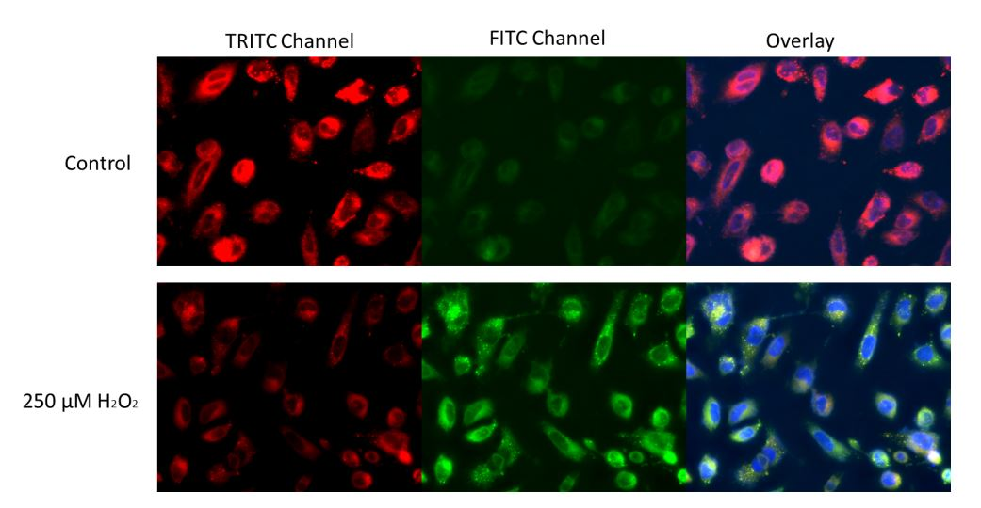
Figure 1. HeLa cells were stained with 1X Lipid Peroxidation Sensor for 30 minutes in complete growth medium at 37°C. For H₂O₂ treatment, approximately 250 µM H₂O₂ was added to the cells and incubated for 30 minutes. The cells were then incubated with 1X Lipid peroxidation Sensor, and stained with Hoechst 33342 during the last 10 minutes of incubation. The cells were washed 3 times with HHBS and imaged with a Keyence fluorescent microscope. With H₂O₂ treatment, a clear shift of fluorescence signal of red to green was observed.

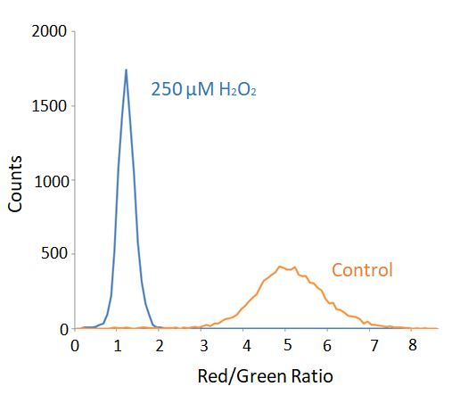

Figure 2. Jurkat cells were stained with 1X Lipid Peroxidation Reagent for 30 minuts in complete growth medium at 37°C. For H₂O₂ treatment, approximately 250 µM H₂O₂ was added to the cells and incubated for 30 minutes. The cells were then incubated with 1X Lipid Peroxidation Sensor, and analyzed with a flow cytometer through FITC (488/530 nm) and PE (488/572 nm) channels. The data are represented as the ratios of red (PE)/green (FITC) fluorescence intensities. The ratio of red/green decreases in H₂O₂ treated cells indicating the presence of H₂O₂-induced lipid peroxidation.

- Notes

Technical Support
Copyright © 2012-2018 Abcam. All Rights Reserved. The Abcam logo is a registered trademark. All information / detail is correct at time of going to print.
Austria
wissenschaftlicherdienst@abcam.com | 019-288-259
France
supportscientifique@abcam.com | 01.46.94.62.96
Germany
wissenschaftlicherdienst@abcam.com | 030-896-779-154
Spain
soportecientifico@abcam.com | 91-114-65-60
Switzerland
technical@abcam.com
Deutsch: 043-501-64-24 | Français: 061-500-05-30
UK, EU and ROW
technical@abcam.com | +44(0)1223-696000
Canada
ca.technical@abcam.com | 877-749-8807
US and Latin America
us.technical@abcam.com | 888-772-2226
Asia Pacific
hk.technical@abcam.com | (852) 2603-6823
China
cn.technical@abcam.com |+86 21 2070 0500 | 400 921 0189
Japan
technical@abcam.co.jp | +81-(0)3-6231-0940
Singapore
sg.technical@abcam.com | 800 188-5244
Australia
au.technical@abcam.com | +61-(0)3-8652-1450
New Zealand
nz.technical@abc.com | +64-(0)9-909-7829

