Version 2 updated 15 November 2019

ab252902

Sorbitol Dehydrogenase Activity Assay Kit (Colorimetric)
View Kit datasheet: https://www.abcam.com/ab252902
(use https://www.abcam.cn/ab252902 for china, or https://www.abcam.co.jp/ab252902 for Japan)

For the measurement of Sorbitol Dehydrogenase Activity in various tissues/cells.

This product is for research use only and is not intended for diagnostic use.

Table of Contents
1. Overview 3
2. Protocol Summary 4
3. Materials Supplied and Storage 5
4. Materials Required, Not Supplied 6
5. General guidelines, precautions, and troubleshooting 7
6. Reagent Preparation 8
7. Standard Preparation 9
8. Sample Preparation 10
9. Assay Procedure 11
10. Typical Data 13
11. Notes 15

- Overview
The Sorbitol Dehydrogenase Activity Assay Kit (Colorimetric) (ab252902) provides a quick and easy way for monitoring SDH activity in various samples. In this Assay, Sorbitol Dehydrogenase utilizes a provided substrate while reducing NAD⁺ to form NADH. NADH reacts with the developer, leading to the formation of a chromophore with strong absorbance at OD 450 nm. The assay is simple, sensitive and can detect Sorbitol Dehydrogenase Activity less than 50 μU in variety of samples.

Sorbitol dehydrogenase
Sorbitol Fructose + NADH + Probe Color
(OD 450nm)

- Protocol Summary

Prepare all samples, standards and controls as instructed.

Add 2-50 μL of each sample into a 96 well clear plate; adjust final volume to 50 μL with SDH Assay Buffer.

Create the 50 µL Reaction Mix and add to standards, positive controls and test samples.

Measure the absorbance immediately at 450nm in kinetic mode for 5-60 minutes at 37°C. The Standard curve may be read in end-point mode.

Calculate the Sorbitol Dehydrogenase Activity using the OD values.

- Materials Supplied and Storage
Store kit at -20°C in the dark immediately on receipt and check below for storage for individual components. Kit can be stored for 1 year from receipt, if components have not been reconstituted.
Avoid repeated freeze-thaws of reagents.
Item | Quantity | Storage temperature (before prep) | Storage temperature (after prep)
SDH Assay Buffer | 25 mL | -20°C | -20°C
SDH Substrate | 200 µL | -20°C | -20°C
SDH Developer | 1 vial | -20°C | -20°C
NADH Standard | 1 vial | -20°C | -20°C
SDH Positive Control | 1 vial | -20°C | -20°C

- Materials Required, Not Supplied
These materials are not included in the kit, but will be required to successfully perform this assay:
- Fluorescent microplate reader capable of measuring Ex/Em = 360/465 nm.
- 96-well white plate with flat bottom.
- Dounce homogenizer.

- General guidelines, precautions, and troubleshooting
Please observe safe laboratory practice and consult the safety datasheet.
For general guidelines, precautions, limitations on the use of our assay kits and general assay troubleshooting tips, particularly for first time users, please consult our guide: www.abcam.com/assaykitguidelines
For typical data produced using the assay, please see the assay kit datasheet on our website.

- Reagent Preparation
Briefly centrifuge small vials at low speed prior to opening.

SDH Developer:
Reconstitute with 220 μL dH₂O. Pipette up and down to dissolve completely. Store at -20°C. Use within two months.
NADH Standard:
Reconstitute with 500 μL Assay buffer to generate 1 mM NADH Standard solution. Store at –20°C. Use within two months. Keep on ice while in use.
SDH Positive control:
Reconstitute with 100 μL of dH2O and mix thoroughly. Aliquot and store at –20°C.

All other reagents are ready to use as supplied.

- Standard Preparation
- Always prepare a fresh set of standards for every use.
- Discard working standard dilutions after use as they do not store well.

  - Add 0, 2, 4, 6, 8, and 10 μL of the 1 mM NADH standard to a series of wells in duplicate in a 96-well plate.
  - Bring the total volume of each well to 50 μL with SDH Assay Buffer to generate 0, 2, 4, 6, 8, and 10 nmol of NADH standard per well.

Standard# | NADH Standard (µL) | SDH Assay Buffer (µL) | End amount of NADH in well (nmol/well)
1 | 0 | 50 | 0
2 | 2 | 48 | 2
3 | 4 | 46 | 4
4 | 6 | 44 | 6
5 | 8 | 42 | 8
6 | 10 | 40 | 10

- Sample Preparation
For whole cells or tissue lysate:
- Rapidly homogenize tissue (10 mg) or cells (2 x 10⁶) with 200 μL ice cold SDH Assay Buffer, and place on ice for 10 minutes.
- Centrifuge at 10,000 X g for 5 minutes and collect the supernatant.
- Use the ammonium sulfate precipitation method to remove interfering small molecules: Aliquot the tissue samples (100 μL) to a clean centrifuge tube, add saturated 4.32 M ammonium sulfate to 65% saturation (1 volume of sample + 2 volumes of 4.32M ammonium sulfate) and place on ice for 30 minutes.
- Spin down samples at 10,000 x g at 4°C for 10 minutes, discard the supernatant, and resuspend the pellet back to the original volume.

SDH Assay:
- Add 2-50 μL of each sample into a 96 well clear plate; adjust final volume to 50 μL with SDH Assay Buffer.
- For SDH Positive Control, dilute 2 μL of SDH stock with 18 μL SDH Assay Buffer, mix well.
- Add 2-20 μL of diluted Positive Control; adjust final volume to 50 μL with SDH assay buffer. Aliquot and store the rest of SDH stock at -20 °C.

∆Note: For unknown samples, we suggest testing several doses to ensure the readings are within the standard curve range.
∆Note: For samples exhibiting elevated background, prepare parallel sample wells as sample background controls.

- Assay Procedure
Reaction mix:
- Mix enough reagents for the number of assays to be performed.
- For each well Reaction, Background and standard, create the 50µL Reaction Mix shown Below:

 | Reaction Mix | Background Control Mix
SDH Assay Buffer | 44 µL | 48 µL
SDH Developer | 2 µL | 2 µL
SDH Substrate | 2 µL | -

- Mix well. Add 50 µL Reaction Mix to wells of the 96-well plate, containing the standard, positive control and test samples.
- Add 50 µL of Background Control Mix to each well containing Sample Background Control. Mix Well.

Measurement:
- Measure absorbance immediately at 450 nm in kinetic mode for 5-60 minutes at 37ºC.

∆Note: Incubation time depends on the Sorbitol Dehydrogenase activity in the samples. We recommend measuring the OD in kinetic mode, and choose two time points (t1 & t2) in the linear range to calculate the SDH activity of the samples. The NADH standard curve can be read in Endpoint mode (i.e., at the end of the incubation period).

Calculation:
- Subtract the 0 standard reading from all standard readings.
- Plot the NADH standard curve.
- Correct sample background by subtracting the value derived from the sample background controls from their respective sample readings.
- Calculate the signal generated by SDH activity of the test sample: ΔOD = A2 – A1. Apply the ΔOD to the NADH standard curve to get B nmol of NADH generated by Sorbitol Dehydrogenase during the reaction time (ΔT = t2 - t1).

Sorbitol Dehydrogenase Activity = B/(ΔT X V) x D = nmol/min/ml/ = mU/ml

Where:
B = NADH amount from Standard Curve (in nmol)
V = Sample volume added into the reaction well (in mL)
D = Dilution factor
∆T = Reaction time in minutes.

Unit Definition: One unit of Sorbitol Dehydrogenase is the amount of enzyme that will generate 1.0 μmol of NADH per minute at pH 9 at
37ºC.

- Typical Data
Data provided for demonstration purposes only.

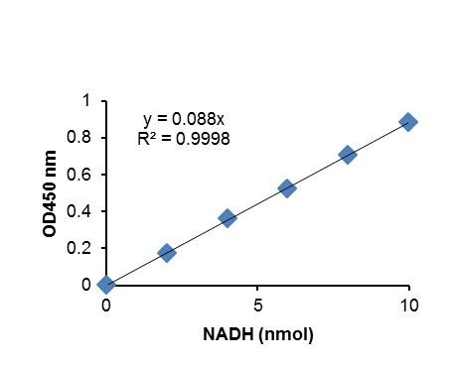

Figure 1. NADH standard curve.

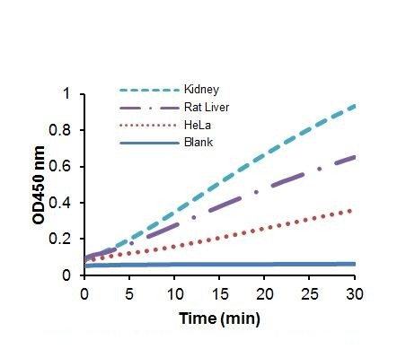

Figure 2. Kinetic measurement of Sorbitol Dehydrogenase activity from various samples.

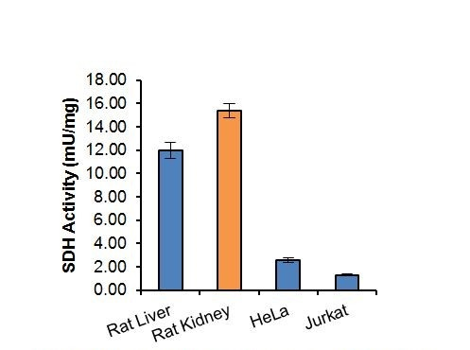

Figure 3. Relative SDH Activity was calculated in lysates (μg protein) prepared from Rat Liver (8 μg), Rat Kidney (10 μg), HeLa (42 μg) and Jurkat (73 μg).
- Notes

Technical Support
Copyright © 2019 Abcam. All Rights Reserved. The Abcam logo is a registered trademark. All information / detail is correct at time of going to print.
Austria
wissenschaftlicherdienst@abcam.com | 019-288-259
France
supportscientifique@abcam.com | 01.46.94.62.96
Germany
wissenschaftlicherdienst@abcam.com | 030-896-779-154
Spain
soportecientifico@abcam.com | 91-114-65-60
Switzerland
technical@abcam.com
Deutsch: 043-501-64-24 | Français: 061-500-05-30
UK, EU and ROW
technical@abcam.com | +44(0)1223-696000
Canada
ca.technical@abcam.com | 877-749-8807
US and Latin America
us.technical@abcam.com | 888-772-2226
Asia Pacific
hk.technical@abcam.com | (852) 2603-6823
China
cn.technical@abcam.com | 400 921 0189 / +86 21 2070 0500
Japan
technical@abcam.co.jp | +81-(0)3-6231-0940
Singapore
sg.technical@abcam.com | 800 188-5244
Australia
au.technical@abcam.com | +61-(0)3-8652-1450
New Zealand
nz.technical@abc.com | +64-(0)9-909-7829

