Version 1b Last updated 9 August 2022

ab253380

LysoLiveTM Lysosomal Acid Lipase Assay Kit Kit
View LysoLiveTM Lysosomal Acid Lipase Assay Kit datasheet:
www.abcam.com/ab253380
(use www.abcam.cn/ab253380 for China, or www.abcam.co.jp/ab253380 for Japan)

For the measurement of acid lipase activity in lysosomes of live cells.

This product is for research use only and is not intended for diagnostic use.

Table of Contents
1. Overview 3
2. Materials Supplied and Storage 5
3. Materials Required, Not Supplied 6
4. General guidelines, precautions, and troubleshooting 6
5. Reagent Preparation 7
6. Assay Procedure 8
7. Typical Data 10
8. Notes 12
Technical Support 13

- Overview
Lysosomes are acidic cytoplasmic organelles that are present in all nucleated mammalian cells. Lysosomes have been found to be involved in a variety of cellular processes including repair of the plasma membrane, defense against pathogens, cholesterol homeostasis, bone remodeling, metabolism, apoptosis, and cell signaling. Defects in lysosomal enzyme activity have been associated with a variety of neurological diseases including Parkinson’s, Tay-Sachs, Sandhoff, Krabbe, Wolman, and Gaucher syndromes.
Lysosomal Acid Lipase Deficency (LALD) is an autosomal recessive disorder that results from a deficiency in an enzyme known as lysosomal acid lipase (LAL). Defects in the gene coding for lysosomal acid lipase result in this lysosomal storage disease, affecting about 1 in 40000 live births. LALD occurs in two forms: the infant onset form often referred to as Wolman’s disease and the later onset form termed Cholesteryl Ester Storage Disease (CESD). In both forms a large buildup of lipids occurs, especially in the liver, which leads to dysfunction and enlargement of the liver and can ultimately lead to liver failure. Recent evidence has also pointed to a link between lipase deficiencies and pancreatitis, coronary heart disease and peripheral vascular disease.
The LysoLiveTM kits contain unique targeted lysosomal staining compounds that are useful for labeling lysosomes in a live-cell format and are capable of simultaneously monitoring lysosomal metabolic activity. These targeted substrates are based upon fluorescent probes that have a low pKa value for optimal fluorescence at the lower physiological pH values found in the lysosomes as well as specific targeting groups to direct their accumulation to the lysosomes using a live-cell staining format.
The LysoLiveTM Lysosomal Acid Lipase Assay Kit utilizes a sensitive substrate for lysosomal acid lipase (LAL) called LipaGreenTM. The substrate only becomes fluorescent upon cleavage by the enzyme. Lysosomes with low acid lipase activity will exhibit reduced staining in a manner proportional to the enzyme activity levels found in the cell.

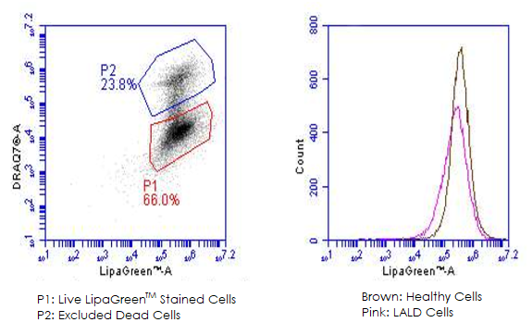
- Materials Supplied and Storage
Store kit immediately on receipt. Kit can be stored for 6 months from receipt, if components have not been diluted. LysoLiveTM LipaGreenTM is a clear oil which should be protected from light and stored at -20˚C until needed. Prolonged exposure of labeled cells to fluorescent light sources may result in photobleaching of the dyes therein.
Aliquot components in working volumes before storing at the recommended temperature.
Avoid repeated freeze-thaws of reagents.
Item | Quantity | Storage temperature
LysoLiveTM LipaGreeenTM | 5 units | -20°C
DMSO | 500 µL | RT
Flow Holding and Sorting Buffer for Adherent Cells (5X) | 10 mL | 4°C
Flow Holding and Sorting Buffer for non-Adherent Cells (5X) | 10 mL | 4°C

- Materials Required, Not Supplied
These materials are not included in the kit, but will be required to successfully perform this assay:
- Flow cytometer.
- 96-well microplate

- General guidelines, precautions, and troubleshooting
Please observe safe laboratory practice and consult the safety datasheet.
For general guidelines, precautions, limitations on the use of our assay kits and general assay troubleshooting tips, particularly for first time users, please consult our guide: www.abcam.com/assaykitguidelines
For typical data produced using the assay, please see the assay kit datasheet on our website.

- Reagent Preparation
- Equilibrate all reagents to room temperature prior to use. Adjust volumes as needed for your experiment.
- Prepare only as much reagent as is needed on the day of the experiment.

5.1. 1X Flow Holding and Sorting Buffer for Adherent Cells. Dilute 5X with sterile water prior to use. To prepare 10mL of 1X buffer, combine 2mL of 5X buffer with 8mL sterile water and briefly mix.

5.2. 1X Flow Holding and Sorting Buffer for non-Adherent Cells. Dilute 5X with sterile water prior to use. To prepare 10mL of 1X buffer, combine 2mL of 5X buffer with 8mL sterile water and briefly mix.

- Assay Procedure
All reagent preparation and cell staining procedures should be performed under sterile conditions, such as in a laminar flow hood. Please read Notes below.

If a biological agent is being tested for its effects on enzyme activity, treat cells in culture with the agent/drug prior to use of this kit.

6.1 For Adherent Cells:
    - Remove growth medium from cells by aspiration.
    - Prepare a staining medium by adding 10 µL of DMSO to one unit of LysoLiveTM LipaGreenTM and diluting 1:1000 in serum free growth medium.
    - Add the staining medium from Step 6.1.2 to cells. See Table (1) for recommended volumes for different culture vessels.
    - Incubate cells at 37°C/5% CO₂ for 2-16 hours. Inspect the cells by fluorescence microscopy for staining levels during this interval to determine the optimum staining time(s) for your particular cell type. Use the optimum staining time/level determined in the above trial for all further assays.
    - Lift cells using appropriate disassociation protocol (e.g. trypsin treatment) and centrifuge to a weak pellet.
    - Resuspend cells with 1X Flow Holding and Sorting Buffer for Adherent Cells containing a vital stain if required.
    - Read cells on flow cytometer using 488nm laser and FL-1 detection (~520nm emission).
    - Capture at least 10000 live cell events.

6.2 For Non-Adherent Cells

6.2.1 Harvest cells and prepare samples to have at least 50000 cells per sample.
6.2.2 Prepare a staining medium by adding 10 µL of DMSO to one unit of LysoLiveTM LipaGreenTM and diluting 1:500 in serum free growth medium.
6.2.3 Add an equal volume of the staining medium from Step 6.2.2 to cells. See Table (1) for recommended volumes for different culture vessels.
6.2.4 Incubate cells at 37°C/5% CO₂ for 2-16 hours.
6.2.5 Centrifuge cells as appropriate for the vial/plate and remove the supernatant staining medium (see NOTE (2)).
6.2.6 Resuspend cells in 1X Flow Holding and Sorting Buffer for non-Adherent Cells containing a vital stain if required.
6.2.7 Read cells on flow cytometer using 488nm laser and FL-1 detection (~520nm emission).
    - Capture at least 10000 live cell events.

NOTE (1): It is recommended that the LysoLiveTM LipaGreenTM be diluted in a serum-free growth medium appropriate for the cell line to be assayed. Use of serum may produce inaccurate results due to potential exogenous enzyme activities as well as other lipidic components present in serum. It is also suggested that medium used for staining be free of antibiotics/antimycotics, to avoid any potential effects of these compounds on enzyme activities within the cells.

NOTE (2): For non-adherent cells grown in 96-well microplate formats, the centrifugation/removal of the staining medium and resuspension in Flow Holding and Sorting Buffer may not be necessary if the plate is be read on the Flow Cytometer immediately.

NOTE (3): It is strongly recommended that users determine their own optimum staining concentrations and incubation times. Optimum conditions can vary greatly depending on cell line, culture conditions, and sensitivity of fluorescence microscopy equipment.

Culture Vessel | Recommended Staining Medium Volume | Recommended 1X PBS Volume
100mm culture dish | 10 mL | 5 mL
60mm culture dish | 4 mL | 2 mL
6-well culture plate | 2 mL/well | 1 mL
12-well culture plate | 1 mL/well | 500 µL
24-well culture plate | 500 µL/well | 250 µL
96-well culture plate | 200 µL/well | 100 µL
Table 1. Recommended Reagent Volumes for Different Cultures Vessels.

- Typical Data
Data provided for demonstration purposes only.

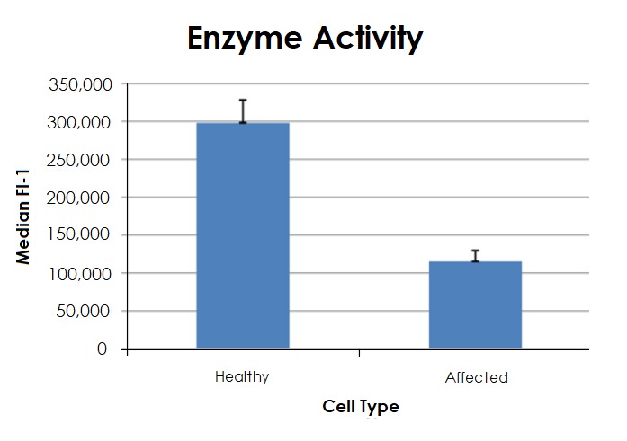
Figure 1. Labeling cells with LysoLiveTM Lysosomal Acid Lipase Assay Kit in healthy cells and those from a LALD patient.
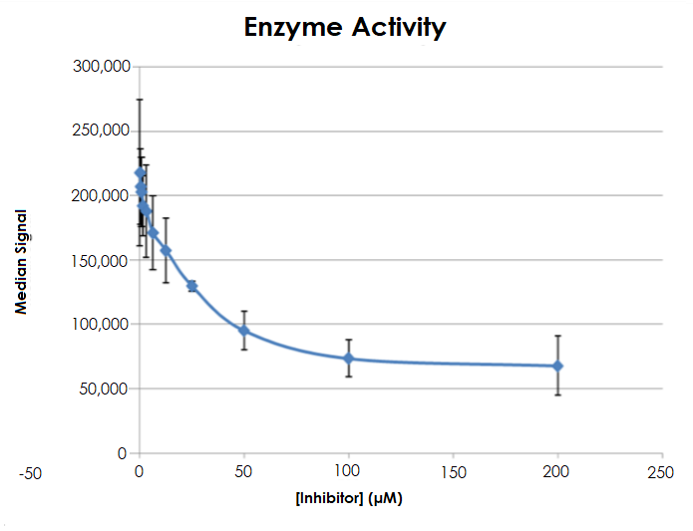
Figure 2: Labeling of healthy cells with LysoLive™ Lysosomal Assay Kit after treatment with Lipase inhibiter (Orlistat).

Technical Support
Copyright © 2022 Abcam, All Rights Reserved. The Abcam logo is a registered trademark. All information / detail is correct at time of going to print.
For all technical or commercial enquiries please go to:
www.abcam.com/contactus
www.abcam.cn/contactus (China)
www.abcam.co.jp/contactus (Japan)

