Version 1 Last updated 12 May 2020

ab272518

Alcohol Dehydrogenase Assay Kit
View ab272518
Alcohol Dehydrogenase Assay Kit datasheet:
www.abcam.com/ab272518
(use www.abcam.cn/ab272518 for China, or www.abcam.co.jp/ab272518 for Japan)

For quantitative determination of alcohol dehydrogenase activity and evaluation of drug effects on its metabolism.

This product is for research use only and is not intended for diagnostic use.

Table of Contents
1. Overview 1
2. Protocol Summary 2
3. Precautions 3
4. Storage and Stability 3
5. Limitations 4
6. Materials Supplied 4
7. Materials Required, Not Supplied 5
8. Technical Hints 6
9. Reagent Preparation 7
10. Sample Preparation 8
11. Assay Procedure 9
12. Calculations 11
13. Typical Data 12
14. Notes 13

- Overview
Alcohol Dehydrogenase Assay Kit (ab272518) is a non-radioactive, colorimetric ADH assay is based on the reduction of the tetrazolium salt MTT in a NADH coupled enzymatic reaction to a reduced form of MTT which exhibits an absorption maximum at 565 nm. The increase in absorbance at 565 nm is directly proportional to the enzyme activity.

Fast and Sensitive: Linear detection range (20 µL sample): 0.4 to 80 U/L for 30 min reaction. Detection Limit of 0.1 U/L for 120 min reaction.

Linear detection range (20 µL sample): 0.4 to 80 U/L for 30 min reaction. Detection Limit of 0.1 U/L for 120 min reaction.
- Protocol Summary

Prepare all reagents and samples as instructed

Add Calibrator, blanks and samples to appropriate tubes.

Read OD₅₆₅ (= OD₀)

Incubate for 30 minutes at desired reaction temperature.

Read OD₅₆₅ (= OD₃₀)

Calculate ADH activity

- Precautions
Please read these instructions carefully prior to beginning the assay.
- All kit components have been formulated and quality control tested to function successfully as a kit.
- We understand that, occasionally, experimental protocols might need to be modified to meet unique experimental circumstances. However, we cannot guarantee the performance of the product outside the conditions detailed in this protocol booklet.
- Reagents should be treated as possible mutagens and should be handled with care and disposed of properly. Please review the Safety Datasheet (SDS) provided with the product for information on the specific components.
- Observe good laboratory practices. Gloves, lab coat, and protective eyewear should always be worn. Never pipet by mouth. Do not eat, drink or smoke in the laboratory areas.
- All biological materials should be treated as potentially hazardous and handled as such. They should be disposed of in accordance with established safety procedures.
- Storage and Stability
Store kit at -20°C immediately upon receipt. Avoid multiple freeze-thaw cycles. Kit has a storage time of 6 months from receipt, providing components have not been reconstituted.
Refer to list of materials supplied for storage conditions of individual components. Observe the storage conditions for individual prepared components in the Materials Supplied section.

- Limitations
- Assay kit intended for research use only. Not for use in diagnostic procedures.
- Do not mix or substitute reagents or materials from other kit lots or vendors. Kits are QC tested as a set of components and performance cannot be guaranteed if utilized separately or substituted.
- Materials Supplied
Item | Quantity | Storage Condition
Assay Buffer | 10 mL | -20°C
Diaphorase | 0.12 mL | -20°C
NAD Solution | 1mL | -20°C
MTT Solution | 1.5 mL | -20°C
Calibrator | 1.5 mL | -20°C
Substrate (10% Ethanol) | 1 mL | -20°C

- Materials Required, Not Supplied
These materials are not included in the kit, but will be required to successfully perform this assay:
- Centrifuge tubes
- 96-well clear plate with flat bottom
- Standard microplate reader - capable of reading absorbance at 565 nm
- Technical Hints
- This kit is sold based on number of tests. A ‘test’ simply refers to a single assay well. The number of wells that contain sample, control or standard will vary by product. Review the protocol completely to confirm this kit meets your requirements. Please contact our Technical Support staff with any questions.
- Pre-rinse the pipette tip with the reagent, use fresh pipette tips for each sample, standard and reagent.
- Pipette standards and samples to the bottom of the wells.
- Add the reagents to the side of the tube to avoid contamination.
- Some Solutions supplied in this kit are caustic; care should be taken with their use.

- Reagent Preparation
- Equilibrate all reagents to room temperature (18-25°C) prior to use. The kit contains enough reagents for 100 assays.

All reagents are supplied ready to use.
- Sample Preparation
Plasma and serum are assayed directly.
  - Tissue:
    - Prior to dissection, rinse tissue in phosphate buffered saline (pH 7.4) to remove blood.
    - Homogenize tissue (50 mg) in ~200 µL buffer containing 50 mM potassium phosphate (pH 7.5).
    - Centrifuge at 10,000 x g for 15 minutes at 4°C. Remove supernatant for assay.

  - Cell lysate:
    - Collect cells by centrifugation at 2,000 x g for 5 minutes at 4°C.

Δ Note: For adherent cells, do not harvest cells using proteolytic enzymes; rather use a rubber policeman.

    - Homogenize or sonicate cells in an appropriate volume of cold buffer containing 50 mM potassium phosphate (pH 7.5).
    - Centrifuge at 10,000 x g for 15 minutes at 4°C. Remove supernatant for assay.

Δ Note: All samples can be stored at –20°C to –80°C for at least one month.

- Assay Procedure
- Equilibrate all materials and prepared reagents to the desired reaction temperature (e.g. 25°C or 37°C) prior to use.
- We recommend that you assay all standards, controls and samples in duplicate.
Prepare Working Reagent (WR) by mixing for each reaction: 5 µL Substrate, 14 µL MTT Solution, 9 µL NAD Solution, 1 µL Diaphorase and 55 µL Assay Buffer.
Prepare Blank Working Reagent (BWR) by mixing for each reaction: 14 µL MTT Solution, 9 µL NAD Solution, 1 µL Diaphorase and 60 µL Assay Buffer (i.e. no Substrate).
Component | Working Reagent (WR) (µL/reaction) | Blank Working Reagent (BWR) (µL/reaction)
Substrate | 5 | -
MTT Solution | 14 | 14
NAD Solution | 9 | 9
Diaphorase | 1 | 1
Assay Buffer | 55 | 60
Δ Note: It is recommended that the Working Reagents be prepared fresh.
Reaction:
  - Transfer 100 µL H₂O (OD_{H2O}) and 100 µL Calibrator (OD_{CAL}) solution into wells of a clear flat bottom 96-well plate.
  - Transfer 20 µL sample into 2 separate wells. Add 80 µL WR to one sample well and 80 µL BWR to the other sample well. Tap plate briefly to mix.
  - Read OD565nm (OD₀), and again after 30 min (OD₃₀) on a plate reader.

Δ Note: This assay is based on a kinetic reaction. To ensure identical incubation time, addition of Working Reagent to samples should be quick and mixing should be brief but thorough. Use of a multi-channel pipettor is recommended.

Δ Note: Assays can be executed at any desired temperature (e.g. 25°C or 37°C).

Δ Note: Use 96-well clear, flat-bottom plates.

- Calculations
  - Subtract the OD₀ from OD₃₀ for each sample and sample blank well to compute the ΔOD_{S} and ΔOD_{B} values, respectively.
  - ADH activity can then be calculated as follows:

ΔOD_{S} - ΔOD_{B} Reaction volume (µL)
ADH activity = __________________ x __________________________________________ x n
ε_{MTT} x l t (min) x Sample volume (µL)

273 ΔOD_{S} - ΔOD_{B}
= ________ x _______________________ x n (U/L)
t (min) OD_{CAL} – OD_{H2O}

ε_{MTT} = Molar absorption coefficient of reduced MTT
l = Light pathlength which is calculated from the calibrator
OD_{CAL} = OD₅₆₅ value of the Calibrator
OD_{H20} = OD₅₆₅ value of water
t = Reaction time (30 minutes is recommended)
Reaction volume = 100 µL
Sample volume = 20 µL
n = Dilution factor

Unit definition: 1 Unit (U) of ADH will catalyze the conversion of 1 µmole of ethanol to acetaldehyde per minute at pH 8.2.

Δ Note: If sample ADH activity exceeds 80 U/L, either use a shorter reaction time or dilute samples in water and repeat the assay. For samples with ADH activity < 1 U/L, the incubation time can be extended to 2 hours.

- Typical Data
Typical standard curve – data provided for demonstration purposes only. A new standard curve must be generated for each assay performed.

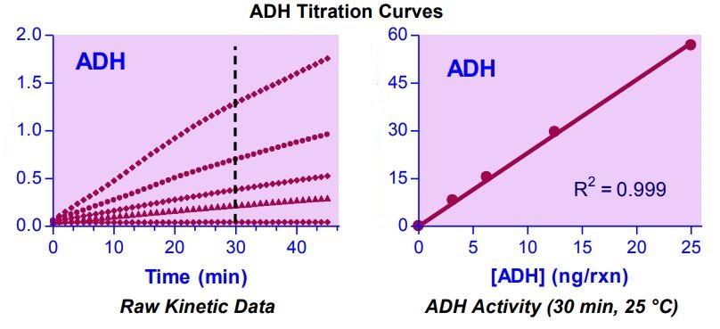

Figure 1. Example of Alcohol Dehydrogenase titration curves.
OD₅₆₅ readings (left) and calculated activity (right).
- Notes

Technical Support
Copyright © 2020 Abcam, All Rights Reserved. The Abcam logo is a registered trademark. All information / detail is correct at time of going to print.
For all technical or commercial enquiries please go to:
www.abcam.com/contactus
www.abcam.cn/contactus (China)
www.abcam.co.jp/contactus (Japan)

