Version 1 Last updated 12 May 2020

ab272521

Beta-Glucosidase Assay Kit
View ab272521
Beta-Glucosidase Assay Kit datasheet:
www.abcam.com/ab272521
(use www.abcam.cn/ab272521 for China, or www.abcam.co.jp/ab272521 for Japan)

For quantitative determination of beta-Glucosidase activity and evaluation of drug effects on its metabolism.

This product is for research use only and is not intended for diagnostic use.

Table of Contents
1. Overview 1
2. Protocol Summary 2
3. Precautions 3
4. Storage and Stability 3
5. Limitations 4
6. Materials Supplied 4
7. Materials Required, Not Supplied 5
8. Technical Hints 6
9. Reagent Preparation 7
10. Sample Preparation 8
11. Assay Procedure 9
12. Calculations 10
13. Typical Data 11
14. Notes 13

- Overview
Beta-Glucosidase Assay Kit (ab272521) is a simple, direct and automation-ready procedure for measuring β-glucosidase. beta-Glucosidase Assay Kit (ab272521) is designed to measure β-glucosidase activity directly in biological samples without pretreatment. The improved method utilizes p-nitrophenyl-β-D-glucopyranoside that is hydrolyzed specifically by β-glucosidase into a yellow colored product (maximal absorbance at 405nm). The rate of the reaction is directly proportional to the enzyme activity.

High sensitivity and wide linear range. Use 20 μL sample. The detection limit is 2 U/L, linear up to 250 U/L.

Homogeneous and simple procedure. Simple "mix-and-measure" procedure allows reliable quantitation of β-glucosidase activity within 20 minutes.

Robust and amenable to HTS. All reagents are compatible with high-throughput liquid handling instruments.
- Protocol Summary

Prepare all reagents and samples as instructed

Add blanks and samples to appropriate wells.

Add Calibrator, H₂O or Working Reagent to appropriate wells.

Read OD₄₀₅ (= OD₀)

Incubate for 20 minutes at desired reaction temperature.

Read OD₄₀₅ (= OD₂₀)

Calculate β-NPG activity

- Precautions
Please read these instructions carefully prior to beginning the assay.
- All kit components have been formulated and quality control tested to function successfully as a kit.
- We understand that, occasionally, experimental protocols might need to be modified to meet unique experimental circumstances. However, we cannot guarantee the performance of the product outside the conditions detailed in this protocol booklet.
- Reagents should be treated as possible mutagens and should be handled with care and disposed of properly. Please review the Safety Datasheet (SDS) provided with the product for information on the specific components.
- Observe good laboratory practices. Gloves, lab coat, and protective eyewear should always be worn. Never pipet by mouth. Do not eat, drink or smoke in the laboratory areas.
- All biological materials should be treated as potentially hazardous and handled as such. They should be disposed of in accordance with established safety procedures.
- Storage and Stability
Store kit at -20°C immediately upon receipt. Avoid multiple freeze-thaw cycles. Kit has a storage time of 6 months from receipt.
Refer to list of materials supplied for storage conditions of individual components. Observe the storage conditions for individual prepared components in the Materials Supplied section.

- Limitations
- Assay kit intended for research use only. Not for use in diagnostic procedures.
- Do not mix or substitute reagents or materials from other kit lots or vendors. Kits are QC tested as a set of components and performance cannot be guaranteed if utilized separately or substituted.
- Materials Supplied
Item | Quantity | Storage Condition
Assay Buffer | 24 mL | -20°C
Calibrator | 10 mL | 20°C
β-NPG Substrate | 1 mL | -20°C

- Materials Required, Not Supplied
These materials are not included in the kit, but will be required to successfully perform this assay:
- Pipetting devices and accessories
- 96-well clear plate with flat bottom
- Standard microplate reader - capable of reading absorbance at 405 nm
- Technical Hints
- This kit is sold based on number of tests. A ‘test’ simply refers to a single assay well. The number of wells that contain sample, control or standard will vary by product. Review the protocol completely to confirm this kit meets your requirements. Please contact our Technical Support staff with any questions.
- Pre-rinse the pipette tip with the reagent, use fresh pipette tips for each sample, standard and reagent.
- Pipette standards and samples to the bottom of the wells.
- Add the reagents to the side of the tube to avoid contamination.
- Some Solutions supplied in this kit are caustic; care should be taken with their use.

- Reagent Preparation
- Equilibrate all reagents to room temperature (18-25°C) prior to use.
- The kit contains enough reagents for 100 assays.

All reagents are supplied ready to use.
- Sample Preparation
- Enzyme samples can be in 50 mM phosphate (pH 7.0) buffer or in any other suitable enzyme buffer.

Δ Note: The following chemicals are known to affect the enzyme activity and should be avoided. SH-containing reagents (e.g. dithiothreitol, 2-mercaptoethanol, glutathione), Ca2+, Cu2+ , Fe3+/Fe2+, Hg2+, Mg2+, Ni2+, Zn2+, SDS, EDTA and Tris.

- Assay Procedure
- Equilibrate all materials and prepared reagents to the desired reaction temperature (e.g. 25°C or 37°C) prior to use.
- We recommend that you assay all standards, controls and samples in duplicate.

Working Reagent:
The Working Reagent is prepared by mixing for each 96-well assay, 200 µL Assay Buffer and 8 µL β-NPG Substrate (final 1.0 mM).
Component | Volume per assay (µL)
Assay Buffer | 200
β-NPG Substrate | 8
Δ Note: Fresh preparation is recommended, although the Working Solution is stable for at least one day at room temperature.
Reaction:
  - Transfer 20 µL distilled water (H₂O) to two wells of a clear bottom 96 well plate. Add 200 µL H₂O to one of these wells and 200 µL Calibrator to the other well (total volume 220 µL).
  - Transfer 20 µL samples into other wells. Transfer 200 µL Working Reagent to the sample wells only. The final reaction volume in the sample wells is 220 µL. Tap plate briefly to mix.
  - Read OD405nm (t = 0), and again after 20 min (t = 20 min) on a plate reader.

Δ Note: This assay is based on a kinetic reaction. To ensure identical incubation time, addition of Working Reagent to samples should be quick and mixing should be brief but thorough. Use of a multi-channel pipettor is recommended.
Δ Note: Assays can be executed at any desired temperature (e.g. RT or 37°C).
- Calculations
  - Calculation: β-glucosidase activity of the sample (U/L) is:

β-Glucosidase Activity =$\frac{OD20-OD0}{OD Calibrator-ODH2O}×250 (U/L)$

OD₀ = OC 405 nm at 0 minutes
OD₂₀ = OD 405 nm at 20 minutes
OD_{Calibrator} = OD 405 nm of calibrator at 20 minutes
OD_{H2O} = OD 405 nm of H₂O at 20 minutes

Unit definition: One unit of β-Glucosidase enzyme catalyzes the hydrolysis of 1 µmole of substrate per min at pH 7.0.

- Typical Data
Typical standard curve – data provided for demonstration purposes only. A new standard curve must be generated for each assay performed.

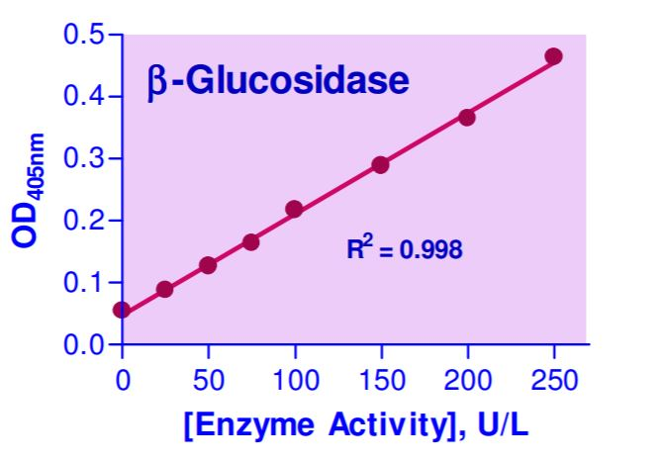

Figure 1. Example of beta-Glucosidase standard curve.
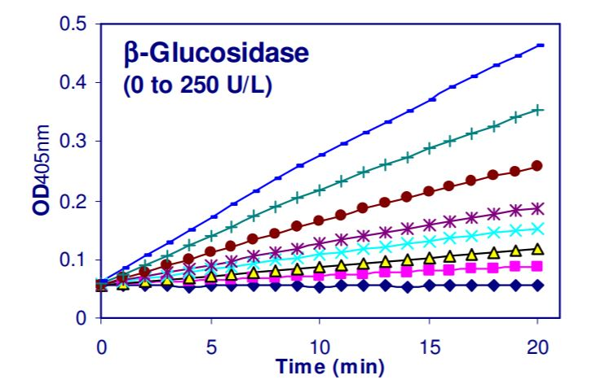
Figure 2. Example of beta-Glucosidase reaction progress curves.
- Notes

Technical Support
Copyright © 2020 Abcam, All Rights Reserved. The Abcam logo is a registered trademark. All information / detail is correct at time of going to print.
For all technical or commercial enquiries please go to:
www.abcam.com/contactus
www.abcam.cn/contactus (China)
www.abcam.co.jp/contactus (Japan)

