Version 1b Last updated 22 November 2023

ab272528

Copper Assay Kit
View ab272528
Copper Assay Kit datasheet:
www.abcam.com/ab272528
(use www.abcam.cn/ab272528 for China, or www.abcam.co.jp/ab272528 for Japan)

For quantitative determination of Copper and evaluation of drug effects on its metabolism.

This product is for research use only and is not intended for diagnostic use.

Table of Contents
1. Overview 1
2. Protocol Summary 2
3. Precautions 3
4. Storage and Stability 3
5. Limitations 4
6. Materials Supplied 4
7. Materials Required, Not Supplied 5
8. Technical Hints 6
9. Reagent Preparation 7
10. Standard Preparation 8
11. Sample Preparation 9
12. Assay Procedure 10
13. Calculations 11
14. Typical Data 12
15. Notes 13

- Overview
ab272528 is a simple, direct and automation-ready procedure for measuring copper concentrations in a wide range of applications in research, drug discovery and environmental monitoring. The Copper assay kit is designed to measure copper with no or minimal sample treatment. The improved method utilizes a chromogen that forms a colored complex specifically with copper ions. The intensity of the color, measured at 359nm, is directly proportional to copper concentration in the sample. The optimized formulation substantially reduces interference by substances in the raw samples.

Sensitive and accurate. Linear detection range 7 µg/dL (1.0 µM) to 300 µg/dL (47 µM) copper in 96-well plate assay.

Simple and high-throughput. The simple procedure can be readily automated as a high-throughput assay in 96-well plates for thousands of samples per day.

Improved reagent stability and versatility. The optimized formulation has greatly enhanced reagent and signal stability. Cuvette or 96-well plate assay.
- Protocol Summary

Prepare all reagents and samples as instructed

Add standards and samples to appropriate tubes.

Add Working Reagent (WR) to samples and standards.

Incubate for 5 minutes at room temperature.

Briefly centrifuge tubes and transfer contents to 96-well plate.

Read absorbance at 356- 362nm (peak absorbance at 359nm).

- Precautions
Please read these instructions carefully prior to beginning the assay.
- All kit components have been formulated and quality control tested to function successfully as a kit.
- We understand that, occasionally, experimental protocols might need to be modified to meet unique experimental circumstances. However, we cannot guarantee the performance of the product outside the conditions detailed in this protocol booklet.
- Reagents should be treated as possible mutagens and should be handled with care and disposed of properly. Please review the Safety Datasheet (SDS) provided with the product for information on the specific components.
- Observe good laboratory practices. Gloves, lab coat, and protective eyewear should always be worn. Never pipet by mouth. Do not eat, drink or smoke in the laboratory areas.
- All biological materials should be treated as potentially hazardous and handled as such. They should be disposed of in accordance with established safety procedures.
- Storage and Stability
Store all reagents at 4°C immediately upon receipt. Kit has a storage time of 12 months from receipt, providing components have not been reconstituted.
Refer to list of materials supplied for storage conditions of individual components. Observe the storage conditions for individual prepared components in the Materials Supplied section.

- Limitations
- Assay kit intended for research use only. Not for use in diagnostic procedures.
- Do not mix or substitute reagents or materials from other kit lots or vendors. Kits are QC tested as a set of components and performance cannot be guaranteed if utilized separately or substituted.
- Materials Supplied
Item | Quantity | Storage Condition
Reagent A | 10 mL | +4ºC
Reagent B | 1.5 mL | +4ºC
Reagent C | 40 mL | +4ºC
Copper Standard (1.5 mg/dL Cu²⁺) | 1 mL | +4ºC

- Materials Required, Not Supplied
These materials are not included in the kit, but will be required to successfully perform this assay:
- Pipetting devices and accessories
- 96-well clear plate with flat bottom (alternatively, 1 mL cuvettes may be used)
- Standard microplate reader - capable of reading absorbance at 356-362nm.

- Technical Hints
- This kit is sold based on number of tests. A ‘test’ simply refers to a single assay well. The number of wells that contain sample, control or standard will vary by product. Review the protocol completely to confirm this kit meets your requirements. Please contact our Technical Support staff with any questions.
- Pre-rinse the pipette tip with the reagent, use fresh pipette tips for each sample, standard and reagent.
- Pipette standards and samples to the bottom of the wells.
- Add the reagents to the side of the tube to avoid contamination.
- Some Solutions supplied in this kit are caustic; care should be taken with their use.

- Reagent Preparation
- Equilibrate all reagents to room temperature (18-25°C) prior to use. The kit contains enough reagents for 250 assays.

All reagents are supplied ready to use.
- Standard Preparation
- Always prepare a fresh set of standards for every use.
- Prepare serially diluted standards immediately prior to use.

- Transfer 100 µL dH2O into one Eppendorf tube labeled “Blank”. Into another tube labeled “Standard”, mix 20 µL 1.5 mg/dL Standard and 80 µL dH2O (final 300 µg/dL Cu2+). Add 35 µL Reagent A (trichloroacetic acid) to each tube and mix by vortexing
- Sample Preparation
Sample treatment:
Transfer 100 µL samples into separate tubes.
Add 35 µL Reagent A (trichloroacetic acid) to each tube and mix by vortexing. If samples contain protein (e.g. serum/plasma), precipitates form. Centrifuge tubes for 2 min at 14,000 rpm and use clear supernatant for assay. For samples that do not contain protein, the mixture remains clear and centrifugation is not necessary.

Transfer 100 µL Blank, Standard and Sample into separate wells of a clear flat-bottom 96-well plate.
- Assay Procedure
- Equilibrate all materials and prepared reagents to room temperature prior to use.
- We recommend that you assay all standards, controls and samples in duplicate.

Component | Working Reagent (µL/reaction)
Reagent A | 35
Reagent B | 5
Reagent C | 150

96-well plate procedure:
For each assay well, prepare Working Reagent by mixing 5 µL Reagent B and 150 µL Reagent C. Transfer 150 µL Working Reagent to each well and tap plate to mix thoroughly.
Incubate 5 min at room temperature and read optical density at 356- 362nm (peak absorbance at 359nm).

Note: if sample OD values are higher than the OD value for the 300µg/dL Standard, dilute sample in dH2O and repeat assay. Multiply the results by the dilution factor.
Cuvette procedure:
Prepare standards and samples as for 96-well assay procedure.
Transfer 400 µL Standards and Samples into separate cuvettes.
Add 600 µL Working Reagent. Mix by pipetting.
Incubate 5 min at room temperature and read optical density at
356-362nm (peak absorbance at 359nm).
- Calculations
  - Subtract blank OD (Standard #4) from the standard OD values and plot the OD against standard concentrations.
  - Determine the slope using linear regression fitting.
  - The copper concentration of Sample is calculated as

[Copper] in µM = $\frac{(ODSample – ODBlank)}{(ODStandard – ODBlank} X 300 (µg/dl)$

OD_{Sample} = OD value of the sample

OD_{Blank} = OD value of water

Δ Note: 100 µg/dL Cu equals 15.5 µM, 0.0001% or 1 ppm

- Typical Data
Typical standard curve – data provided for demonstration purposes only. A new standard curve must be generated for each assay performed.

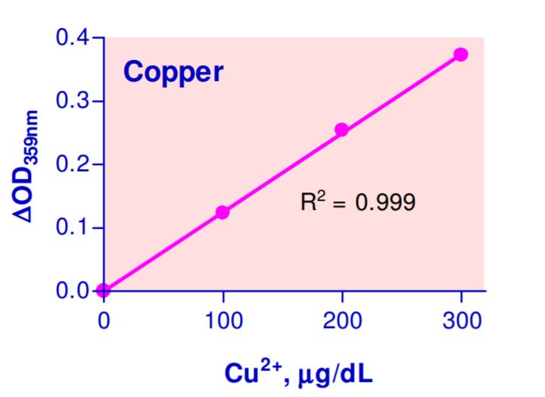
Figure 1. Example of Copper Assay Kit standard curve.
- Notes

Technical Support
Copyright © 2023 Abcam, All Rights Reserved. The Abcam logo is a registered trademark. All information / detail is correct at time of going to print.
For all technical or commercial enquiries please go to:
www.abcam.com/contactus
www.abcam.cn/contactus (China)
www.abcam.co.jp/contactus (Japan)

