Version 2a, Last updated 16 June 2023

ab273296
Ceruloplasmin Activity Assay (Colorimetric)
View Kit datasheet: https://www.abcam.com/ab273296
(use https://www.abcam.cn/ab273296 for china, or https://www.abcam.co.jp/ab273296 for Japan)
For the detection of Ceruloplasmin activity in plasma.

This product is for research use only and is not intended for diagnostic use.

PLEASE NOTE: With the acquisition of BioVision by Abcam, we have made some changes to component names and packaging to better align with our global standards as we work towards environmental-friendly and efficient growth. You are receiving the same high-quality products as always, with no changes to specifications or protocols.

Table of Contents
1. Overview 1
2. Protocol Summary 2
3. Precautions 3
4. Storage and Stability 3
5. Limitations 4
6. Materials Supplied 4
7. Materials Required, Not Supplied 5
8. Technical Hints 6
9. Reagent Preparation 7
10. Sample Preparation 7
11. Standard Curve 8
12. Assay Procedure 9
13. Calculations 10
14. Typical Data 11
15. FAQ / Troubleshooting 12
16. Notes 13

- Overview
Ceruloplasmin Activity Assay Kit (Colorimetric) (ab273296) utilizes an oxidase substrate, which gives an intensely colored product upon oxidation. The kit is fast, easy to use and suitable for high throughput applications and can measure ceruloplasmin activity in serum in the range between approximately 5 and 500 mU/ml.
- Protocol Summary

Remove chloride from Sample via ammonium sulfate precipitation or dialysis

Add Samples to 96-well plate and make volume to 100 µL with Ceruloplasmin Assay Buffer

Prepare Standard Curve as directed

Add Reaction Mix (100 µL) to all Standard and Sample wells

Read OD in kinetic mode at 560 nm at 25°C (reaction is linear for 15 -20 minutes). Standard Curve can be read in end-point mode.

- Precautions
Please read these instructions carefully prior to beginning the assay.
- All kit components have been formulated and quality control tested to function successfully as a kit.
- We understand that, occasionally, experimental protocols might need to be modified to meet unique experimental circumstances. However, we cannot guarantee the performance of the product outside the conditions detailed in this protocol booklet.
- Reagents should be treated as possible mutagens and should be handled with care and disposed of properly. Please review the Safety Datasheet (SDS) provided with the product for information on the specific components.
- Observe good laboratory practices. Gloves, lab coat, and protective eyewear should always be worn. Never pipette by mouth. Do not eat, drink or smoke in the laboratory areas.
- All biological materials should be treated as potentially hazardous and handled as such. They should be disposed of in accordance with established safety procedures.
- Storage and Stability
Store kit at 4°C in the dark immediately upon receipt. Kit has a storage time of 2 months from receipt.
Refer to list of materials supplied for storage conditions of individual components. Observe the storage conditions for individual prepared components in the Materials Supplied section.
Aliquot components in working volumes before storing at the recommended temperature.

- Limitations
- Assay kit intended for research use only. Not for use in diagnostic procedures.
- Do not mix or substitute reagents or materials from other kit lots or vendors. Kits are QC tested as a set of components and performance cannot be guaranteed if utilized separately or substituted.
- Materials Supplied
Item | Quantity | Storage temperature (before prep)
Ceruloplasmin Assay Buffer | 25 mL | 4°C
Ammonium Sulfate/Ammonium Sulfate, saturated (~4.1M) | 10 mL | 4°C
Ceruloplasmin Substrate | 1 mL | 4°C
Oxidizer I/Oxidizer (100 mM) | 100 μL | 4°C
H₂O₂ Standard/Stabilizer | 100 μL | 4°C

- Materials Required, Not Supplied
These materials are not included in the kit, but will be required to successfully perform this assay:
- Microplate reader capable of measuring absorbance at 560 nm

- Technical Hints
- This kit is sold based on number of tests. A “test” simply refers to a single assay well. The number of wells that contain sample, control or standard will vary by product. Review the protocol completely to confirm this kit meets your requirements. Please contact our Technical Support staff with any questions.
- Selected components in this kit are supplied in surplus amount to account for additional dilutions, evaporation, or instrumentation settings where higher volumes are required. They should be disposed of in accordance with established safety procedures.
- Avoid foaming or bubbles when mixing or reconstituting components.
- Avoid cross contamination of samples or reagents by changing tips between sample, standard and reagent additions.
- Ensure plates are properly sealed or covered during incubation steps.
- Ensure all reagents and solutions are at the appropriate temperature before starting the assay.
- Samples generating values that are greater than the most concentrated standard should be further diluted in the appropriate sample dilution buffer.
- Make sure all necessary equipment is switched on and set at the appropriate temperature.
- Reagent Preparation
All components are ready to use as supplied.
Use within two months.

- Sample Preparation
Δ Note: Chloride in serum is an inhibitor of the ceruloplasmin enzyme activity and needs to be removed prior to analysis.

This can be accomplished by Ammonium Sulfate precipitation of the serum proteins followed by removal of the supernatant containing the chloride or by dialysis of samples against a 1000X volume of dH₂O for 1 hour.

  - For the Ammonium Sulfate method, take 100 µL of serum and add 100 µL of saturated Ammonium Sulfate, vortex briefly to mix then place on ice for 5 minutes.
  - Centrifuge at 10,000 rpm at ambient temperature for 5 minutes to pellet the protein precipitate and remove 160 µL of the clear supernatant with a pipette.
  - Add 160 µL of dH₂O to the pellet and dissolve. Add samples equivalent to 5-20 µL into 96-well plate and bring volumes to 100 µL with Ceruloplasmin Assay Buffer.

- Standard Curve
  - Dilute the Oxidizer I/Oxidizer to 5 mM by adding 10 µL of 100 mM Oxidizer I/Oxidizer to 180 µL of Ceruloplasmin Assay Buffer.
  - Add 10 µL H₂O₂ Standard/Stabilizer and mix well.
  - Add 0, 2, 4, 6, 8 & 10 µL of 5 mM Oxidizer I/Oxidizer into a series of wells in 96-well plate to generate 0, 10, 20, 30, 40 & 50 nmol Standard.
  - Bring the volume to 100 µL with Ceruloplasmin Assay Buffer.

Standard # | 5 mM Oxidizer I/Oxidizer (µL) | Ceruloplasmin Assay Buffer (µL) | Standard (nmol/well)
1 | 10 | 90 | 50
2 | 8 | 92 | 40
3 | 6 | 94 | 30
4 | 4 | 96 | 20
5 | 2 | 98 | 10
6 | 0 | 100 | 0

∆ Note: The Standard Curve is produced by a nonenzymatic
oxidation using chemical Oxidizer I/Oxidizer. The H₂O₂ Standard/Stabilizer protects the color of the product for up to 15 min.
The Standard Curve has to be read within the same time
(compatible time-frame for measuring the enzyme activity as well).

- Assay Procedure
Set the plate reader to 25°C and place the Ceruloplasmin Assay Buffer into a water bath set at 25°C for 30 minutes prior to use.

  - Reaction Mix:
    - For each sample and Standard well, prepare 100 µL of Reaction Mix as shown below:

Constituent | Reaction Mix
Ceruloplasmin Substrate | 10 µL
Ceruloplasmin Assay Buffer | 90 µL

    - Mix and add 100 µL of the Reaction Mix to each Sample and Standard well.

  - Measurement
    - Read OD in kinetic mode at 560 nm.
    - The reaction is linear for only around 15-20 minutes and tends to appear to slow slightly after that.
    - Cold samples (not adequately equilibrated to 25°C) will cause a slight lag phase detectable for the first 1-2 minutes.
    - The Standard curve can read at the end of the incubation time in end-point mode.

∆Note: Ceruloplasmin performs a 1 electron oxidation of the substrate to a red product.
This product is increasingly unstable as its concentration increases and 2 molecules of the product undergo disproportionation to 1 molecule of substrate and 1 molecule of a 2-electron oxidation product which has a slightly lower absorbance than the 1 electron product at 560 nm.
The enzymatic oxidation is linear over a wide range but the disproportionation results in a slight downward bend of the enzymatic reaction after around 15 minutes as the OD gets near and above 1.

- Calculations
  - Plot the Standard Curve (OD vs. nmol) and determine the slope of the Standard Curve. For more accurate work, only use OD’s less than 1 to determine the slope. Slope = OD/nmol of oxidized substrate.
  - Determine the linear portion of the curve for the samples and calculate the ∆OD/minute for this portion of the curve (equal to OD₂ - OD₁ /T₂ -T₁), where OD₂ and OD₁ is absorbance at the end and beginning of linear portion, respectively and T₂ and T₁ is the time at the end and beginning of linear portion in minutes.

Sample Ceruloplasmin Activity = S_{k} / Ss / V x 2 (mU/mL or U/L)

S_{k} = Kinetic slope of the sample (OD/min) in the linear portion of the curve Ss = slope of the standard curve (OD/nmol)
V = Volume of the sample in ml
2 = Dilution factor (only for ammonium sulphate precipitated samples not for the dialyzed samples).

Unit definition: One unit of Ceruloplasmin is the amount of enzyme that will oxidize one µmol of Substrate per minutes at 25°C.

- Typical Data
Typical standard curve – data provided for demonstration purposes only. A new standard curve must be generated for each assay performed.
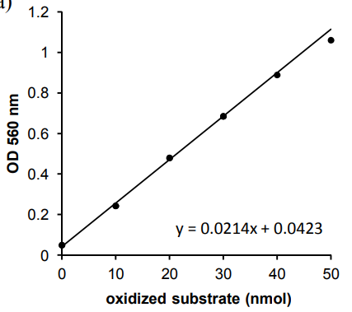
Figure 1. Typical Standard Curve of chemically oxidized substrate. The Standard Curve slope (for the points below 1.0 OD) is 0.0214 OD/nmol.

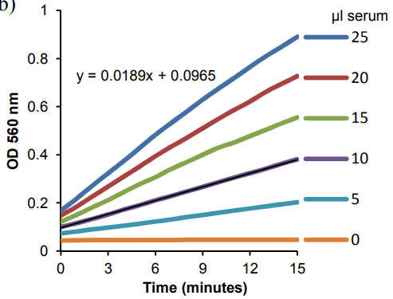
Figure 2. Ceruloplasmin Activity Assay. Kinetic curves obtained from varying sample volumes of human serum. The kinetic slope for a 10 μL sample of an Ammonium Sulfate precipitate of frozen pooled human serum is 0.0189. Serum Ceruloplasmin Activity = 0.0189 (OD/min)/0.0214 (OD/nmol)/0.01mL X 2 = 176 mU/mL.
- FAQ / Troubleshooting
General troubleshooting points are found at www.abcam.com/assaykitguidelines.

- Notes

Technical Support
Copyright © 2023 Abcam, All Rights Reserved. The Abcam logo is a registered trademark. All information / detail is correct at time of going to print.
For all technical or commercial enquiries please go to:
www.abcam.com/contactus
www.abcam.cn/contactus (China)
www.abcam.co.jp/contactus (Japan)

