Version 2a, Last updated 25 March 2024
ab273315
Acyl-CoA Synthetase Assay Kit (Fluorometric)
View Kit datasheet: https://www.abcam.com/ab273315
(use https://www.abcam.cn/ab273315 for china, or https://www.abcam.co.jp/ab273315 for Japan)

For the determination of ACS activity in various cells and tissues

This product is for research use only and is not intended for diagnostic use.

PLEASE NOTE: With the acquisition of BioVision by Abcam, we have made some changes to component names and packaging to better align with our global standards as we work towards environmental-friendly and efficient growth. You are receiving the same high-quality products as always, with no changes to specifications or protocols.
Table of Contents
1. Overview 1
2. Protocol Summary 2
3. Precautions 3
4. Storage and Stability 3
5. Limitations 4
6. Materials Supplied 4
7. Materials Required, Not Supplied 5
8. Technical Hints 6
9. Reagent Preparation 7
10. Sample Preparation 8
11. Standard Curve 9
12. Assay Procedure 10
13. Calculations 11
14. Typical Data 12
15. FAQ / Troubleshooting 14
16. Notes 15

- Overview
Acyl-CoA Synthetase (ACS) Assay Kit (Fluorometric) (ab273315) provides a rapid, sensitive and straightforward way to measure ACS activity in various samples. In the assay, acyl-CoA produced by ACS activity is metabolized by the Enzyme Mix, Developer Mix and Converter Mix to generate an intermediate compound, which reacts with a probe, yielding a fluorescent signal that can be measured with excitation at 535 nm and emission at 587 nm. This assay can detect ACS activity as low as 5 mU/µl sample.
- Protocol Summary

Prepare samples as directed

Prepare all reagents as directed

Prepare standard curve and measure fluorescence at Ex/Em = 535/587 nm. Calculate slope

Add Positive Control, Samples, Background Control to appropriate wells and adjust volume to 50 µL

Add Reaction Mix or Background Mix (50 µL)

Measure fluorescence (Ex/Em= 535/587 nm) in a kinetic mode
for 30 min at 37°C.

- Precautions
Please read these instructions carefully prior to beginning the assay.
- All kit components have been formulated and quality control tested to function successfully as a kit.
- We understand that, occasionally, experimental protocols might need to be modified to meet unique experimental circumstances. However, we cannot guarantee the performance of the product outside the conditions detailed in this protocol booklet.
- Reagents should be treated as possible mutagens and should be handled with care and disposed of properly. Please review the Safety Datasheet (SDS) provided with the product for information on the specific components.
- Observe good laboratory practices. Gloves, lab coat, and protective eyewear should always be worn. Never pipette by mouth. Do not eat, drink or smoke in the laboratory areas.
- All biological materials should be treated as potentially hazardous and handled as such. They should be disposed of in accordance with established safety procedures.
- Storage and Stability
Store kit at -20°C in the dark immediately upon receipt. Kit has a storage time of 2 months from receipt.
Refer to list of materials supplied for storage conditions of individual components. Observe the storage conditions for individual prepared components in the Materials Supplied section.
Aliquot components in working volumes before storing at the recommended temperature.

- Limitations
- Assay kit intended for research use only. Not for use in diagnostic procedures.
- Do not mix or substitute reagents or materials from other kit lots or vendors. Kits are QC tested as a set of components and performance cannot be guaranteed if utilized separately or substituted.
- Materials Supplied
Item | Quantity | Storage temperature (before prep)
Assay Buffer V/ACS Assay Buffer | 25 mL | -20°C
ACS Substrate | 1 mL | -20°C
Acyl CoA Enzyme Mix/ACS Enzyme Mix (Lyophilized) | 1 vial | -20°C
ACS Converter (Lyophilized) | 1 vial | -20°C
ACS Developer (Lyophilized) | 1 vial | -20°C
ACS Positive Control (Lyophilized) | 1 vial | -20°C
OxiRed Probe/ACS Probe | 0.2 mL | -20°C
H₂O₂ Standard | 100 μL | -20°C

- Materials Required, Not Supplied
These materials are not included in the kit, but will be required to successfully perform this assay:
- Fluorescence microplate reader capable of measuring fluorescence at Ex/Em = 535/587 nm
- 96-well black plate with flat bottom

- Technical Hints
- This kit is sold based on number of tests. A “test” simply refers to a single assay well. The number of wells that contain sample, control or standard will vary by product. Review the protocol completely to confirm this kit meets your requirements. Please contact our Technical Support staff with any questions.
- Selected components in this kit are supplied in surplus amount to account for additional dilutions, evaporation, or instrumentation settings where higher volumes are required. They should be disposed of in accordance with established safety procedures.
- Avoid foaming or bubbles when mixing or reconstituting components.
- Avoid cross contamination of samples or reagents by changing tips between sample, standard and reagent additions.
- Ensure plates are properly sealed or covered during incubation steps.
- Ensure all reagents and solutions are at the appropriate temperature before starting the assay.
- Samples generating values that are greater than the most concentrated standard should be further diluted in the appropriate sample dilution buffer.
- Make sure all necessary equipment is switched on and set at the appropriate temperature.
- Reagent Preparation
Briefly centrifuge small vials at low speed prior to opening.

  - Assay Buffer V/ACS Assay Buffer:
Store at -20 °C. Bring to room temperature before use.
Use within two months.
  - ACS Substrate:
Ready to use. Thaw and warm to room temperature.
  - Acyl CoA Enzyme Mix/ACS Enzyme Mix:
Reconstitute with 220 µl Assay Buffer V/ACS Assay Buffer, pipette up and down to mix.
Store at –20°C, protected from light. Use within two months.
  - ACS Converter:
Reconstitute with 220 µl dH2O. Aliquot and store at -20°C.
Use within two months.
  - ACS Developer:
Reconstitute with 220 µl dH2O. Aliquot and store at -20°C.
Use within two months.
  - ACS Positive Control:
Reconstitute with 100 µl Assay Buffer V/ACS Assay Buffer, pipette up and down to mix.
Aliquot and store at –20°C, protected from light.
Use within two months.
  - OxiRed Probe/ACS Probe:
Ready to use. Thaw and warm to room temperature.
  - H₂O₂ Standard:
Ready to use. Thaw and warm to room temperature.

- Sample Preparation
  - Tissue/cell lysate preparation:
    - Homogenize tissue (10 mg) or cells (1 x 10⁶) with 100 µl ice cold Assay Buffer V/ACS Assay Buffer.
    - Centrifuge at 10,000x g and 4ºC for 15 min.
    - Transfer the supernatant to a fresh tube.
Δ Note: Since any given Sample may produce Background signal, you will need to designate two wells of a 96-well black plate (Sample & Sample Background) for each concentration of the Sample.

Δ Note: a. For Unknown Samples, we suggest testing several volumes to ensure the readings are within the Standard Curve range.
b. If too much ACS activity is present in the well, the assay kinetics will not be linear for more than a minute or two. In this case, additional dilution of the Sample is recommended.

- Standard Curve
  - Prepare a 10 µM solution of H₂O₂ Standard by diluting 10 µl H₂O₂ Standard with 870 µl dH₂O.
  - Prepare a 0.1 mM solution of H₂O₂ Standard by diluting 10 µl of the 10 mM H₂O₂ Standard into 990 µl.
  - Add 0, 2, 4, 6, 8, and 10 µl of the 0.1 mM H₂O₂ Standard into a 96-well plate and adjust the final volume to 50 µL/well with Assay Buffer V/ACS Assay Buffer. This will generate 0, 0.2, 0.4, 0.6, 0.8, 1.0 nmol/well H₂O₂ Standard respectively.

Standard # | 0.1 µM H2O2 -Standard (µL) | Assay Buffer V/ACS Assay Buffer (µL) | H2O2 (nmol/well)
1 | 0 | 50 | 0
2 | 2 | 48 | 0.2
3 | 4 | 46 | 0.4
4 | 6 | 44 | 0.6
5 | 8 | 42 | 0.8
6 | 10 | 40 | 1.0

- Assay Procedure
Thaw all reagents thoroughly and mix gently.
  - Add the same desired volume (2-20 µl) of the Sample supernatant to both the wells (Sample & Sample Background).
  - Positive Control: Add 2-4 µl Positive Control to Positive Control well(s).
  - Adjust the volume to 50 µl/well with Assay Buffer V/ACS Assay Buffer. Mix well.

Reaction Mix:
    - Prepare enough reagents for the number of assays to be performed. For each well, prepare 50 μl of each Mix:

Component | Reaction Mix (µL) | Background Control Mix (µL)
Assay Buffer V/ACS Assay Buffer | 41.6 | 43.6
ACS Substrate | 2 | 0
Acyl CoA Enzyme Mix/ACS Enzyme Mix | 2 | 2
ACS Converter | 2 | 2
ACS Developer | 2 | 2
OxiRed Probe/ACS Probe | 0.4 | 0.4

    - Add 50 µl of the Reaction Mix into Standard and Sample wells.
    - Add 50 µl of the Background Control Mix into Sample Background well(s).
Δ Note: The Sample Background reading should be subtracted from all Sample reading.
    - Measure fluorescence (Ex/Em= 535/587 nm) in a kinetic mode for 30 min at 37°C.
    - The Standard Curve should reach the endpoint (maximal signal) within 10 min.

Δ Note: Measurement time for the linear phase of the reaction depends on the ACS activity in Samples. Measure the fluorescence in kinetic mode and choose any two time points (t1 and t2) in the linear range to calculate the ACS activity of the Sample(s).
Do NOT use the first 5 min of the reaction for activity calculations.
- Calculations
  - Subtract the 0 nmol/well Standard reading from all Standard readings.
  - Plot the H₂O₂ Standard Curve.
  - Subtract the Sample Background reading from all Sample readings within t1 and t2.
  - Apply the ∆RFU = RFU1 – RFU2 to the Standard Curve to get B nmol of H₂O₂ generated during the reaction time (∆t = t2 - t1).
  - Sample Acyl-CoA Synthetase Activity is calculated as:
$$Sample ACS activity =\frac{B }{\left(Δt x V\right)}x D (nmol/min/ml)$$

B = H₂O₂ amount from the Standard Curve
Δt = Reaction time (min)
V = Sample volume added into the reaction well (m)
D = Dilution factor (D = 1 for undiluted Samples)

Unit definition:
One unit of Acyl-CoA Synthetase is the amount of enzyme that generates 1.0 µmole of Umbelliferone per min at pH 7.5 at 37°C.
- Typical Data
Typical standard curve – data provided for demonstration purposes only. A new standard curve must be generated for each assay performed.

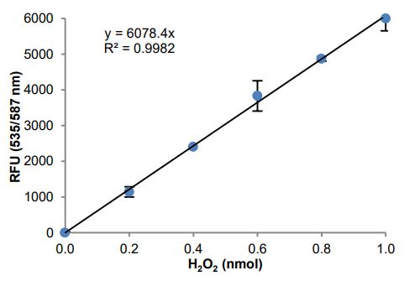
Figure 1. H₂O₂ Standard Curve.

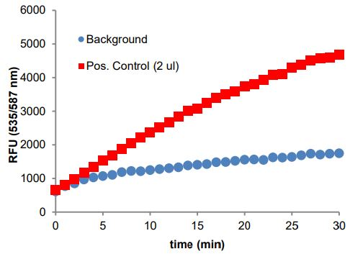
Figure 2. Reaction kinetics of ACS Positive Control.

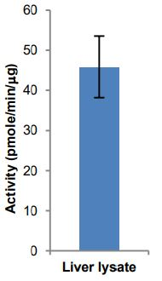
Figure 3. ACS activity in Rat liver lysate. Rat liver was prepared according to the described protocol. For activity determination, experiments were run in duplicates. 3.3-13.3 µg protein was loaded per well.

- FAQ / Troubleshooting
General troubleshooting points are found at www.abcam.com/assaykitguidelines.

- Notes

Technical Support
Copyright © 2023 Abcam, All Rights Reserved. The Abcam logo is a registered trademark. All information / detail is correct at time of going to print.
For all technical or commercial enquiries please go to:
www.abcam.com/contactus
www.abcam.cn/contactus (China)
www.abcam.co.jp/contactus (Japan)

