Version 2 Last updated 18 November 2021

ab274392

Human TFPI SimpleStep ELISA® Kit

For the quantitative measurement of TFPI in human serum, plasma, urine, and cell culture supernatant.

This product is for research use only and is not intended for diagnostic use.

Table of Contents
1. Overview 3
2. Protocol Summary 4
3. Precautions 5
4. Storage and Stability 5
5. Limitations 6
6. Materials Supplied 6
7. Materials Required, Not Supplied 7
8. Technical Hints 7
9. Reagent Preparation 9
10. Standard Preparation 10
11. Sample Preparation 11
12. Plate Preparation 13
13. Assay Procedure 14
14. Calculations 16
15. Typical Data 17
16. Typical Sample Values 18
17. Assay Specificity 25
18. Species Reactivity 26
19. Troubleshooting 27
20. Notes 28
Technical Support 28

- Overview
TFPI in vitro SimpleStep ELISA® (Enzyme-Linked Immunosorbent Assay) kit is designed for the quantitative measurement of TFPI protein in human serum, plasma, urine, and cell culture supernatant.

The SimpleStep ELISA® employs an affinity tag labeled capture antibody and a reporter conjugated detector antibody which immunocapture the sample analyte in solution. This entire complex (capture antibody/analyte/detector antibody) is in turn immobilized via immunoaffinity of an anti-tag antibody coating the well. To perform the assay, samples or standards are added to the wells, followed by the antibody mix. After incubation, the wells are washed to remove unbound material. TMB Development Solution is added and during incubation is catalyzed by HRP, generating blue coloration. This reaction is then stopped by addition of Stop Solution completing any color change from blue to yellow. Signal is generated proportionally to the amount of bound analyte and the intensity is measured at 450 nm. Optionally, instead of the endpoint reading, development of TMB can be recorded kinetically at 600 nm.

Tissue factor pathway inhibitor (TFPI), also known as extrinsic pathway inhibitor (EPI) or Lipoprotein-associated coagulation inhibitor (LACI), inhibits coagulation through the formation of a complex with coagulation factor X, VII, and tissue factor (TF). TFPI functions to prevent the activation of factor X which thus preventing clot formation. Active TFPI is a 40kDa full-length protein is found 50% in LDL, 40% in LHDL, and 10% in VLDL. Abnormally high levels of TFPI are thought to lead to severe hemostatic disturbances such as thrombosis, disseminated intravascular coagulation, and septic shock. Similarly, TFPI is also used clinically to treat inflammatory and cardiovascular diseases where clot formation is a high prevalence.
- Protocol Summary

Prepare all reagents, samples, and standards as instructed

Add 50 µL standard or sample to appropriate wells

Add 50 µL Antibody Cocktail to all wells

Incubate at room temperature for 1 hour

Aspirate and wash each well three times with 350 µL 1X Wash Buffer PT

Add 100 µL TMB Development Solution to each well and incubate for 10 minutes.

Add 100 µL Stop Solution and read OD at 450 nm

- Precautions
Please read these instructions carefully prior to beginning the assay.
- All kit components have been formulated and quality control tested to function successfully as a kit.
- We understand that, occasionally, experimental protocols might need to be modified to meet unique experimental circumstances. However, we cannot guarantee the performance of the product outside the conditions detailed in this protocol booklet.
- Reagents should be treated as possible mutagens and should be handle with care and disposed of properly. Please review the Safety Datasheet (SDS) provided with the product for information on the specific components.
- Observe good laboratory practices. Gloves, lab coat, and protective eyewear should always be worn. Never pipet by mouth. Do not eat, drink or smoke in the laboratory areas.
- All biological materials should be treated as potentially hazardous and handled as such. They should be disposed of in accordance with established safety procedures.
- Storage and Stability
Store kit at +4°C immediately upon receipt. Kit has a storage time of 1 year from receipt, providing components have not been reconstituted.
Refer to list of materials supplied for storage conditions of individual components.

- Limitations
- Assay kit intended for research use only. Not for use in diagnostic procedures.
- Do not mix or substitute reagents or materials from other kit lots or vendors. Kits are QC tested as a set of components and performance cannot be guaranteed if utilized separately or substituted.
- Materials Supplied
Item | Quantity | Storage Condition
Human TFPI Capture Antibody 10X | 600 µL | +4ºC
Human TFPI Detector Antibody 10X | 600 µL | +4ºC
Human TFPI Lyophilized Recombinant Protein | 2 Vials | +4ºC
Antibody Diluent 5BI | 6 mL | +4ºC
Sample Diluent NS | 50 mL | +4ºC
Wash Buffer PT 10X | 20 mL | +4ºC
TMB Development Solution | 12 mL | +4ºC
Stop Solution | 12 mL | +4ºC
SimpleStep Pre-Coated 96-Well Microplate | 96 Wells | +4ºC
Plate Seal | 1 | +4ºC

- Materials Required, Not Supplied
These materials are not included in the kit, but will be required to successfully perform this assay:
- Microplate reader capable of measuring absorbance at 450 or 600 nm.
- Method for determining protein concentration (BCA assay recommended).
- Deionized water.
- Multi- and single-channel pipettes.
- Tubes for standard dilution.
- Plate shaker for all incubation steps.
- Optional: Phenylmethylsulfonyl Fluoride (PMSF) (or other protease inhibitors).

- Technical Hints
- Samples generating values higher than the highest standard should be further diluted in the appropriate sample dilution buffers.
- Avoid foaming or bubbles when mixing or reconstituting components.
- Avoid cross contamination of samples or reagents by changing tips between sample, standard and reagent additions.
- Ensure plates are properly sealed or covered during incubation steps.
- Complete removal of all solutions and buffers during wash steps is necessary to minimize background.
- As a guide, typical ranges of sample concentration for commonly used sample types are shown below in Sample Preparation (section 11).
- All samples should be mixed thoroughly and gently.
- Avoid multiple freeze/thaw of samples.
- Incubate ELISA plates on a plate shaker during all incubation steps.
- When generating positive control samples, it is advisable to change pipette tips after each step.
- To avoid high background always add samples or standards to the well before the addition of the antibody cocktail.
- This kit is sold based on number of tests. A ‘test’ simply refers to a single assay well. The number of wells that contain sample, control or standard will vary by product. Review the protocol completely to confirm this kit meets your requirements. Please contact our Technical Support staff with any questions.

- Reagent Preparation
- Equilibrate all reagents to room temperature (18-25°C) prior to use. The kit contains enough reagents for 96 wells. The sample volumes below are sufficient for 48 wells (6 x 8-well strips); adjust volumes as needed for the number of strips in your experiment.
- Prepare only as much reagent as is needed on the day of the experiment. Capture and Detector Antibodies have only been tested for stability in the provided 10X formulations.

1X Wash Buffer PT:
Prepare 1X Wash Buffer PT by diluting Wash Buffer PT 10X with deionized water. To make 50 mL 1X Wash Buffer PT combine 5 mL Wash Buffer PT 10X with 45 mL deionized water. Mix thoroughly and gently.
Antibody Cocktail:
Prepare Antibody Cocktail by diluting the capture and detector antibodies in Antibody Diluent 5BI. To make 3 mL of the Antibody Cocktail combine 300 µL 10X Capture Antibody and 300 µL 10X Detector Antibody with 2.4 mL Antibody Diluent 5BI. Mix thoroughly and gently.
- Standard Preparation
- Always prepare a fresh set of standards for every use.
- Discard working standard dilutions after use as they do not store well.
- The following section describes the preparation of a standard curve for duplicate measurements (recommended).

  - IMPORTANT: If the protein standard vial has a volume identified on the label, reconstitute the TFPI by adding that volume of Sample Diluent NS indicated on the label. Alternatively, if the vial has a mass identified, reconstitute the TFPI standard by adding 500 µL of Sample Diluent NS. Hold at room temperature for 10 minutes and mix gently. This is the 150,000 pg/mL Stock Standard Solution.
    - Label eight tubes, Standards 1– 8.
    - Add 355 μL Sample Diluent NS into tube number 1 and 150 μL of Sample Diluent NS into numbers 2-8.
    - Use the Stock Standard to prepare the following dilution series. Standard #8 contains no protein and is the Blank control:

20 µL
µ

150 µL
µ

150 µL
µ

150 µL
µ

150 µL
µ

150 µL
µ

150 µL
µ

150 µL
µ

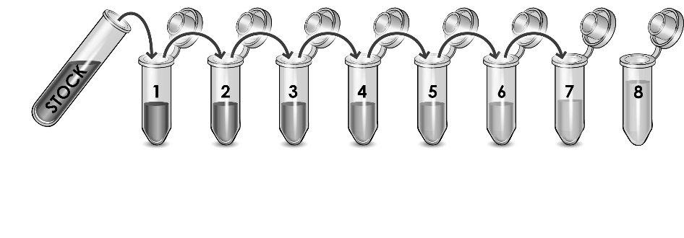
150,000
pg/mL

8,000
pg/mL

4,000
pg/mL

2,000
pg/mL

1,000
pg/mL

500
pg/mL

125
pg/mL

250
pg/mL

0
pg/mL

- Sample Preparation
Typical Sample Dynamic Range
Sample Type | Range
Serum | 0.0625% - 1%
Plasma - Citrate | 0.0625% - 1%
Plasma - EDTA | 0.0625% - 1%
Plasma - Heparin | 0.0625% - 1%
Urine | 3.125% - 50%
HepG2 Cell Culture Supernatant | 0.0625% - 0.5%
10F RPMI Cell Culture Media* | ≤100%
*Based on spiked sample

Plasma:
Collect plasma using citrate, EDTA or heparin. Centrifuge samples at 2,000 x g for 10 minutes. Dilute samples at least 1:100 into Sample Diluent NS and assay. Store un-diluted plasma samples at -20ºC or below for up to 3 months. Avoid repeated freeze-thaw cycles.

Serum:
Samples should be collected into a serum separator tube. After clot formation, centrifuge samples at 2,000 x g for 10 minutes and collect serum. Dilute samples at least 1:100 into Sample Diluent NS and assay. Store un-diluted serum at -20ºC or below. Avoid repeated freeze-thaw cycles.

Cell Culture Supernatants:
Centrifuge cell culture media at 2,000 x g for 10 minutes to remove debris. Collect supernatants and assay. Or dilute samples at least 1:200 into Sample Diluent NS and assay. Store un-diluted samples at -20°C or below. Avoid repeated freeze-thaw cycles.
  - Urine:
Centrifuge urine at 2,000 x g for 10 minutes to remove debris. Dilute samples at least 1:2 into Sample Diluent NS and assay. Store un-diluted urine samples at -20ºC or below. Avoid repeated freeze-thaw cycles.
- Plate Preparation
- The 96 well plate strips included with this kit are supplied ready to use. It is not necessary to rinse the plate prior to adding reagents.
- Unused plate strips should be immediately returned to the foil pouch containing the desiccant pack, resealed and stored at 4°C.
- For each assay performed, a minimum of two wells must be used as the zero control.
- For statistical reasons, we recommend each sample should be assayed with a minimum of two replicates (duplicates).
- Differences in well absorbance or “edge effects” have not been observed with this assay.

- Assay Procedure
- Equilibrate all materials and prepared reagents to room temperature prior to use.
- We recommend that you assay all standards, controls and samples in duplicate.

  - Prepare all reagents, working standards, and samples as directed in the previous sections.
  - Remove excess microplate strips from the plate frame, return them to the foil pouch containing the desiccant pack, reseal and return to 4ºC storage.
  - Add 50 µL of all sample or standard to appropriate wells.
  - Add 50 µL of the Antibody Cocktail to each well.
  - Seal the plate and incubate for 1 hour at room temperature on a plate shaker set to 400 rpm.
  - Wash each well with 3 x 350 µL 1X Wash Buffer PT. Wash by aspirating or decanting from wells then dispensing 350 µL 1X Wash Buffer PT into each well. Wash Buffer PT should remain in wells for at least 10 seconds. Complete removal of liquid at each step is essential for good performance. After the last wash invert the plate and tap gently against clean paper towels to remove excess liquid.
  - Add 100 µL of TMB Development Solution to each well and incubate for 10 minutes in the dark on a plate shaker set to 400 rpm.
Given variability in laboratory environmental conditions, optimal incubation time may vary between 5 and 20 minutes.
Note: The addition of Stop Solution will change the color from blue to yellow and enhance the signal intensity about 3X. To avoid signal saturation, proceed to the next step before the high concentration of the standard reaches a blue color of O.D.600 equal to 1.0.
  - Add 100 µL of Stop Solution to each well. Shake plate on a plate shaker for 1 minute to mix. Record the OD at 450 nm. This is an endpoint reading.
  - Alternative to 13.7 – 13.8: Instead of the endpoint reading at 450 nm, record the development of TMB Substrate kinetically. Immediately after addition of TMB Development Solution begin recording the blue color development with elapsed time in the microplate reader prepared with the following settings:

Mode | Kinetic
Wavelength: | 600 nm
Time: | up to 20 min
Interval: | 20 sec - 1 min
Shaking: | Shake between readings
- Note: that an endpoint reading can also be recorded at the completion of the kinetic read by adding 100 µL Stop Solution to each well and recording the OD at 450 nm.
  - Analyze the data as described below.

- Calculations
  - Calculate the average absorbance value for the blank control (zero) standards. Subtract the average blank control standard absorbance value from all other absorbance values.
  - Create a standard curve by plotting the average blank control subtracted absorbance value for each standard concentration (y-axis) against the target protein concentration (x-axis) of the standard. Use graphing software to draw the best smooth curve through these points to construct the standard curve.
- Note: Most microplate reader software or graphing software will plot these values and fit a curve to the data. A four-parameter curve fit (4PL) is often the best choice; however, other algorithms (e.g. linear, semi-log, log/log, 4-parameter logistic) can also be tested to determine if it provides a better curve fit to the standard values.
  - Determine the concentration of the target protein in the sample by interpolating the blank control subtracted absorbance values against the standard curve. Multiply the resulting value by the appropriate sample dilution factor, if used, to obtain the concentration of target protein in the sample.
  - Samples generating absorbance values greater than that of the highest standard should be further diluted and reanalyzed. Similarly, samples which measure at an absorbance values less than that of the lowest standard should be retested in a less dilute form.

- Typical Data
Typical standard curve – data provided for demonstration purposes only. A new standard curve must be generated for each assay performed.
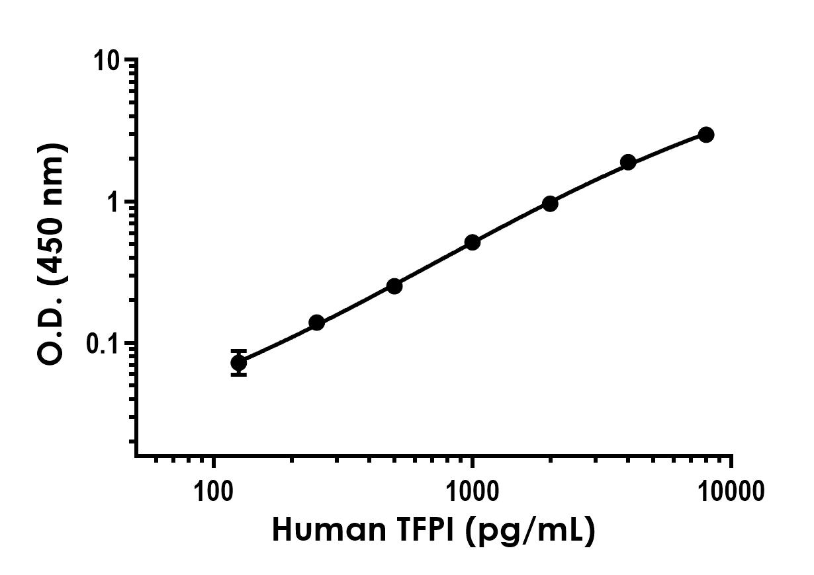
Standard Curve Measurements
Concentration (pg/mL) | O.D 450 nm |  | Mean  O.D
Concentration (pg/mL) | 1 | 2 | Mean  O.D
0 | 0.103 | 0.103 | 0.103
125 | 0.186 | 0.166 | 0.176
250 | 0.242 | 0.243 | 0.243
500 | 0.345 | 0.364 | 0.355
1000 | 0.609 | 0.626 | 0.617
2000 | 1.057 | 1.072 | 1.064
4000 | 2.015 | 1.975 | 1.995
8000 | 3.000 | 3.125 | 3.063
Figure 1. Example of human TFPI standard curve in Sample Diluent NS. The TFPI standard curve was prepared as described in Section 10. Raw data values are shown in the table. Background-subtracted data values (mean +/- SD) are graphed.

- Typical Sample Values
SENSITIVITY –
The calculated minimal detectable dose (MDD) is 21.4 pg/mL. The MDD was determined by calculating the mean of zero standard replicates (n=24) and adding 2 standard deviations then extrapolating the corresponding concentration.

RECOVERY –
Three concentrations of TFPI recombinant protein were spiked in duplicate to the indicated biological matrix to evaluate signal recovery in the working range of the assay.
Sample Type | Average % Recovery | Range (%)
0.25 % Serum | 115 | 111 - 119
0.25 % Plasma - Citrate | 102 | 96 - 106
0.25 % Plasma - EDTA | 116 | 114 - 117
0.125 % Plasma - Heparin | 117 | 113 - 120
12.5 % Urine | 110 | 105 - 117
0.0625 % HepG2 Cell Culture Supernatant* | 106 | 100 - 112
100 % Cell Culture Media* | 91 | 88 - 94
*Media is RPMI 1640 containing 10% fetal calf serum.

Linearity of Dilution
Linearity of dilution is determined based on interpolated values from the standard curve. Linearity of dilution defines a sample concentration interval in which interpolated target concentrations are directly proportional to sample dilution.

Native TFPI was measured in the following biological samples in a 2-fold dilution series. Sample dilutions are made in Sample Diluent NS.
Dilution  Factor | Interpolated value | 1%  Human  Serum | 1%  Human  Plasma  (Citrate) | 1%  Human  Plasma  (EDTA) | 1%  Human  Plasma  (Heparin) | 50%  Human  Urine | 0.5%  HepG2  Super-  natant
Undiluted | pg/mL | 4367.12 | 3357.17 | 4659.25 | 3466.94 | 4300.59 | 5292.62
Undiluted | % Expected value | 100 | 100 | 100 | 100 | 100 | 100
2 | pg/mL | 2048.96  = | 1602.39 | 2079.24 | 1740.64 | 2254.64 | 2565.51
2 | % Expected value | 94 | 95 | 89 | 100 | 105 | 97
4 | pg/mL | 1049.01 | 894.30 | 1042.08 | 869.80 | 1085.67 | 1139.23
4 | % Expected value | 96 | 107 | 89 | 100 | 101 | 86
8 | pg/mL | 511.65 | 446.60 | 527.78 | 422.11 | 512.21 | 555.27
8 | % Expected value | 94 | 106 | 91 | 97 | 95 | 84
16 | pg/mL | 250.74 | 195.92 | 241.12 | 186.57 | 258.39 | NL
16 | % Expected value | 92 | 93 | 83 | 86 | 96 | NL
NL – Non-Linear

Recombinant TFPI was spiked into the following biological samples and diluted in a 2-fold dilution series in Sample Diluent NS.
Dilution  Factor | Interpolated value | 100%  10F RPMI Media
Undiluted | pg/mL | 7925.66
Undiluted | % Expected value | 100
2 | pg/mL | 3882.21
2 | % Expected value | 98
4 | pg/mL | 1815.84
4 | % Expected value | 92
8 | pg/mL | 1032.93
8 | % Expected value | 104
16 | pg/mL | 550.51
16 | % Expected value | 111

PRECISION –
Mean coefficient of variations of interpolated values of TFPI from a single concentration of human serum within the working range of the assay.
 | Intra-  Assay | Inter-  Assay
n = | 8 | 3
CV(%) | 6.5 | 6.9

Figure 2. Interpolated concentrations of native TFPI in human serum and plasma. The concentrations of TFPI were measured in duplicates, interpolated from the TFPI standard curves and corrected for sample dilution. Undiluted samples are as follows: serum 1%, plasma (citrate) 1%, plasma (EDTA) 1% and plasma (Heparin) 1%. The interpolated dilution factor corrected values are plotted (mean +/- SD, n=2). The mean TFPI concentration was determined to be 415.32 ng/mL in serum, 336.93 ng/mL in plasma (citrate), 421.32 ng/mL in plasma (EDTA), and 335.79 ng/mL in plasma (Heparin).

Figure 3. Interpolated concentrations of native TFPI in human urine and cell culture supernatant samples. The concentrations of TFPI were measured in duplicates, interpolated from the TFPI standard curves and corrected for sample dilution. Undiluted samples are as follows: Urine 50% and HepG2 cell culture supernatant 0.5%. The interpolated dilution factor corrected values are plotted (mean +/- SD, n=2). The mean TFPI concentration was determined to be 8.55 ng/mL in urine, and 971.14 ng/mL in HepG2 supernatant.

Figure 4. 0.5% Serum from ten individual healthy human female donors was measured in duplicate. Interpolated dilution factor corrected values are plotted (mean +/- SD, n=2). The mean TFPI concentration was determined to be 502.80 ng/mL with a range of 290.26 – 698.50 ng/mL.

- Assay Specificity
This kit recognizes both native and recombinant human TFPI protein in serum, plasma, and cell culture supernatant samples only.

Milk, and cell and tissue extract samples have not been tested with this kit.

- Species Reactivity
This kit recognizes human TFPI protein.

Other species reactivity was determined by measuring 1% serum samples of various species, interpolating the protein concentrations from the human standard curve, and expressing the interpolated concentrations as a percentage of the protein concentration in human serum assayed at the same dilution.

Cross reactive species:
- Monkey (40%)

Reactivity < 3% was determined for the following species:
- Mouse
- Rat
- Cow

Other species reactivity not determined.

Please contact our Technical Support team for more information.

- Troubleshooting
Problem | Reason | Solution
Poor standard  curve | Inaccurate Pipetting | Check pipettes
Poor standard  curve | Improper standard  dilution | Prior to opening, briefly spin the stock standard tube and dissolve the powder thoroughly by gentle mixing
Low Signal | Incubation times too brief | Ensure sufficient incubation times; increase to 2 or 3 hour standard/sample incubation
Low Signal | Inadequate reagent volumes or improper dilution | Check pipettes and ensure correct preparation
Low Signal | Incubation times with TMB too brief | Ensure sufficient incubation time until blue color develops prior addition of Stop solution
Large CV | Plate is insufficiently washed | Review manual for proper wash technique. If using a plate washer, check all ports for obstructions.
Large CV | Contaminated wash buffer | Prepare fresh wash buffer
Low sensitivity | Improper storage of the ELISA kit | Store your reconstituted standards at -80°C, all other assay components 4°C. Keep TMB Development Solution protected from light.
Precipitate in Diluent | Precipitation and/or coagulation of components within the Diluent. | Precipitate can be removed by gently warming the Diluent to 37ºC.

- Notes

Technical Support
Copyright © 2021 Abcam, All Rights Reserved. The Abcam logo is a registered trademark. All information / detail is correct at time of going to print.
For all technical or commercial enquiries please go to:
www.abcam.com/contactus
www.abcam.cn/contactus (China)
www.abcam.co.jp/contactus (Japan)

