

ab46029 –
Human IL-6 Receptor ELISA Kit

Instructions for Use

For the quantitative measurement of IL-6 Receptor in Human serum, plasma, buffered solutions and cell culture media.

This product is for research use only and is not intended for diagnostic use.

Table of Contents

INTRODUCTION
1. BACKGROUND 2
2. ASSAY SUMMARY 3
GENERAL INFORMATION
3. PRECAUTIONS 4
4. STORAGE AND STABILITY 4
5. MATERIALS SUPPLIED 4
6. MATERIALS REQUIRED, NOT SUPPLIED 5
7. LIMITATIONS 5
8. TECHNICAL HINTS 6
ASSAY PREPARATION
9. REAGENT PREPARATION 8
10. STANDARD PREPARATION 10
11. SAMPLE PREPARATION AND STORAGE 12
12. PLATE PREPARATION 13
ASSAY PROCEDURE
13. ASSAY PROCEDURE 14
DATA ANALYSIS
14. CALCULATIONS 16
15. TYPICAL DATA 17
16. TYPICAL SAMPLE VALUES 18
17. ASSAY SPECIFICITY 19
RESOURCES
18. TROUBLESHOOTING 20
19. NOTES 21

BACKGROUND
Abcam’s IL-6 Receptor Human in vitro ELISA (Enzyme-Linked Immunosorbent Assay) kit is designed for the quantitative measurement of soluble IL-6 Receptor in Human serum, plasma, buffered solutions and cell culture medium.
A monoclonal antibody specific for IL-6 Receptor has been coated onto the wells of the microtiter strips provided. Samples, including standards of known IL-6 Receptor concentrations, control specimens or unknowns are pipetted into these wells. During the first incubation, the standards or samples and a biotinylated monoclonal antibody specific for IL-6 Receptor are simultaneously incubated. After washing, the enzyme Streptavidin-HRP, that binds the biotinylated antibody is added, incubated and washed. A TMB substrate solution is added which acts on the bound enzyme to induce a colored reaction product. The intensity of this colored product is directly proportional to the concentration of IL-6 Receptor present in the samples.
This kit will recognize both endogenous and recombinant Human IL-6 Receptor.

ASSAY SUMMARY
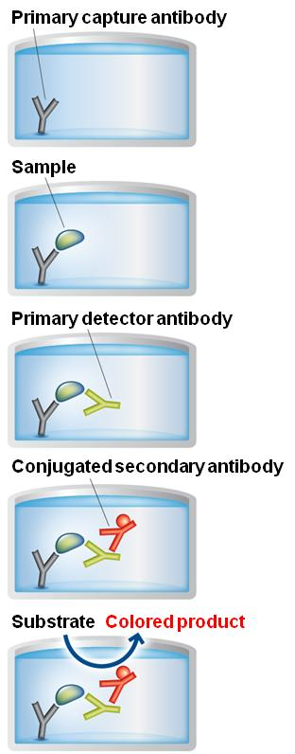
Remove appropriate number of antibody coated well strips. Equilibrate all reagents to room temperature. Prepare all the reagents, samples, and standards as instructed.

Add standard or sample to each well used.

Add prepared Biotinylated labeled detector antibody. Incubate at room temperature

Aspirate and wash each well. Add prepared Streptavidin-HRP mix to each well. Incubate at room temperature

Aspirate and wash each well. Add the TMB Solution to each well until color develops and then add the Stop Solution. Immediately begin recording the color development

PRECAUTIONS
Please read these instructions carefully prior to beginning the assay.
All kit components have been formulated and quality control tested to function successfully as a kit. Modifications to the kit components or procedures may result in loss of performance.

STORAGE AND STABILITY
Store kit at +2-8ºC immediately upon receipt.
Refer to list of materials supplied for storage conditions of individual components. Observe the storage conditions for individual prepared components in section 9. Reagent Preparation.

MATERIALS SUPPLIED
Item | Quantity |  | Storage  Condition (Before Preparation)
Item | 1 x 96 tests | 2 x 96 tests | Storage  Condition (Before Preparation)
IL-6 Receptor Microplate  (12 x 8 well strips) | 96 wells | 2 x 96 wells | +2-8ºC
IL-6 Receptor Standard (Lyophilized) | 2 vials | 4 vials | +2-8ºC
10X Standard Diluent Buffer | 15 mL | 25 mL | +2-8ºC
Control | 2 vials | 4 vials | +2-8ºC
Biotinylated anti-IL-6 Receptor | 400 µL | 2 x 400 µL | +2-8ºC
Biotinylated Antibody Diluent | 7 mL | 13 mL | +2-8ºC
Streptavidin-HRP | 2 x 5 µL | 4 x 5 µL | +2-8ºC
HRP Diluent | 12 mL | 23 mL | +2-8ºC
200X Wash Buffer | 10 mL | 2 x 10mL | +2-8ºC
Chromogen TMB Substrate Solution | 11 mL | 24 mL | +2-8ºC
Stop Reagent | 11 mL | 2 x11 mL | +2-8ºC

Note: This ELISA kit will soon contain the “Easy View” colored reagents. The Standard diluent buffer will now be red, and the Streptavidin-HRP Diluent will be green. Please note that while stock lasts you may still receive colorless diluents. This change does not impact the results provided by the kit or the assay procedure.

MATERIALS REQUIRED, NOT SUPPLIED
These materials are not included in the kit, but will be required to successfully utilize this assay:
- Microplate reader capable of measuring absorbance at 450 nm.
- Precision pipettes to deliver 2 μL to 1 mL volumes.
- Adjustable 1-25 mL pipettes for reagent preparation.
- 100 mL and 1 liter graduated cylinders.
- Absorbent paper.
- Distilled or deionized water.
- Tubes to prepare standard or sample dilutions.
- Log-log graph paper or computer and software for ELISA data analysis.

LIMITATIONS
- Do not mix or substitute reagents or materials from other kit lots or vendors. Kits are QC tested as a set of components and performance cannot be guaranteed if utilized separately or substituted.
- Since exact conditions may vary from assay to assay, a standard curve must be established for every assay performed.
- Bacterial or fungal contamination of either samples or reagents or cross-contamination between reagents may cause erroneous results.
- Disposable pipette tips, flasks or glassware are preferred, reusable glassware must be washed and thoroughly rinsed of all detergents before use.
- Improper or insufficient washing at any stage of the procedure will result in either false positive or false negative results. Completely empty wells before dispensing fresh 1X Wash Buffer. Do not allow wells to sit uncovered or dry for extended periods.

TECHNICAL HINTS
- Kit components should be stored as indicated. All the reagents should be equilibrated to room temperature before use. Reconstituted standards should be discarded after use.
- Once the desired number of strips has been removed, immediately reseal the bag to protect the remaining strips from degradation.
- Use a clean disposable plastic pipette tip for each reagent, standard, or specimen addition in order to avoid cross-contamination; for the dispensing of the Stop Solution and substrate solution, avoid pipettes with metal parts.
- Thoroughly mix the reagents and samples before use by agitation or swirling.
- All residual washing liquid must be drained from the wells by efficient aspiration or by decantation followed by tapping the plate forcefully on absorbent paper. Never insert absorbent paper directly into the wells.
- The TMB solution is light sensitive. Avoid prolonged exposure to light. Also, avoid contact of the TMB solution with metal to prevent color development. Warning TMB is toxic avoid direct contact with hands. Dispose off properly.
- If a dark blue color develops within a few minutes after preparation, this indicates that the TMB solution has been contaminated and must be discarded. Read absorbances within 1 hour after completion of the assay.
- When pipetting reagents, maintain a consistent order of addition from well-to-well. This will ensure equal incubation times for all wells.
- Dispense the TMB solution within 15 minutes following the washing of the microtiter plate.
- This kit is sold based on number of tests. A ‘test’ simply refers to a single assay well. The number of wells that contain sample, control or standard will vary by product. Review the protocol completely to confirm this kit meets your requirements. Please contact our Technical Support staff with any questions.

REAGENT PREPARATION
Equilibrate all reagents and samples to room temperature (18-25°C) prior to use.
  - 1X Standard Diluent Buffer.
Dilute the 10X Standard Diluent Buffer 10-fold in distilled water before use.
  - 1X Wash Buffer
Dilute the 200X Wash Buffer Concentrate 200-fold in distilled water before use. Mix gently to avoid foaming.
The 1X Wash Buffer can be prepared as needed according to the following table:
Number of well strips used | Volume of 200X Wash Buffer Concentrate (mL) | Volume of distilled water (mL)
1-6 | 5 | 995
1-12 | 10 | 1,990

  - 1X Control Solution
Control vials must be reconstituted with the volume of 1X Standard Diluent Buffer that is indicated on the vial. Reconstitution of the lyophilized material with the indicated volume will yield a solution for which the IL-6 Receptor concentration is stated on the vial. Allow the reconstituted 1X Control Solution to stand for 5 minutes with gentle swirling prior to use in the assay procedure. Do not store the 1X Control Solution after reconstitution.

  - 1X Biotinylated anti-IL-6 Receptor
Prepare the 1X Biotinylated anti-IL-6 Receptor immediately prior to use. According to the table below, dilute the Biotinylated anti-IL-6 Receptor with the Biotinylated Antibody Diluent based on the number of wells being used in the assay procedure:
Number of well strips used | Volume of Biotinylated anti IL-6 Receptor (µL) | Volume of Biotinylated Antibody Diluent (µL)
2 | 40 | 1,060
3 | 60 | 1,590
4 | 80 | 2,120
6 | 120 | 3,180
12 | 240 | 6,360

  - 1X Streptavidin-HRP Solution
Add 500 µL of HRP-Diluent to the Streptavidin-HRP vial prior to use to create a Streptavidin-HRP Concentrate. Do not keep this solution for further experiments.
Subsequently, prior to use in the assay procedure, prepare the 1X Streptavidin-HRP Solution by further diluting the Streptavidin-HRP Concentrate with HRP-Diluent. Use the table below to determine the volumes of each solution required to prepare the final 1X Streptavidin-HRP Solution:
Number of well strips used | Volume of Streptavidin-HRP (µL) | Volume of HRP-Diluent (mL)
2 | 30 | 2
3 | 45 | 3
4 | 60 | 4
6 | 75 | 5
12 | 150 | 10

STANDARD PREPARATION
Prepare serially diluted standards immediately prior to use. Always prepare a fresh set of standards for every use.
  - Prepare a 1,000 pg/mL Standard #1 by reconstituting with the volume indicated on the vial using 1X Standard Diluent Buffer.
  - Label tubes #2-6 and add 100 μL of 1X Standard Diluent Buffer into each tube.
  - Prepare Standard #2 by adding 100 μL of Standard #1 to tube #2 and mix thoroughly.
  - Prepare Standard #3 by adding 100 μL of Standard #2 to tube #3 and mix thoroughly.
  - Using the table below as a guide, prepare further serial dilutions.
  - 1X Standard Diluent Buffer serves as the zero standard (0 pg/mL).

Standard Dilution Preparation Table
Standard  # | Volume to  Dilute  (µL) | Diluent  (µL) | Total  Volume  (µL) | Starting  Conc.  (pg/mL) | Final Conc.  (pg/mL)
1 | - | - | - | 1,000 | 1,000
2 | 100 | 100 | 200 | 1,000 | 500
3 | 100 | 100 | 200 | 500 | 250
4 | 100 | 100 | 200 | 250 | 125
5 | 100 | 100 | 200 | 125 | 62.5
6 | 100 | 100 | 200 | 62.5 | 31.25

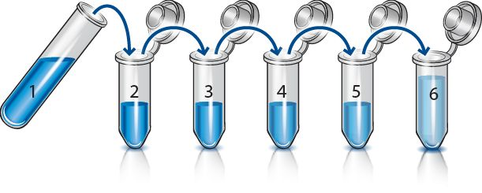

SAMPLE PREPARATION AND STORAGE
- Preparation of Cell culture Supernatants
Centrifuge cell culture media at 1,000 x g for 10 minutes to remove debris. Collect supernatants and assay. Store samples at -20°C or below. Avoid repeated freeze-thaw cycles.

- Preparation of Plasma Samples
Collect plasma using citrate, EDTA or heparin. Centrifuge samples at 1,000 x g for 30 minutes. Dilute samples 1:200 into 1X Standard Diluent Buffer and assay. Store un-diluted plasma samples at -20ºC or below for up to 3 months. Avoid repeated freeze-thaw cycles.

- Preparation of Serum Samples
Samples should be collected into a serum separator tube. After clot formation, centrifuge samples at 1,000 x g for 10 minutes and collect serum. Dilute samples 1:200 into 1X Standard Diluent Buffer and assay. Store un-diluted serum at -20ºC or below. Avoid repeated freeze-thaw cycles.

PLATE PREPARATION
- The 96 well plate strips included with this kit is supplied ready to use. It is not necessary to rinse the plate prior to adding reagents.
- Unused well strips should be returned to the plate packet and stored at 4°C.
- For statistical reasons, we recommend each sample should be assayed with a minimum of two replicates (duplicates).
- Well effects have not been observed with this assay. Contents of each well can be recorded on the template sheet included in the Resources section.

ASSAY PROCEDURE
● Equilibrate all materials and prepared reagents to room temperature prior to use.
● It is recommended to assay all standards, controls and samples in duplicate.
  - Prior to use, mix all reagents thoroughly taking care not to create any foam within the vials.
  - Determine the number of microplate strips required to test the desired number of samples, plus appropriate number of wells needed for controls and standards. Remove sufficient microplate strips from the pouch.
  - Add 100 µL of each standard (see Section 10), including blank controls to the appropriate wells.
  - Add 100 µL of sample and 1X Control Solution to the appropriate wells.
  - Add 50 µL of 1X Biotinylated anti-IL-6 Receptor to all wells (see Section 9).
  - Cover and incubate for 1 hour at room temperature (18-25°C).
  - Remove the cover and wash the plate as follows:
    - Aspirate the liquid from each well.
    - Add 300 µL of 1X Wash Buffer into each well
    - Aspirate the liquid from each well.
    - Repeat for a total of 3 washes.
  - Add 100 µL of 1X Streptavidin-HRP solution into all wells, including the blank wells. Re-cover and incubate at room temperature for 30 minutes.
  - Wash as described in Step 13.7.
  - Add 100 µL of Chromogen TMB substrate solution into each well and incubate in the dark for 10-20 minutes at room temperature. Avoid direct exposure to light by wrapping the plate in aluminum foil.
Note: Incubation time of the substrate solution is usually determined by the microplate reader performances: many microplate readers record absorbance only up to 2.0 O.D. The O.D. values of the plate should be monitored and the substrate reaction stopped before positive wells are no longer accurately readable (maximum ~20 minutes).
  - Add 100 µL of Stop Reagent into each well. Results must be taken immediately after the addition of Stop Reagent, or within one hour, if the microplate is stored at 2-8°C in the dark.
  - Read absorbance of each well on a spectrophotometer using 450 nm as the primary wavelength and optionally 620 nm (610 nm to 650 nm is acceptable) as the reference wavelength.

CALCULATIONS
Calculate the mean absorbance for each set of duplicate standards, controls and samples, and subtract the average zero standard optical density. Plot the standard curve on log-log graph paper, with standard concentration on the x-axis and absorbance on the y-axis. Draw the best-fit straight line through the standard points.

For samples that have been diluted, the concentration read from the standard curve has to be multiplied by the dilution factor to determine the actual concentration of the target protein present.

TYPICAL DATA
TYPICAL STANDARD CURVE - Data provided for demonstration purposes only. A new standard curve must be generated for each assay performed.

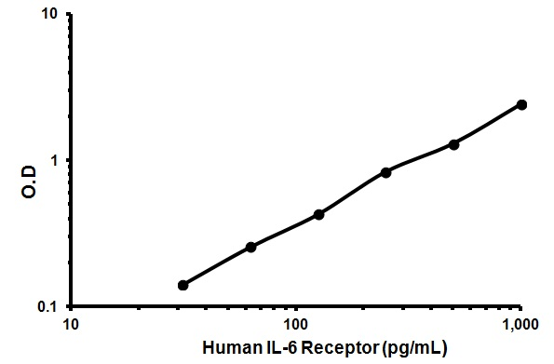

Conc. (pg/mL) | O.D.
1,000 | 2.400
500 | 1.296
250 | 0.831
125 | 0.426
62.5 | 0.255
31.25 | 0.141
0 | 0.024

TYPICAL SAMPLE VALUES
NORMAL SERUM VALUES -
The average concentration of IL-6 Receptor detected in 80 normal Human serum is 117+/-34 ng/mL ranging from 79 to 185 ng/mL.

SENSITIVITY –
The sensitivity, minimum detectable dose of Human IL-6 Receptor using this IL-6 Receptor ELISA kit was found to be < 5.0 g/mL. This was determined by adding 3 standard deviations to the mean OD obtained when the zero standard was assayed 32 times.

PRECISION –Sample A
 | Intra-  Assay | Inter-  Assay
n= | 7 | 24
Mean (pg/mL) | 977.7 | 983.9
SD | 3.040 | 10.46
CV (%) | 0.31 | 1.06

PRECISION –Sample B
 | Intra-  Assay | Inter-  Assay
n= | 7 | 24
Mean (pg/mL) | 131.1 | 136.2
SD | 2.489 | 6.086
CV (%) | 2.489 | 4.46

SPIKE RECOVERY -
Recovery of IL-6 Receptor added to pooled Human serum was 96%, concentrations ranging from 1,000 to 31.12 pg/mL.

ASSAY SPECIFICITY
This kit detects IL-6 Receptor in Human samples. Other species have not yet been tested with this kit.
Please contact our Technical Support team for more information.

TROUBLESHOOTING
Problem | Cause | Solution
Poor standard curve | Inaccurate pipetting | Check pipettes
Poor standard curve | Improper standards dilution | Prior to opening, briefly spin the stock standard tube and dissolve the powder thoroughly by gentle mixing
Low Signal | Incubation times too brief | Ensure sufficient incubation times; change to overnight standard/sample incubation
Low Signal | Inadequate reagent volumes or improper dilution | Check pipettes and ensure correct preparation
Large CV | Plate is insufficiently washed | Review manual for proper wash technique. If using a plate washer, check all ports for obstructions
Large CV | Contaminated wash buffer | Prepare fresh wash buffer
Low sensitivity | Improper storage of the ELISA kit | Store the reconstituted protein at -80°C, all other assay components 4°C. Keep substrate solution protected from light.

NOTES

For all technical and commercial enquires please go to:

www.abcam.com/contactus

www.abcam.cn/contactus (China)

www.abcam.co.jp/contactus (Japan)

Copyright © 2024 Abcam, All Rights Reserved. The Abcam logo is a registered trademark.
All information / detail is correct at time of going to print.

