

ab65391
LDH-Cytotoxicity Assay Kit
Instructions for Use
For the rapid, sensitive and accurate measurement of LDH-Cytotoxicity in cell culture samples.

This product is for research use only and is not intended for diagnostic use.

PLEASE NOTE: With the acquisition of BioVision by Abcam, we have made some changes to component names and packaging to better align with our global standards as we work towards environmental-friendly and efficient growth. You are receiving the same high-quality products as always, with no changes to specifications or protocols.

Table of Contents
1. Overview 3
2. Protocol Summary 4
3. Components and Storage 5
4. Assay Protocol 7
5. Data Analysis 9
6. Troubleshooting 10

Overview
Cell death or cytotoxicity is classically evaluated by the quantification of plasma membrane damage. Abcam’s LDH-Cytotoxicity Assay Kit provides a fast and simple method for quantitating cytotoxicity based on the measurement of activity of lactate dehydrogenase (LDH) released from damaged cells.
Unlike many other cytoplasmic enzymes which exist in many cells either in low amount (e.g., alkaline and acid phosphatase) or unstable, LDH is a stable cytoplasmic enzyme present in all cells and rapidly released into the cell culture supernatant upon damage of the plasma membrane. LDH activity can be determined by a coupled enzymatic reaction: LDH oxidizes lactate to pyruvate which then reacts with tetrazolium salt INT to form formazan. The increase in the amount of formazan produced in culture supernatant directly correlates to the increase in the number of lysed cells. The formazan dye is water-soluble and can be detected by spectrophotometer at 500 nm.
The LDH-cytotoxicity assay is sensitive, convenient, and precise, and is applicable to a variety of cytotoxicity studies. Assay takes ~0.5-1 hr.

Protocol Summary

Sample Preparation

Sample Incubation

Prepare and Add Reaction Mixture

Measure Absorbance

Components and Storage
- Kit Components
Item | Quantity
LDH Catalyst Reagent/Catalyst (Lyophilized) | 1 vial
Dye Solution I/Dye Solution | 45 mL
* Store kit at -20°C
LDH CATALYST REAGENT/CATALYST SOLUTION: Reconstitute the Catalyst in 1 ml ddH₂O for 10 min and mix thoroughly. The Catalyst Solution is stable for several weeks at +4°C.
DYE SOLUTION I/DYE SOLUTION: After thawing, the Dye Solution I/Dye Solution is stable for several weeks at +4°C. Avoid freeze/thaw cycles.
REACTION MIXTURE: For 100 assays, mix 250 μl of Catalyst Solution with 11.25 ml of Dye Solution I/Dye Solution. The mixture solution should be prepared immediately before use.

- Additional Materials Required
- Microcentrifuge
- Pipettes and pipette tips
- Colorimetric microplate reader
- 96 well plate
- Orbital shaker

Assay Protocol
- Collect cells (adherent and suspension) and wash 1X with assay medium (e.g., medium containing 1% serum or 1% BSA).
Note: Trypsin may be used to remove adherent cells from a culture surface.
- Prepare the following samples individually in a 96-well plate:
- Background Control:
Add 200 μl medium/well into triplicate wells. The background value has to be subtracted from all other values.
- Low Control:
Add 1-2 x 10⁴ cells/well in 200 μl assay medium into triplicate wells.
- High Control:
Add 1-2 x 10⁴ cells/well in 200 μl assay medium containing 1% Triton X-100 into triplicate wells.
- Test Sample:
Add 1-2 x 10⁴ cells/well in 200 μl assay medium containing test substance into triplicate wells.
- Incubate cells in an incubator (5 % CO₂, 90 % humidity, 37°C) for the appropriate time of treatment determined for test substance.
- Centrifuge the cells at 250 x g for 10 min.
- Transfer 100 μl/well supernatant carefully into corresponding wells of an optically clear 96-well plate.
- Add 100 μl Reaction Mixture to each well and incubate for up to 30 min at room temperature. Protect the plate from light.
- Measure the absorbance of all samples at 490-500 nm using a microtiter plate reader. The reference wavelength should be more than 600 nm.

Data Analysis
Cytotoxicity (%) = | (Test Sample – Low Control) | X 100
Cytotoxicity (%) = | (High Control – Low Control) | X 100

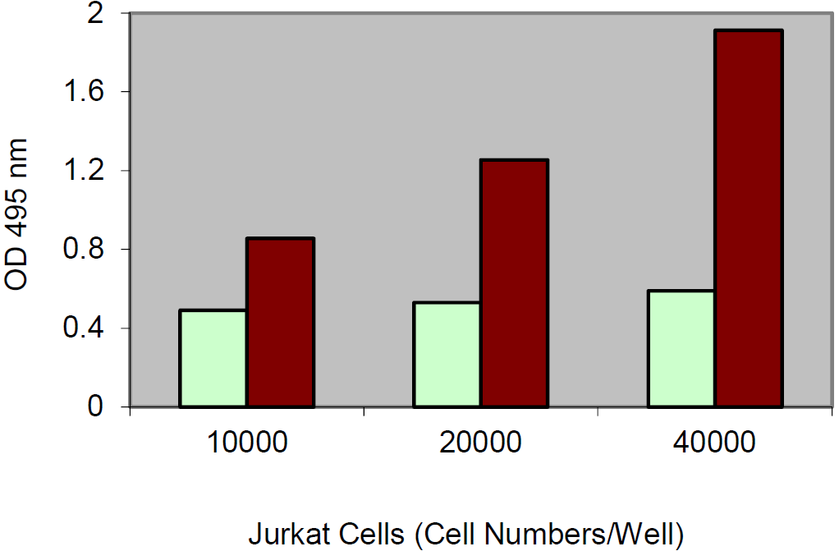 Light bar: Low control
Dark bar: High control.
Jurkat cells were cultured in 96-well plate in 100 μl of culture medium. LDH assay was performed using 10 μl of culture medium according to the kit instructions.

Troubleshooting
Problem | Reason | Solution
Assay not working | Assay buffer at wrong temperature | Assay buffer must not be chilled - needs to be at RT
Assay not working | Protocol step missed | Re-read and follow the protocol exactly
Assay not working | Plate read at incorrect wavelength | Ensure you are using appropriate reader and filter settings (refer to datasheet)
Assay not working | Unsuitable microtiter plate for assay | Fluorescence: Black plates (clear bottoms);  Luminescence: White plates;  Colorimetry: Clear plates.  If critical, datasheet will indicate whether to use flat- or U-shaped wells
Unexpected results | Measured at wrong wavelength | Use appropriate reader and filter settings described in datasheet
Unexpected results | Samples contain impeding substances | Troubleshoot and also consider deproteinizing samples
Unexpected results | Unsuitable sample type | Use recommended samples types as listed on the datasheet
Unexpected results | Sample readings are outside linear range | Concentrate/ dilute samples to be in linear range

Samples with inconsistent readings | Unsuitable sample type | Refer to datasheet for details about incompatible samples
Samples with inconsistent readings | Samples prepared in the wrong buffer | Use the assay buffer provided (or refer to datasheet for instructions)
Samples with inconsistent readings | Samples not deproteinized (if indicated on datasheet) | Use the 10kDa spin column (ab93349)
Samples with inconsistent readings | Cell/ tissue samples not sufficiently homogenized | Increase sonication time/ number of strokes with the Dounce homogenizer
Samples with inconsistent readings | Too many freeze-thaw cycles | Aliquot samples to reduce the number of freeze-thaw cycles
Samples with inconsistent readings | Samples contain impeding substances | Troubleshoot and also consider deproteinizing samples
Samples with inconsistent readings | Samples are too old or incorrectly stored | Use freshly made samples and store at recommended temperature until use
Lower/ Higher readings in samples and standards | Not fully thawed kit components | Wait for components to thaw completely and gently mix prior use
Lower/ Higher readings in samples and standards | Out-of-date kit or incorrectly stored reagents | Always check expiry date and store kit components as recommended on the datasheet
Lower/ Higher readings in samples and standards | Reagents sitting for extended periods on ice | Try to prepare a fresh reaction mix prior to each use
Lower/ Higher readings in samples and standards | Incorrect incubation time/ temperature | Refer to datasheet for recommended incubation time and/or temperature
Lower/ Higher readings in samples and standards | Incorrect amounts used | Check pipette is calibrated correctly (always use smallest volume pipette that can pipette entire volume)

Problem | Reason | Solution
Standard curve is not linear | Not fully thawed kit components | Wait for components to thaw completely and gently mix prior use
Standard curve is not linear | Pipetting errors when setting up the standard curve | Try not to pipette too small volumes
Standard curve is not linear | Incorrect pipetting when preparing the reaction mix | Always prepare a master mix
Standard curve is not linear | Air bubbles in wells | Air bubbles will interfere with readings; try to avoid producing air bubbles and always remove bubbles prior to reading plates
Standard curve is not linear | Concentration of standard stock incorrect | Re-check datasheet for recommended concentrations of standard stocks
Standard curve is not linear | Errors in standard curve calculations | Refer to datasheet and re-check the calculations
Standard curve is not linear | Use of other reagents than those provided with the kit | Use fresh components from the same kit

For further technical questions please do not hesitate to contact us by email (technical@abcam.com) or phone (select “contact us” on www.abcam.com for the phone number for your region).

Technical Support
Copyright © 2023 Abcam, All Rights Reserved. The Abcam logo is a registered trademark. All information / detail is correct at time of going to print.
For all technical or commercial enquiries please go to:
www.abcam.com/contactus
www.abcam.cn/contactus (China)
www.abcam.co.jp/contactus (Japan)

